**VIBRATION MEASUREMENT**

**AND ANALYSIS**

Ryan Kim

*Department of Mechanical and Aerospace Engineering*

*Rutgers University, Piscataway, New Jersey 08854*

**Measurements taken from vibrating cantilever beams are analyzed to produce numerical values for the vibrational properties of the beams. These include the damping ratios of the natural frequencies of the aluminum beam. LabVIEW measurements for sinewaves are used to calculate properties and also recreate experimental and theoretical plots. Natural frequencies of the beam are calculated to be 15.685 Hz and 98.3059 Hz theoretically, and measured as 14.246 Hz and 86.9754 Hz (with respective errors of 9.18% and 11.53%). Damping factors are determined by estimates, which are ζ = .0042 and .0025 experimentally, and .00183 theoretically. An average experimental damping factor from 25 peaks of response is .004265. Resonance frequency is found to be 13.5 Hz.**

**INTRODUCTION**

Vibrations are monitored for analyzing loads on structures and components to understand their effects and verify mathematical models. This allows engineers to determine the performance of machines and the structural integrity of components, as well as detecting any damages. Vibration monitoring is done using motion sensors which measure displacements (and their time rates) and other measurements like strain and temperature. In this lab, the motion sensors used are accelerometers. These are attached to cantilever beams, and they use the inertia of an internal mass along with the reciprocating motion of the beam to create a force on the piezoelectric material resulting in a voltage proportional to the acceleration. The voltage signal is converted to the desired measurements with a signal conditioner. This has obvious physical logic because the electromotive force is created from the force due to an accelerating mass. The beam is Aluminum 6061-T6.

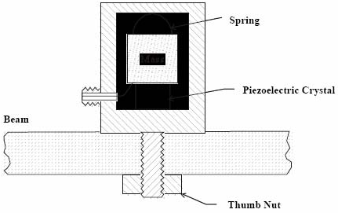

**Figure 1. Accelerometer attached to the cantilever beam measures vibration**

In a free vibrating cantilever beam, displacement is only in one direction. Therefore, it has only one degree of motion, and Equation [1] below represents the model for the spring-mass-damper system with one degree of motion:

[1]

Equation [1] describes the vibrational displacement *y(t)* of the beam as a spring-mass-damper system for which m is the mass, *c* is the damping coefficient, *k* is the spring constant, and *F(t)* is the applied force or excitation. Dividing Equation [1] by the mass yields the following:

 [2]

Equation [2] shows that the natural frequency *ωn* is equal to the square root of *(k/m)*, and *(c/m)* is *2ζωn* where *ζ* is the damping factor. Damping is normally a nonlinear and time-varying variable, but here the damping is represented as a constant to analyze the damping factor and the frequency, so Equation [1] is a practical simplification. The motion of a free vibrating cantilever beam is expressed as the partial differential equation below.

 [3]

The deformation of point x at time t is *u(x,t)*, *ρ* is the beam mass per unit length, *c(x)* is the damping function, and *L* is an operator that determines the shear force on the beam. For a uniform beam, *L = E*I*∂4/∂x4* where E is the Young’s modulus and I is the moment of inertia of the cross section. Assuming proportional damping, *c/ρ = 2ζω*, and the solution of Equation [3] is given in Equation [4] as a product of functions of *x* and *t*.

*u(x,t) = φ(x)q(t)* [4]

*EI = ω2ρφ*  [5]

*(t) + 2ζω(t) + ω2q(t)* [6]

For Equations [5, 6], boundary conditions are at the fixed and free ends of the cantilever beam, resulting in an infinite set of independent eigenfunctions called modes:

*u(x,t)=* [7]The eigenfunctions’ superposition yields the shape of the vibrating beam. The nth mode has n-1 zero crossings, and here the assumption is that two modes sufficiently represent the motion.

This lab involves using a LabVIEW Program that controls an analog to digital (A/D) board connected to a computer. This program acquires data of waveforms and amplitude spectra. The first part of the lab simply uses a function generator to create the data involving a sine wave and a square wave. The function generator is set to an amplitude of 50.00 mVRMS and a frequency of 2.00 Hz. A sine wave is created first, and then a square wave is created, for which each raw waveform and amplitude spectra are recorded. LabVIEW finds the amplitude spectrum with a Fast Fourier Transform which shows amplitude peaks at each frequency of all the sine waves that can sum up to create the measured waveform. The following equation is the combined waveform of N different sine waves:

[8]

The FFT is used in this lab to find the frequencies involved in Equation [8].

The second experiment involves a cantilever beam that is free on one end and clamped on the other. The top and bottom faces of the beam are 1”x32” and it is 0.5” thick. A single initial pull and release of the vertically bending cantilever beam causes a free vibration that slowly fades. The accelerometer takes measurements that determine the displacement of the beam at the end of the beam and at the node of the beam. Since this is a second mode vibration, there is one point on the beam for which the displacement remains zero; this is the node. Through LabVIEW, the voltage measurements are recorded as a waveform and as an amplitude spectrum.

The third experiment involves a cantilever beam that is free on one end and fixed to an oscillating clamp on the other end. The wide flat sides face horizontally. The oscillations are controlled and set to frequencies ranging from 2 Hz to 50 Hz. Under resonance, the accelerometer will pick up the largest beam deflection because the excitation frequency will match the natural frequency of the beam. Therefore, by experimenting at the right frequency, the natural frequency is determined. Once this frequency is found, measurements at this frequency are taken (at the end of the beam). Amplitudes at the different frequencies can be used to find a non-dimensional experimental amplitude ratio given by the equation below:

[9]

Also, the frequency response or response amplitude ratio has the value below:

 [10]

Both amplitude ratios are plotted together as a function of the frequency over natural frequency. Using MATLAB graphing, the damping factor can be determined for the beam experiments. The picture below shows the beam setup.

|  |
| --- |
|  |
| **Figure 2. Top shows a statically clamped cantilever beam which bends vertically, used in second experiment. Bottom shows identical beam held by horizontally oscillating clamp, bending horizontally, used in third experiment.** |

|  |  |
| --- | --- |
| Square Wave  Spectrum Peaks | |
|  | |
| Freq [Hz] | Amplitude [V] |
| 1.9994 | 0.0645 |
| 5.9983 | 0.0215 |
| 9.9972 | 0.0129 |
| 13.996 | 0.0092 |
| 17.9949 | 0.0071 |
| 21.9938 | 0.006 |
| 25.9927 | 0.0049 |
| 29.9915 | 0.0043 |
| 33.9904 | 0.0038 |
| 37.9893 | 0.0034 |
| 41.9881 | 0.003 |
| 45.987 | 0.0028 |
| 49.9859 | 0.0026 |
| 53.9847 | 0.0024 |
| 57.9836 | 0.0022 |
| 61.9825 | 0.0021 |
| 65.9814 | 0.0019 |
| 69.9802 | 0.0019 |
| 73.9791 | 0.0018 |
| 77.978 | 0.0016 |
| 81.9768 | 0.0015 |
| 85.9757 | 0.0015 |
| 89.9746 | 0.0013 |
| 93.9734 | 0.0013 |
| 97.9723 | 0.0014 |
| 101.9712 | 0.0013 |
| 105.9701 | 0.0013 |
| 109.9689 | 0.0011 |
| 113.9678 | 0.0011 |
| 117.9667 | 0.001 |

**RESULTS AND DISCUSSION**



**Figure 3. Amplitude Spectra of Sine wave and Square wave.**



**Figure 4. Waveform of Sine Wave**



**Figure 5. Waveform of Square wave measured, and Recreation of wave using sum of sinewaves with 1, 5, and All frequencies measured in Spectra**

**Table 1. Square wave amplitude spectra.**

The results of the first experiment are plotted in Figures [3, 4, 5]. The sine waveform is easily reproduced using the FFT peak frequency. It is a sinewave, so a single frequency can create it accurately as seen in Figure 4. The Square wave frequencies taken from Figure 3 are used as sinewave frequencies. Using only one frequency makes a simple sinewave, and using the first 5 frequencies sums up to a waveform that more closely follows the square waveform. Using all measured peaks gives a more complete sum of sinewaves that very accurately creates the waveform that is measured. The measured values are shown in Table 1 and the different waveforms are all compared on one plot in Figure 5. Figure 4 shows that the measured sinewave closely matches the FFT frequency-computed sinewave, and its resolution gives a proper result. The Square waveform creation does not look square enough until way more than 5 different frequencies are used in the sum of sinewaves. A high amount of terms must be used to correctly represent the shape of the Square waveform. However, the amount of zero crossings are matched with all waveforms. Sampling rate is satisfied for all measurements to be twice the frequency of the true waveform, thus satisfying the Nyquist criterion.

The second part of the experiment involves the waveforms and amplitude spectra measured by the accelerometer on the two positions of the free vibrating beam.



**Figure 6. Free vibrating beam waveform/spectra at 2 locations.**

It is seen that the node location yields only one amplitude spectrum peak frequency, while the end of the beam gives 2 frequencies. This is because there is one zero crossing for the 2nd mode and two for the 3rd mode. At the first node, only one mode is considered, and the second node only two. Thus, the first location has one natural frequency, and the second has two natural frequencies. Theoretical values are found with Equation [5], and another value is found from a 7 peak average frequency:

|  |  |  |
| --- | --- | --- |
| Frequency | [Hz] | % Error |
| ω1 [Eq. 5] | 15.6854 | [theoretical] |
| ω2 [Eq. 5] | 98.3059 | [theoretical] |
| ω1 [7 peaks] | 14.3546 | 0.1006 |
| ω1 [Spectrum] | 14.246 | 0.0918 |
| ω2 [Spectrum] | 86.9754 | 0.1153 |

**Table 2. Natural Frequency Values/Error**

Next, we take the peaks of the waveform at the first location where the node is, and the amplitudes q(t), periods T, changes in amplitudes δ, and damping factors ζ are tabulated below, where ζ = δ/2π and δ = ln(q(ts)/q(ts+1)).

|  |  |  |  |  |  |
| --- | --- | --- | --- | --- | --- |
| s | q(ts) | q(ts+1) | T | δ | ζ |
| 1 | 2.954102 | 2.856445 | 0.063479 | 0.033617 | 0.00535 |
| 2 | 2.856445 | 2.426758 | 0.07471 | 0.163022 | 0.025946 |
| 3 | 2.426758 | 2.37793 | 0.066897 | 0.020326 | 0.003235 |
| 4 | 2.37793 | 2.236328 | 0.071292 | 0.061395 | 0.009771 |
| 5 | 2.236328 | 2.167969 | 0.070803 | 0.031044 | 0.004941 |
| 6 | 2.167969 | 2.099609 | 0.070804 | 0.03204 | 0.005099 |
| 7 | 2.099609 | 2.036133 | 0.070803 | 0.030699 | 0.004886 |
| 8 | 2.036133 | 1.938477 | 0.071781 | 0.04915 | 0.007822 |
| 9 | 1.938477 | 1.928711 | 0.070315 | 0.005051 | 0.000804 |
| 10 | 1.928711 | 1.889648 | 0.071292 | 0.020461 | 0.003257 |
| 11 | 1.889648 | 1.855469 | 0.070315 | 0.018253 | 0.002905 |
| 12 | 1.855469 | 1.835937 | 0.070803 | 0.010583 | 0.001684 |
| 13 | 1.835937 | 1.791992 | 0.070804 | 0.024227 | 0.003856 |
| 14 | 1.791992 | 1.777344 | 0.070803 | 0.008208 | 0.001306 |
| 15 | 1.777344 | 1.738281 | 0.071292 | 0.022223 | 0.003537 |
| 16 | 1.738281 | 1.723633 | 0.070315 | 0.008462 | 0.001347 |
| 17 | 1.723633 | 1.694336 | 0.071292 | 0.017143 | 0.002728 |
| 18 | 1.694336 | 1.674805 | 0.070315 | 0.011594 | 0.001845 |
| 19 | 1.674805 | 1.650391 | 0.070804 | 0.014685 | 0.002337 |
| 20 | 1.650391 | 1.630859 | 0.070315 | 0.011905 | 0.001895 |
| 21 | 1.630859 | 1.611328 | 0.070803 | 0.012048 | 0.001918 |
| 22 | 1.611328 | 1.586914 | 0.070316 | 0.015267 | 0.00243 |
| 23 | 1.586914 | 1.577148 | 0.070315 | 0.006173 | 0.000982 |
| 24 | 1.577148 | 1.552734 | 0.070803 | 0.015601 | 0.002483 |

**Table 3. First 25 peaks of 1st mode waveform.**

**Average ζ of 24 peak intervals is .004265**

By graphing 20 peaks at a time, the linear curve fit can help trial-and-error damping factor solutions to the decay envelope of the sinewave peak amplitudes. This decay equation represents the logarithmically decaying peak amplitude of the response, given by:

*De-ζωt* [11] 



**Figure 7. Measured response q(t) compared with decay equation estimate. Top uses values from peaks 1-20 [on Table 2, s = 1:19]. Bottom uses values from 6-25 [s = 6:24]**

Through observation, a more linear slope is taken by using the 20 points after the first 5 peaks because the curve decays slower with later time (and lower amplitudes). Estimation of the damping factor as a constant value is a better estimate when the data is truncated with later time. The decay is much larger initially, so damping coefficient decreases with time. A higher beam deflection causes a higher damping due to resistive forces in the material. The first set of 20 peaks yields D = 2.5812 ζ = .0042 and the second set of peaks yields D = 2.0682 ζ = .0025 for the Decay Equation [11].

On the final experiment, excitation is set to different frequencies, and here are the amplitudes of the response:

|  |  |  |
| --- | --- | --- |
| Freq [Hz] | A(in) | A(out) |
| 1.999435 | 0.253134 | 0.060953 |
| 2.499294 | 0.331467 | 0.081053 |
| 2.999153 | 0.404241 | 0.101151 |
| 3.499011 | 0.471029 | 0.121577 |
| 3.99887 | 0.530277 | 0.141605 |
| 4.498729 | 0.581524 | 0.161336 |
| 4.998588 | 0.621736 | 0.180277 |
| 5.498446 | 0.650459 | 0.19838 |
| 5.998305 | 0.671227 | 0.216442 |
| 6.498164 | 0.678667 | 0.233191 |
| 6.998023 | 0.677033 | 0.250013 |
| 7.497882 | 0.666057 | 0.266525 |
| 7.99774 | 0.654343 | 0.286799 |
| 8.497599 | 0.634382 | 0.307494 |
| 8.997458 | 0.609775 | 0.332682 |
| 9.497317 | 0.579372 | 0.362173 |
| 9.997175 | 0.544068 | 0.401036 |
| 10.49703 | 0.501861 | 0.460419 |
| 10.99689 | 0.464219 | 0.509061 |
| 11.49675 | 0.404156 | 0.633737 |
| 11.99661 | 0.312549 | 0.810944 |
| 12.49647 | 0.165343 | 1.115264 |
| 12.99633 | 0.202047 | 1.768011 |
| 13.49619 | 1.151536 | 3.250301 |
| 13.99605 | 1.355113 | 2.324742 |
| 14.4959 | 1.030914 | 1.276583 |
| 14.99576 | 0.876803 | 0.854196 |
| 15.49562 | 0.791635 | 0.649214 |
| 15.99548 | 0.735049 | 0.527093 |
| 16.49534 | 0.686737 | 0.436455 |
| 16.9952 | 0.651777 | 0.372943 |
| 17.49506 | 0.621255 | 0.320655 |
| 17.99492 | 0.596041 | 0.280125 |
| 18.49478 | 0.575312 | 0.248736 |
| 18.99463 | 0.556584 | 0.223127 |
| 19.49449 | 0.540322 | 0.20231 |
| 19.99435 | 0.525898 | 0.185037 |
| 29.99153 | 0.366272 | 0.0892 |
| 39.9887 | 0.270058 | 0.051601 |
| 49.98588 | 0.224963 | 0.046554 |

**Table 4. Input Excitation and Output Response Amplitude for Frequencies 2-50 Hz**

Here it is found that the natural frequency is 13.5 Hz. Equations [9 ,10] are used to graph the experimental and the theoretical frequency response ratios for which the theoretical damping factor is estimated to be ζ = .00183.

**Figure 8. Response Ratio comparison**

Using 13.5 Hz as the excitation on the beam, the waveform and amplitude spectrum is plotted.



**Figure 9. Resonance wave/spectrum. Resonance shows amplitude peak at 13.5 Hz.**

With a constant vibration of natural frequency excitation (resonance), the damping factor seems to be very low. It has a constant value since amplitude of response stays the same with each period, unlike the Part 2 results. In the Part 2 estimations, the more constant the peaks (less slope, closer to constant) the closer the Part 2 damping factor is to the theoretical one calculated in this last (3rd) part. Damping factors of first 20 peaks is 0.0042 which is much greater than the 6th-25th peaks’ 0.0025. The second one is very close to 0.00183 from the 3rd experiment. Also, in Figure 9, the excitation is completely out of phase with the response. One is the acceleration (input) of the other, so the second derivative of a sinewave is simply the negative of that sinewave with some coefficient. At the peak of displacement, it has the most elastic potential, so it has the most force or acceleration in the opposite direction.

**CONCLUSIONS**

This lab has demonstrated the ability to find natural frequencies while showing the difficulty of determining a damping factor. Damping clearly changes in a nonlinear fashion and it is related to the amplitude of displacement of a point on the aluminum beam. With a higher resolution of measurement of the beam response to vibration, the second experiment could yield a better logarithmic curve so that tangent slopes could be taken at many different parts of the curve. This would give more specific values of the damping factor with respect to each amplitude of response. This is more demonstrated from Table 3 where the damping factor is changed with each measured interval. The mean value from Table 3 is .004265, which is very similar to the damping factor taken from the first 20 peaks of the free vibrating beam. The later 20 peaks give a value closer to that of the constant-amplitude 3rd experimental response, respectively .0025 and .00183, most likely because the rate of decay is much smaller with later time, making the amplitude closer to constant amplitude. The amplitude is less damped when it is already low, so energy is conserved when there is less elastic force on it. The study of the vibrating cantilever beam has generally produced results for which experimental calculations reasonably matched the theoretical calculations, so the use of the accelerometer and the applied sampling rate was a success in the study of vibrations.

**REFERENCES**

[1] Lab Manual

[2] Google – Aluminum Properties

[3] Lab Data and Excel Functions

Appendix: Sample Calculations

Part 1.1 1

Part 1.2 2

Part 1.3 2

## Part 1.1

sinf=sinspec(:,1);  
squf=squspec(:,1);  
sinamp=sinspec(:,2);  
squamp=squspec(:,2);  
  
subplot(1,2,1)  
plot(sinf,sinamp,'r')  
xlabel('Frequency [Hz]')  
ylabel('Amplitiude Spectrum [VDC]')  
title('Sine Wave')  
subplot(1,2,2)  
plot(squf,squamp)  
xlabel('Frequency [Hz]')  
ylabel('Amplitiude Spectrum [VDC]')  
title('Square Wave')

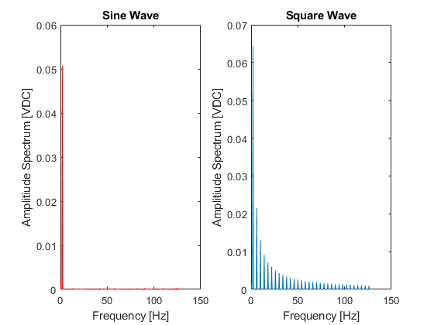

## Part 1.2

t1 = sinwave(:,1)';  
y1 = sinwave(:,2)';  
y2 = 0.0507*sin(2*pi*1.9994*t1);  
plot(t1,y1,t1,y2)  
title('Sine Wave')  
legend('Measured','Computed')  
xlabel('Time [s]')  
ylabel('Amplitude [VDC]')

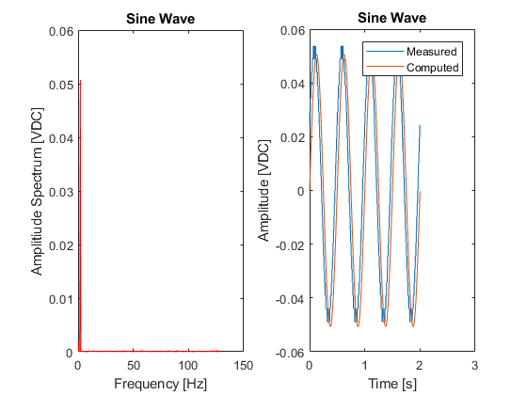

## Part 1.3

squpeaks = [1.999435 .064474; 5.998305 0.021516; 9.997175 .012913; 13.996046 .009172; 17.994916 .007138;  
 21.993786 .005955; 25.992656 .004943; 29.991526 .004252; 33.990397 .003815; 37.989267 .003383;  
 41.988137 .003048; 45.987007 .0028; 49.985877 .002619; 53.984747 .00239; 57.983618 .0022;  
 61.982488 .002052; 65.981358 .001927; 69.980228 .001851; 73.979098 .001771; 77.977968 .001618;  
 81.976839 .001525; 85.975709 .001478; 89.974579 .001318; 93.973449 .001333; 97.972319 .001357;  
 101.97119 .001254; 105.97006 .001273; 109.96893 .001129; 113.9678 .001134; 117.96667 .001034];  
  
t1sq = squwave(:,1);  
y1sq = squwave(:,2);  
  
one = squpeaks(1,2)*sin(2*pi*squpeaks(1,1)*t1sq);  
  
five = one;  
for i = 2:5  
 five = five + squpeaks(i,2)*sin(2*pi*squpeaks(i,1)*t1sq);  
end  
  
all = one;  
for i = 2:30  
 all = all + squpeaks(i,2)*sin(2*pi*squpeaks(i,1)*t1sq);  
end  
  
plot(t1sq,y1sq,'x-',t1sq,one,t1sq,five,t1sq,all)  
legend('Measured','One Peak','Five Peaks','All Peaks')  
title('Square Wave')  
xlabel('Time [s]')  
ylabel('Amplitude [VDC]')

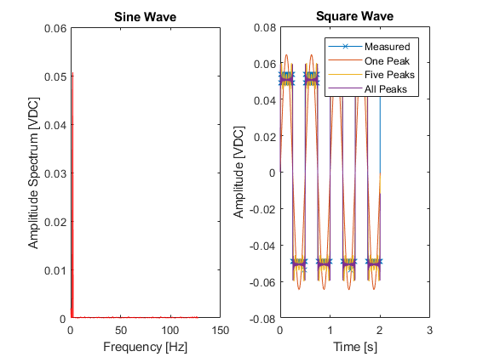

[Published with MATLAB® R2017b](http://www.mathworks.com/products/matlab)

Part 2.1 1

Part 2.2 2

2.3 3

b) s(peak #),decrement, q(t)and q(t+1)="response", T,damping-factor 4

2.3 c) 5

plotting on plot a 5

## Part 2.1

subplot(2,2,1)  
plot(nodewave(:,1),nodewave(:,2))  
title('Node of 2nd Mode Waveform')  
xlabel('Time [s]')  
ylabel('Amplitude [VDC]')  
  
subplot(2,2,2)  
plot(nodespec(:,1),nodespec(:,2))  
title('Node of 2nd Mode Spectrum')  
xlabel('Frequency [Hz]')  
ylabel('Amplitude Spectrum [VDC]')  
  
subplot(2,2,3)  
plot(endwave(:,1),endwave(:,2))  
title('End of Beam Waveform')  
xlabel('Time [s]')  
ylabel('Amplitude [VDC]')  
  
subplot(2,2,4)  
plot(endspec(:,1),endspec(:,2))  
title('End of Beam Spectrum')  
xlabel('Frequency [Hz]')  
ylabel('Amplitude Spectrum [VDC]')

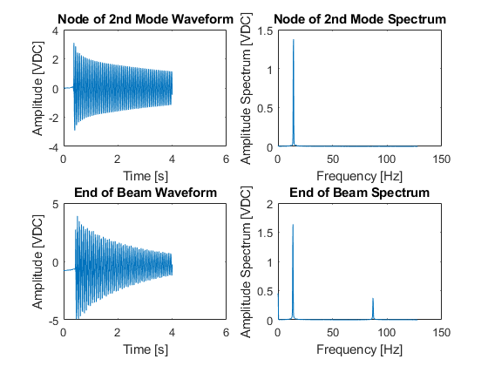

## Part 2.2

a) Theoretical Natural Freq

I = 1/96; % in^4  
rho = 0.04875; % lb/in  
E = 10^7; % lb/in^2  
L = 32; % in  
BL1 = 1.875; BL2 = 4.694; BL3 = 7.855;  
  
% Metric:  
mI = 4.33574402*10^(-9); % m^4  
h2 = 0.00016129; % m^2 (height^2)  
mrho = 2700; % (kg/m^3)  
mE = 68.9*(10^9); % N/m^2 (Pa)  
mL = 0.8128; % m  
% (EI/rhoL^4) = (E*h^2)/(12*density*L^4)  
w1 = (BL1^2)*sqrt(mE*h2/(12*mrho*mL^4))/(2*pi) % [Hz]  
w2 = (BL2^2)*sqrt(mE*h2/(12*mrho*mL^4))/(2*pi) % [Hz]  
w3 = (BL3^2)*sqrt(mE*h2/(12*mrho*mL^4))/(2*pi); % [Hz]  
  
% b) node freq = 1/(average period of 7 peaks)  
T1b = (1.221238-0.795929)/6;  
f1b = 1/T1b  
  
% c) node spectrum peak frequency  
f1c = 14.245975  
  
% d) end spectrum 2nd peak frequency  
f2d = 86.975426  
  
% e) %-error  
err1b = (w1-f1b)/w1  
err1c = (w1-f1c)/w1  
err2d = (w2-f2d)/w2

w1 =  
  
 15.6854  
  
  
w2 =  
  
 98.3059  
  
  
f1b =  
  
 14.1074  
  
  
f1c =  
  
 14.2460  
  
  
f2d =  
  
 86.9754  
  
  
err1b =  
  
 0.1006  
  
  
err1c =  
  
 0.0918  
  
  
err2d =  
  
 0.1153

## 2.3

a) time/amplitude of 20 peaks

plot(timeamp20peaks(:,1),timeamp20peaks(:,2),'o-')  
xlabel('Time [s]')  
ylabel('Amplitude [VDC]')  
legend('Peaks')  
title('20 Peaks of Node Waveform')  
% plot should look like logorithmic decay

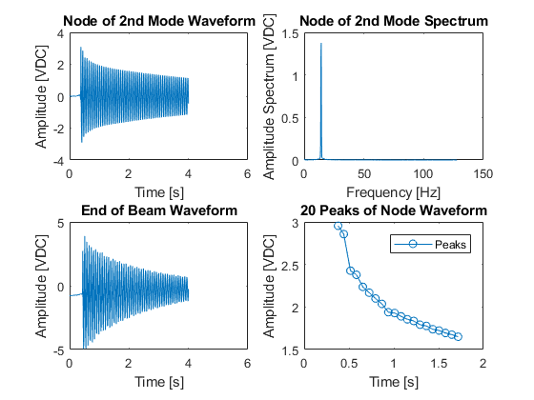

## b) s(peak #),decrement, q(t)and q(t+1)="response", T,damping-factor

decrement = 1:9;  
for i=1:9;  
 decrement(i) = timeamp20peaks(i+1,2) - timeamp20peaks(i,2);  
end  
delta = decrement';  
q = timeamp20peaks(1:10,2);  
period = 1:9;  
for i=1:9;  
 period(i) = timeamp20peaks(i+1,1)-timeamp20peaks(i,1);  
end  
T23b = period';  
damping = delta./(2*pi);

## 2.3 c)

yfit = 1:20;  
for i = 1:20  
 yfit(i)=-log(timeamp20peaks(i,2)/2.5812)/(2*pi);  
end  
yfit2=yfit;  
x23 = 0:19;  
y23 = timeamp20peaks(:,2);  
for i=1:20;  
yfit2(i) = 2.5812*exp(-0.0042*2*pi*x23(i));  
end  
plot(x23,y23,'r',x23,yfit2,'bo')  
legend('q(t) = Response','Estimate')  
xlabel('T (period)')  
ylabel('Amplitude [VDC]')  
title('20 Peaks of Node Waveform')  
% Estimated Damping Factor = 0.0042  
% Estimated D = 2.5812

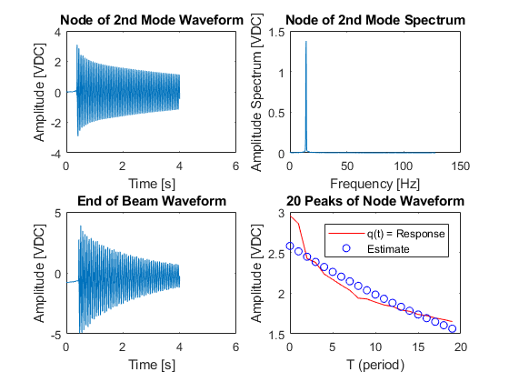

## plotting on plot a

plot(timeamp20peaks(:,1),timeamp20peaks(:,2),'bo-',timeamp20peaks(:,1),yfit2,'ro-')  
legend('q(t) = Response','Estimate')  
xlabel('Time [s]')  
ylabel('Amplitude [VDC]')  
title('20 Peaks of Node Waveform')

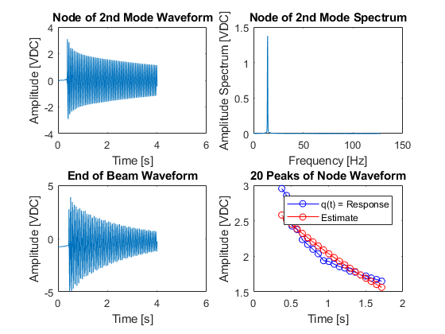

[Published with MATLAB® R2017b](http://www.mathworks.com/products/matlab)

Part 3 - Ratios 1

Waveform 1

## Part 3 - Ratios

expratio=((Aout.*Ain(40))./(Aout(40).*Ain));  
wwr = freq3/freq3(24);  
damp3 = 0.0116; % (rad/sec)  
Griw = ((1-wwr.^2).^2+(2*damp3*wwr).^2).^(-0.5);  
theory = (wwr.^2).*Griw;  
plot(wwr,theory,'r',wwr,expratio,'b')  
legend('Theoretical','Experimental')  
xlabel('w/w_r')  
ylabel('(w/w_r)^2|G(iw)|')  
title('Frequency Response Ratio (Acceleration)')  
damp3Hz = damp3/(2*pi); % 0.00183

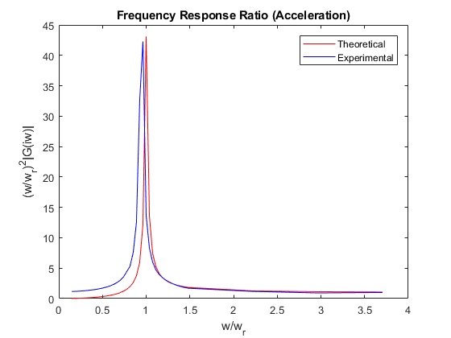

## Waveform

wave3 = [time,input,output] spec3 = [freq,input,output]

subplot(2,1,1)  
plot(wave3(:,1),wave3(:,2),'r',wave3(:,1),wave3(:,3),'b')  
legend('Excitation/Input','Response/Output')  
xlabel('Time [s]')  
ylabel('Amplitude [VDC]')  
title('Resonance Waveform')

subplot(2,1,2)  
plot(spec3(:,1),spec3(:,2),'r',spec3(:,1),spec3(:,3),'b')  
legend('Excitation/Input','Response/Output')  
xlabel('Frequency [Hz]')  
ylabel('Amplitude [VDC]')  
title('Resonance Spectra')

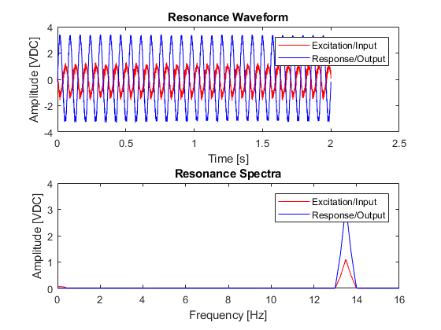

[Published with MATLAB® R2017b](http://www.mathworks.com/products/matlab)

|  |  |  |  |  |  |  |
| --- | --- | --- | --- | --- | --- | --- |
| s | q(ts) | q(ts+1) | T | δ | ζ |  |
| 1 | 2.954102 | 2.856445 | 0.063479 | 0.033617 | 0.00535 |  |
| 2 | 2.856445 | 2.426758 | 0.07471 | 0.163022 | 0.025946 |  |
| 3 | 2.426758 | 2.37793 | 0.066897 | 0.020326 | 0.003235 |  |
| 4 | 2.37793 | 2.236328 | 0.071292 | 0.061395 | 0.009771 |  |
| 5 | 2.236328 | 2.167969 | 0.070803 | 0.031044 | 0.004941 |  |
| 6 | 2.167969 | 2.099609 | 0.070804 | 0.03204 | 0.005099 |  |
| 7 | 2.099609 | 2.036133 | 0.070803 | 0.030699 | 0.004886 |  |
| 8 | 2.036133 | 1.938477 | 0.071781 | 0.04915 | 0.007822 |  |
| 9 | 1.938477 | 1.928711 | 0.070315 | 0.005051 | 0.000804 | 0.007539 |
| 10 | 1.928711 | 1.889648 | 0.071292 | 0.020461 | 0.003257 |  |
| 11 | 1.889648 | 1.855469 | 0.070315 | 0.018253 | 0.002905 |  |
| 12 | 1.855469 | 1.835937 | 0.070803 | 0.010583 | 0.001684 |  |
| 13 | 1.835937 | 1.791992 | 0.070804 | 0.024227 | 0.003856 |  |
| 14 | 1.791992 | 1.777344 | 0.070803 | 0.008208 | 0.001306 |  |
| 15 | 1.777344 | 1.738281 | 0.071292 | 0.022223 | 0.003537 |  |
| 16 | 1.738281 | 1.723633 | 0.070315 | 0.008462 | 0.001347 |  |
| 17 | 1.723633 | 1.694336 | 0.071292 | 0.017143 | 0.002728 |  |
| 18 | 1.694336 | 1.674805 | 0.070315 | 0.011594 | 0.001845 |  |
| 19 | 1.674805 | 1.650391 | 0.070804 | 0.014685 | 0.002337 | 0.004877 |
| 20 | 1.650391 | 1.630859 | 0.070315 | 0.011905 | 0.001895 | 0.004728 |
| 21 | 1.630859 | 1.611328 | 0.070803 | 0.012048 | 0.001918 |  |
| 22 | 1.611328 | 1.586914 | 0.070316 | 0.015267 | 0.00243 |  |
| 23 | 1.586914 | 1.577148 | 0.070315 | 0.006173 | 0.000982 |  |
| 24 | 1.577148 | 1.552734 | 0.070803 | 0.015601 | 0.002483 | 0.004265 |