**PEM FUEL CELL ANALYSIS**

Ryan Kim

*Department of Mechanical and Aerospace Engineering*

*Rutgers University, Piscataway, New Jersey 08854*

**The purpose for this lab is to learn about the effects of different operating parameters on a PEM fuel cell and the characteristic traits of power generation, voltage, current, and resistance. The lab demonstrates the different phases of resistance that a fuel cell has as it operates from 0 to 10 A. The input of oxygen, or lack of input, is directly related to the power output of the fuel cell, since hydrogen fuel input must be coupled with enough oxygen for electrochemical reaction to occur. Effects of internal resistance in the fuel cell shows a clear ohmic relation between voltage and current. Also, resistance is shown to vary inversely with current, and there are non-linear traits of current due to initial activation and mass transport losses, resulting in exponential decreases in voltage at the beginning and end of the increase of current from 0 to 10 A. Using a traffic light undergoing phase changes throughout a minute yields a unit-step relation of power output for each light (red, yellow, green) and the total energy used to power the light is calculated (173.2 J /min). Step-increase in power requires increasing rate of fuel.**

**INTRODUCTION**

The topic of energy in mechanical engineering is widely studied in subjects involving thermodynamics such as heat engines. Heat engines are limited by the second law of thermodynamics due to the inevitable creation of entropy, binding their thermodynamic cycle efficiency to about 40% in the most ideal case (the Carnot Cycle). In this lab, an alternative energy producing device is examined; it is the Polymer Electrolyte Membrane Fuel Cell (PEMFC). A fuel cell produces energy through electrochemical reactions, not limited by the Carnot efficiency, and it sustains electric energy production continuously through injection of a fuel source. The PEMFC in this lab intakes a mixture of hydrogen and atmospheric air (oxygen). The following equation describes the reaction:

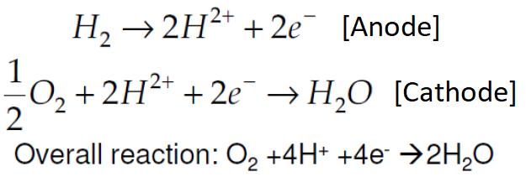

**Equation 1. Hydrogen and Oxygen Reaction**

The continuous hydrogen intake through the anode and the oxygen intake through the cathode (anode and cathode being porous electrode surfaces) are connected in the center polymer electrolyte which conducts ions. A high current is generated from electrochemical reaction as electrons flow in an external circuit. In the experiment, an apparatus is used to adjust input settings and measure performance. A picture of this is shown in Figure 1.

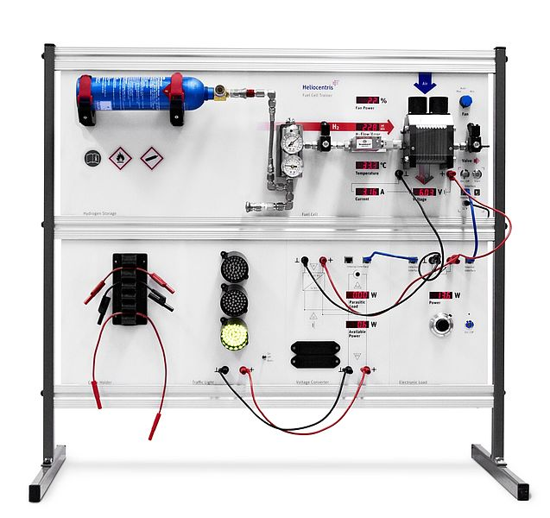

**Figure 1. Heliocentris PEM Fuel Cell Lab Apparatus**

The Heliocentris module includes a tank of hydrogen and an adjustable fan to input oxygen from the air at selected rates. There are also meters that show the current, voltage, and power of the fuel cell stack. Volume flow rates of the input gases are also measured. Using different flow rates, temperatures, and internal resistance, the output parameters are recorded and plotted for understanding the effects of the input parameters.

For the first part, the fuel cell is loaded at 5 amps of current to heat the temperature to 40 degrees Celsius. Then a potentiometer is used for different stack currents to read the corresponding fuel cell stack voltages. Another input parameter to consider is the fan which is initially set to “Auto” in order to intake all the necessary oxygen from the air to react with the hydrogen input for electrolysis and optimal output power. Then the fan is set to 6% power and the result is a limited oxygen input, thus reducing the performance of the fuel cell.

The next experiment involves using a voltmeter to read the output voltage (terminal voltage) of the fuel cell. Using the same temperature as earlier, data from the stack voltage and terminal voltage is recorded. The effects of the internal resistance of the stack and terminal are observed from plotting the data.

In the final portion of the lab, a TL10 traffic light is used to understand practical performance of the fuel cell. Activating the red, yellow, and green lights using the fuel cell gives different values of the power production/usage, and hydrogen input is also recorded.

**RESULTS AND DISCUSSION**



**Figure 2. Stack Voltage vs Stack Current for fan settings on Auto and 6%**

Figure 2 shows that the voltage decreases as current increases. This makes sense because voltage equals the current times the resistance. Here, the resistance is shown to not be constant since the curve is not completely linear. In the first curved section (starting before 1A), there are activation losses. These are kinetic losses that occur due to delayed reactions on the anode and cathode. Initially, the decrease in voltage per current increase is large because of the chemical reactions driving the electrons to the electrode. The middle portion of the curve that is linear represents Ohmic Losses, showing that charge transport results in voltage loss and fuel cell conductors have intrinsic resistance. When the curve slope starts to become more negative after being linear, it indicates concentration losses, which comes from a concentration of the reactant at the surface of the anode and cathode from the hydrogen and oxygen input. The 6% fan setting shows a faster decrease in voltage. Activation loss region slopes are similar, but the ohmic and concentration loss range shows a greater decrease of voltage per current. There must be more resistance and more concentration at the electrodes. With less oxygen input, there is less power production. However, the initial voltage is larger in the first half until it falls below the auto setting due to less electrochemical reaction.



**Figure 3. Stack Power vs Stack Current for fan settings on Auto and 6%**

Figure 3 shows that with less oxygen input, there is less power production. There is eventually a limit to power production when the fan setting of 6% does not allow enough oxygen to react with the hydrogen. Thus, power falls behind after about 5A.



**Figure 4. Stack Resistance vs Stack Current**



**Figure 5. Terminal Resistance vs Stack Current**

Figures 4 and 5, which are almost identical, show that the initial activation loss is very large with such a high resistance, but it decreases quickly when the reaction delay is over and reactions are occurring steadily. It can also be shown that Power is equal to the resistance times the current squared. Using Figure 3, the nearly linear Power curve shows dividing the power by the squared stack current is equal to the internal resistance, hence the quadratic shape of the resistance curves.



**Figure 6. Stack and Terminal Voltage vs Stack Current**

Figure 6 shows the linear relationship between voltage and current, since V=IR. If you multiply the internal resistance by the current shown in Figures 4 and 5, the result is the voltage curve in Figure 6. Multiplying the x-axis and the y-axis together (from Figure 4,5) yields a linearly decreasing slope of voltage (Figure 6).

Say (-a) is the negative slope of the Voltage Curve, and (b) is the initial Voltage. Say (a) and (b) are integers. Say I is the current, and R is the resistance. Now assume:

I*R=V=(-a)I+(b)

🡺 R=(-a)+(b)/I.

🡺 R=(-a)+(b)*(1/I)

By this estimated calculation, R (resistance) has an inverse proportion to the current for some arbitrary values of constants (a) and (b). This matches the shape of Figure 4,5 assuming Figure 6 is a linearly decreasing slope of voltage. The effect of this (1/I)-curved resistance is the V=IR linear decrease in voltage of the stack and the terminal for an increasing current.

The final experiment involves using a traffic light, powering the different phases of lights with the fuel cell. The available power is recorded and plotted in the duration of a minute.



**Figure 7. Traffic Light – Available Power vs Time over a minute of phases.**

|  |  |
| --- | --- |
| 1st Green Light | 2.2167 W |
| 1st Yellow Light | 3.9 W |
| 1st Red Light | 2.8 W |
| 2nd Yellow Light | 6.9 W |
| 2nd Green Light | 2.2059 W |
| 3rd Yellow Light | 3.9 W |
| 2nd Red Light | 2.7909 W |

**Table 1. Mean Power at each light phase**

|  |  |
| --- | --- |
| 1st Green Light | 13.3 J |
| 1st Yellow Light | 11.7 J |
| 1st Red Light | 47.6 J |
| 2nd Yellow Light | 20.7 J |
| 2nd Green Light | 37.5 J |
| 3rd Yellow Light | 11.7 J |
| 2nd Red Light | 30.7 J |
| All 60 Seconds | 173.2 J |

**Table 2. Energy from each and all phases**

**Figure 8. Hydrogen Flow Rate vs Time**

The available power during each light phase is constant, while the input of fuel is increased or decreased over time to meet the power needs. When one light switches to light of greater power, there is a positive slope (increasing rate) of hydrogen input. Equivalently, when one light switches to a light of less power usage, there is a decreasing rate of hydrogen flow. The change in power is proportional to the change in hydrogen flow rate. The mean power of each light phase is listed in Table 1, and the accumulated energy spent with each light phase is summed up in Table 2. The green light uses up about 2.2 W, the red light around 2.8 W, and the yellow light uses either 3.9 W or 6.9 W. Total energy used for the entire 60 seconds is 173.2 J.

**ERROR ANALYSIS**

There might exist openings or lack of tightness in the passage of hydrogen and air, resulting in a different relation between fuel input and power output. The fan setting on auto should have a little excess air to make sure enough oxygen enters the fuel cell. Oxygen density in air is also uncertain. Also, the 6% fan produced more voltage initially than the auto fan, yet the power produced remained identical until current approached 10A. Perhaps oxygen density or inconsistent fan speed could affect it, but change in internal resistance between the auto and 6% settings’ measurements could have changed. The temperature of the fuel cell’s anode, where the hydrogen enters, could have increased throughout the experiment. This could alter the performance of the fuel cell. Maybe the experiment should require a long waiting period between measurements to reach equilibrium with all initial conditions. Figure 6 shows a mismatch of data between the stack and the terminal voltages. Voltmeter readings tend to change often, and there might be small error there, so maybe another system of measurement with more precision could be used.

**CONCLUSIONS**

This lab demonstrates the effects on power generation by variation of fuel/air flow rates and internal resistance. Basic Ohmic relations are demonstrated through plots involving voltage, current, and power. Variation and deviance from linear changing of internal resistance is demonstrated and identified. The Heliocentris apparatus gave useful measurements to find out the behavior of the performance of the fuel cell to understand the effects of input parameters. There is a clear decrease in power as current approaches 10A when the air input does not meet the required air-fuel ratio for the reaction to occur. Resistance within the fuel cell is greatly reduced with high enough current. This lab also gives the relation between air-fuel input and the operation of a street light. Practical usage and optimal parameters are learned for operating the PEM fuel cell.

**REFERENCES**

[1] Lab Manual / Lecture

[2] Google – PEM Fuel Cell

[3] Lab Data