**JET THRUST MEASUREMENTS**

Ryan Kim

*Department of Mechanical and Aerospace Engineering*

*Rutgers University, Piscataway, New Jersey 08854*

**Using the data of air flow from a free jet at five different controlled settings of stagnation pressure, the thrust created is calculated from direct counterweight force measurement, incompressible flow and isentropic compressible flow with a mean jet exit velocity, and isentropic flow from a radial velocity profile. Stagnation pressures are 110.8 kPa, 164.4 kPa, 220.6 kPa, 257.9 kPa, and 316.4 kPa; respective directly measured thrusts are 1.58 N, 8.74 N, 14.55 N, 18.62 N, and 24.64 N. With reference to these measurements, the accuracy of calculations from highest to lowest are from the radial velocity profile integration, isentropic mean exit velocity, and incompressible mean exit velocity. In the same order, the calculations have average percent errors of 1.468%, 3.262%, and 32.071%. Numerical integration with respect to radial velocity profile is the most accurate method of measuring thrust next to direct measurement of force. Schlieren photographs which capture the shape of the shockwaves at high flow velocities imply an inaccuracy of radial pressure profiles due to timing uncertainties.**

**INTRODUCTION**

Jet thrust is the force that drives the jet forward by shooting an accelerated fluid opposite to the direction of the jet’s motion. This driving force may oppose the resistive forces (friction/drag) enough to keep an object moving forward, making it possible for air/space-crafts to fly in a forward direction. In this lab, the thrust of a free jet is calculated and measured under the conditions of different air-property assumptions and different flow rates including both subsonic and supersonic speeds (meaning less than and greater than the speed of sound of the air).

The jet air flow is introduced from a stagnation chamber, and it is passed through a flow straightening section and is accelerated through a nozzle with a .411-inch exit diameter. The stagnation pressure, regulated with a control valve, is measured with a transducer, while the air supply system is isolated with an upstream ball valve. A pressure probe located 4.7 cm from the jet exit measures the total pressure downstream from the jet, and a transducer measures the stagnation probe pressure. The transducers give measurements in kPa with ±1% uncertainty. With a calibrated load cell, direct measurements of force determine the thrust in Newtons.

Measurements/data are acquired through a PC-controlled Labview program. There are five different stagnation pressures used, so in each of these five trials, the control valve is set to a different angle. The valve angles are 21.24°, 26.66°, 30.62°, 33.39°, and 36.75°, which respectively result in stagnation pressures of 110.8 kPa, 164.4 kPa, 220.6 kPa, 257.9 kPa, and 316.4 kPa. For each trial, Labview is used initially to tare the load cell and reset the stagnation probe position to the start position. It is then that the valve angle is adjusted, and the trial is run. The output of each trial includes 31 data points of the current valve angle (degrees), stagnation chamber pressure (kPa), pitot probe pressure (kPa), thrust (N), and probe position (mm). Also, with a high stagnation pressure setting, a schlieren image is recorded when shock waves are visible, which is a view of the flow field’s variation of air density at the jet exit.

There are three main methods of measuring the thrust. The first method is simply a direct measurement as the jet is mounted on a force balance. As shown in Figure 1, the direction of the air flow is in the y-direction, and the jet is not accelerating.

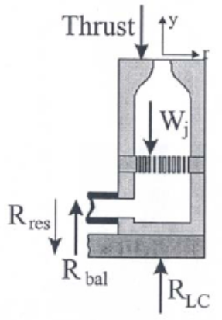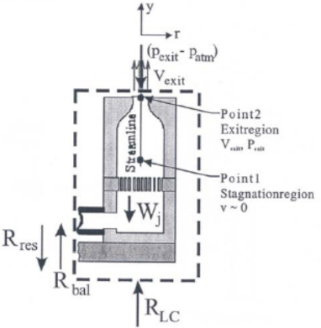

**Figure 1. Experimental setup with the direct thrust measurement free body diagram on the left, and the control volume on the right.**

In the diagram on the left, RLC is the force on the load cell, Rbal is the force from the counter balance, Wj is the weight of the jet, Rres is the residual force (flexing of hose, friction of ball bearings), and the Thrust is the force due to momentum and pressure at the jet exit. Assuming that the residual force is negligible, and that the counter balance force is equal to the weight of the jet, all forces in the y-direction are shown below in Equation [1] which reduces to Equation [2] under the assumptions:

[1]

[2]

Therefore, the force from the load cell directly measures the thrust. This is Method 1 of thrust measurement, and it is the most accurate, thus being a reference point for subsequent methods.

Method 2 is based on the mean jet exit velocity. Using the control volume and control surface shown on the right-side diagram in Figure 1, the y-momentum equation is defined:

[3]

where *FS y* is the sum of external forces, *FB y* is the weight of the jet, and the right-hand side terms are (from left to right) the rate of change of momentum leaving the control volume and the rate of momentum leaving the control volume. With a steady flow, time differential is zero. Exit properties of the jet flow (velocity, pressure, and density) are assumed to be uniform in this method, yielding:

[4]

Using the assumptions from Eq [1] and Eq [2], the above equation may be simplified to:

[5]

Method 2 assumes a constant total temperature of 290 K.

The first part, Method 2A, assumes incompressible ideal flow. The first useful equation is Bernoulli’s Equation.

[6]

With point 1 being from the stagnation chamber and point 2 from the exit of the jet, Bernoulli’s Equation is reduced to find the exit velocity:

[7]

This incompressible flow assumption is only valid for a Mach number of less than 0.3, and it uses a constant density at atmospheric pressure. Mach number is defined by the local gas velocity V divided by the speed of sound c.

[8]

[9]

The specific heat ratio γ is 1.4 for air, and the specific gas constant R is 287 [J/kg*K]. As the Mach number surpasses 0.3, compressibility must be considered.

Method 2B assumes no friction losses or heat transfer, and the air flow is isentropic and compressible. The ratio of total to stagnation pressure and temperature are defined:

[10]

[11]

where *P0* and *T0* are the stagnation properties, and *P*, *T*, and *M* are at exit conditions. The Mach number is found from Eq [10] using the exit pressure as atmospheric pressure. That Mach number is then used in Eq [11] to find the exit temperature. The resulting Mach number and temperature is plugged into Eq [8,9] to find the exit velocity. Also, density is found with the perfect gas equation:

[12]

However, this method is only valid for a Mach number less than 1 (subsonic). When it is computed that M > 1, the flow is supersonic.

For a converging-diverging nozzle, the flow may only be supersonic after the diverging section; the converging nozzle exit has a choked flow where M = 1. This simplifies Eq [11] to a new exit temperature which is then plugged into Eq [8,9] to find the exit velocity, as follows:

[13]

[14]

In the same manner, plugging in M = 1 into Eq [10] gives a new exit pressure which is used in Eq [12] to solve for the density at the exit. This concludes Method 2 of the thrust measurement.

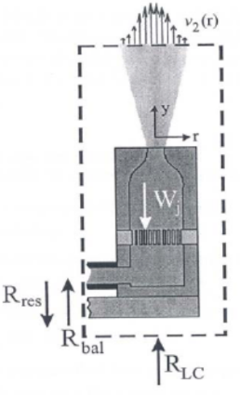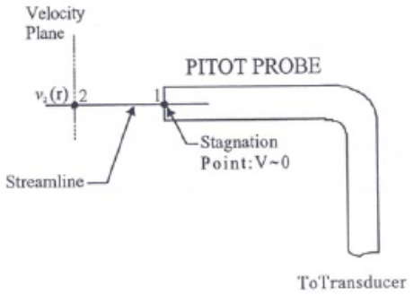

**Figure 2. [Left] Control volume using velocity profile measurement. [Right] Velocity measurement using stagnation probe.**

Method 3 uses the measured jet exit velocity distribution (as shown in Figure 2) rather than a mean velocity. Using Eq [3] with jet exit parameters that vary with radius (distance from center of the control surface normal to air flow), it follows:

[15]

Method 3A uses Bernoulli’s Equation for incompressible ideal flow. Eq [7] is used to find the velocity with respect to radius r, where the stagnation pressure is measured by the probe at position r, and density is constant/atmospheric.

Method 3B assumes compressible isentropic flow to find the velocity and density at jet exit conditions. The Mach number is found with Eq [10] using the stagnation pressure P0 given by the pitot probe and the static pressure P at the probe location (assumed to be atmospheric pressure). With T0 = 290 K at the probe, Eq [11] can be solved with the new Mach number to find the absolute static temperature T at the probe location. With the new temperature and Mach number, the velocity profile may be found with Eq [8,9]. The density at the probe is found with Eq [12] with atmospheric pressure and the new calculated temperature. Numerical integration of Eq [15] gives the thrust for Method 3.

**RESULTS AND DISCUSSION**

Method 1 uses the direct measurement of the thrust produced by the jet. Averaging the forces measured by the load cell for each of the five stagnation pressures, the thrust for each pressure is tabulated below.

|  |  |
| --- | --- |
| P0 [kPa] | Thrust [N] |
| 110.8 | 1.576 |
| 164.44 | 8.741 |
| 220.64 | 14.545 |
| 257.91 | 18.622 |
| 316.41 | 24.636 |

**Table 1. Stagnation Pressure and directly measured thrust.**

Using Method 2, the Mach number is found from Eq [8] for the incompressible ideal flow and the compressible isentropic flow. This is based on the mean velocity at the jet exit, and the Mach numbers for each stagnation pressure is plotted and tabulated below.



**Figure 3. Mach number vs. Stagnation Pressure for Method 2A Incompressible Ideal flow and Method 2B Compressible Isentropic flow, using mean exit velocity.**

|  |  |  |  |
| --- | --- | --- | --- |
| P0 [kPa] | Mach # (Isentropic) | Mach # (Incompressible) | % error |
| 110.8 | 0.3596 | 0.3643 | 1.31 |
| 164.44 | 0.8613 | 0.9404 | 9.18 |
| 220.64 | 1.1158 | 1.293 | 15.88 |
| 257.91 | 1.2368 | 1.4812 | 19.76 |
| 316.41 | 1.3866 | 1.736 | 25.20 |

**Table 2. Stagnation Pressure and Mach number for Isentropic flow and Incompressible flow with percent error**

Table 2 shows the percent error of incompressible flow Mach number based on the correct value being the isentropic flow Mach number. It was stated that after 0.3 Mach number, compressibility must be considered. Figure 3 and Table 2 show the deviation of Mach numbers after a close initial pair of values at around 0.36, starting with a 1.31% error, leading to a deviation of 25.2% at the highest stagnation pressure. As Mach number increases from 0.3, incompressible flow calculations become less accurate.

Method 3 gives the radial Mach number profile at the stagnation probe for each stagnation chamber pressure.



**Figure 4. Radial Mach number profile vs. Stagnation Probe position.**

The plot above shows peak values of radial Mach numbers occurring in the center of the control surface where the radius r = 0. This Mach number profile is consistent with the idea that the jet nozzle’s wall friction slows down the air at the outermost radius of the velocity profile. With a higher stagnation pressure, the velocity (and therefore the Mach number) increases in overall magnitude.

Going back to Method 2 of thrust measurement, the plot below shows the exit mean jet velocity for each stagnation pressure using the incompressible ideal flow assumption and the isentropic compressible flow assumption.



**Figure 5. Exit Mean Jet Velocity vs. Stagnation Pressure using Method 2A and Method 2B.**

Figure 5 shows an inaccurate increase in velocity for the incompressible flow calculations, and it demonstrates an increasing deviation from the isentropic values. Also, the isentropic velocity is capped after the third stagnation pressure. This is because the Mach number exceeds 1, so there is a supersonic flow. However, since this is a velocity right at the exit of the converging nozzle, M = 1 at that point because it is a choked flow. If M is constant, and the exit temperature does not change, then velocity will not change either as the stagnation pressure increases, as shown in Eq [8,9].

Next, the radial velocity profiles calculated from the stagnation probe pressures, under the incompressible ideal flow assumption and the isentropic flow assumption, are plotted together:



**Figure 6. Radial velocity profiles vs. probe position. Each stagnation pressure is assigned a constant color, ‘o’ points for isentropic, ‘x’ points for incompressible.**

Figure 6 shows that a larger magnitude of velocity creates a larger deviation of incompressible radial velocity from the isentropic radial velocity. As demonstrated in Figure 3, the lowest pressure (with Mach number close to 0.3) has very little error of incompressible flow calculations, and it is visible in the red velocity profiles in Figure 6. Also, the peaks of the curves tend to indicate center positions for radius r = 0 at varying probe positions. It is also apparent that the larger incompressible flow velocities have a messy curve shape with radial peaks inconsistent with the isentropic peaks.

Taking note of each peak position, the thrust can be calculated with chosen radial boundaries using Eq [15]. Numerical integration gives the next calculation of thrust with respect to stagnation probe pressure profiles and the isentropic flow assumption.



**Figure 7. Thrust vs. Stagnation Pressure; thrust determined by direct measurement, calculation by incompressible and isentropic with mean exit velocity, and numerical integration with radial velocity profile.**

Figure 7 shows a comparison of the different methods of calculating thrust. Direct measurement is the most accurate, so the next most accurate is the numerically integrated thrust using the radial velocity profiles for each stagnation pressure. Using the mean jet exit velocities, the isentropic calculations are almost as accurate as the radial calculations, and the incompressible calculations are the least accurate. The calculated thrusts are tabulated:

|  |  |  |  |  |
| --- | --- | --- | --- | --- |
|  | Thrust [N] | | | |
| P0 [kPa] | Direct | Incomp. | Isent. | Radial |
| 110.8 | 1.576 | 1.622 | 1.57 | 1.579 |
| 164.44 | 8.741 | 10.804 | 9.007 | 8.6 |
| 220.64 | 14.545 | 20.426 | 15.271 | 14.321 |
| 257.91 | 18.622 | 26.806 | 19.315 | 18.987 |
| 316.41 | 24.636 | 36.82 | 25.664 | 24.134 |

**Table 3. Stagnation Pressure; Thrust calculated by direct measurement, incompressible flow with mean jet exit velocity, isentropic flow with mean jet exit velocity, and isentropic flow with radial velocity profiles.**

Radial velocity profiles give the most accurate calculations for thrust.

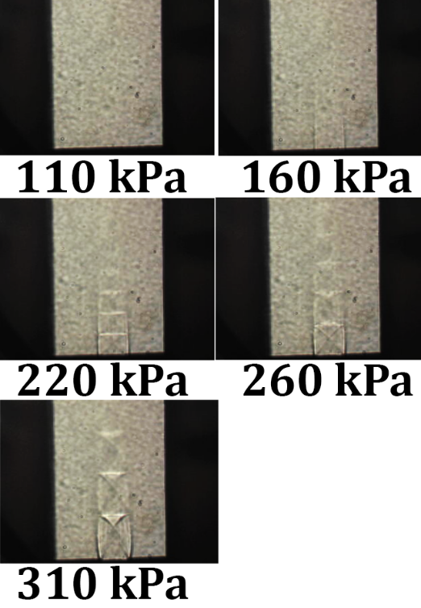

**Figure 8. Schlieren photographs taken at each stagnation pressure.**

The Schlieren photographs are pictures taken at the jet exit using a set of lenses that capture the shape of the shockwaves at a parallel position. This shows the compression which changes the air’s index of refraction resulting in the image of the shockwave. As observed earlier in the lab, the supersonic air velocities occur during and after the third stagnation pressure setting. As shown in Figure 8, shockwaves occur at 220 kPa, 260 kPa, and 310 kPa. The shapes that are captured are rectangular and repeat in a fading manner along the stream. This is the repeating waveform of compression which flows in the streamline. As the stagnation pressure and Mach number increase, the patterns expand along the streamline because they are traveling faster, and the image becomes more pronounced. The final image at 310 kPa shows the shockwaves curving and rounding out. At a high pressure and velocity, it would make sense that the waves flow outward more. Examining the Schlieren images, it can be seen that the shapes are not perfectly symmetrical, so the pitot probe may not be taking each shockwave’s pattern identically. Changes in compression of flowing air is not constant with time and position, so the moving probe would not take symmetrical pressure measurements along the actual axis of velocity symmetry (the center of the jet thrust profile). This may be why there were inconsistent positions of velocity profile peaks taken from the isentropic flows at each stagnation pressure.

Error in integral calculation with radial profiles includes the estimation of peak velocity probe positions. When choosing the offset of center positions, the radii used in the calculations were chosen in favor of matching the values of directly measured thrust. Rounding errors are large due to the inability to perfectly determine the radii strictly based on the graphical image; radial values were chosen to a 0.1mm resolution while it is not clear enough from the graph to choose these values. This flaw greatly reduces the validity of the calculation and its accuracy to the true measurement of thrust. Also, the integral calculations included temperature mean values and only peak values of velocity; radial velocity in its entirety was not included, thus making an incomplete numerical integration. Values were mainly used for matching the direct measurements of thrust, so conclusion of accuracy is faulty. Aside from the numerical integration, the pitot probe measurements taken across the jet profile were varied due to the variation of air density with time and position during supersonic conditions. Future measurements could be perhaps more precise if multiple traversed measurements were taken and averaged to create a more uniform profile.

**CONCLUSIONS**

This lab has demonstrated direct measurement of thrust and indirect measurement using exit mean jet velocities and radial velocity profiles which were determined through five controlled stagnation pressure settings and exit pressure measurements. Radial measurements with isentropic flow, although estimated with large unknown error, resulted in an average of 1.468% calculated error. Using mean jet velocities to find thrust, isentropic flow assumptions yielded an average calculated 3.262% error, while incompressible flow assumptions led to an average calculated 32.07% error. When Mach number is higher than 0.3, incompressibility is an invalid condition increasingly as Mach number increases. When pitot probe measurements were taken across a stream pressure profile, the plots of radial velocity profiles showed inconsistent peak positions, and inconsistency was further proven with the variation of shockwave pressures and air densities shown in the Schlieren photographs. Still, it was valid enough to visualize the existence of the bell-curved profile due to boundary layer conditions. Although conclusion of accuracy between Method 2B and Method 3B was possibly inconclusive, it is clearly demonstrated that isentropic-compressible flow is necessary for calculating thrust from a jet with air velocity above 30% of its local speed of sound.

**REFERENCES**

[1] Lab Manual

[2] Lab Data

[3] Appendix - Calculations

Appendix: Calculations

%% Initial Data

% thrust [N] -- thrust1, thrust2...

% probe position [mm] -- probe1, probe2...

% pitot pressure [kPa] -- pitot1, pitot2...

% valve position [deg] -- valve(1:5)

% stagnation pressure [kPa] -- stag(1:5)

valve=[21.243782 26.660504 30.624508 33.385702 36.748245];

stag=[110.798734 164.438063 220.643515 257.91144 316.411738];

## Contents

* 1 - Isentropic Mach
* 2 - Radial Mach Profile
* Ideal Incompressible - probe
* 3 - Plot - isentropic and ideal velocity
* 4 - Plot - isent and ideal vel - Radial
* 5 - Plot - thrust vs stag pressure

## 1 - Isentropic Mach

clc;

R = .287; %kJ/kg*K

T0 = 290; %K (stag)

k = 1.4;

atm = 101.325;

% isentropic compressible

Mex = sqrt((2/.4)*((stag./atm).^(.4/1.4)-1));

Mex12 = Mex(1:2);

Tex12 = T0./(1+0.2*Mex12.^2);

Vex12 = Mex12.*sqrt(k*R*1000*Tex12);

Pex12 = stag(1:2)./((1+0.2*Mex12.^2).^(1.4/.4)); % Pex = atm

rhoex12 = Pex12./(R*Tex12);

Tex345 = [T0/1.2 T0/1.2 T0/1.2];

Vex345 = sqrt(k*1000*R.*Tex345);

Pex345 = stag(3:5)./1.893;

rhoex345 = Pex345./(R*Tex345);

Mex = sqrt((2/.4)*((stag./atm).^(.4/1.4)-1));

Tex = [Tex12 Tex345];

Vex = [Vex12 Vex345];

Pex = [Pex12 Pex345];

rhoex = [rhoex12 rhoex345];

% incompressible ideal

rhoc = 1.225; % constant kg/m^3

Vc = sqrt(2000*(stag-atm)./rhoc);

Mc = Vc./sqrt(k*R*1000*T0);

plot(stag,Mex,'o-',stag,Mc,'o-')

title('Mach vs. Stagnation Pressure')

xlabel('Stagnation Pressure [kPa]')

ylabel('Mach Number')

legend('Isentropic','Incompressible')

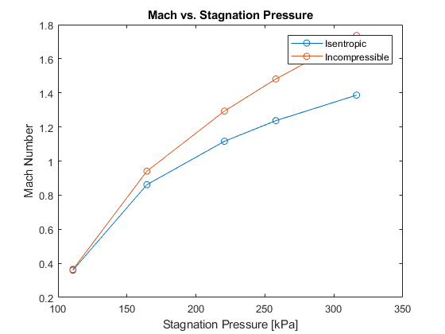

## 2 - Radial Mach Profile

Mrad1 = sqrt(5*((pitot1/atm).^(.4/1.4)-1));

Mrad2 = sqrt(5*((pitot2/atm).^(.4/1.4)-1));

Mrad3 = sqrt(5*((pitot3/atm).^(.4/1.4)-1));

Mrad4 = sqrt(5*((pitot4/atm).^(.4/1.4)-1));

Mrad5 = sqrt(5*((pitot5/atm).^(.4/1.4)-1));

plot(probe1,Mrad1,'o-',probe2,Mrad2,'o-',probe3,Mrad3,'o-',probe4,Mrad4,'o-',probe5,Mrad5,'o-')

title('Radial Mach vs Probe Position')

xlabel('Probe Position [mm]')

ylabel('Mach Number')

legend('110.80 kPa','164.44 kPa','220.64 kPa','257.91 kPa','316.41 kPa')

Warning: Imaginary parts of complex X and/or Y arguments ignored

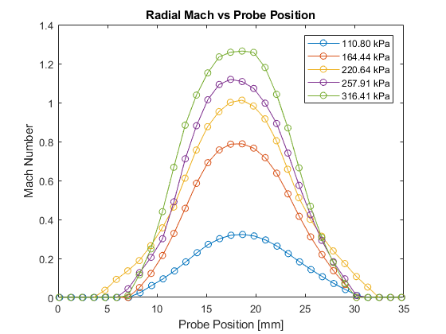

## Ideal Incompressible - probe

Vpro1 = sqrt(2000*(pitot1-atm)/rhoc);

Vpro2 = sqrt(2000*(pitot2-atm)/rhoc);

Vpro3 = sqrt(2000*(pitot3-atm)/rhoc);

Vpro4 = sqrt(2000*(pitot4-atm)/rhoc);

Vpro5 = sqrt(2000*(pitot5-atm)/rhoc);

% Temperature - Isentropic Compressible

Trad1 = T0./(1+.2*(Mrad1.^2));

Trad2 = T0./(1+.2*(Mrad2.^2));

Trad3 = T0./(1+.2*(Mrad3.^2));

Trad4 = T0./(1+.2*(Mrad4.^2));

Trad5 = T0./(1+.2*(Mrad5.^2));

Vrad1 = Mrad1.*sqrt(k*R*1000*Trad1);

Vrad2 = Mrad2.*sqrt(k*R*1000*Trad2);

Vrad3 = Mrad3.*sqrt(k*R*1000*Trad3);

Vrad4 = Mrad4.*sqrt(k*R*1000*Trad4);

Vrad5 = Mrad5.*sqrt(k*R*1000*Trad5);

## 3 - Plot - isentropic and ideal velocity

plot(stag,Vex,'o-',stag,Vc,'o-')

title('Exit Velocity vs Stagnation Pressure')

xlabel('Stagnation Pressure [kPa]')

ylabel('Exit Velocity [m/s]')

legend('Isentropic/Compressible','Ideal/Incompressible')

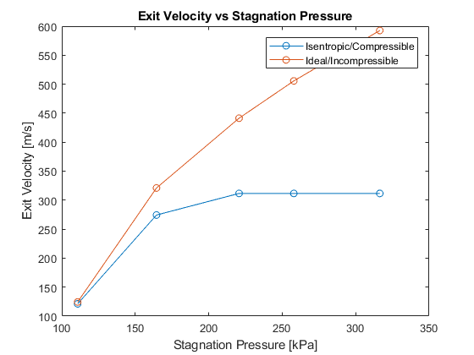

## 4 - Plot - isent and ideal vel - Radial

plot(probe1,Vrad1,'ro-',probe2,Vrad2,'bo-',probe3,Vrad3,'mo-',probe4,Vrad4,'yo-',probe5,Vrad5,'go-')

hold on

plot(probe1,Vpro1,'rx-',probe2,Vpro2,'bx-',probe3,Vpro3,'mx-',probe4,Vpro4,'yx-',probe5,Vpro5,'gx-')

hold off

title('Radial Velocity vs Probe Position')

xlabel('Probe Position [mm]')

ylabel('Radial Velocity [m/s]')

legend('110.8 kPa Isentropic','164.4 kPa Isentropic','220.6 kPa Isentropic','257.9 kPa Isentropic','316.4 kPa Isentropic','110.8 kPa Incompressible','164.4 kPa Incompressible','220.6 kPa Incompressible','257.9 kPa Incompressible','316.4 kPa Incompressible')

Warning: Imaginary parts of complex X and/or Y arguments ignored

Warning: Imaginary parts of complex X and/or Y arguments ignored

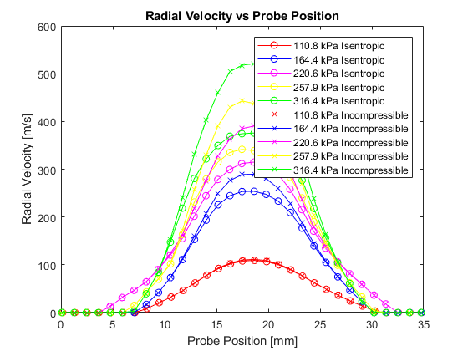

## 5 - Plot - thrust vs stag pressure

radius = 0.0052197; %m

area = 8.55935341e-5; %m^2

eq2 = [mean(thrust1),mean(thrust2),mean(thrust3),mean(thrust4),mean(thrust5)]; %Measured

eq5a = (Vc.^2).*(rhoc).*(area); %Incompressible

eq5b = (Pex-atm)*1000*area+(Vex.^2).*rhoex*area; %Isentropic

Tmean = [mean(Trad1),mean(Trad2),mean(Trad3),mean(Trad4),mean(Trad5)];

Tmean2 = [mean(Trad1(12:22)),mean(Trad2(12:22)),mean(Trad3(12:22)),mean(Trad4(12:22)),mean(Trad5(12:22))];

rho2 = atm./(R*Tmean);

Vmean = [mean(Vrad1),mean(Vrad2),mean(Vrad3),mean(Vrad4),mean(Vrad5)];

Vmean2 = [mean(Vrad1(12:22)),mean(Vrad2(12:22)),mean(Vrad3(12:22)),mean(Vrad4(12:22)),mean(Vrad5(12:22))];

Mmean = [mean(Mrad1),mean(Mrad2),mean(Mrad3),mean(Mrad4),mean(Mrad5)];

Vsum = [sum(Vrad1),sum(Vrad2),sum(Vrad3),sum(Vrad4),sum(Vrad5)];

Tsum = [sum(Trad1),sum(Trad2),sum(Trad3),sum(Trad4),sum(Trad5)];

Vmax = [max(Vrad1),max(Vrad2),max(Vrad3),max(Vrad4),max(Vrad5)];

rho3 = atm./(R*Tmean2);

%radial - thrust

eq23 = (abs(Vmean).^2).*rho2*area*10; %rejected estimate

%closest estimate: [at r=R, v=0; at r=center, v=max(v); different r-values

%used in calculating [R^2 - r(center)^2]. rho3 is the average density.

EQ23 = ((Vmax).^2).*rho3*pi.*[(.0059^2-0.0008^2),(.0057^2-0.0006^2),(0.0058^2-0.0007^2),(.0061^2-0.001^2),(.0061^2-0.001^2)]

eq2

plot(stag,eq2,'o-',stag,eq5a,'o-',stag,eq5b,'o-',stag,EQ23,'o-')

legend('Direct Measurement','Incompressible','Isentropic','Radial')

xlabel('Stagnation Pressure [kPa]')

ylabel('Thrust [N]')

title('Thrust vs. Stagnation Pressure')

EQ23 =

1.5792 8.6001 14.3214 18.9871 24.1338

eq2 =

1.5757 8.7409 14.5449 18.6217 24.6363

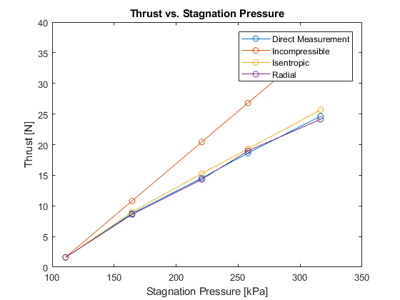

[*Published with MATLAB® R2017b*](http://www.mathworks.com/products/matlab/)



Error(incomp) = (incomp–direct)/direct

Avg%error1 = average(error1)*100%



-constructed with photoshop, contrast increased