**SPECTRAL PROPERTIES**

**OF RADIATION**

Ryan Kim

*Department of Mechanical and Aerospace Engineering*

*Rutgers University, Piscataway, New Jersey 08854*

**The purpose for this lab is to determine the relationships between measured radiation values and theoretically calculated properties of radiation sources. By using a blackbody’s radiation to measure radiant intensity at various wavelengths of adjusted monochromator settings, voltage readings and calculations yield a calibration factor used to find the properties of an incandescent light. The goal is to find the temperatures and intensities of the incandescent light based on the blackbody measurement conditions. The blackbody radiation color is noted and compared with a color-temperature chart; the temperature correspondence was only 47°F to 50°F off. Intensities of the incandescent light are compared with a neon emission spectrum graph with only one accurate correspondence out of 12 different wave spectra; it was mostly inconclusive of the correlation of calculated values and given spectrum graph due to large inaccuracies and inconsistency. Temperatures calculated for the incandescent lights were about 13.6% off from the color-temperature chart’s corresponding absolute temperatures. Calibration may be inaccurate in solving spectral properties.**

**INTRODUCTION**

Radiation and heat transfer are studied for various applications that range from sunglasses to space craft. Radiation is energy that interacts with an object according to the object’s ability to absorb, transmit, reflect, and emit the radiation. For a blackbody, radiation is neither transmitted nor reflected; all radiation is absorbed in the blackbody until thermodynamic equilibrium is reached (a maximum energy storage), and the radiation is emitted as it is absorbed (energy in = energy out). In this experiment, a blackbody is used to emit radiation at two temperature settings, and the color of the radiation source is noted to later be matched with a color-temperature chart displayed in the lab manual. The lab setup is shown in Figure 1:

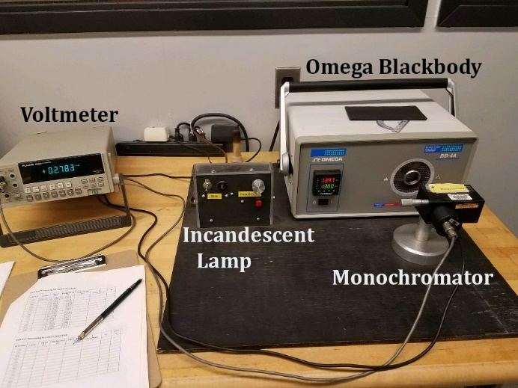

**Figure 1. Experimental setup with the monochromator placed 6 inches from the source of radiation. Transmitted radiation signaled through voltmeter.**

In the first part of the experiment, the Omega Blackbody emits radiation at a constant temperature of 1600°F with a digital controller. Radiation is directed towards an Optometrics monochromator placed 6 inches away which transmits a prescribed 24nm wide wavelength band of the radiation centered at wavelength λc. Adjustments are done with a micrometer screw on the monochromator panel with indicators equal to half of the center wavelength with units of nanometers. Transmitted radiation reaches a Germanium detector at the outlet, and the light intensity is converted to voltage readings on a digital voltmeter. The monochromator is adjusted to take voltages with respect to center wavelengths of 1100nm to 1700nm in 50nm increments. With each voltage reading of direct blackbody radiation, measurements are also taken with the radiation blocked in order to get the background radiation voltages. Subtracting the background voltage from the direct radiation voltage indicates the voltage that is only from the blackbody. The entire process is repeated with the blackbody at 1297°F. Using the voltage readings, Equation 1 below can be used to solve the radiant intensities at each wavelength and temperature.

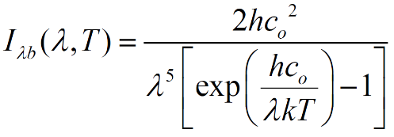

**Equation 1. Radiant Intensity as a function of wavelength and temperature where h is Planck’s constant, co is the speed of light, k is Boltzmann’s constant, λ is wavelength, and T is temperature.**

The 1550nm setting is used for reference of intensity and voltage, and Equation 2 below is applied at each wavelength to compute each of the calibration factors.

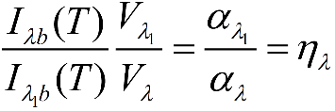

**Equation 2. Calibration factor at each wavelength with respect to the reference wavelength of 1550nm.**

For precise results, the monochromator must stay in the exact same position throughout the entire experiment. Once every calibration factor is calculated, the 1600°F values and 1297°F values at each wavelength are averaged. These values are used in the next part of the experiment involving an incandescent lamp operating at two different settings as well. First, a bright setting is set with the monochromator setup the same way as the blackbody arrangement. The voltmeter outputs values in the same manner as before. Taking the differences of the signal and background voltages for each wavelength and multiplying them by the blackbody’s average calibration factors (from each corresponding wavelength) yields the Vληλ values. These values are used in Equation 3 below:

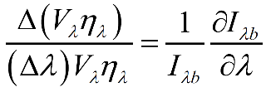

**Equation 3. Left Hand Side calculated by differences of Vληλ divided by the product of the wavelength increments and the averaged Vληλ values for each increment. Right Hand Side is the partial derivative of I with respect to λ, divided by I.**

Using Equation 3, the Right Hand Side can be modified to be a function of Temperature. Through MATLAB iterations and loops, the incandescent lamp’s temperatures can be found based on the values from the Left Hand Side of Equation 3.

**RESULTS AND DISCUSSION**





**Tables 1-2. Measurements and calculated values of both blackbody radiation temperature settings.**

Using the voltage readings for each wavelength for the two blackbody temperatures, Equation 1 solves for the intensities and Equation 2 solves for the calibration factors. The calibration factors are 1 for the 775nm indicator setting because that is the reference value. Intensities for each blackbody temperature are plotted below in Figure 2. The calibration factors are plotted in Figure 3.



**Figure 2. Blackbody radiant intensity as a function of wavelength for each temperature.**



**Figure 3. Blackbody calibration factor as a function of wavelength for each temperature.**

Figure 2 shows that intensity increases with wavelength, and Figure 3 shows an increasing calibration factor as the wavelength moves away from 1550nm (the reference wavelength). Due to the maximum voltage being at 1550nm wavelength, it makes sense that the calibration factor would be inversely proportional to the voltages which decrease as they deviate from 1550nm wavelength.

The next set of data involves the radiation from the incandescent source. To solve Equation 3 based on the blackbody calibration factors, a derivation of intensity with respect to wavelength must be done. The following is the written process of solving this.

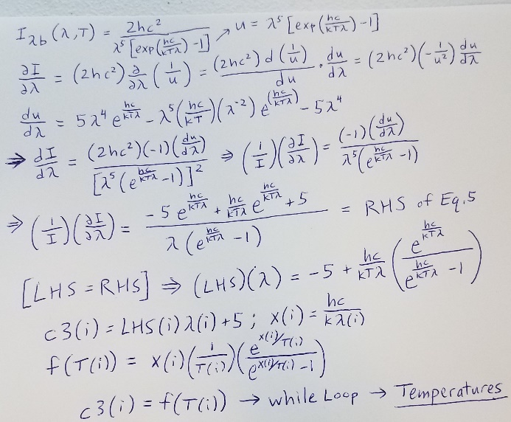

**Figure 4. Simplification of Equation 3 for the use of MATLAB iterations shown in the Appendix**

In MATLAB, constants, variables, and functions are defined to operate in a while loop to find the temperatures of the incandescent lights. The results are shown below.





**Tables 3-4. Measurements and calculated values of both incandescent light settings.**

With the calculated temperatures above along with midpoint wavelengths in 50nm increments, the resulting intensities are plotted in Figure 5.



**Figure 5. Intensity of incandescent lamp at bright and dim settings. Average and maximum temperatures indicated in legend.**

There is a large spike in intensity and temperature at 1325nm wavelength, and this is probably an inaccuracy due to calculation of values which were estimated. Maximum temperatures are 4068 K for the dim light and 2325 K for the bright light. The brighter light should have more radiant intensity and temperature than the dim light, and these spike values cause their mean temperatures to be only 16 K apart.

Using Wien’s displacement law, under the assumption of blackbody emissivity from the incandescent source, temperatures are estimated by taking the Right Hand Side of Equation 3 (the partial derivative of intensity with respect to wavelength) and setting it equal to zero. This yields the following written steps:

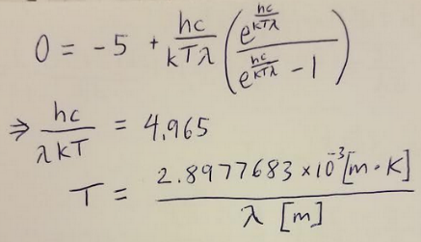

**Figure 6. Wien’s law calculation**

By using each wavelength value for the simplified formula, the temperatures are easily calculated for the Wien’s law approximation. These solutions are compared with the temperatures calculated earlier, and they are displayed in Table 5.



**Table 5. Wien’s displacement law approximations. Temperatures from Tables 3 and 4 are subtracted from the Wien’s temperatures to give the uncertainties, units in Kelvins.**

Table 5 shows that uncertainty can be as high as 1921 K between the dim light and the Wien’s blackbody temperature calculation. With temperatures all above 1367 K for both incandescent settings (from Tables 3-4) and a minimum of 1704 K from the Wien’s calculation, the melting temperature of glass (873 K) is far below the calculated values. However, the glass does not melt because of this. The glass on a light bulb is highly transmissive, so most of the radiation passes directly through it without much absorption of radiation. Therefore, temperature of the heat source inside the bulb may be much higher than the melting temperature of the glass, since the glass reaches a state of thermal equilibrium at a lower temperature.

Moving on to the subject of the lab manual’s color-temperature table, accuracy of observation is determined. Firstly, for the 1600°F blackbody radiation, the color was reported as “Light Cherry, Light Red” which corresponds to 1550°F on the Color Scale of Temperature; the scale temperature is 50°F below the actual value. For the second temperature of 1297°F from the blackbody, the color was reported as “Dark/Medium Cherry Red.” The corresponding scale temperature is 1175 – 1250°F which is at least 47°F less than the actual temperature 1297°F. If one were to add about 50°F to the scale temperature of the observed color, involving the blackbody radiation, a calculated value of the actual blackbody temperature would be well estimated.

The bright incandescent light’s minimum temperature was calculated to be 1728 K which is 253 K more than the reported “White” color scale temperature of 1475 K. The calculated minimum temperature of the dim light was 1338 K which is 168 K more than the reported “Orange” scale temperature of 1170 K. The bright light temperature difference was 14.64% of the calculated value; the dim light temperature difference was 12.56% of the calculated value. Dividing the reported scale temperature by about 13.6% gives a close estimate of the light’s temperature.

My guess is that a multiplier correction would apply to the absolute temperature Kelvin scale, and the additive method would apply to the Fahrenheit scale. These methods of estimation based on the spectrum graph values do not hold much value because it is very limited to only two views of reference for each the blackbody and the incandescent/neon lamps. It might make more sense to take more data points using more radiation settings; this way error can be identified more easily with respect to a data pattern with more points of reference. People have also reported different color choices for each radiation setting, so there is variance in the initial observation of color; more color observations could be taken if more settings were used in the experiment.



**Figure 7. Comparison of Intensity: calculated versus lab manual’s spectrum graph.**



**Table 6. Lab manual neon emission spectrum graph versus calculations: comparison of intensity with respect to each wavelength from 1125nm to 1425nm in 50nm increments.**

In the manual’s Spectral Radiant Intensity graph, the wavelength ranges from 1.125μm to 1.425μm in 50nm increments. Values from the provided neon emission spectrum graph (in the manual) are plotted for each wavelength, and the corresponding calculated intensities of the bright and the dim incandescent lights are plotted on the same graph. The differences in the intensities of the incandescent lights from the intensities in the manual’s graph are given in the chart. The mean differences are of the order of 10^11 [W/(m^3)(steradian)]. This result shows a large inconsistency. However, for the second wavelength (1.175μm) the calculated temperature for the bright light was only 5.34% off from the manual’s graph value. With only one close value in the temperature comparison, it may not be best to assume a useful correlation between the manual spectrum and the experimental temperatures.

Regarding the calculation of the incandescent lamp temperatures, there is a possibility of excessive error in using the derivative of intensity to find T with relation to the average calibration factor from the blackbody data. This calibration factor multiplied by the neon lamp voltages creates a possible error, especially since there is large variation in the second decimal of the voltage readings while using the voltmeter. Lamp temperatures were calculated through iterations of adjusting every temperature by a resolution of 1 K. Mostly, the signal voltage uncertainty and the calibration factors can lead to large inaccuracy. For example, maximum calculated temperatures include 2325 K for the bright light and 4068 K for the dim light. These values greatly deviate from the rest of the temperatures, and it causes the average temperature of the bright and dim lights to be only 16 K apart. This may be a large deviation from the true temperature of the neon lamp.

Radiation and radiative heat transfer are used to limit or maximize the temperature of an object. This may include a space shuttle with white on the top and black on the bottom. Increasing the heat from the bottom of the space shuttle creates buoyancy so that pressurized air pushes it upwards. An increase in heat transfer to the bottom is done by using black to absorb all the radiation the way a blackbody does. This will then emit heat, so it adds energy to the air below it. Oppositely, a white top would not absorb the radiation as much. This is to minimize the heat emission from the top to avoid heating the air above it, so that it does not pressurize and force the space shuttle downwards. A spacecraft may be wrapped in a very reflective material such as gold or silver foil. With more reflection of radiation there is less absorption and emission of radiation. Therefore, radiation is sent away from the reflective material which will minimize the heat transfer from that area. Painting would not work as well as a reflective foil because paint is not perfectly reflective; it absorbs a lot of the light it receives, so it has a larger emissivity than foil.

**CONCLUSIONS**

For the wavelength of 1325nm, the incandescent radiation source calculations are largely inaccurate for both temperature and radiant intensity. This caused the calculation of a very similar average temperature between the bright light and the dim light. Between the blackbody calibration factor and the varying voltmeter readings, large inaccuracies were created in finding temperatures of the incandescent lamp. Using the minimum calculated temperatures of the incandescent lights, the color-temperature chart showed about a 13.6% difference. The blackbody color-temperature chart versus actual temperatures showed about a 50°F difference with respect to reported colors. With only two settings for each radiation source, data is very limited. Average calibration factors lack quantity of measurements, so a correlation between calculations of both sides of Equation 3 is inconclusive. The mean differences between the neon emission spectrum graph and the values from Equation 3 are of the order of 10^11 [W/(m^3)(steradian)], so there is a weak correlation between experimental values and the given spectrum. Finally, temperature values of the bright light were consistently closer to the Wien’s displacement law calculated values than the temperatures of the dim light were; this implies a greater similarity of the bright setting to blackbody emission perhaps because more radiation is emitted on the bright setting.

**REFERENCES**

[1] Lab Manual / Lecture

[2] Incropera and DeWitt, *Fundamentals of Heat and Mass Transfer, Wiley*, New York. Fifth edition*.*

[3] Lab Data

[4] MATLAB calculations in Appendix

**Appendix**

%%Calculations and plots

%% Constants + Values

clear;clc;

h = 6.62607004*10^(-34); % (m^2)(kg)/(s)

k = 1.38064852*10^(-23); % (m^2)(kg)/(s^2)(K)

c = 299792458; % (m)/(s)

T1 = 1144.26; % (K) = 1600 F

T2 = 975.93; % (K) = 1297 F

wavelength = (1100:50:1700)*10^(-9); % (m)

V1 = [0.686 0.955 1.319 1.77 2.341 3.023 3.53 4.518 5.722 6.683 6.38 5.864 5.289]';

V2 = [0.113 0.163 0.229 0.319 0.442 0.611 0.743 1 1.316 1.607 1.591 1.516 1.414]';

%% I - Spectral Radiant Intensity

I1 = ((2*h*c^2)./((wavelength.^5).*(exp(h*c./(wavelength.*k*T1))-1)))';

I2 = ((2*h*c^2)./((wavelength.^5).*(exp(h*c./(wavelength.*k*T2))-1)))';

%% n - calibration factor

n1 = (I1.*V1(10))./(I1(10).*V1);

n2 = (I2.*V2(10))./(I2(10).*V2);

avgn12 = (n1+n2)./2;

%% plot - intensities

plot(wavelength,I1,'ro-',wavelength,I2,'bo-')

title('Spectral Radiant Intensity')

legend('1600 degrees F','1297 degrees F')

xlabel('\bf\lambda \rm- Wavelength [m]')

ylabel('\it\bf I_{\lambdab} \rm- Intensity [W/(m^3)(steradian)]')

%% plot - cal.factors

plot(wavelength,n1,'ro-',wavelength,n2,'bo-',wavelength,avgn12,'go-')

title('Spectral Calibration Factor')

legend('1600 degrees F','1297 degrees F','Average')

xlabel('\bf\lambda \rm- Wavelength [m]')

ylabel('\bf\eta_{\lambda} \rm- Calibration Factor')

%% Bright/Dim Voltages (Signal - Back)

V3 = [0.664 0.754 0.944 1.124 1.284 1.374 1.424 1.634 1.834 1.904 1.674 1.394 1.164]';

V4 = [0.054 0.074 0.104 0.124 0.144 0.134 0.164 0.204 0.244 0.274 0.264 0.214 0.164]';

Vn3 = V3.*avgn12;

Vn4 = V4.*avgn12;

%% LHS Loop

clc;

LHS3 = ones(12,1);

LHS4 = ones(12,1);

for i = 1:12

LHS3(i)=(Vn3(i+1)-Vn3(i))./((10^-7)*0.5*(Vn3(i+1)+Vn3(i)));

LHS4(i)=(Vn4(i+1)-Vn4(i))./((10^-7)*0.5*(Vn4(i+1)+Vn4(i)));

end

%% LHS=RHS => T (Kelvins)

clc;

x=ones(12,1);

c3=ones(12,1);

c4=ones(12,1);

T3=ones(12,1);

T4=ones(12,1);

wave=wavelength(2:13)'-.000000025;

for i = 1:12

c3(i)=LHS3(i)*wave(i)+5;

x(i)=h*c/(k*wave(i));

c4(i)=LHS4(i)*wave(i)+5;

end

i=1;

T0=1300;

while i <= 12

T0=T0+1;

if temp(T0,x(i))<c3(i)

T3(i)=T0;

i=i+1; T0=1300;

end

end

T0=1300;

i=1;

while i <= 12

T0=T0+1;

if temp(T0,x(i))<c4(i)

T4(i)=T0;

i=i+1; T0=1300;

end

end

T3

T4

%% Finding the temperature range for above iterations

apple = ones(12,1);

for i=1:12

oranges = 1000+100*i;

apple(i) = temp(oranges,x(i));

end

apple'

%% plot - x=wavelength y=intensity

clc;

I3 = ((2*h*c^2)./((wave.^5).*(exp(h*c./(wave.*k.*T3))-1)));

I4 = ((2*h*c^2)./((wave.^5).*(exp(h*c./(wave.*k.*T4))-1)));

plot(wave,I3,'ro-',wave,I4,'bo-')

hold on

plot(wave(5),I4(5),'s','MarkerEdge','b','MarkerFace',[1,0.2,1],'MarkerSize',9)

plot(wave(5),I3(5),'s','MarkerEdge','r','MarkerFace',[.5,1,0],'MarkerSize',9)

hold off

title('Spectral Radiant Intensity')

legend('Bright: mean(Temp) = 1920 K','Dim: mean(Temp) = 1904 K','4068 K','2325 K')

xlabel('\bf\lambda \rm- Wavelength [m]')

ylabel('\it\bf I_{\lambdab} \rm- Intensity [W/(m^3)(steradian)]')

%% Wien's Displacement Law

WT = ((2.89776829*10^-3)./wavelength)';

%% Part 7.

clc;

Igraph = [10^9 5*10^10 2.5*10^10 10^10 1.5*10^8 9.5*10^9 8*10^9]';

dI3 = I3(1:7)-Igraph;

dI4 = I4(1:7)-Igraph;

mdI3=mean(dI3);

mdI4=mean(dI4);

plot(wave(1:7),I3(1:7),'ro-',wave(1:7),I4(1:7),'bo-',wave(1:7),Igraph,'mo-')

legend('Bright','Dim','Neon Emission Spectrum Graph')

xlabel('\bf\lambda \rm- Wavelength [m]')

ylabel('\it\bf I_{\lambdab} \rm- Intensity [W/(m^3)(steradian)]')

title('Spectral Radiant Intensity')

temp.m

function temp=temp(T,x)

a1=(exp(x/T));

temp=(x/(T))*(a1/(a1-1));

end