WE

Developer & designer handoff
  - Beta readiness, visual refinement, and the next useful leap.
Recommendation. Consolidate the Field experience, make its first useful action immediate, and verify the exact release build before inviting an unsupervised cohort.

What this review establishes
Source review covers main at f4322f7, the Field branch at 68ba1ac, and the September repair branch at b57365d. The earlier backend review inspected the connected WE project. This follow up visually inspected committed iPhone reference screenshots, a widget reference, and original design boards.
Xcode and the current Mac screen were not accessible in this session. No simulator, signed archive, or TestFlight build was run. Screenshot observations are evidence about those saved references; they are not confirmation of defects in the current binary. Runtime verification remains open.

The product direction
WE should make a shared life easier to carry. Preserve its dark atmosphere, editorial typography, personal colors, private reflection, and mutual consent. Make actions, ownership, and the next useful step immediately legible.
Before beta. One release candidate; executable privacy checks; readable controls; predictable navigation; a complete capture and shared action loop; accurate release feature flags.
During beta. Observe first usefulness, misunderstanding, uneven participation, and whether WE actually removes a burden. Complete only the history features needed to test those outcomes.
After beta. Prototype Make room and Rehearse a life change using existing shared journeys and explicit permissions.

Working agreement
Developer owns state, persistence, permissions, and release evidence. Designer owns hierarchy, navigation, copy, motion, and complete state coverage. Each feature closes only when both verify the same build. Recommendations below are proposed work, not implemented changes.
  - 01 / VISUAL EVIDENCE

What the saved screens reveal
Committed iPhone 16e references: Today and Life. Seeded data is illustrative. These are not new screenshots from your Mac.
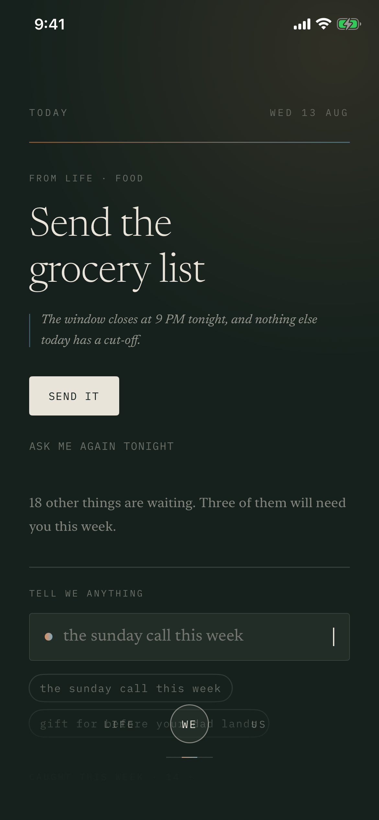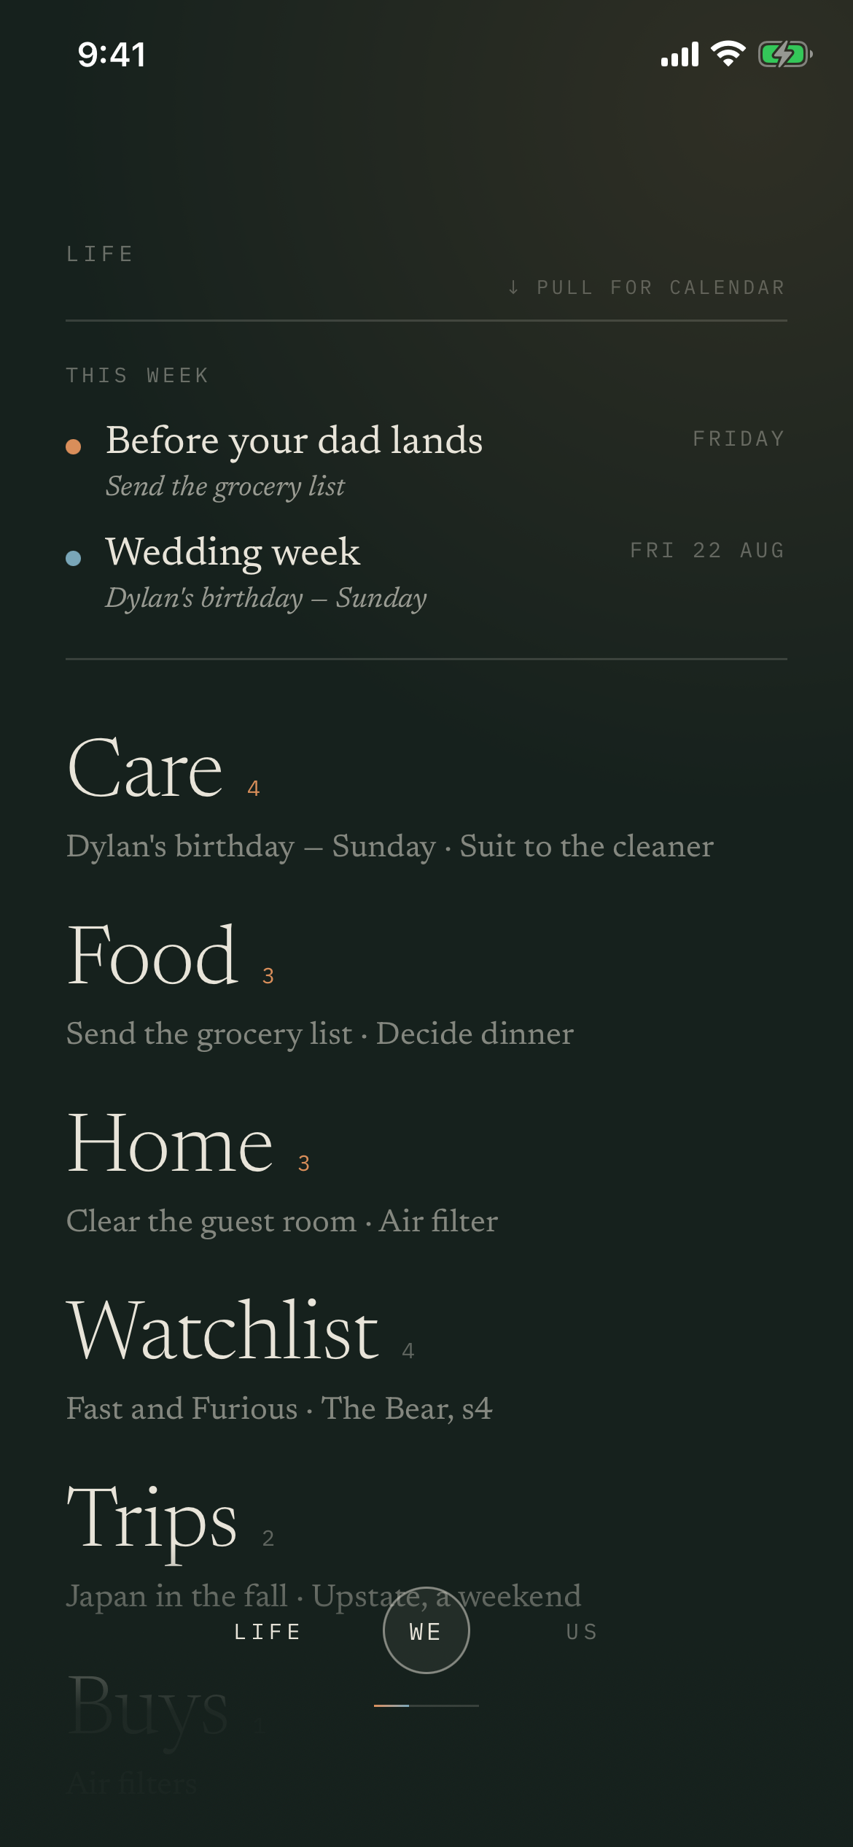
Preserve. The warm ivory text, deep green field, restrained hairlines, and generous hero typography give WE a recognizable identity.
Refine. Supporting copy and navigation are visually faint. Large Life category names compete with actual obligations. The bottom gradient and controls visually overlap content in these references; verify scrolling clearance before calling this a current layout defect.
Refresh the evidence. The Us reference shows the older horizon report. Current Field code can show the newer shared journey room. Recreate baselines for both enabled and disabled rollout states, then approve only the intended beta state.
Source: committed iPhone reference images
  - 02 / DESIGNER SPECIFICATION

Give each screen its own job

Today: one useful action, then capture
Keep a large serif headline for the single decision. Place one short reason immediately beneath it, then a clearly named action. Replace vague verbs such as “Send it” with the destination or object when it changes the decision: “Review grocery message.” Put the capture field next, with optional supporting context below.
Acceptance. At the default text size on the smallest supported phone, the main action appears without scrolling for the standard short headline fixture. With larger text, content reflows and remains fully reachable. Drafts survive interruption and failed saves.

Life: occasions lead; categories organize
Give the upcoming occasion the first visual emphasis. Use smaller, consistent category rows with a short preview and a readable count. The current oversized category treatment makes Food and Home feel more important than the things inside them. Keep categories stable while ranking the most relevant items within them.

Us: move from an explanation to a decision
Design distinct empty, private answer, held, proposed direction, active journey, processing failure, and completed states. Show the shared question or agreed direction first. Put its supporting shared evidence behind an obvious “Why this?” control. Keep unfinished or unsupported source material out of the explanation.

Navigation and type
Give Today, Life, and Us stable labeled destinations. Give Yours a visible personal entry and Account a consistent control. Gestures remain shortcuts. Avoid requiring a long press to reach privacy, feedback, or account departure.
Proposed starting tokens: hero 34 to 42 pt; section heading 24 to 28 pt; item title 20 to 22 pt; body 16 to 17 pt; metadata 12 to 13 pt. Scale with Dynamic Type. Use the serif for key meaning; reserve spaced capitals and mono for brief labels. Reduce long italic explanations.
Accessibility target. Use readable foreground tokens over the worst point of each gradient. Target contrast of at least 4.5:1 for normal text and 3:1 for large text and meaningful control boundaries. Keep touch areas at least 44 by 44 pt. These are proposed QA targets, not measured results of this review.
Layout contract. Reserve navigation space using actual bar and safe area dimensions. The last field and last action must scroll completely above the bar with the keyboard both open and closed. Do not fade interactive content into invisibility.
  - 03 / PRODUCT & CAPTURE

Make the first week useful

Start with this week
Offer three optional entry points: something coming up, something to remember, and something to enjoy together. Let the person enter their own material rather than copying demonstration content into a live account. One useful entry is enough to proceed. The partner can join later.
Designer. Create a brief working introduction: enter a thought, see where it went, correct it if necessary, then choose whether anything is shared. Keep the ceremony replayable and skippable. Explain privacy at the action where it matters.
Developer. Use the real capture and correction paths. Bind drafts to the correct account. Never interpret onboarding completion, partner pairing, or silence as permission to publish private material.
Acceptance. A new person can save and retrieve one useful item without the partner being present. Two people can complete one shared action without a facilitator. Time to first usefulness is measured in the cohort, not asserted in marketing.

Ordinary language is the core interface
The classifier uses keyword rules, and the walkthrough source records that “that Greek place” had to become “that Greek restaurant” to route correctly. Build a fixed evaluation set of realistic phrases covering shorthand, typos, ambiguous titles, dates, and multiple intentions. Retain the original text and offer a small correction when uncertain.
Acceptance. No dropped clause during a multi intention capture. Ambiguous input can remain a note. Corrections are reversible and preserve privacy. Date interpretations are visible before commitment. Optional model processing follows the existing consent contract.

Release private importing deliberately
The Share Sheet intake already exists, but the project enables it in Debug and disables it in Release. Verify encrypted drafts, account separation, exact revision review, publication, cleanup, and failed upload recovery before enabling it for beta.
Designer. Show the original beside the proposed result. Keep sharing scope visible. Distinguish “Saved privately,” “Ready to share,” and “Shared.” Importing a link must not imply that WE read its contents unless that actually happened.
Sources: classifier and interpretation
Sources: walkthrough example and release flags
Release build configuration
  - 04 / DEVELOPER RELEASE GATES

Create one trustworthy release

R1 · Establish the candidate
Reconcile Field product work with compatible September repairs and the intended onboarding. Compare the candidate migrations with the connected database before applying anything. Do not blindly merge historical migration sequences or restore deleted screens. Record commit, build number, schema versions, feature flags, and backend in release notes.
Evidence. Main remains f4322f7. The branch API reports it unprotected with required status checks off. The earlier repository Actions query returned zero runs. This does not prove tests were never run elsewhere; request the actual build and test evidence.

R2 · Restore executable database checks
Field still includes the three argument like() assertions addressed on the repair branch. Integrate the corrected assertions and compatible write boundary fixes, then execute the suites. Count assertion failures as well as process errors. Make the candidate reproduce from a clean database and a supported upgrade path.
The connected database still had the defective legacy plans trigger during the prior inspection. Field uses newer tables for much of its experience, so trace reachability before assigning user impact. Repair a reachable path or retire it explicitly. Do not describe every current planning feature as broken.

R3 · Prove the two person contract
Use isolated test accounts for Partner A, Partner B, and an outsider. Verify invitation expiry and reuse, private capture, correction, explicit sharing, mutual decision, decline, withdrawal, departure, sign out, and account switching. Exercise interrupted writes, restart, retry, and simultaneous actions.
Acceptance. No cross account data, duplicate mutation, unintended publication, or resurrection of withdrawn material. Private rejection remains private. Successful retry creates one intended result. Both devices converge after reconnection.

R4 · Validate the distributed product
Test the signed Release archive installed outside Xcode. Verify packaged configuration, enabled capabilities, extensions, privacy text, callbacks, and support destination. Require successful schema/privacy, native build/unit, and critical UI checks on the candidate. Keep broader jobs isolated from production.
Security follow up. Review advisory findings individually. The previous backend inspection found privileged callable function warnings and disabled leaked password protection. Function visibility is not itself proof of an exploit. Verify intended access and authorization before changing grants.
Source: repair branch
Source: QA contracts
  - 05 / EXPERIENCE INTEGRITY

Finish the promises already visible

History and supporting evidence
Field backend loading currently supplies empty Anchors, Threads, and Seasons. Weekly synthesis always returns nil. Either complete the relevant storage, loading, and display path or remove the unavailable promise from the beta experience. Do not populate production with demonstration history.
For this beta, favor one small weekly reflection based only on shared records: what resolved, what changed, and what remains open. Let people inspect the underlying items. Do not infer relationship quality or financial progress from missing information.
Shared journey source resolution cannot currently resolve every originating question, rhythm, or shared item. Complete the supported types and distinguish an unsupported implementation from legitimately unavailable evidence. An explanation must not reveal that a private record exists.

Notifications and the widget
The local daily notification uses the moment headline and reasoning. Default to neutral copy with an explicit preference for detailed previews. Test a partner completing or withdrawing an item while the other phone stays closed. Local scheduling cannot guarantee that the closed phone has current partner state.
The saved widget reference says “Something opened for both of you.” Keep that neutral tone. Verify exactly when the mutual condition is satisfied, when it expires, and how stale snapshots are removed. Never expose a private readiness tap, mood, or draft through color, brightness, animation, or wording.

State language and user control
Use calm, factual distinctions: saved on this device, waiting to sync, saved privately, shared, and unavailable. A failed sync must not look like an empty relationship. Reserve “Nothing needs you” for a state WE can support with current information.
Let people mute or retire irrelevant suggestions without explaining themselves. Keep deferred tasks distinct from consent declines. A practical reminder can have a chosen return date; a private “not now” must not become partner visible pressure.
Designer acceptance. Provide error, offline, empty, long text, disabled, processing, and success variants for every delivered flow. Repeated color ownership cues must also carry accessible names. Do not use personal hue alone to distinguish private from shared.
Sources: loading and weekly synthesis
Source: incomplete source resolution
Source: daily notification scheduling
  - 06 / INNOVATION AFTER THE CORE

Two directions worth owning

Make room · the next practical experiment
A person privately chooses “I have less room today.” WE proposes one adjustment using permitted information: move a flexible item, simplify a plan, or offer a handoff. The person edits and confirms the exact proposal before anything crosses to their partner.
Designer. Use a compact private sheet with a chosen time window. Show one proposed change, its consequence, and Keep as is. Completion should visibly remove a burden. Do not turn capacity into a gauge, score, shared aura change, or performance comparison.
Developer. Store capacity privately with an expiry. Evaluate only permitted inputs. Never move an external calendar event or assign a partner silently. Handoffs require acceptance; pending handoffs retain the current owner. Preserve a reversible action history.
Success. The person reports that one thing became easier. If the result merely creates another task or another discussion, revise the feature. This is an extension of existing coordination, not a prerequisite for the first cohort.

Rehearse a life change · an experimental direction
Inside a shared journey, explore an alternative such as moving together or changing a weekly routine. WE assembles a temporary scenario from explicitly shared facts and assumptions. The couple sees what would change before either person commits.
Designer. Use a calm Current and Possible comparison with concrete changes. Keep assumptions visible. A proposal should feel editable and provisional. Avoid a relationship simulation score or predictions about either person’s emotions.
Developer. Create a scenario that references the original records without changing them. Label generated assumptions and preserve provenance. Before applying, revalidate against current records, show the exact change set, and obtain the required approvals. An expired approval cannot authorize a revised scenario.
Success. A couple can explore and discard a possibility without creating obligations. The experiment earns expansion only if it helps people reach a decision they would otherwise postpone.

Visual inspiration to carry forward
Use space and emphasis to show progress: an unresolved action is prominent; a resolved one recedes into a brief receipt; the shared direction becomes the visual anchor. Keep the atmosphere stable. Relationship activity must never become an ambient signal that leaks one person’s private state.
  - 07 / TEAM HANDOFF

Delivery order and definition of done

First delivery · establish what ships
Developer supplies the reconciled candidate and build inventory. Designer supplies a state map keyed to its feature flags. Capture fresh Today, Life, current Us, Yours, Account, onboarding, capture review, and share review screens. Include small and large phones and the largest supported text sizes.

Second delivery · remove friction
Implement navigation and bottom clearance, readable text tokens, compact Life categories, concrete action labels, and the first useful capture. Verify source based explanations and release importing. Update the README and onboarding copy so they describe the actual candidate.

Third delivery · observe five couples
Run two weeks with five couples. Include uneven enthusiasm, separate homes, busy schedules, and at least one accessibility or small screen stress case. Use the existing feedback tool. Do not add surveillance or private content logging to make evaluation easier.
Ask each partner separately: What did WE take off your mind? What did you have to correct? What felt like work? Could you tell what was private? Did you ever feel nudged by your partner through the app? Capture the specific event and result with their permission.
Proposed usability gate. At least four of five couples complete the first shared action without coaching. Every participant can find Account and explain the privacy of a saved item. Any unintended disclosure or persistent data loss stops expansion regardless of aggregate scores.

Required Xcode and device verification
Confirm the active project, branch, scheme, build configuration, feature flags, OS, and device. Inspect actual controls with VoiceOver. Check keyboard interactions, one handed reach, device rotation where supported, backgrounds, app switching, offline restart, and both partners changing state. Screenshots alone cannot establish these behaviors.

Source register
Field product and saved reference images · 68ba1ac
Main product · f4322f7
Navigation and account access
Current Us rollout and states
Private input and deliberate release contract
Backend observations refer to the connected WE project inspected on 6 September 2026. No production data was changed. Final runtime signoff is pending access to the actual beta build.

