Ryan Keeney  
4/18/2017

Geoscripting Project

One of the components of the MSGIS capstone project (and the only one I have not yet started) is a parcel walkability to neighborhood amenities analysis. Specifically I want to take one of Denver’s official neighborhoods and run an analysis using Esri’s Network Analyst that builds the following table for every parcel:

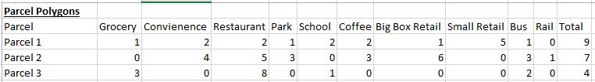

Each amenity category would be represented by one field and the cell content would indicate the number of amenities located within a ½ mile sidewalk network distance of that parcel. From this it would be possible to create a number of interesting choropleth maps. It could be for individual categories, like the number of restaurants for example. Another possibility would be to symbolize the map for the total number of categories overall (0-10) with at least 1.

Once the data is acquired, I would need to figure out how to use Network Analyst and Python to run the analysis and fill in the table. I strongly suspect that I cannot accomplish this without Python scripting because this will involve thousands of parcels and hundreds of amenity locations. I will likely have to string together several Network Analyst geoprocessing functions and loop them so that the attribute table for the entire neighborhood is completed.

To do this, first I will need to determine what specific Network Analyst sub-processes I need to use. Then I will need to figure out how to use Python to string them together and get the resulting data formatted like the above table.

I was planning to complete this in ArcMap and the Python IDLE GUI because I am most familiar with those and I have no idea if using R, if it is capable of network analysis, would be easier. Hopefully this will work for this course. If not, I will think of something else.