***Entire Kikta family settles in Western NY***

Prokop Kikta was born about 1854 in Kostazowce, Poland. Prokop and his wife were married about 1878 in Poland and had 4 children there. Makary, John, Joseph and Mary. All four children immigrated to the US and settled in Western NY. I have found no record that Prokop ever came to this country.

First son Makary Patronik Kikta ***33***  settled in Buffalo by the name of Charles Joseph (also Carl Joseph) Kikta(B 8 Oct 1879 ) in 1893 or 1904. Carl worked for the Lackawanna Railroad and later the B&O as a carpenter in Buffalo. Makary (Charles) died 25 Jan 1959 in Buffalo, NY. His wife is listed in the US census as Conaund (later Konstantyn, later Kunegunda) (B1883) immigrated in either 1891 or 1901 before Carl. Makary’s immigration records indicated his wife’s name was Tekla. They were married in 1906 but I’m not sure if that was in NY or Austria. According to the 1910 census, Carl and Conaund had 4 children who were all born in NY, Helen (B 1907), Mary (B1907), Genoveve (B 1908) and Victoria (B 1909). Victoria died in 1991. By 1920 they had two additional sons by the name of Frank (B 1912) and Joesph (B 1914). Joseph died in 1987.

Second son ***30*** John Kikta(B 26 Jun 1882) is shown some places as having immigrated from Poland in 1898 and others show 1882. Unless he came with a parent, I doubt if he came in 1882 as he was only 1 year old. John immigrates to North Hampton, Pa. in 1902 with ***42*** Simon Kikta(B:1867) and later relocates in Buffalo, NY. I’m not sure how Simon is related if at all. According to the 1920 census, John lived in Buffalo with his wife Klemintine(B1886) and he was a laborer with Lackawana Steel Co. They had been married in Poland before coming to the US and by 1910, they had 4 children all born in NY, Leonarda (B1905), Bernard (B1906, Wladyslawa (Lottie) (B1908) and son Kazimira (B1909). By the 1930 census they had three more children which makes 7 total, but only 6 were living at home. Their names were, Leonarda (B1905), Lottie (B1908), Casimer(B1909), Edward (B1914), Martha (B1915) and Henry (B1920). I am not sure what happened to Bernard. By 1940, Klemintine had married Andrew Krankowski with their three children and Kazmira and Henry from her marriage with first husband John.

Third son Joseph Kikta (B 1886) ***34***  in Austria, immigrated to Rochester, NY in 1903. His wife Katherine Mikata(B 1889) preceded him in 1902 and by 1930 they had 6 children born in NY; John (B 1918), Anthony (B 1920), Helen (B 1922), Anna (B 1924), twins Joseph and Dorothy (B 1929). According to the 1925 NY State census, Katherine was a widow and had (8) children living with her; John (B1908), Anthony (B1910), Helen(B1913), Anna (B1914), Joseph (B1916), Dorothy (B1917), Theodore (B1913) and Richard (B1923). By 1940 Katherine has only four youngest children living with her. It appears as father Joseph died between 1923-1925.

By 1940, son Anthony was living in Rochester, NY with his wife Mary. He was a chef in a restaurant and Mary was a waitress in the restaurant.

Fourth child (daughter) Mary ***35***  who was born in Poland in 1888 came to the US in year? and died in Buffalo, NY in 1927.



In 1910, ***31***Michael Kikta (B1892) arrived from Kozuchow, Poland. His wife Anna (B1890) later followed him immigrating in 1914 and they both settled in Oneida, NY on their own farm. Michael Kikta‘s passenger records indicate his nearest relative at home when he left was his mother Tekla Kikta. Anna and Michael had their first child Katherine in NY in 1920. They had two more children: Henry (B1923) and Michael Jr (B1928).

Katherine married a Ringrose and lived in Blossvale, NY.

Henry A. Kikta married Carolyn June Peck and ran a successful farm with over 380 acres of land in Verona NY and had 5 children.  Shelly (Michelle) Anne was born on 20 Oct 1953 in Oneida, NY, and she married Jerry Kiner in Nov 1989.  Shelly and Jerry have one child Ryan Henry Kikta (B1982).  Tina Marie was born 10 April 1956 and married Fred Conover. Tami June was born 9 Dec 1959 and was married to Ron Jenkins. She served in the US Army as a medical laboratory specialist. Trudy Fern born 11 July 1958 and is married to Ken Dinnhaupt.   Randy Paul was born on 26 Aug 1965 and is divorced. Henry died 11 Jul 1989 and Carolyn on 29 May 2002. Both are buried at Maple Flats Cemetery in Vienna, NY.



***32*** Peter Dimetrio Kikta (Brother to Michael Kikta just above) immigrated from Sanok, Poland through Niagra Falls, New York via Halifax, Nova Scotia. He landed in Halifax on 14 Mar 1926 and then through the US border at Niagra Falls on 24 Apr 1926.

***Peter Kikta comes to Washington, DC***

Peter Kikta left New York to settle in Johnstown, Pa. and then on to Washington, DC. His brother Michael and family settled in Oneida, NY as stated above. Peter was born 18 Aug 1896 in Sanok, Poland. Peter and his wife Theresa Tenick, were married in Poland on 25 Nov 1920 when Theresa was only 16 years old. While living in Pa. they had 4 children. Mildred was born 31 Aug 1921 and Darthy was born 18 Dec 1923.Their only son Peter C. was born 11 Nov 1925 and Irene was born 6 September 1927. Peter Sr. was a butcher at the Mayfair Market in SE Wash DC before being killed by a DC Transit bus that slid on an icy street to crush him up against a pole on 23 December 1967. Peter’s wife Theresa died in 1986. Both Peter and Theresa are buried in the Lincoln National Cemetery in Washington, DC.

Mildred and Irene were never married and last lived together in Santa Fe, NM when Mildred died 3 Oct 2006 and Irene 4 Jun 2008. Son Platoon Sergeant Peter C. Kikta was killed 26 Dec 1945 in a plane crash as the top turret gunner of a B-24 in the Army Air Corps. Darthy married James Lindberg Hughes (Col USAF) who was a Vietnam POW 1967-1973 and they were divorced in 1975.

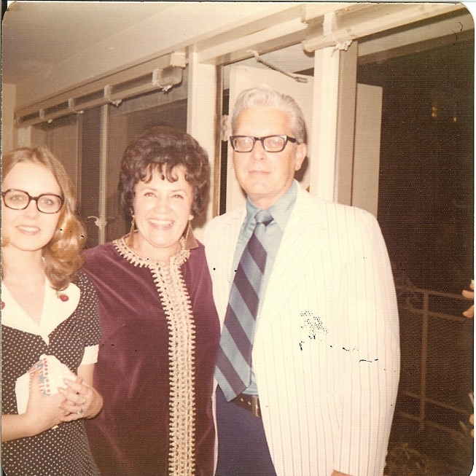

***Mildred in Wash DC with my Father and my sister (Vince & Michelle Kikta) 1960’s***



Buffalo, NY was the home of Peter Kuchta (B1891) who arrived in 1913. He was most likely a Kikta before Immigrating and his name was probably changed to Kuchta upon entering.



***36*** Gustav Kikta (B 1884) in Hungary (Poland), immigrated to NY and settled in Manhattan. He was married three times according to the IGI. He married Susanna Juriak in Hungary before immigrating, then he married Christina Polansky on 1 Apr 1906 in Manhattan, NY and then married Catherine Kapusta on 9 Feb 1907 . I have no idea what happened to his first two wives of if they ever had any children.



***37*** Wasyl Kikta(B 1880) also came from the same town of Kostazowce, Poland in 1903 and settled in Manhattan, NY. His parents were Matthew Kikta and Anna Clopick. Wasyl married Catherine Twarde on 7 Oct 1906 in Manhattan, NY.