**4. Lee-Fi**

**Description**

Professor Lee just invented a new mobile internet system, which he named “Lee-Fi.” He made $N$ routers (routers are machines which provide internet connections) providing “Lee-Fi” connections. These routers are named $R_{1}, R_{2} , …,R_{N}$. Then, he placed each router in position $\left(x_{i} , y_{i}\right)$.

“Lee-Fi” has some special properties.

1. The altitude of users/routers doesn’t matter. So, we can consider the world as a 2D-plane.

2. Each router $R_{i}$ can serve the internet up to distance $d_{i}$, measured in **‘manhattan distance’**. ()

3. A single user can connect to multiple routers.

For example, think about a router placed on $\left(2,2\right)$ and service distance $d=2$. The area user can connect to this router is drawn as below.

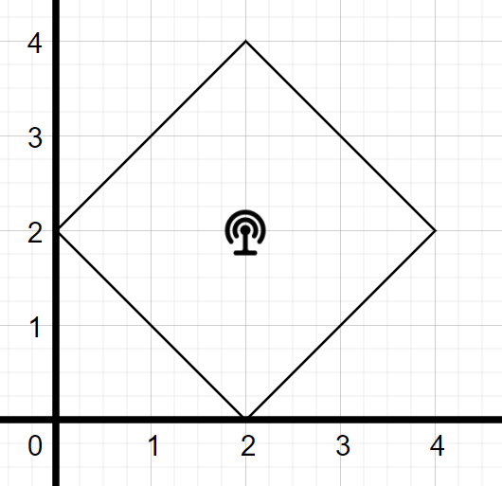

Your task is to calculate the total area a user can connect to all $N$ routers.

**Constraints**

$$N≤100,000$$

$$-1,000,000≤x_{i} , y_{i}≤1,000,000$$

$$0≤d_{i}≤1,000,000$$

**All $x_{i} , y_{i} , d_{i}$ are even integers. Therefore, final answer (total area) is guaranteed to be natural number or zero. That is, you don’t have to worry about decimal places.**

**Input**

On the first line, the number of routers $N$ is given.

On the next $N$ lines, information of routers is given. Specifically, on the $\left(i+1\right)$-th line, three integers $x_{i} y_{i} d_{i}$ are given.(separated by space), which is information of router $R_{i}$.

**Output**

Print one integer, which is the total area where a user can connect to all $N$ routers. It is guaranteed that this value is a natural number or zero.

**Example**

|  |  |
| --- | --- |
| **Input** | **Output** |
| 2  2 2 2  4 2 2 | 2 |
| 2  0 0 4  4 4 4 | 0 |
| 2  0 0 4  2 2 2 | 4 |
| 3  0 0 2  0 0 4  2 0 2 | 2 |
| 3  -2 0 100  0 0 100  0 0 2 | 8 |

Diagram of first example.

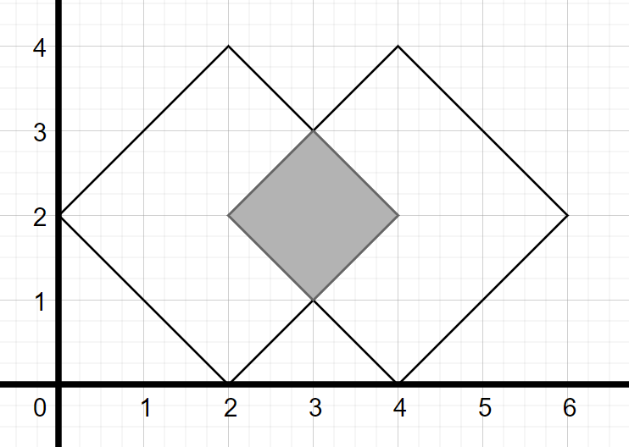

Connectable area of two routers is drawn as large squares. A user can connect to both routers if he/she is in gray area. Therefore, the answer is 2.