Nez Perce Tribe Adult Chinook and Steelhead Monitoring - 2019 Annual Report

Ryan N. Kinzer

28 January 2021

Table of Contents

Results and Discussion 2

Fall Chinook Salmon 2

Abundance 2

Life History 7

Productivity 11

Spring/summer Chinook Salmon 13

Snake Basin Abundance 13

Life History 19

Productivity 28

Summer Steelhead 29

Snake Basin Abundance 29

Life History 32

Spatial Distribution 36

Productivity 37

Appendix 37

## Logged in as: API User

## Response [https://npt-cdms.nezperce.org/services/api/v1/account/login]  
## Date: 2021-01-25 15:14  
## Status: 200  
## Content-Type: application/json; charset=utf-8  
## Size: 702 B

# Results and Discussion

## Fall Chinook Salmon

### Abundance

**Snake Basin Abundance** Annual return abundance of Snake River fall Chinook Salmon back to Lower Granite Dam in 2019 remained below the ten-year average (Figure 1; Young et al. 2020). The total abundance of natural fall Chinook Salmon generally followed the same declining abundance trend as hatchery fish to Lower Granite Dam. However, the ten-year geometric mean escapement of natural-origin adults was 10,856, which continued to be significantly higher than the NOAA recovery goal of a minimum of 4,000 adults (Young et al. 2020).

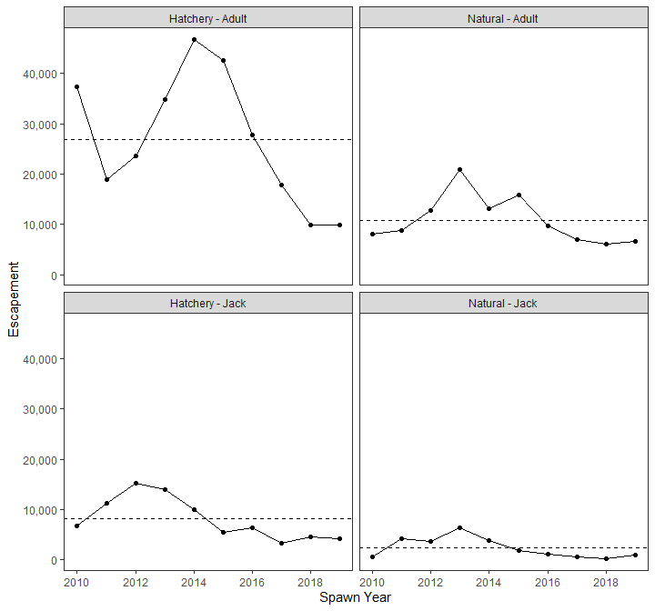

Figure 1: Natural and hatchery origin Snake River fall Chinook Salmon (adults and jacks <57 centimeters) returns to Lower Granite Dam (Young et al. 2020). The dashed line indicates the 10 year average.

**Index of Abundance - Redd Counts** The Nez Perce Tribe completed multiple-pass aerial spawning ground surveys during the 2019 fall Chinook Salmon spawning period (Table 1). The total redds in the Clearwater River was similar to 2018, and lower than the previous 10 years (Figure 2). The M.F. Clearwater River, Salmon River and Selway River redd counts were slightly higher than in 2018, however, all other survey streams declined from the previous year (Figure 3).

The UAV surveys for fall Chinook Salmon redds in the lower Clearwater River resulted in an estimated 885 total redds as compared to 727 observed during traditional helicopter surveys. As others have reported, UAV counts seemed more accurate because staff could review the high definition video multiple times to see individual redd pockets more clearly; especially in high density spawning transects or where redd superimposition occurred. We will continue our comparisons between UAV and traditional helicopter surveys during spawn year 2020.

Table 1: Fall Chinook Salmon redds counted during 2019 aerial spawning ground surveys.

|  |  |  |  |  |  |  |
| --- | --- | --- | --- | --- | --- | --- |
| Stream | Transect | Pass 1 | Pass 2 | Pass 3 | Pass 4 | Total |
| Clearwater River | Lower Clearwater River | 104 | 225 | 335 | 63 | 727 |
| Clearwater River | Upper Clearwater River | 11 | 21 | 0 | 0 | 32 |
| Grande Ronde River | Lower Grande Ronde River | 5 | 34 | 6 | 12 | 57 |
| Imnaha River | Lower Imnaha River | 0 | 1 | 1 | 5 | 7 |
| Middle Fork Clearwater River | M.F. Clearwater | 0 | 26 | 2 | 0 | 28 |
| Potlatch River | Lower Potlatch River | 0 | 6 | 8 | 0 | 14 |
| Salmon River | Salmon River | 5 | 12 | 0 | 0 | 17 |
| Selway River | Lower Selway River | 4 | 10 | 9 | 0 | 23 |
| South Fork Clearwater River | SF1 | 0 | 34 | 11 | 0 | 45 |

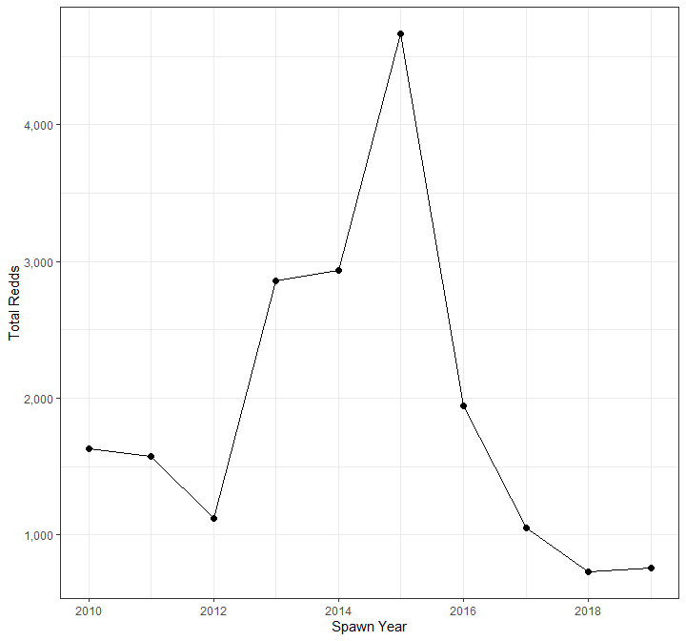

Figure 2: Total fall Chinook Salmon redds counted during aerial Clearwater River spawning ground surveys in 2019.

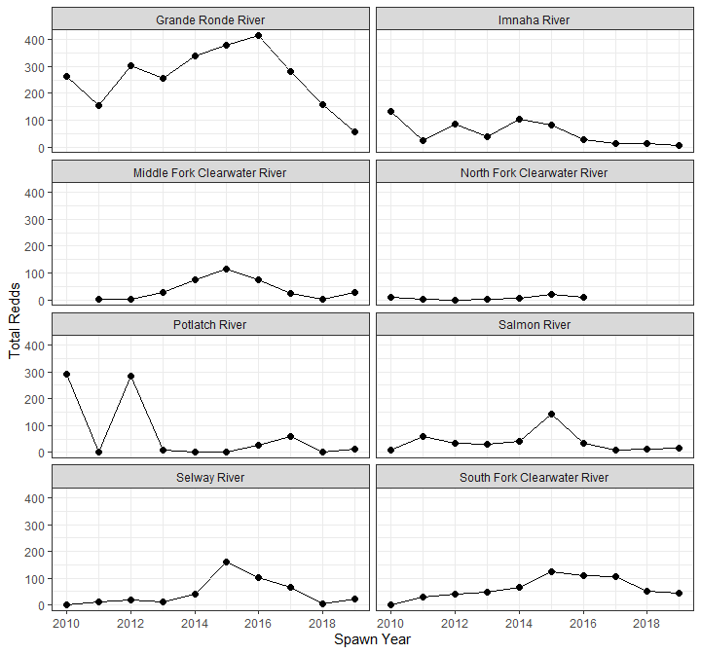

Figure 3: Total fall Chinook Salmon redds counted throughout the Snake River basin during aerial spawning ground surveys in 2019.

### Life History

#### Female Proportion

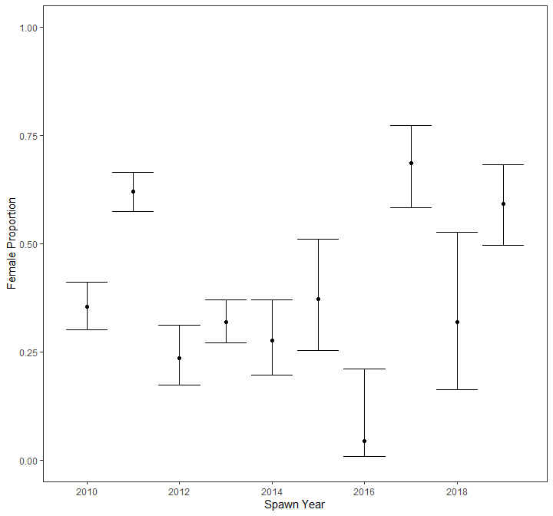

Figure 4: Fall Chinook Salmon female proportions estimated from carcass collected during spawning ground surveys.

#### Proportion Hatchery Origin Spawners (pHOS)

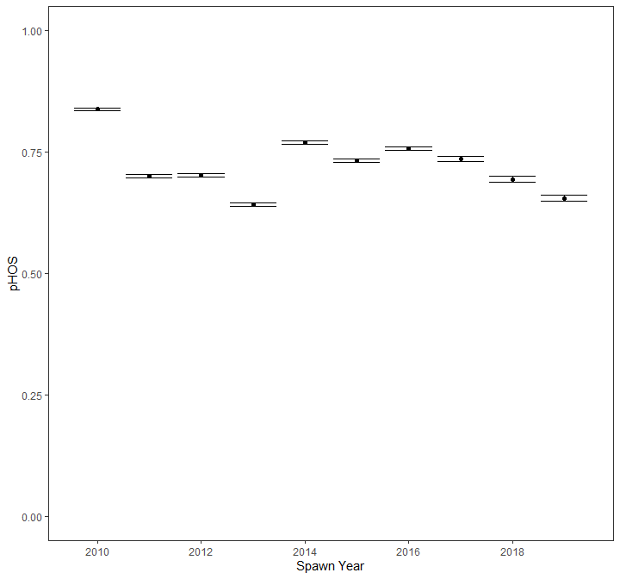

Figure 5: Proportion of Fall Chinook Salmon hatchery origin spawners (pHOS) estimated escaping Lower Granite Dam through run-reconstruction efforts.

#### Age Composition

Table 2: Fall Chinook Salmon life history metrics (unmarked proportion, female proportion and age compostion) calculated from carcass collected during 2019 spawning ground surveys (95% confidence intervals are shown in parentheses).

|  |  |  |  |  |  |  |
| --- | --- | --- | --- | --- | --- | --- |
| Stream | Transect | Unmarked | Female | Age 2 | Age 3 | Age 4 |
| Clearwater River | Lower Clearwater River | 0.31 (0.23, 0.41) | 0.59 (0.50, 0.68) | 0.04 (0.01, 0.19) | 0.35 (0.19, 0.54) | 0.62 (0.43, 0.78) |

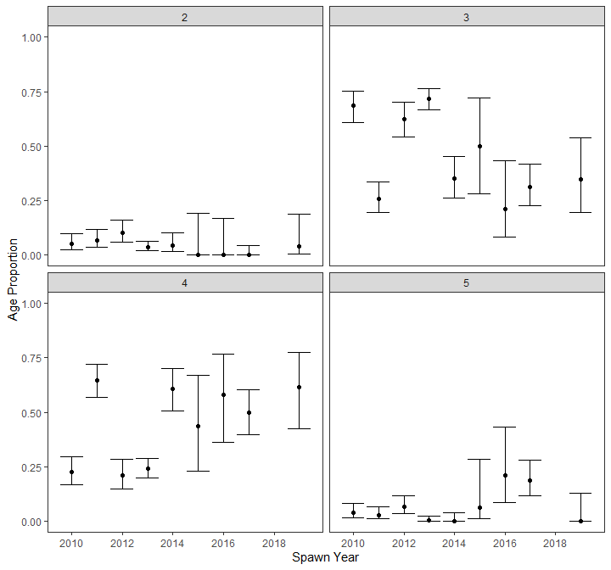

Figure 6: Fall Chinook Salmon age composition in the Clearwater River estimated from carcass collected during spawning ground surveys.

#### Size at Return

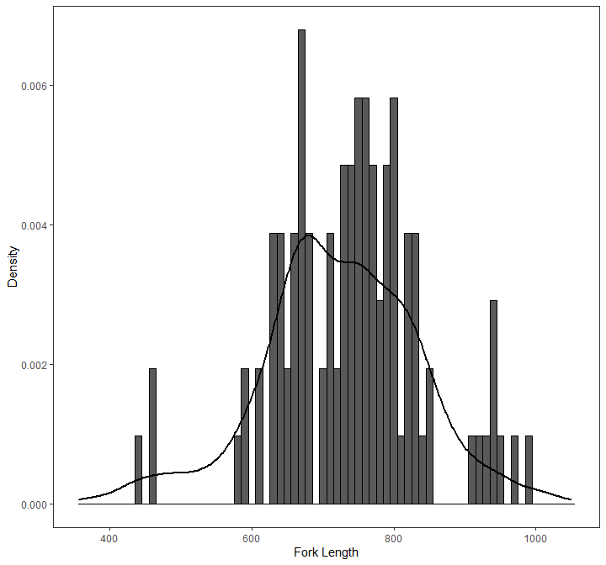

Figure 7: Fork length distributions of fall Chinook Salmon carcasses collected from the Clearwater River during 2019 spawning ground surveys (bars) and from all year of record (line).

### Productivity

#### Pre-spawn Mortality

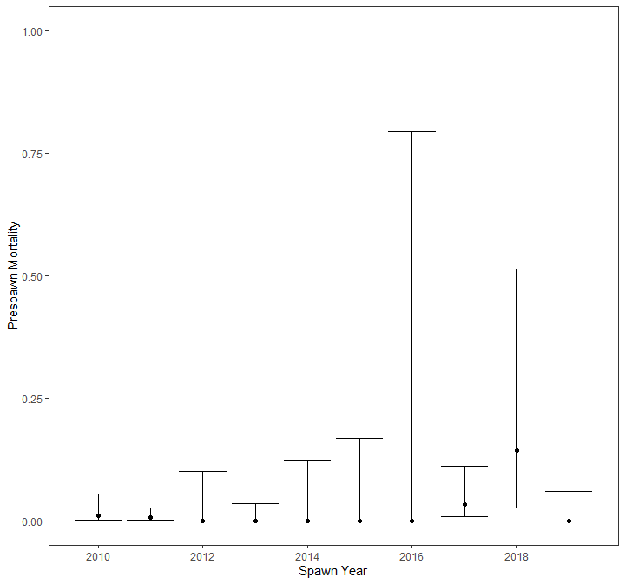

Figure 8: Fall Chinook Salmon prespawn mortality estimated from carcass collected during spawning ground surveys.

#### Progeny per Parent

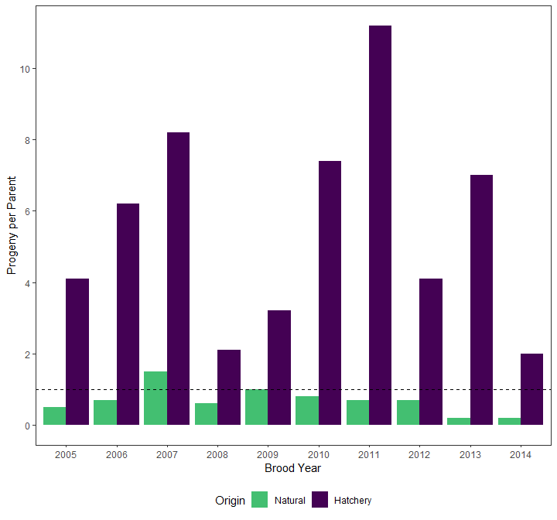

Figure 9: Natural and hatchery fall Chinook Salmon progeny-to-parent (P:P) ratios to Lower Granite Dam from brood year 2005-2014.

#### Smolt to Adult Ratio

## Spring/summer Chinook Salmon

### Snake Basin Abundance

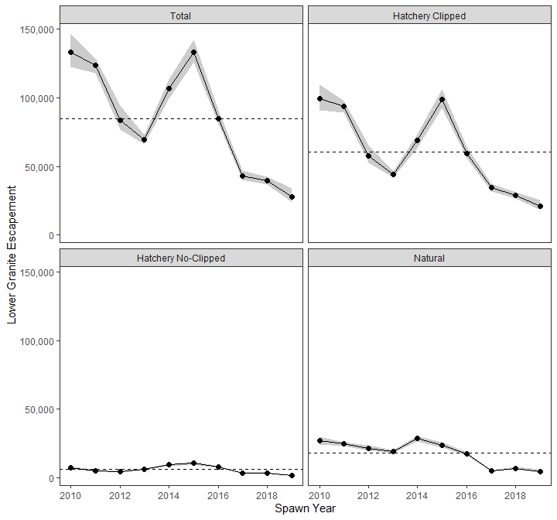

Figure 10: Escapement of unique spring/summer Chinook Salmon passing Lower Granite Dam as estimated by STADEM (grey bands represent 95% confidence intervals). The dashed line represents the 10 year average.

#### Population Abundance

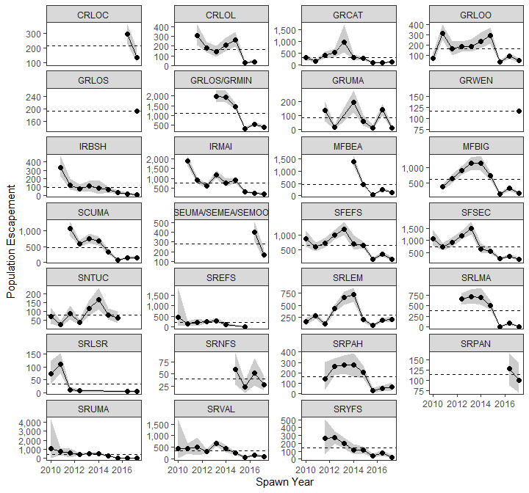

Figure 11: Escapement of natural origin spring/summer Chinook Salmon into ICTRT populations as estimated by STADEM and DABOM models (grey bands represent 95% confidence intervals). The dashed line represents the 10 year average.

#### Tributary Escapement

Table 3: Escapement of natural and hatchery origin spring/summer Chinook Salmon to DFRM weirs in spawn year 2019 and the estimated hatchery and female proportions of fish returning to the weir (95% CIs are reported in the parentheses).

|  |  |  |  |  |
| --- | --- | --- | --- | --- |
| Weir | Escapement | Weir Removal | Hatchery Fraction | Female Proportion |
| Johnson Creek | 277 (250, 303) | 63 | 0.30 (0.25, 0.36) | 0.43 (0.37, 0.49) |
| Lostine River | 535 (502, 568) | 108 | 0.77 (0.74, 0.80) | 0.36 (0.33, 0.40) |

Table 4: Dispositions of spring/summer Chinook Salmon trapped during spawn year 2019 at DFRM weirs.

|  |  |  |  |  |  |
| --- | --- | --- | --- | --- | --- |
| Stream | Disposition | Female | Male | Female | Male |
| Johnson Creek | Brood Stock | 33 | 29 | - | - |
| Johnson Creek | Natural Spawning | 29 | 79 | 43 | 29 |
| Johnson Creek | Stray Removal | - | - | - | 1 |
| Lostine River | Brood Stock | 17 | 17 | 66 | 69 |
| Lostine River | Distribution | - | - | - | 107 |
| Lostine River | Natural Spawning | 48 | 89 | 122 | 127 |
| Lostine River | Other | - | - | - | 1 |
| Lostine River | Outplant | - | - | - | 23 |

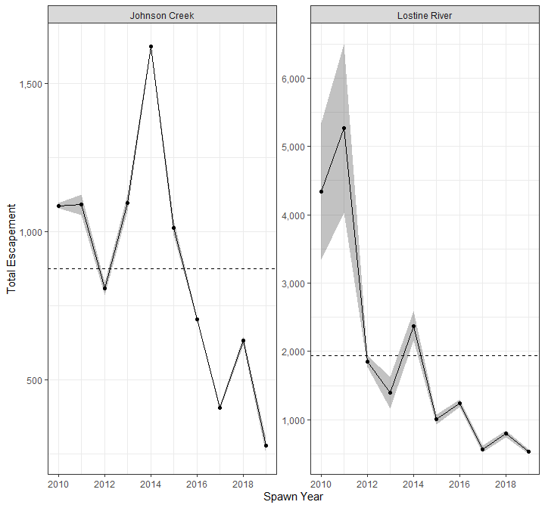

Figure 12: Natural and hatchery origin spring/summer Chinook Salmon escapement to DFRM operated weirs.

#### Index of Abundance - Redd Surveys

Table 5: Total redds counted and estimated life history metrics from combined natural and hatchery origin carcasses collected during 2019 spawning ground surveys.

|  |  |  |  |  |  |  |  |  |  |
| --- | --- | --- | --- | --- | --- | --- | --- | --- | --- |
| MPG | Population | Total Redds | pHOS | Female Proportion | Prespawn Mortality | Age 2 | Age 3 | Age 4 | Age 5 |
| Dry Clearwater | Upper South Fork Clearwater | 21 | 1.00 (0.51, 1.00) | 0.75 (0.30, 0.95) | 0.00 (0.00, 0.56) | 0.00 (0.00, 0.66) | 0.50 (0.09, 0.91) | 0.00 (0.00, 0.66) | 0.50 (0.09, 0.91) |
| Grande Ronde / Imnaha | Wallowa/Lostine | 160 | 0.62 (0.53, 0.71) | 0.48 (0.38, 0.57) | 0.10 (0.04, 0.23) | 0.00 (0.00, 0.23) | 0.00 (0.00, 0.23) | 0.92 (0.67, 0.99) | 0.08 (0.01, 0.33) |
| Middle Fork Salmon River | Big Creek | 12 | 0.00 (0.00, 0.39) | 0.50 (0.19, 0.81) | 0.00 (0.00, 0.56) | 0.00 (0.00, 0.39) | 0.00 (0.00, 0.39) | 1.00 (0.61, 1.00) | 0.00 (0.00, 0.39) |
| South Fork Salmon River | East Fork South Fork Salmon River | 97 | 0.38 (0.25, 0.53) | 0.66 (0.51, 0.78) | 0.00 (0.00, 0.12) | 0.00 (0.00, 0.08) | 0.07 (0.02, 0.19) | 0.93 (0.81, 0.98) | 0.00 (0.00, 0.08) |
| South Fork Salmon River | Little Salmon River | 0 | - | - | - | - | - | - | - |
| South Fork Salmon River | Secesh River | 70 | 0.00 (0.00, 0.06) | 0.42 (0.31, 0.54) | 0.00 (0.00, 0.13) | 0.02 (0.00, 0.08) | 0.20 (0.12, 0.32) | 0.78 (0.67, 0.86) | 0.00 (0.00, 0.06) |
| South Fork Salmon River | South Fork Salmon River mainstem | 63 | 0.83 (0.63, 0.93) | 0.61 (0.41, 0.78) | 0.09 (0.02, 0.38) | 0.00 (0.00, 0.26) | 0.18 (0.05, 0.48) | 0.64 (0.35, 0.85) | 0.18 (0.05, 0.48) |
| Wet Clearwater | Lochsa River | 4 | - | - | - | - | - | - | - |
| Wet Clearwater | Lolo Creek | 21 | 1.00 (0.61, 1.00) | 0.83 (0.44, 0.97) | 0.00 (0.00, 0.43) | 0.00 (0.00, 0.66) | 0.00 (0.00, 0.66) | 1.00 (0.34, 1.00) | 0.00 (0.00, 0.66) |
| Wet Clearwater | Meadow Creek | 4 | - | - | - | - | - | - | - |
| Wet Clearwater | Upper Selway River | 2 | - | - | - | - | - | - | - |

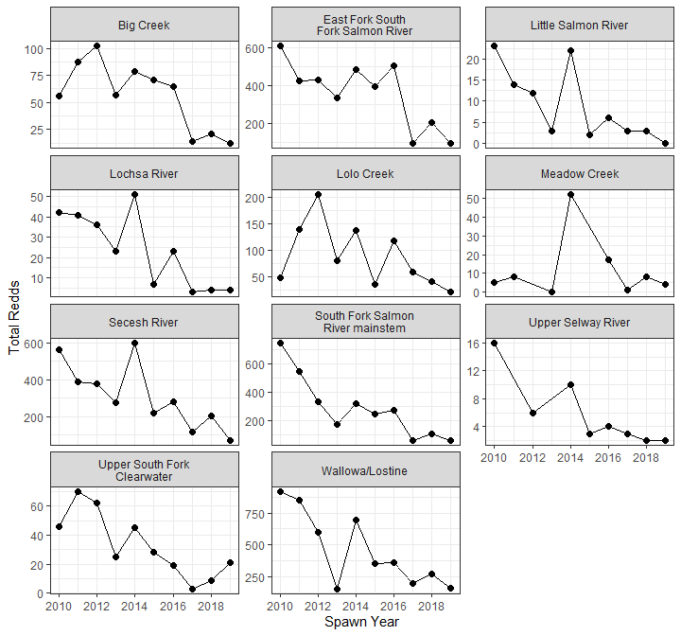

Figure 13: Total spring/summer Chinook salmon redds counted in surveyed ICTRT populations during NPT Snake River Basin surveys.

### Life History

#### Female Proportion

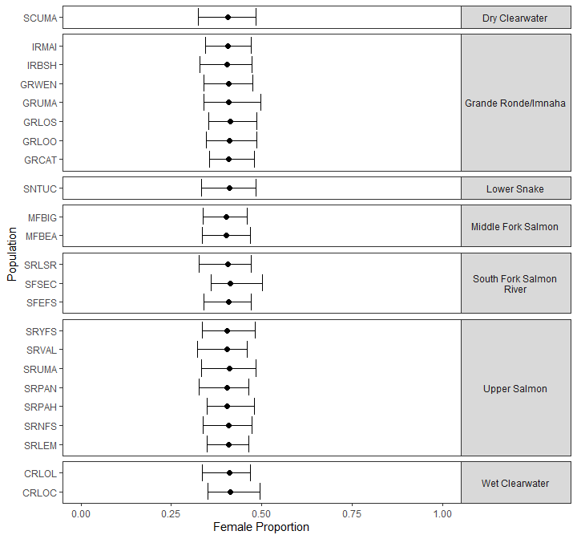

Figure 14: Female proportion of natural origin spring/summer Chinook Salmon in ICTRT populations estimated from PIT-tag detections at instream arrays during spawn year 2019. Populations are grouped by ICTRT major population designations with bars representing 95% confidence intervals.

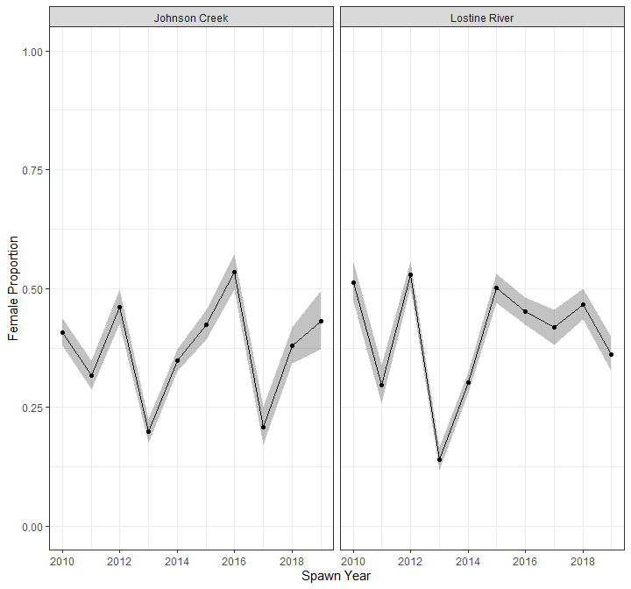

Figure 15: Female proportion of natural and hatchery origin spring/summer Chinook Salmon escaping to DFRM operated weirs.

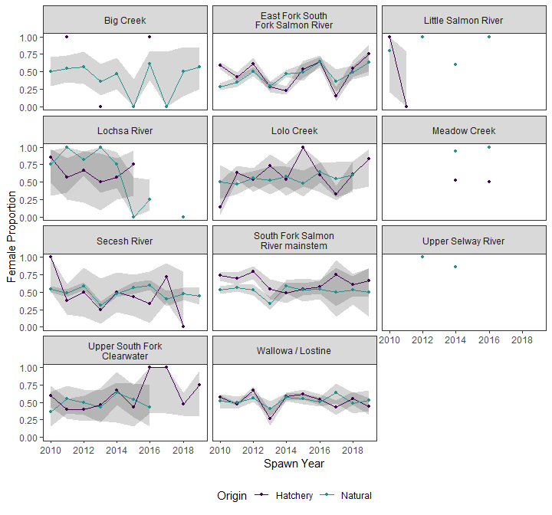

Figure 16: Proportion of natural and hatchery origin spring/summer Chinook Salmon females in each surveyed ICTRT population estimated from carcasses collected during spawning ground surveys.

#### Proportion Hatchery Origin Spawner (pHOS)

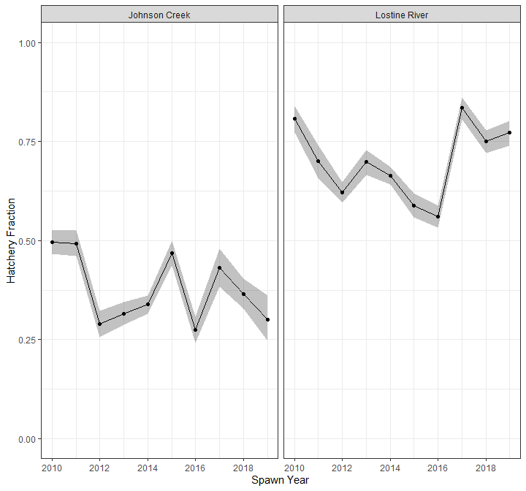

Figure 17: Hatchery fraction of spring/summer Chinook Salmon escaping to DFRM operated weirs.

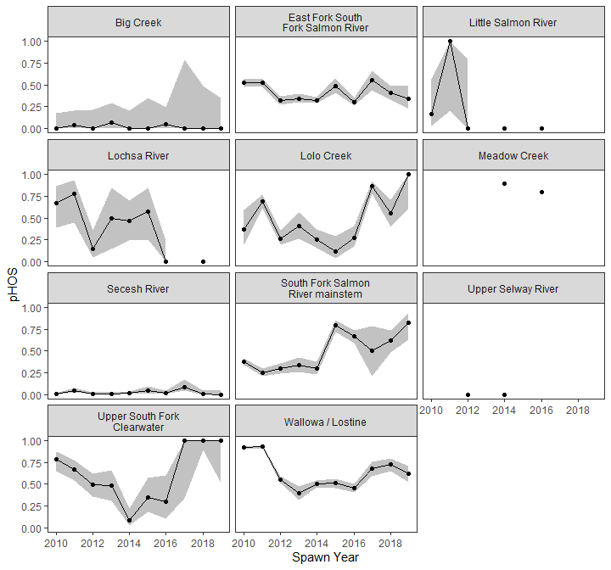

Figure 18: Proportion of hatchery origin spring/summer Chinook Salmon spawners (pHOS) in each surveyed ICTRT population estimated from carcasses collected during spawning ground surveys.

#### Age Composition

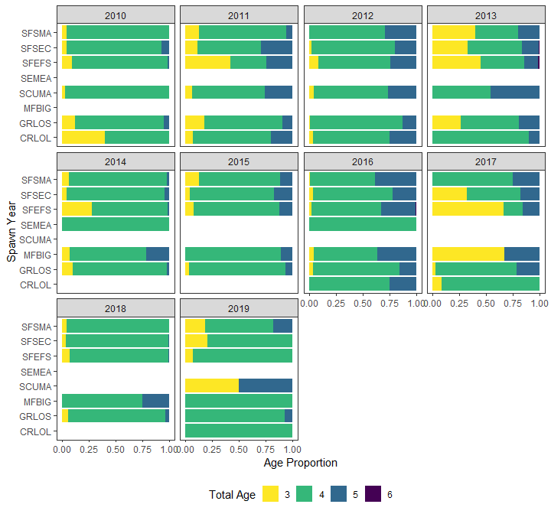

Figure 19: Combined natural and hatchery origin age proportion of spring/summer Chinook Salmon in each surveyed ICTRT population estimated from carcasses collected during spawning ground surveys.

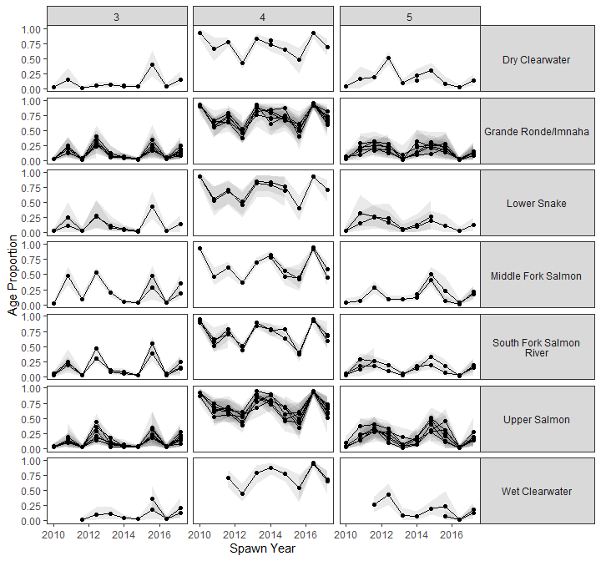

Figure 20: Age proportions of natural origin spring/summer Chinook Salmon in ICTRT populations estimated from PIT-tag detections at instream arrays (grey bands represent 95% confidence intervals). Populations are grouped by ICTRT major population designations.

#### Size at Return

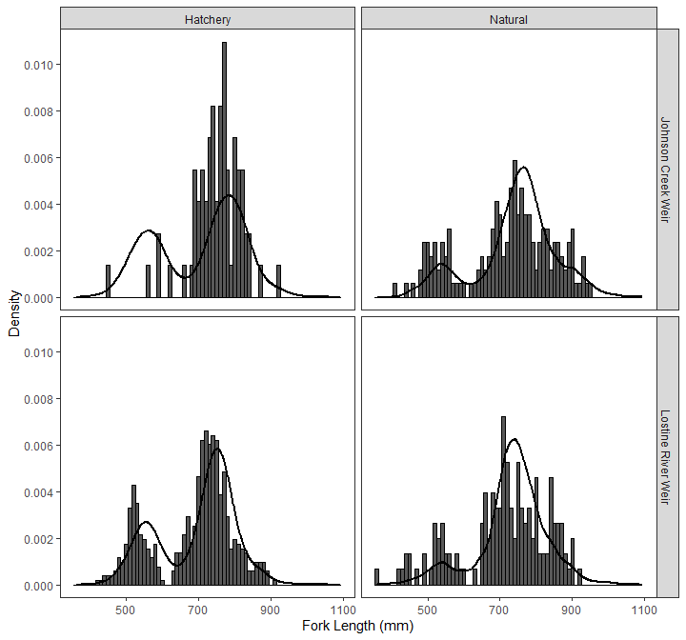

Figure 21: Fork length distribution of spring/summer Chinook Salmon trapped at DFRM operated weirs during spawn year 2019 (bars) and the period of record (line).

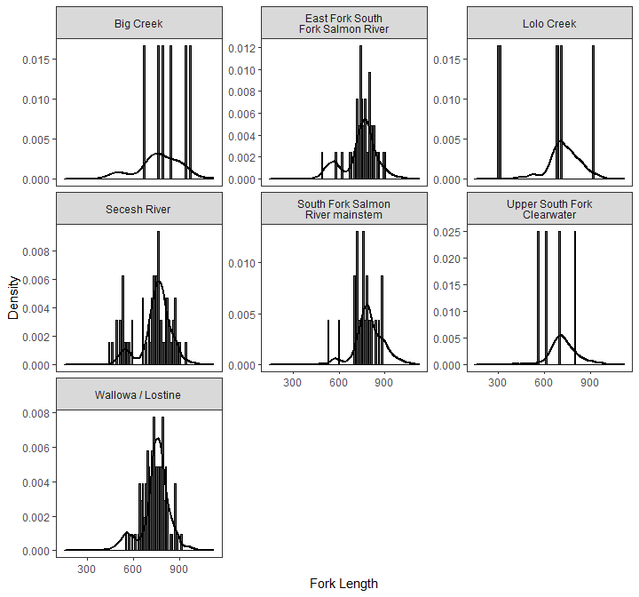

Figure 22: Fork length distributions of natural and hatchery origin spring/summer Chinook salmon carcasses collected from ICTRT populations during 2019 spawning ground surveys.

### Productivity

#### Pre-spawn Mortality

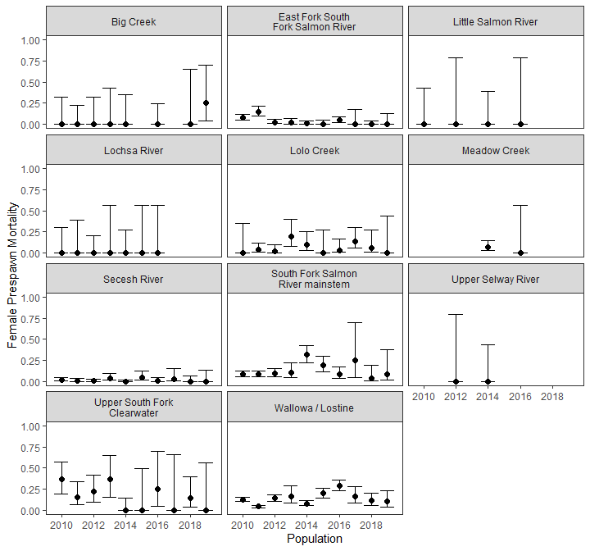

Figure 23: Pre-spawn mortality of natural and hatchery origin spring/summer Chinook Salmon in each surveyed ICTRT population estimated from carcasses collected during spawning ground surveys.

#### Progeny per Parent

Insert Craig’ Table 6

#### Smolt to Adult Ratio

Insert Craig’ Table 7

## Summer Steelhead

### Snake Basin Abundance

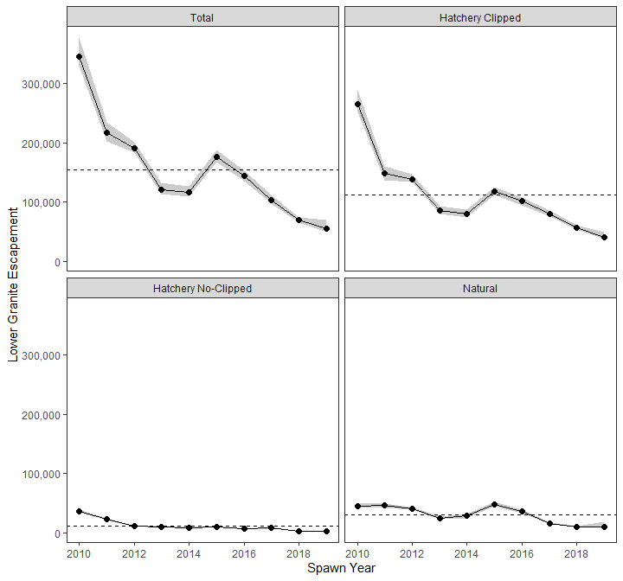

Figure 24: Escapement of unique summer steelhead passing Lower Granite Dam estimated by STADEM (grey bands represent 95% confidence intervals).

#### Population Abundance

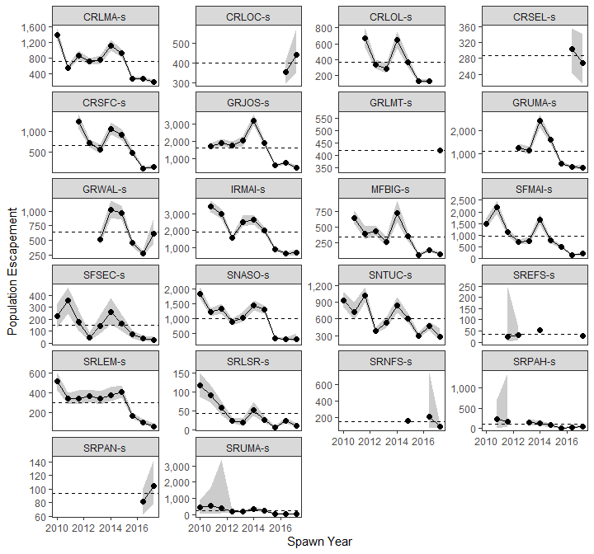

Figure 25: Escapement of natural origin summer steelhead into ICTRT populations estimated by STADEM and DABOM models (grey bands represent 95% confidence intervals).

#### Tributary Abundance

Table 6: Summer steelhead trapped during spawn year 2019 at DFRM operated weirs.

|  |  |  |  |  |
| --- | --- | --- | --- | --- |
| Weir | Ponded | Unique Fish Released | Disposed | Transferred |
| Freezeout Creek | 0 | 3 | 1 | 0 |
| Lostine River | 0 | 19 | 0 | 0 |

Table 7: Escapement of steelhead above DFRM weirs in spawn year 2019 and the estimated hatchery and female proportions of fish returning to the weir (95% CIs are reported in the parentheses).

|  |  |  |  |  |
| --- | --- | --- | --- | --- |
| Weir | Escapement | Weir Removal | Hatchery Fraction | Female Proportion |
| Freezeout Creek | 5 (5, 5) | 1 | 0.00 (0.00, 0.49) | 0.75 (0.30, 0.95) |

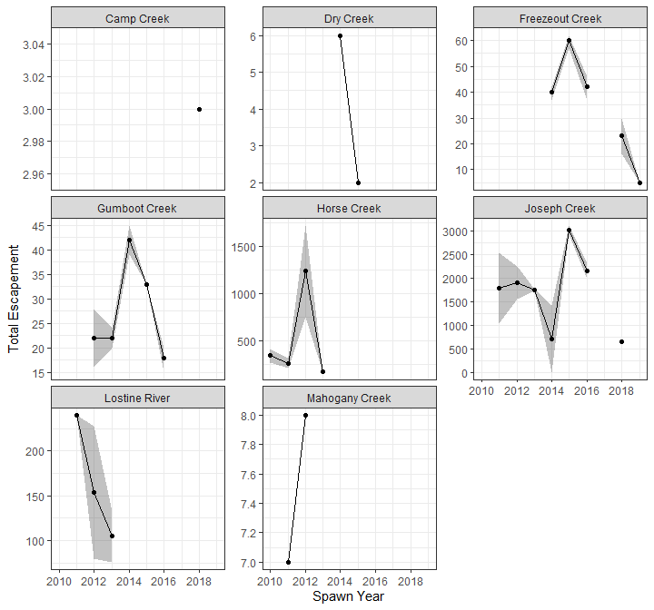

Figure 26: Total summer steelhead escapement to DFRM operated weirs.

### Life History

#### Female Proportion

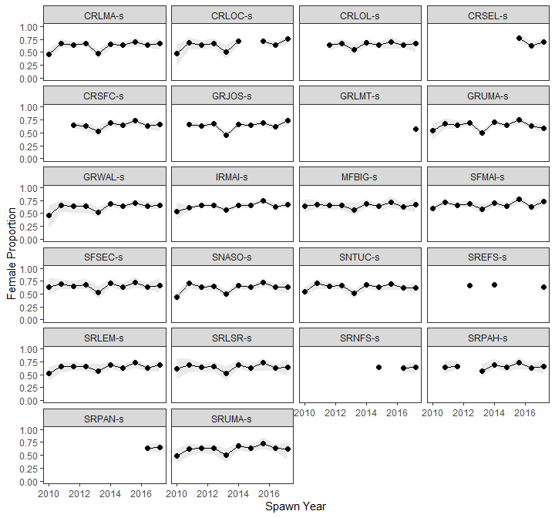

Figure 27: Female proportion of natural origin summer steelhead in ICTRT populations estimated from PIT-tag detections at instream arrays (grey bands represent 95% confidence intervals). Populations are grouped by ICTRT major population designations.

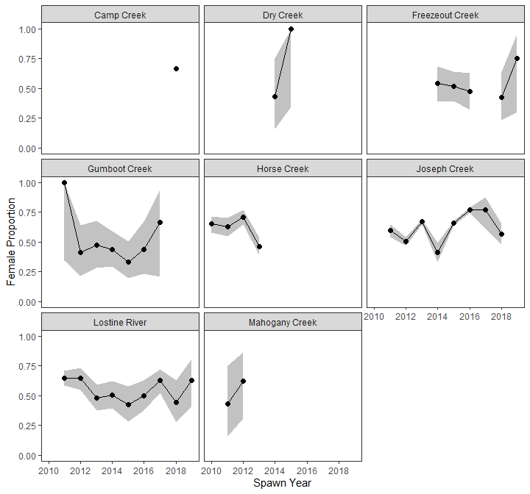

Figure 28: Female proportions of summer steelhead returning to DFRM operated weirs.

#### Proportion Hatchery Origin Spawners (pHOS)

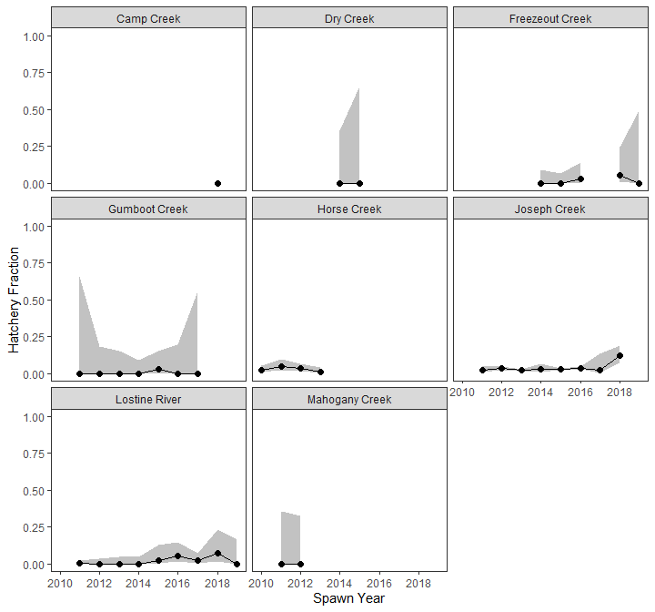

Figure 29: Hatchery fraction of summer steelhead returning to DFRM operated weirs.

#### Age Composition

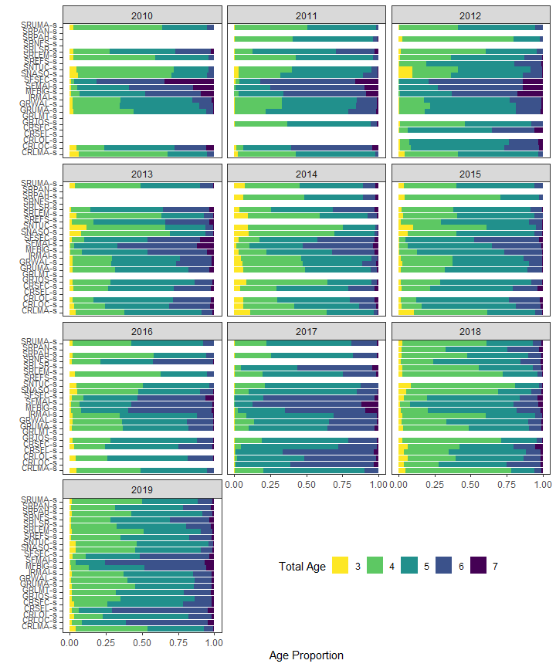

Figure 30: Age proportions of natural origin summer steelhead in ICTRT populations estimated from PIT-tag detections at instream arrays (grey bands represent 95% confidence intervals)

### Spatial Distribution

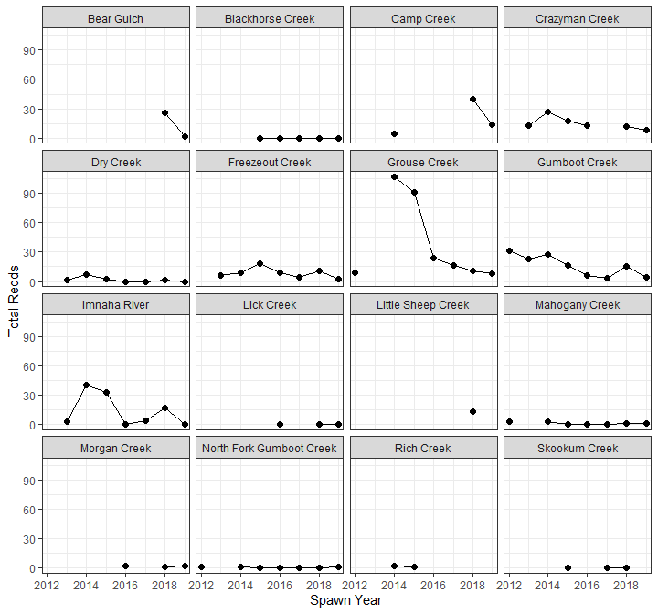

Figure 31: Total summer steelhead redds counted in the ICTRT Imanha River major population group during spawning ground surveys.

#### Migration

Insert Jim’s Table

### Productivity

# Appendix

Table 8: Final dispostion of all fish trapped at DFRM operated weirs in 2019.

|  |  |  |  |  |  |  |  |  |
| --- | --- | --- | --- | --- | --- | --- | --- | --- |
| Species | Run | Weir | Disposition | Purpose | Release Site | Origin | Sex | Count |
| Chinook | Fall | Lower Granite Dam Trap | Ponded | Brood Stock | - | Hatchery | Female | 32 |
| Chinook | Fall | Lower Granite Dam Trap | Ponded | Brood Stock | - | Hatchery | Male | 31 |
| Chinook | Fall | Lower Granite Dam Trap | Ponded | Brood Stock | - | Natural | Female | 15 |
| Chinook | Fall | Lower Granite Dam Trap | Ponded | Brood Stock | - | Natural | Male | 12 |
| Chinook | Spring | Lolo Creek | Ponded | Brood Stock | - | Hatchery | Male | 2 |
| Chinook | Spring | Lolo Creek | Ponded | Brood Stock | - | Natural | Female | 3 |
| Chinook | Spring | Lolo Creek | Ponded | Brood Stock | - | Natural | Male | 3 |
| Chinook | Spring | NPT Hatchery Trap | Ponded | Brood Stock | - | Hatchery | Female | 18 |
| Chinook | Spring | NPT Hatchery Trap | Ponded | Brood Stock | - | Hatchery | Male | 14 |
| Chinook | Spring | NPT Hatchery Trap | Ponded | Brood Stock | - | Natural | Female | 1 |
| Chinook | Summer | Johnson Creek | Disposed | Stray Removal | - | Hatchery-Stray | Male | 1 |
| Chinook | Summer | Johnson Creek | Ponded | Brood Stock | - | Natural | Female | 33 |
| Chinook | Summer | Johnson Creek | Ponded | Brood Stock | - | Natural | Male | 29 |
| Chinook | Summer | Johnson Creek | Released | Natural Spawning | Johnson Creek: Above Weir | Hatchery-Stray | Female | 1 |
| Chinook | Summer | Johnson Creek | Released | Natural Spawning | Johnson Creek: Above Weir | Hatchery-Supplementation | Female | 42 |
| Chinook | Summer | Johnson Creek | Released | Natural Spawning | Johnson Creek: Above Weir | Hatchery-Supplementation | Male | 29 |
| Chinook | Summer | Johnson Creek | Released | Natural Spawning | Johnson Creek: Above Weir | Natural | Female | 29 |
| Chinook | Summer | Johnson Creek | Released | Natural Spawning | Johnson Creek: Above Weir | Natural | Male | 79 |
| Chinook | Summer | Lostine River | Disposed | Distribution | - | Hatchery | Male | 107 |
| Chinook | Summer | Lostine River | Disposed | Other | - | Hatchery | Male | 1 |
| Chinook | Summer | Lostine River | Released | Natural Spawning | Lostine River: Above Weir | Hatchery | Female | 122 |
| Chinook | Summer | Lostine River | Released | Natural Spawning | Lostine River: Above Weir | Hatchery | Male | 129 |
| Chinook | Summer | Lostine River | Released | Natural Spawning | Lostine River: Above Weir | Natural | Female | 36 |
| Chinook | Summer | Lostine River | Released | Natural Spawning | Lostine River: Above Weir | Natural | Male | 82 |
| Chinook | Summer | Lostine River | Released | Outplant | Outplant - Wallowa River: Sunrise Road Bridge | Hatchery | Male | 23 |
| Chinook | Summer | Lostine River | Transferred | Within FINS Facility | - | Hatchery | Female | 66 |
| Chinook | Summer | Lostine River | Transferred | Within FINS Facility | - | Hatchery | Male | 69 |
| Chinook | Summer | Lostine River | Transferred | Within FINS Facility | - | Natural | Female | 17 |
| Chinook | Summer | Lostine River | Transferred | Within FINS Facility | - | Natural | Male | 17 |
| Steelhead | Summer | Freezeout Creek | Disposed | Nutrient Enhancement | - | Natural | Female | 1 |
| Steelhead | Summer | Freezeout Creek | Released | Natural Spawning | Freezeout Creek: Above Weir | Natural | Female | 1 |
| Steelhead | Summer | Freezeout Creek | Released | Natural Spawning | Freezeout Creek: Above Weir | Natural | Male | 1 |
| Steelhead | Summer | Freezeout Creek | Released | Natural Spawning | Freezeout Creek: Below Weir | Natural | Female | 2 |
| Steelhead | Summer | Freezeout Creek | Released | Natural Spawning | Freezeout Creek: Below Weir | Natural | Male | 1 |
| Steelhead | Summer | Lostine River | Released | Natural Spawning | Lostine River: Above Weir | Natural | Female | 13 |
| Steelhead | Summer | Lostine River | Released | Natural Spawning | Lostine River: Above Weir | Natural | Male | 8 |

Table 9: Total redds counted in 2019 during spawning ground surveys.

|  |  |  |  |
| --- | --- | --- | --- |
| Species | Run | Stream | Total Redds |
| Chinook salmon | Fall | Clearwater River | 759 |
| Chinook salmon | Fall | Grande Ronde River | 57 |
| Chinook salmon | Fall | Imnaha River | 7 |
| Chinook salmon | Fall | Middle Fork Clearwater River | 28 |
| Chinook salmon | Fall | Potlatch River | 14 |
| Chinook salmon | Fall | Salmon River | 17 |
| Chinook salmon | Fall | Selway River | 23 |
| Chinook salmon | Fall | South Fork Clearwater River | 45 |
| Chinook salmon | Spring/summer | Baldy Creek | 0 |
| Chinook salmon | Spring/summer | Bear Creek | 8 |
| Chinook salmon | Spring/summer | Big Creek | 12 |
| Chinook salmon | Spring/summer | Burntlog Creek | 10 |
| Chinook salmon | Spring/summer | East Fork South Fork Salmon River | 19 |
| Chinook salmon | Spring/summer | Eldorado Creek | 0 |
| Chinook salmon | Spring/summer | Fishing Creek | 0 |
| Chinook salmon | Spring/summer | Grouse Creek | 7 |
| Chinook salmon | Spring/summer | Hurricane Creek | 21 |
| Chinook salmon | Spring/summer | Johnson Creek | 68 |
| Chinook salmon | Spring/summer | Lake Creek | 30 |
| Chinook salmon | Spring/summer | Legendary Bear Creek | 4 |
| Chinook salmon | Spring/summer | Lick Creek | 0 |
| Chinook salmon | Spring/summer | Little Slate Creek | 0 |
| Chinook salmon | Spring/summer | Lolo Creek | 20 |
| Chinook salmon | Spring/summer | Lostine River | 130 |
| Chinook salmon | Spring/summer | Meadow Creek | 8 |
| Chinook salmon | Spring/summer | Mill Creek | 3 |
| Chinook salmon | Spring/summer | Musselshell Creek | 0 |
| Chinook salmon | Spring/summer | Newsome Creek | 14 |
| Chinook salmon | Spring/summer | Pilot Creek | 0 |
| Chinook salmon | Spring/summer | Secesh River | 31 |
| Chinook salmon | Spring/summer | Selway River | 2 |
| Chinook salmon | Spring/summer | Slate Creek | 0 |
| Chinook salmon | Spring/summer | South Fork Salmon River | 63 |
| Chinook salmon | Spring/summer | Sugar Creek | 0 |
| Chinook salmon | Spring/summer | Summit Creek | 2 |
| Chinook salmon | Spring/summer | Wallowa River | 1 |
| Chinook salmon | Spring/summer | Yoosa Creek | 1 |
| Steelhead | Summer | Bear Gulch | 2 |
| Steelhead | Summer | Blackhorse Creek | 0 |
| Steelhead | Summer | Camp Creek | 14 |
| Steelhead | Summer | Crazyman Creek | 8 |
| Steelhead | Summer | Dry Creek | 0 |
| Steelhead | Summer | Freezeout Creek | 2 |
| Steelhead | Summer | Grouse Creek | 8 |
| Steelhead | Summer | Gumboot Creek | 4 |
| Steelhead | Summer | Imnaha River | 0 |
| Steelhead | Summer | Lick Creek | 0 |
| Steelhead | Summer | Mahogany Creek | 1 |
| Steelhead | Summer | Morgan Creek | 2 |
| Steelhead | Summer | North Fork Gumboot Creek | 1 |

Table 10: Total carcasses collected in 2019 during spawning ground surveys.

|  |  |  |  |  |  |  |
| --- | --- | --- | --- | --- | --- | --- |
| Species | Run | Stream | Origin | Sex | Spawned | Count |
| Chinook salmon | Fall | Clearwater River | Hatchery | Female | Yes | 22 |
| Chinook salmon | Fall | Clearwater River | Hatchery | Male | NA | 9 |
| Chinook salmon | Fall | Clearwater River | Hatchery | Male | Yes | 1 |
| Chinook salmon | Fall | Clearwater River | Natural | Female | Yes | 39 |
| Chinook salmon | Fall | Clearwater River | Natural | Male | NA | 32 |
| Chinook salmon | Spring/summer | Big Creek | Natural | Female | No | 1 |
| Chinook salmon | Spring/summer | Big Creek | Natural | Female | Yes | 3 |
| Chinook salmon | Spring/summer | Big Creek | Natural | Male | NA | 3 |
| Chinook salmon | Spring/summer | Big Creek | Unknown | Unknown | Unknown | 1 |
| Chinook salmon | Spring/summer | Big Creek | - | - | - | 0 |
| Chinook salmon | Spring/summer | Burntlog Creek | Hatchery | Female | Yes | 1 |
| Chinook salmon | Spring/summer | Burntlog Creek | - | - | - | 0 |
| Chinook salmon | Spring/summer | East Fork South Fork Salmon River | Natural | Female | Yes | 3 |
| Chinook salmon | Spring/summer | East Fork South Fork Salmon River | Natural | Unknown | Unknown | 1 |
| Chinook salmon | Spring/summer | East Fork South Fork Salmon River | - | - | - | 0 |
| Chinook salmon | Spring/summer | Grouse Creek | Natural | Female | Yes | 4 |
| Chinook salmon | Spring/summer | Grouse Creek | Natural | Male | NA | 3 |
| Chinook salmon | Spring/summer | Grouse Creek | - | - | - | 0 |
| Chinook salmon | Spring/summer | Hurricane Creek | Hatchery | Female | Unknown | 1 |
| Chinook salmon | Spring/summer | Hurricane Creek | Hatchery | Female | Yes | 1 |
| Chinook salmon | Spring/summer | Hurricane Creek | Hatchery | Male | Unknown | 3 |
| Chinook salmon | Spring/summer | Hurricane Creek | Natural | Female | No | 1 |
| Chinook salmon | Spring/summer | Hurricane Creek | Natural | Female | Unknown | 1 |
| Chinook salmon | Spring/summer | Hurricane Creek | Natural | Female | Yes | 9 |
| Chinook salmon | Spring/summer | Hurricane Creek | Natural | Male | Unknown | 4 |
| Chinook salmon | Spring/summer | Johnson Creek | Hatchery | Female | Unknown | 2 |
| Chinook salmon | Spring/summer | Johnson Creek | Hatchery | Female | Yes | 9 |
| Chinook salmon | Spring/summer | Johnson Creek | Hatchery | Male | NA | 4 |
| Chinook salmon | Spring/summer | Johnson Creek | Natural | Female | Yes | 14 |
| Chinook salmon | Spring/summer | Johnson Creek | Natural | Male | NA | 10 |
| Chinook salmon | Spring/summer | Johnson Creek | Natural | Unknown | Unknown | 3 |
| Chinook salmon | Spring/summer | Johnson Creek | Unknown | Male | NA | 2 |
| Chinook salmon | Spring/summer | Johnson Creek | - | - | - | 0 |
| Chinook salmon | Spring/summer | Lake Creek | Natural | Female | Yes | 3 |
| Chinook salmon | Spring/summer | Lake Creek | Natural | Male | NA | 1 |
| Chinook salmon | Spring/summer | Lake Creek | Natural | Unknown | Unknown | 1 |
| Chinook salmon | Spring/summer | Lake Creek | Unknown | Unknown | Unknown | 1 |
| Chinook salmon | Spring/summer | Lake Creek | - | - | - | 0 |
| Chinook salmon | Spring/summer | Lick Creek | - | - | - | 0 |
| Chinook salmon | Spring/summer | Little Slate Creek | - | - | - | 0 |
| Chinook salmon | Spring/summer | Lolo Creek | Hatchery | Female | Yes | 5 |
| Chinook salmon | Spring/summer | Lolo Creek | Hatchery | Male | Unknown | 1 |
| Chinook salmon | Spring/summer | Lostine River | Hatchery | Female | No | 3 |
| Chinook salmon | Spring/summer | Lostine River | Hatchery | Female | Unknown | 5 |
| Chinook salmon | Spring/summer | Lostine River | Hatchery | Female | Yes | 18 |
| Chinook salmon | Spring/summer | Lostine River | Hatchery | Male | Unknown | 33 |
| Chinook salmon | Spring/summer | Lostine River | Hatchery | Unknown | Unknown | 2 |
| Chinook salmon | Spring/summer | Lostine River | Natural | Female | Unknown | 3 |
| Chinook salmon | Spring/summer | Lostine River | Natural | Female | Yes | 7 |
| Chinook salmon | Spring/summer | Lostine River | Natural | Male | Unknown | 15 |
| Chinook salmon | Spring/summer | Lostine River | Unknown | Female | Unknown | 1 |
| Chinook salmon | Spring/summer | Lostine River | Unknown | Female | Yes | 1 |
| Chinook salmon | Spring/summer | Lostine River | Unknown | Male | Unknown | 1 |
| Chinook salmon | Spring/summer | Lostine River | Unknown | Unknown | Unknown | 1 |
| Chinook salmon | Spring/summer | Newsome Creek | Hatchery | Female | Yes | 3 |
| Chinook salmon | Spring/summer | Newsome Creek | Hatchery | Male | Yes | 1 |
| Chinook salmon | Spring/summer | Secesh River | Natural | Female | Unknown | 2 |
| Chinook salmon | Spring/summer | Secesh River | Natural | Female | Yes | 17 |
| Chinook salmon | Spring/summer | Secesh River | Natural | Male | NA | 27 |
| Chinook salmon | Spring/summer | Secesh River | Unknown | Male | NA | 2 |
| Chinook salmon | Spring/summer | Secesh River | - | - | - | 0 |
| Chinook salmon | Spring/summer | Slate Creek | - | - | - | 0 |
| Chinook salmon | Spring/summer | South Fork Salmon River | Hatchery | Female | Unknown | 3 |
| Chinook salmon | Spring/summer | South Fork Salmon River | Hatchery | Female | Yes | 9 |
| Chinook salmon | Spring/summer | South Fork Salmon River | Hatchery | Male | NA | 6 |
| Chinook salmon | Spring/summer | South Fork Salmon River | Hatchery | Unknown | Unknown | 1 |
| Chinook salmon | Spring/summer | South Fork Salmon River | Natural | Female | No | 1 |
| Chinook salmon | Spring/summer | South Fork Salmon River | Natural | Female | Yes | 1 |
| Chinook salmon | Spring/summer | South Fork Salmon River | Natural | Male | NA | 2 |
| Chinook salmon | Spring/summer | South Fork Salmon River | Unknown | Male | NA | 1 |
| Chinook salmon | Spring/summer | South Fork Salmon River | Unknown | Unknown | Unknown | 1 |
| Chinook salmon | Spring/summer | South Fork Salmon River | - | - | - | 0 |
| Chinook salmon | Spring/summer | Sugar Creek | - | - | - | 0 |
| Chinook salmon | Spring/summer | Summit Creek | Natural | Female | Yes | 1 |
| Chinook salmon | Spring/summer | Summit Creek | Natural | Male | NA | 3 |
| Chinook salmon | Spring/summer | Summit Creek | Unknown | Male | NA | 1 |
| Chinook salmon | Spring/summer | Summit Creek | - | - | - | 0 |

Table 11: STADEM estimates from 2010-2019.

|  |  |  |  |  |  |  |
| --- | --- | --- | --- | --- | --- | --- |
| Species | Spawn Year | Origin-Clip | Escapement | SD | Lower CI | Upper CI |
| Spring/summer Chinook | 2010 | Total | 133338 | 6169.88 | 122544 | 146512 |
| Spring/summer Chinook | 2010 | Natural | 26948 | 1437.28 | 24274 | 30005 |
| Spring/summer Chinook | 2010 | Hatchery Clipped | 99334 | 4678.30 | 91037 | 109356 |
| Spring/summer Chinook | 2010 | Hatchery No-Clipped | 7072 | 558.75 | 6083 | 8292 |
| Spring/summer Chinook | 2011 | Total | 123730 | 2572.88 | 117880 | 128768 |
| Spring/summer Chinook | 2011 | Natural | 24694 | 661.41 | 23346 | 26058 |
| Spring/summer Chinook | 2011 | Hatchery Clipped | 93948 | 2042.61 | 89281 | 97891 |
| Spring/summer Chinook | 2011 | Hatchery No-Clipped | 5069 | 233.70 | 4631 | 5530 |
| Spring/summer Chinook | 2012 | Total | 83360 | 4350.92 | 76696 | 94058 |
| Spring/summer Chinook | 2012 | Natural | 21328 | 1022.25 | 19667 | 23787 |
| Spring/summer Chinook | 2012 | Hatchery Clipped | 57542 | 3249.42 | 52584 | 65509 |
| Spring/summer Chinook | 2012 | Hatchery No-Clipped | 4501 | 312.20 | 3965 | 5193 |
| Spring/summer Chinook | 2013 | Total | 69406 | 1607.27 | 66360 | 72984 |
| Spring/summer Chinook | 2013 | Natural | 19051 | 624.88 | 17972 | 20433 |
| Spring/summer Chinook | 2013 | Hatchery Clipped | 44145 | 1175.13 | 41904 | 46574 |
| Spring/summer Chinook | 2013 | Hatchery No-Clipped | 6243 | 298.81 | 5712 | 6889 |
| Spring/summer Chinook | 2014 | Total | 106940 | 3637.68 | 99419 | 113469 |
| Spring/summer Chinook | 2014 | Natural | 28490 | 1052.20 | 26423 | 30484 |
| Spring/summer Chinook | 2014 | Hatchery Clipped | 69048 | 2651.04 | 63423 | 73624 |
| Spring/summer Chinook | 2014 | Hatchery No-Clipped | 9380 | 446.59 | 8514 | 10262 |
| Spring/summer Chinook | 2015 | Total | 133016 | 4009.80 | 125645 | 142147 |
| Spring/summer Chinook | 2015 | Natural | 23829 | 1051.37 | 21981 | 26053 |
| Spring/summer Chinook | 2015 | Hatchery Clipped | 98684 | 3240.43 | 92623 | 106212 |
| Spring/summer Chinook | 2015 | Hatchery No-Clipped | 10489 | 620.16 | 9447 | 11875 |
| Spring/summer Chinook | 2016 | Total | 84426 | 2608.65 | 80501 | 91051 |
| Spring/summer Chinook | 2016 | Natural | 17244 | 544.70 | 16366 | 18567 |
| Spring/summer Chinook | 2016 | Hatchery Clipped | 59190 | 1998.90 | 56082 | 64149 |
| Spring/summer Chinook | 2016 | Hatchery No-Clipped | 8018 | 293.27 | 7517 | 8662 |
| Spring/summer Chinook | 2017 | Total | 43130 | 1676.83 | 39888 | 46666 |
| Spring/summer Chinook | 2017 | Natural | 5159 | 239.53 | 4716 | 5670 |
| Spring/summer Chinook | 2017 | Hatchery Clipped | 34468 | 1400.02 | 31793 | 37471 |
| Spring/summer Chinook | 2017 | Hatchery No-Clipped | 3508 | 177.86 | 3176 | 3874 |
| Spring/summer Chinook | 2018 | Total | 39604 | 1469.85 | 36782 | 42671 |
| Spring/summer Chinook | 2018 | Natural | 6997 | 314.93 | 6408 | 7656 |
| Spring/summer Chinook | 2018 | Hatchery Clipped | 28980 | 1122.59 | 26849 | 31316 |
| Spring/summer Chinook | 2018 | Hatchery No-Clipped | 3615 | 188.60 | 3266 | 4011 |
| Spring/summer Chinook | 2019 | Total | 27539 | 2899.39 | 23767 | 33684 |
| Spring/summer Chinook | 2019 | Natural | 4668 | 610.61 | 3942 | 6090 |
| Spring/summer Chinook | 2019 | Hatchery Clipped | 20936 | 2222.71 | 18056 | 25569 |
| Spring/summer Chinook | 2019 | Hatchery No-Clipped | 1913 | 211.67 | 1593 | 2390 |
| Summer Steelhead | 2010 | Total | 346118 | 12137.11 | 330022 | 377411 |
| Summer Steelhead | 2010 | Natural | 45093 | 1702.76 | 42515 | 49185 |
| Summer Steelhead | 2010 | Hatchery Clipped | 265144 | 9502.21 | 252245 | 289543 |
| Summer Steelhead | 2010 | Hatchery No-Clipped | 36022 | 1418.09 | 33941 | 39220 |
| Summer Steelhead | 2011 | Total | 217201 | 7958.82 | 202481 | 235191 |
| Summer Steelhead | 2011 | Natural | 45866 | 1706.04 | 42625 | 49528 |
| Summer Steelhead | 2011 | Hatchery Clipped | 148278 | 5666.21 | 137795 | 161023 |
| Summer Steelhead | 2011 | Hatchery No-Clipped | 23122 | 953.85 | 21333 | 25123 |
| Summer Steelhead | 2012 | Total | 190444 | 4464.22 | 183719 | 201569 |
| Summer Steelhead | 2012 | Natural | 40373 | 1072.90 | 38613 | 42879 |
| Summer Steelhead | 2012 | Hatchery Clipped | 139136 | 3399.69 | 133827 | 147386 |
| Summer Steelhead | 2012 | Hatchery No-Clipped | 10984 | 420.98 | 10223 | 11885 |
| Summer Steelhead | 2013 | Total | 120764 | 4508.68 | 113905 | 132258 |
| Summer Steelhead | 2013 | Natural | 25048 | 1059.21 | 23416 | 27511 |
| Summer Steelhead | 2013 | Hatchery Clipped | 85370 | 3238.92 | 80381 | 93609 |
| Summer Steelhead | 2013 | Hatchery No-Clipped | 10328 | 601.84 | 9455 | 11823 |
| Summer Steelhead | 2014 | Total | 116776 | 4387.79 | 109182 | 127152 |
| Summer Steelhead | 2014 | Natural | 28106 | 1878.45 | 24760 | 32228 |
| Summer Steelhead | 2014 | Hatchery Clipped | 80970 | 3381.32 | 74985 | 88244 |
| Summer Steelhead | 2014 | Hatchery No-Clipped | 7723 | 635.15 | 6840 | 9274 |
| Summer Steelhead | 2015 | Total | 176218 | 5060.45 | 167671 | 187801 |
| Summer Steelhead | 2015 | Natural | 47816 | 1710.38 | 45058 | 51592 |
| Summer Steelhead | 2015 | Hatchery Clipped | 117954 | 3515.29 | 111753 | 125958 |
| Summer Steelhead | 2015 | Hatchery No-Clipped | 10437 | 567.29 | 9493 | 11704 |
| Summer Steelhead | 2016 | Total | 144432 | 4420.18 | 135179 | 153186 |
| Summer Steelhead | 2016 | Natural | 36082 | 1329.87 | 33829 | 38642 |
| Summer Steelhead | 2016 | Hatchery Clipped | 102068 | 3198.36 | 95200 | 108337 |
| Summer Steelhead | 2016 | Hatchery No-Clipped | 6225 | 350.11 | 5641 | 6966 |
| Summer Steelhead | 2017 | Total | 104314 | 3632.30 | 98280 | 111885 |
| Summer Steelhead | 2017 | Natural | 15432 | 606.80 | 14470 | 16716 |
| Summer Steelhead | 2017 | Hatchery Clipped | 80606 | 2790.75 | 75778 | 86222 |
| Summer Steelhead | 2017 | Hatchery No-Clipped | 8245 | 508.57 | 7529 | 9395 |
| Summer Steelhead | 2018 | Total | 69508 | 2264.91 | 65369 | 74261 |
| Summer Steelhead | 2018 | Natural | 10096 | 380.40 | 9376 | 10888 |
| Summer Steelhead | 2018 | Hatchery Clipped | 56812 | 1902.62 | 53271 | 60847 |
| Summer Steelhead | 2018 | Hatchery No-Clipped | 2604 | 143.82 | 2353 | 2923 |
| Summer Steelhead | 2019 | Total | 54770 | 5847.76 | 49446 | 70329 |
| Summer Steelhead | 2019 | Natural | 10388 | 2746.21 | 8366 | 18348 |
| Summer Steelhead | 2019 | Hatchery Clipped | 41138 | 3280.43 | 37600 | 49583 |
| Summer Steelhead | 2019 | Hatchery No-Clipped | 3186 | 295.63 | 2821 | 3879 |

Table 12: DABOM population estimates for spawn year 2019.

|  |  |  |  |  |  |  |  |
| --- | --- | --- | --- | --- | --- | --- | --- |
| Species | MPG | TRT | Escapement | SD | CV | Lower CI | Upper CI |
| Chinook | Dry Clearwater | SCUMA | 140 | 31.1 | 0.22 | 94 | 202 |
| Chinook | Grande Ronde/Imnaha | GRCAT | 101 | 19.7 | 0.19 | 68 | 140 |
| Chinook | Grande Ronde/Imnaha | GRLOO | 50 | 17.6 | 0.34 | 29 | 77 |
| Chinook | Grande Ronde/Imnaha | GRUMA | 14 | 9.8 | 0.60 | 2 | 36 |
| Chinook | Grande Ronde/Imnaha | GRWEN | 116 | 45.3 | 0.38 | 74 | 164 |
| Chinook | Grande Ronde/Imnaha | IRBSH | 8 | 6.9 | 0.74 | 0 | 22 |
| Chinook | Grande Ronde/Imnaha | IRMAI | 190 | 46.0 | 0.23 | 133 | 268 |
| Chinook | Middle Fork Salmon | MFBEA | 134 | 22.8 | 0.17 | 99 | 183 |
| Chinook | Middle Fork Salmon | MFBIG | 174 | 28.9 | 0.16 | 128 | 231 |
| Chinook | South Fork Salmon River | SFEFS | 188 | 49.5 | 0.26 | 127 | 265 |
| Chinook | South Fork Salmon River | SFSEC | 200 | 55.6 | 0.26 | 135 | 309 |
| Chinook | South Fork Salmon River | SRLSR | 5 | 2.2 | 0.42 | 2 | 9 |
| Chinook | Upper Salmon | SRLEM | 216 | 34.0 | 0.16 | 156 | 277 |
| Chinook | Upper Salmon | SRLMA | 3 | 3.4 | 0.97 | 0 | 10 |
| Chinook | Upper Salmon | SRNFS | 28 | 9.2 | 0.31 | 16 | 46 |
| Chinook | Upper Salmon | SRPAH | 64 | 20.8 | 0.32 | 28 | 108 |
| Chinook | Upper Salmon | SRPAN | 101 | 27.9 | 0.27 | 71 | 143 |
| Chinook | Upper Salmon | SRUMA | 37 | 15.0 | 0.38 | 14 | 68 |
| Chinook | Upper Salmon | SRVAL | 100 | 28.4 | 0.28 | 50 | 152 |
| Chinook | Upper Salmon | SRYFS | 25 | 10.4 | 0.40 | 8 | 46 |
| Chinook | Wet Clearwater | CRLOC | 134 | 30.1 | 0.22 | 94 | 197 |
| Chinook | Wet Clearwater | SEUMA/SEMEA/SEMOO | 167 | 37.6 | 0.22 | 102 | 228 |
| Chinook | Grande Ronde/Imnaha | GRLOS/GRMIN | 403 | 60.8 | 0.15 | 310 | 512 |
| Chinook | Grande Ronde/Imnaha | GRLOS | 192 | 33.5 | 0.17 | 133 | 259 |
| Steelhead | Clearwater | CRLMA-s | 190 | 29.7 | 0.15 | 146 | 247 |
| Steelhead | Clearwater | CRLOC-s | 444 | 69.1 | 0.15 | 352 | 576 |
| Steelhead | Clearwater | CRSEL-s | 269 | 35.2 | 0.13 | 217 | 340 |
| Steelhead | Clearwater | CRSFC-s | 150 | 26.2 | 0.17 | 114 | 208 |
| Steelhead | Grande Ronde River | GRJOS-s | 478 | 67.1 | 0.14 | 366 | 618 |
| Steelhead | Grande Ronde River | GRLMT-s | 421 | 70.7 | 0.16 | 342 | 566 |
| Steelhead | Grande Ronde River | GRUMA-s | 401 | 48.1 | 0.12 | 330 | 502 |
| Steelhead | Grande Ronde River | GRWAL-s | 624 | 150.6 | 0.23 | 446 | 888 |
| Steelhead | Imnaha | IRMAI-s | 698 | 124.0 | 0.17 | 524 | 925 |
| Steelhead | Lower Snake | SNASO-s | 300 | 103.3 | 0.32 | 196 | 502 |
| Steelhead | Lower Snake | SNTUC-s | 279 | 73.5 | 0.25 | 186 | 430 |
| Steelhead | Salmon River | MFBIG-s | 80 | 15.8 | 0.19 | 58 | 114 |
| Steelhead | Salmon River | SFMAI-s | 196 | 30.0 | 0.15 | 151 | 253 |
| Steelhead | Salmon River | SFSEC-s | 28 | 11.8 | 0.40 | 10 | 53 |
| Steelhead | Salmon River | SREFS-s | 28 | 12.1 | 0.41 | 11 | 51 |
| Steelhead | Salmon River | SRLEM-s | 63 | 15.1 | 0.23 | 45 | 91 |
| Steelhead | Salmon River | SRLSR-s | 11 | 5.2 | 0.46 | 6 | 17 |
| Steelhead | Salmon River | SRNFS-s | 91 | 17.1 | 0.18 | 70 | 124 |
| Steelhead | Salmon River | SRPAH-s | 36 | 13.5 | 0.36 | 13 | 66 |
| Steelhead | Salmon River | SRPAN-s | 105 | 17.9 | 0.17 | 78 | 143 |
| Steelhead | Salmon River | SRUMA-s | 38 | 14.4 | 0.36 | 18 | 70 |

Table 13: DABOM site estimates for spawn year 2019.

|  |  |  |  |  |  |  |
| --- | --- | --- | --- | --- | --- | --- |
| Species | Site | Escapement | SD | CV | Lower CI | Upper CI |
| Chinook | BRC | 134 | 22.3 | 0.16 | 93 | 178 |
| Chinook | BSC | 8 | 6.4 | 0.73 | 0 | 21 |
| Chinook | CATHEW | 101 | 21.1 | 0.20 | 66 | 146 |
| Chinook | ESS | 185 | 41.7 | 0.22 | 123 | 266 |
| Chinook | ESS_bb | 60 | 18.9 | 0.30 | 33 | 102 |
| Chinook | FISTRP | 7 | 6.3 | 0.75 | 0 | 21 |
| Chinook | GRANDW | 14 | 9.9 | 0.60 | 2 | 35 |
| Chinook | HYC | 78 | 18.8 | 0.24 | 43 | 117 |
| Chinook | IML | 134 | 28.6 | 0.21 | 87 | 184 |
| Chinook | IR1 | 195 | 36.1 | 0.18 | 139 | 257 |
| Chinook | IR1_bb | 12 | 7.9 | 0.58 | 0 | 28 |
| Chinook | IR3 | 173 | 33.4 | 0.19 | 119 | 230 |
| Chinook | IR3_bb | 28 | 10.5 | 0.36 | 10 | 51 |
| Chinook | IR4 | 144 | 30.3 | 0.21 | 99 | 200 |
| Chinook | IR5 | 75 | 19.6 | 0.25 | 43 | 112 |
| Chinook | IR5_bb | 75 | 19.6 | 0.25 | 43 | 112 |
| Chinook | JOHNSC | 123 | 30.4 | 0.24 | 78 | 181 |
| Chinook | KRS | 150 | 37.2 | 0.24 | 93 | 223 |
| Chinook | LAKEC | 9 | 6.7 | 0.62 | 1 | 24 |
| Chinook | LC1 | 616 | 198.0 | 0.32 | 266 | 1017 |
| Chinook | LLR | 216 | 30.6 | 0.14 | 161 | 280 |
| Chinook | LLR_bb | 56 | 15.7 | 0.27 | 30 | 89 |
| Chinook | LOOKGC | 51 | 13.1 | 0.25 | 30 | 76 |
| Chinook | LOSTIW | 100 | 20.4 | 0.20 | 64 | 139 |
| Chinook | LRL | 134 | 25.2 | 0.19 | 88 | 185 |
| Chinook | LRW | 80 | 17.7 | 0.22 | 48 | 117 |
| Chinook | LRW_bb | 80 | 17.7 | 0.22 | 48 | 117 |
| Chinook | LTR | 32 | 9.4 | 0.28 | 18 | 51 |
| Chinook | Main_bb | 838 | 199.6 | 0.24 | 458 | 1234 |
| Chinook | MTR | 29 | 9.2 | 0.31 | 13 | 46 |
| Chinook | NFS | 28 | 8.3 | 0.28 | 15 | 46 |
| Chinook | PAHH | 63 | 18.8 | 0.29 | 33 | 104 |
| Chinook | PCA | 100 | 18.7 | 0.18 | 72 | 137 |
| Chinook | RAPH | 5 | 2.5 | 0.47 | 2 | 10 |
| Chinook | RFL | 7 | 5.7 | 0.74 | 0 | 18 |
| Chinook | SC1 | 139 | 28.2 | 0.20 | 93 | 198 |
| Chinook | SFG | 542 | 103.3 | 0.18 | 410 | 737 |
| Chinook | SFG_bb | 4 | 5.0 | 0.91 | 0 | 16 |
| Chinook | STL | 36 | 14.0 | 0.37 | 13 | 64 |
| Chinook | STR | 50 | 17.1 | 0.32 | 23 | 82 |
| Chinook | SW1 | 168 | 32.1 | 0.19 | 118 | 236 |
| Chinook | TAY | 174 | 26.4 | 0.15 | 127 | 226 |
| Chinook | TUCH | 20 | 7.7 | 0.38 | 8 | 36 |
| Chinook | UGR | 142 | 25.4 | 0.17 | 100 | 194 |
| Chinook | UGR_bb | 25 | 12.4 | 0.48 | 1 | 48 |
| Chinook | USE | 609 | 93.6 | 0.15 | 461 | 785 |
| Chinook | USI | 238 | 50.9 | 0.21 | 150 | 346 |
| Chinook | USI_bb | 3 | 3.8 | 1.02 | 0 | 11 |
| Chinook | UTR | 25 | 8.7 | 0.33 | 12 | 43 |
| Chinook | VC2 | 100 | 26.4 | 0.26 | 53 | 153 |
| Chinook | WEN | 116 | 22.9 | 0.19 | 79 | 164 |
| Chinook | WR1 | 398 | 50.1 | 0.12 | 302 | 487 |
| Chinook | WR1_bb | 209 | 32.4 | 0.15 | 153 | 277 |
| Chinook | WR2 | 189 | 30.1 | 0.16 | 140 | 249 |
| Chinook | WR2_bb | 186 | 36.5 | 0.19 | 116 | 255 |
| Chinook | YFK | 25 | 10.8 | 0.41 | 6 | 47 |
| Chinook | ZEN | 202 | 44.6 | 0.21 | 133 | 285 |
| Steelhead | ACB | 135 | 53.3 | 0.37 | 64 | 241 |
| Steelhead | ACB_bb | 91 | 39.9 | 0.40 | 42 | 175 |
| Steelhead | ACM | 243 | 89.7 | 0.34 | 156 | 442 |
| Steelhead | ACM_bb | 52 | 29.9 | 0.52 | 14 | 116 |
| Steelhead | AFC | 41 | 22.1 | 0.49 | 12 | 88 |
| Steelhead | ALPOWC | 32 | 17.3 | 0.47 | 16 | 66 |
| Steelhead | ASOTIC | 145 | 58.0 | 0.37 | 70 | 258 |
| Steelhead | BHC | 14 | 7.7 | 0.50 | 3 | 30 |
| Steelhead | BSC | 197 | 45.9 | 0.22 | 127 | 289 |
| Steelhead | CATHEW | 36 | 14.5 | 0.39 | 12 | 65 |
| Steelhead | CMP | 17 | 14.0 | 0.68 | 1 | 48 |
| Steelhead | COC | 19 | 8.2 | 0.40 | 11 | 35 |
| Steelhead | CZY | 26 | 13.8 | 0.49 | 7 | 56 |
| Steelhead | ESS | 103 | 21.1 | 0.20 | 66 | 145 |
| Steelhead | ESS_bb | 103 | 21.1 | 0.20 | 66 | 145 |
| Steelhead | FISTRP | 21 | 11.8 | 0.51 | 4 | 47 |
| Steelhead | FREEZC | 9 | 8.1 | 0.73 | 0 | 26 |
| Steelhead | GEORGC | 46 | 25.2 | 0.50 | 12 | 99 |
| Steelhead | GRANDW | 94 | 23.4 | 0.24 | 54 | 142 |
| Steelhead | HLM | 9 | 4.2 | 0.47 | 2 | 16 |
| Steelhead | HLM_bb | 9 | 4.2 | 0.47 | 2 | 16 |
| Steelhead | HYC | 11 | 6.8 | 0.56 | 1 | 24 |
| Steelhead | IML | 64 | 22.6 | 0.34 | 28 | 110 |
| Steelhead | IR1 | 677 | 122.4 | 0.17 | 518 | 916 |
| Steelhead | IR1_bb | 182 | 44.9 | 0.24 | 122 | 276 |
| Steelhead | IR3 | 240 | 53.2 | 0.22 | 162 | 348 |
| Steelhead | IR3_bb | 126 | 35.9 | 0.27 | 70 | 201 |
| Steelhead | IR4 | 73 | 25.2 | 0.33 | 32 | 125 |
| Steelhead | IR5 | 54 | 19.5 | 0.35 | 22 | 92 |
| Steelhead | IR5_bb | 54 | 19.5 | 0.35 | 22 | 92 |
| Steelhead | JOC | 477 | 68.0 | 0.14 | 386 | 615 |
| Steelhead | JUL | 11 | 4.6 | 0.38 | 6 | 20 |
| Steelhead | JUL_bb | 2 | 2.8 | 0.92 | 0 | 8 |
| Steelhead | KEN | 14 | 7.5 | 0.49 | 3 | 29 |
| Steelhead | KRS | 67 | 17.6 | 0.26 | 36 | 102 |
| Steelhead | LAP | 177 | 38.2 | 0.21 | 133 | 233 |
| Steelhead | LAP_bb | 92 | 26.6 | 0.28 | 54 | 138 |
| Steelhead | LBS | 5 | 4.3 | 0.74 | 0 | 14 |
| Steelhead | LC1 | 2047 | 786.6 | 0.36 | 964 | 3535 |
| Steelhead | LLR | 62 | 14.6 | 0.22 | 44 | 91 |
| Steelhead | LLR_bb | 11 | 7.0 | 0.61 | 0 | 24 |
| Steelhead | LOOKGC | 46 | 12.7 | 0.26 | 33 | 70 |
| Steelhead | LOSTIW | 28 | 14.7 | 0.49 | 8 | 60 |
| Steelhead | LRL | 448 | 67.7 | 0.15 | 341 | 581 |
| Steelhead | LRW | 9 | 6.5 | 0.61 | 2 | 23 |
| Steelhead | LRW_bb | 4 | 4.4 | 0.90 | 0 | 12 |
| Steelhead | LSHEEF | 38 | 16.8 | 0.41 | 14 | 74 |
| Steelhead | LTR | 276 | 75.9 | 0.26 | 190 | 413 |
| Steelhead | Main_bb | 3588 | 466.2 | 0.13 | 2953 | 4480 |
| Steelhead | MIS | 54 | 17.5 | 0.31 | 26 | 86 |
| Steelhead | MTR | 263 | 72.7 | 0.26 | 172 | 392 |
| Steelhead | NFS | 91 | 15.9 | 0.17 | 67 | 122 |
| Steelhead | PAHH | 35 | 13.3 | 0.36 | 13 | 63 |
| Steelhead | PCA | 105 | 18.5 | 0.17 | 78 | 141 |
| Steelhead | PENAWC | 17 | 6.1 | 0.34 | 10 | 29 |
| Steelhead | RAPH | 11 | 4.1 | 0.36 | 6 | 19 |
| Steelhead | SALEFT | 28 | 12.1 | 0.41 | 9 | 52 |
| Steelhead | SC1 | 150 | 29.4 | 0.19 | 112 | 207 |
| Steelhead | SFG | 222 | 29.7 | 0.13 | 182 | 290 |
| Steelhead | SFG_bb | 24 | 10.7 | 0.42 | 5 | 46 |
| Steelhead | STL | 14 | 8.4 | 0.55 | 2 | 31 |
| Steelhead | STR | 33 | 22.4 | 0.65 | 0 | 76 |
| Steelhead | SW1 | 269 | 39.9 | 0.14 | 211 | 341 |
| Steelhead | SWT | 30 | 14.1 | 0.45 | 8 | 57 |
| Steelhead | TAY | 80 | 15.9 | 0.19 | 58 | 110 |
| Steelhead | TENMC2 | 6 | 3.3 | 0.46 | 3 | 13 |
| Steelhead | TUCH | 59 | 23.5 | 0.38 | 24 | 106 |
| Steelhead | UGR | 351 | 46.8 | 0.13 | 280 | 438 |
| Steelhead | UGR_bb | 221 | 36.4 | 0.16 | 166 | 300 |
| Steelhead | USE | 231 | 34.9 | 0.15 | 176 | 301 |
| Steelhead | USI | 109 | 29.0 | 0.26 | 56 | 166 |
| Steelhead | USI_bb | 3 | 3.7 | 1.01 | 0 | 11 |
| Steelhead | UTR | 146 | 48.2 | 0.31 | 81 | 238 |
| Steelhead | VC2 | 10 | 6.7 | 0.62 | 1 | 24 |
| Steelhead | WALH | 10 | 8.5 | 0.73 | 0 | 28 |
| Steelhead | WEN | 421 | 73.7 | 0.17 | 326 | 551 |
| Steelhead | WR1 | 632 | 131.0 | 0.20 | 466 | 898 |
| Steelhead | WR1_bb | 266 | 64.2 | 0.23 | 168 | 394 |
| Steelhead | WR2 | 366 | 81.3 | 0.21 | 254 | 534 |
| Steelhead | WR2_bb | 563 | 120.6 | 0.21 | 396 | 800 |
| Steelhead | YFK | 13 | 8.3 | 0.56 | 3 | 32 |
| Steelhead | ZEN | 27 | 11.3 | 0.39 | 11 | 54 |

Table 14: Estimated DABOM node detection probabilities for spawn year 2019.

|  |  |  |  |  |  |  |  |
| --- | --- | --- | --- | --- | --- | --- | --- |
| Species | Node | Obs. Tags | Det. p | SD | CV | Lower CI | Upper CI |
| Chinook | BRC | 30 | 1.00 | 0.00 | 0.00 | 1.00 | 1.00 |
| Chinook | BSCA0 | 1 | 0.63 | 0.25 | 0.39 | 0.19 | 1.00 |
| Chinook | BSCB0 | 1 | 0.62 | 0.25 | 0.41 | 0.16 | 0.99 |
| Chinook | CATHEW | 21 | 0.86 | 0.07 | 0.08 | 0.72 | 0.98 |
| Chinook | CCWA0 | 24 | 0.97 | 0.04 | 0.04 | 0.89 | 1.00 |
| Chinook | CCWB0 | 24 | 0.97 | 0.04 | 0.04 | 0.88 | 1.00 |
| Chinook | ESSA0 | 47 | 0.95 | 0.03 | 0.03 | 0.88 | 0.99 |
| Chinook | ESSB0 | 45 | 0.91 | 0.04 | 0.05 | 0.82 | 0.98 |
| Chinook | FISTRP | 1 | 1.00 | 0.00 | 0.00 | 1.00 | 1.00 |
| Chinook | HYCA0 | 17 | 0.91 | 0.07 | 0.08 | 0.76 | 1.00 |
| Chinook | HYCB0 | 18 | 0.96 | 0.05 | 0.05 | 0.84 | 1.00 |
| Chinook | IMLA0 | 33 | 0.88 | 0.05 | 0.06 | 0.77 | 0.97 |
| Chinook | IMLB0 | 34 | 0.90 | 0.05 | 0.05 | 0.80 | 0.98 |
| Chinook | IMNAHW | 24 | 0.64 | 0.07 | 0.12 | 0.51 | 0.81 |
| Chinook | IR1 | 49 | 0.97 | 0.03 | 0.03 | 0.91 | 1.00 |
| Chinook | IR2 | 48 | 0.95 | 0.03 | 0.03 | 0.88 | 0.99 |
| Chinook | IR3A0 | 23 | 0.50 | 0.07 | 0.14 | 0.37 | 0.64 |
| Chinook | IR3B0 | 46 | 0.99 | 0.02 | 0.02 | 0.94 | 1.00 |
| Chinook | IR4A0 | 37 | 0.94 | 0.04 | 0.04 | 0.85 | 0.99 |
| Chinook | IR4B0 | 37 | 0.93 | 0.04 | 0.04 | 0.84 | 0.99 |
| Chinook | IR5A0 | 21 | 0.97 | 0.04 | 0.04 | 0.87 | 1.00 |
| Chinook | IR5B0 | 18 | 0.83 | 0.08 | 0.09 | 0.67 | 0.96 |
| Chinook | JOHNSC | 33 | 1.00 | 0.00 | 0.00 | 1.00 | 1.00 |
| Chinook | KRS | 38 | 0.95 | 0.04 | 0.04 | 0.87 | 1.00 |
| Chinook | LAKEC | 2 | 1.00 | 0.00 | 0.00 | 1.00 | 1.00 |
| Chinook | LC1 | 9 | 0.11 | 0.35 | 3.31 | 0.01 | 0.95 |
| Chinook | LLRA0 | 49 | 0.97 | 0.03 | 0.03 | 0.91 | 1.00 |
| Chinook | LLRB0 | 50 | 0.99 | 0.02 | 0.02 | 0.94 | 1.00 |
| Chinook | LOOKGC | 11 | 1.00 | 0.00 | 0.00 | 1.00 | 1.00 |
| Chinook | LOSTIW | 25 | 1.00 | 0.00 | 0.00 | 1.00 | 1.00 |
| Chinook | LRL | 16 | 0.53 | 0.10 | 0.19 | 0.35 | 0.72 |
| Chinook | LRU | 21 | 0.70 | 0.10 | 0.15 | 0.50 | 0.90 |
| Chinook | LRWA0 | 19 | 0.97 | 0.04 | 0.04 | 0.86 | 1.00 |
| Chinook | LRWB0 | 16 | 0.82 | 0.09 | 0.10 | 0.63 | 0.95 |
| Chinook | LTR | 7 | 0.91 | 0.10 | 0.12 | 0.66 | 1.00 |
| Chinook | MTR | 7 | 0.92 | 0.10 | 0.10 | 0.69 | 1.00 |
| Chinook | NFSA0 | 6 | 0.89 | 0.12 | 0.13 | 0.63 | 1.00 |
| Chinook | NFSB0 | 6 | 0.89 | 0.13 | 0.14 | 0.59 | 1.00 |
| Chinook | PAHH | 16 | 1.00 | 0.00 | 0.00 | 1.00 | 1.00 |
| Chinook | PCAA0 | 25 | 0.97 | 0.04 | 0.04 | 0.89 | 1.00 |
| Chinook | PCAB0 | 25 | 0.97 | 0.03 | 0.04 | 0.89 | 1.00 |
| Chinook | RAPH | 1 | 1.00 | 0.00 | 0.00 | 1.00 | 1.00 |
| Chinook | RFL | 1 | 1.00 | 0.00 | 0.00 | 1.00 | 1.00 |
| Chinook | SC1 | 18 | 0.58 | 0.11 | 0.20 | 0.34 | 0.78 |
| Chinook | SC2B0 | 14 | 0.45 | 0.10 | 0.23 | 0.26 | 0.66 |
| Chinook | SFG | 61 | 0.43 | 0.04 | 0.10 | 0.34 | 0.51 |
| Chinook | STL | 9 | 1.00 | 0.00 | 0.00 | 1.00 | 1.00 |
| Chinook | STR | 13 | 1.00 | 0.00 | 0.00 | 1.00 | 1.00 |
| Chinook | SW1 | 27 | 0.74 | 0.12 | 0.17 | 0.50 | 0.95 |
| Chinook | SW2 | 7 | 0.20 | 0.07 | 0.36 | 0.09 | 0.35 |
| Chinook | TAYA0 | 29 | 0.66 | 0.09 | 0.13 | 0.49 | 0.81 |
| Chinook | TAYB0 | 30 | 0.68 | 0.08 | 0.12 | 0.52 | 0.83 |
| Chinook | TUCH | 6 | 1.00 | 0.00 | 0.00 | 1.00 | 1.00 |
| Chinook | UGR | 24 | 0.74 | 0.07 | 0.10 | 0.59 | 0.87 |
| Chinook | UGSA0 | 2 | 0.67 | 0.23 | 0.34 | 0.24 | 1.00 |
| Chinook | UGSB0 | 1 | 0.40 | 0.23 | 0.57 | 0.04 | 0.85 |
| Chinook | USE | 66 | 0.44 | 0.06 | 0.14 | 0.33 | 0.57 |
| Chinook | UTR | 6 | 0.79 | 0.13 | 0.17 | 0.50 | 0.97 |
| Chinook | VC1 | 15 | 0.57 | 0.09 | 0.16 | 0.40 | 0.74 |
| Chinook | VC2 | 26 | 0.97 | 0.04 | 0.04 | 0.89 | 1.00 |
| Chinook | WENA0 | 22 | 0.87 | 0.07 | 0.09 | 0.71 | 0.99 |
| Chinook | WENB0 | 19 | 0.75 | 0.08 | 0.11 | 0.58 | 0.90 |
| Chinook | WR1 | 64 | 0.65 | 0.05 | 0.07 | 0.55 | 0.74 |
| Chinook | WR2A0 | 40 | 0.84 | 0.05 | 0.06 | 0.74 | 0.93 |
| Chinook | WR2B0 | 28 | 0.59 | 0.07 | 0.11 | 0.47 | 0.73 |
| Chinook | YFKA0 | 6 | 0.90 | 0.10 | 0.11 | 0.67 | 1.00 |
| Chinook | YFKB0 | 5 | 0.77 | 0.15 | 0.19 | 0.48 | 0.99 |
| Chinook | ZENA0 | 46 | 0.84 | 0.05 | 0.06 | 0.74 | 0.92 |
| Chinook | ZENB0 | 53 | 0.97 | 0.03 | 0.03 | 0.91 | 1.00 |
| Chinook | AFCB0 | 0 | 0.51 | 0.28 | 0.56 | 0.06 | 1.00 |
| Steelhead | ACBA0 | 12 | 0.69 | 0.10 | 0.15 | 0.49 | 0.88 |
| Steelhead | ACBB0 | 11 | 0.62 | 0.10 | 0.17 | 0.40 | 0.80 |
| Steelhead | ACMA0 | 15 | 0.54 | 0.09 | 0.17 | 0.37 | 0.72 |
| Steelhead | ACMB0 | 4 | 0.15 | 0.07 | 0.44 | 0.05 | 0.29 |
| Steelhead | AFCA0 | 5 | 1.00 | 0.00 | 0.00 | 1.00 | 1.00 |
| Steelhead | ALPOWC | 4 | 1.00 | 0.00 | 0.00 | 1.00 | 1.00 |
| Steelhead | ASOTIC | 14 | 0.78 | 0.10 | 0.12 | 0.59 | 0.94 |
| Steelhead | BHCA0 | 3 | 0.82 | 0.18 | 0.22 | 0.42 | 1.00 |
| Steelhead | BHCB0 | 3 | 0.81 | 0.17 | 0.20 | 0.46 | 1.00 |
| Steelhead | BSCA0 | 34 | 0.98 | 0.03 | 0.03 | 0.91 | 1.00 |
| Steelhead | BSCB0 | 34 | 0.98 | 0.03 | 0.03 | 0.91 | 1.00 |
| Steelhead | CATHEW | 6 | 0.79 | 0.13 | 0.16 | 0.52 | 0.98 |
| Steelhead | CCWA0 | 7 | 0.92 | 0.11 | 0.12 | 0.66 | 1.00 |
| Steelhead | CCWB0 | 7 | 0.92 | 0.10 | 0.11 | 0.68 | 1.00 |
| Steelhead | CMPA0 | 2 | 0.72 | 0.23 | 0.31 | 0.25 | 1.00 |
| Steelhead | CMPB0 | 2 | 0.72 | 0.22 | 0.30 | 0.28 | 1.00 |
| Steelhead | COCA0 | 3 | 0.82 | 0.17 | 0.21 | 0.43 | 1.00 |
| Steelhead | COCB0 | 3 | 0.81 | 0.18 | 0.22 | 0.41 | 1.00 |
| Steelhead | CZYA0 | 4 | 0.86 | 0.16 | 0.19 | 0.48 | 1.00 |
| Steelhead | CZYB0 | 4 | 0.85 | 0.15 | 0.18 | 0.49 | 1.00 |
| Steelhead | ESSA0 | 21 | 0.92 | 0.06 | 0.06 | 0.80 | 1.00 |
| Steelhead | ESSB0 | 17 | 0.76 | 0.09 | 0.12 | 0.57 | 0.89 |
| Steelhead | FISTRP | 3 | 1.00 | 0.00 | 0.00 | 1.00 | 1.00 |
| Steelhead | FREEZC | 1 | 1.00 | 0.00 | 0.00 | 1.00 | 1.00 |
| Steelhead | GEORGC | 5 | 1.00 | 0.00 | 0.00 | 1.00 | 1.00 |
| Steelhead | HLMA0 | 2 | 1.00 | 0.00 | 0.00 | 1.00 | 1.00 |
| Steelhead | HYCA0 | 2 | 0.75 | 0.21 | 0.28 | 0.31 | 1.00 |
| Steelhead | HYCB0 | 2 | 0.76 | 0.20 | 0.27 | 0.33 | 1.00 |
| Steelhead | IR1 | 103 | 0.89 | 0.03 | 0.03 | 0.83 | 0.94 |
| Steelhead | IR2 | 99 | 0.86 | 0.03 | 0.04 | 0.79 | 0.92 |
| Steelhead | IR3A0 | 22 | 0.54 | 0.08 | 0.14 | 0.40 | 0.68 |
| Steelhead | IR3B0 | 33 | 0.80 | 0.06 | 0.07 | 0.67 | 0.89 |
| Steelhead | IR4A0 | 9 | 0.67 | 0.12 | 0.18 | 0.44 | 0.91 |
| Steelhead | IR4B0 | 2 | 0.18 | 0.10 | 0.56 | 0.03 | 0.40 |
| Steelhead | IR5A0 | 11 | 0.94 | 0.07 | 0.08 | 0.78 | 1.00 |
| Steelhead | IR5B0 | 3 | 0.30 | 0.12 | 0.41 | 0.09 | 0.55 |
| Steelhead | JOCA0 | 97 | 0.96 | 0.02 | 0.02 | 0.92 | 0.99 |
| Steelhead | JOCB0 | 93 | 0.92 | 0.03 | 0.03 | 0.87 | 0.97 |
| Steelhead | KENA0 | 3 | 0.81 | 0.17 | 0.21 | 0.43 | 1.00 |
| Steelhead | KENB0 | 3 | 0.81 | 0.18 | 0.23 | 0.40 | 1.00 |
| Steelhead | KRS | 14 | 1.00 | 0.00 | 0.00 | 1.00 | 1.00 |
| Steelhead | LAPA0 | 35 | 0.96 | 0.04 | 0.04 | 0.87 | 1.00 |
| Steelhead | LAPB0 | 34 | 0.93 | 0.04 | 0.05 | 0.84 | 0.99 |
| Steelhead | LBSA0 | 1 | 0.70 | 0.24 | 0.35 | 0.19 | 1.00 |
| Steelhead | LBSB0 | 1 | 0.65 | 0.24 | 0.37 | 0.20 | 1.00 |
| Steelhead | LC1 | 15 | 0.14 | 0.14 | 0.99 | 0.05 | 0.50 |
| Steelhead | LC2 | 3 | 0.03 | 0.05 | 1.33 | 0.00 | 0.13 |
| Steelhead | LLRA0 | 13 | 0.95 | 0.06 | 0.06 | 0.81 | 1.00 |
| Steelhead | LLRB0 | 12 | 0.88 | 0.09 | 0.10 | 0.70 | 1.00 |
| Steelhead | LOOKGC | 10 | 1.00 | 0.00 | 0.00 | 1.00 | 1.00 |
| Steelhead | LOSTIW | 4 | 1.00 | 0.00 | 0.00 | 1.00 | 1.00 |
| Steelhead | LRL | 51 | 0.65 | 0.05 | 0.08 | 0.55 | 0.75 |
| Steelhead | LRU | 75 | 0.95 | 0.03 | 0.03 | 0.89 | 0.99 |
| Steelhead | LRWA0 | 2 | 0.80 | 0.20 | 0.25 | 0.35 | 1.00 |
| Steelhead | LRWB0 | 2 | 0.78 | 0.19 | 0.25 | 0.36 | 1.00 |
| Steelhead | LSHEEF | 6 | 1.00 | 0.00 | 0.00 | 1.00 | 1.00 |
| Steelhead | LTR | 31 | 0.73 | 0.07 | 0.09 | 0.59 | 0.85 |
| Steelhead | MISA0 | 5 | 0.82 | 0.17 | 0.21 | 0.47 | 1.00 |
| Steelhead | MISB0 | 3 | 0.51 | 0.18 | 0.35 | 0.16 | 0.84 |
| Steelhead | MTR | 39 | 0.94 | 0.04 | 0.04 | 0.86 | 1.00 |
| Steelhead | NFSA0 | 21 | 0.97 | 0.04 | 0.04 | 0.86 | 1.00 |
| Steelhead | NFSB0 | 21 | 0.97 | 0.05 | 0.05 | 0.86 | 1.00 |
| Steelhead | PAHH | 9 | 1.00 | 0.00 | 0.00 | 1.00 | 1.00 |
| Steelhead | PCAA0 | 25 | 0.97 | 0.04 | 0.04 | 0.88 | 1.00 |
| Steelhead | PCAB0 | 25 | 0.97 | 0.04 | 0.04 | 0.88 | 1.00 |
| Steelhead | PENAWC | 3 | 1.00 | 0.00 | 0.00 | 1.00 | 1.00 |
| Steelhead | RAPH | 2 | 1.00 | 0.00 | 0.00 | 1.00 | 1.00 |
| Steelhead | SALEFT | 7 | 1.00 | 0.00 | 0.00 | 1.00 | 1.00 |
| Steelhead | SC1 | 24 | 0.86 | 0.08 | 0.09 | 0.70 | 0.98 |
| Steelhead | SC2B0 | 18 | 0.64 | 0.09 | 0.14 | 0.47 | 0.81 |
| Steelhead | SFG | 32 | 0.69 | 0.07 | 0.09 | 0.56 | 0.81 |
| Steelhead | STL | 3 | 1.00 | 0.00 | 0.00 | 1.00 | 1.00 |
| Steelhead | SW1 | 46 | 0.88 | 0.05 | 0.06 | 0.76 | 0.96 |
| Steelhead | SW2 | 37 | 0.71 | 0.06 | 0.09 | 0.59 | 0.83 |
| Steelhead | SWTA0 | 11 | 0.94 | 0.08 | 0.08 | 0.75 | 1.00 |
| Steelhead | SWTB0 | 11 | 0.94 | 0.08 | 0.08 | 0.76 | 1.00 |
| Steelhead | TAYA0 | 17 | 0.96 | 0.05 | 0.06 | 0.83 | 1.00 |
| Steelhead | TAYB0 | 16 | 0.91 | 0.07 | 0.08 | 0.76 | 0.99 |
| Steelhead | TENMC2 | 1 | 1.00 | 0.00 | 0.00 | 1.00 | 1.00 |
| Steelhead | TUCH | 9 | 1.00 | 0.00 | 0.00 | 1.00 | 1.00 |
| Steelhead | UGR | 64 | 0.88 | 0.04 | 0.04 | 0.80 | 0.94 |
| Steelhead | UGSA0 | 18 | 0.92 | 0.09 | 0.10 | 0.71 | 1.00 |
| Steelhead | UGSB0 | 8 | 0.43 | 0.11 | 0.25 | 0.20 | 0.61 |
| Steelhead | USE | 23 | 0.45 | 0.10 | 0.21 | 0.28 | 0.65 |
| Steelhead | UTR | 21 | 0.92 | 0.09 | 0.10 | 0.71 | 1.00 |
| Steelhead | VC1 | 1 | 0.49 | 0.22 | 0.44 | 0.12 | 0.89 |
| Steelhead | VC2 | 2 | 0.81 | 0.20 | 0.24 | 0.38 | 1.00 |
| Steelhead | WALH | 1 | 1.00 | 0.00 | 0.00 | 1.00 | 1.00 |
| Steelhead | WENA0 | 66 | 0.75 | 0.05 | 0.06 | 0.67 | 0.84 |
| Steelhead | WENB0 | 81 | 0.91 | 0.04 | 0.04 | 0.84 | 0.97 |
| Steelhead | WR1 | 57 | 0.54 | 0.05 | 0.09 | 0.44 | 0.63 |
| Steelhead | WR2A0 | 46 | 0.75 | 0.05 | 0.07 | 0.64 | 0.85 |
| Steelhead | WR2B0 | 54 | 0.88 | 0.04 | 0.05 | 0.79 | 0.95 |
| Steelhead | YFKA0 | 2 | 0.62 | 0.20 | 0.33 | 0.20 | 0.94 |
| Steelhead | YFKB0 | 3 | 0.84 | 0.15 | 0.18 | 0.49 | 1.00 |
| Steelhead | ZENA0 | 4 | 0.70 | 0.17 | 0.24 | 0.35 | 0.96 |
| Steelhead | ZENB0 | 5 | 0.86 | 0.15 | 0.17 | 0.53 | 1.00 |