Project Experiment-1
Team Members: Ryan, Sarisht, Taranjot

1) End-Users

Primary Users (Students & Staff)
- Students: Preorder food during lunch breaks to avoid waiting in queues.
- College Staff & Faculty: Require a quick and convenient ordering experience.

Secondary Users (Cafeteria Staff)
- Kitchen & Counter Staff: Receive and manage incoming orders.
- Cashiers: Manage order payment confirmations.

System Administrators
- Manage menu items, pricing, notifications, and system maintenance.

2) Functional Requirements
- User registration/login using university credentials
- View updated cafeteria menu
- Place and customize orders
- Secure payment integration
- Order tracking and status updates
- Notifications for order readiness
- Admin panel for managing menu and tracking orders
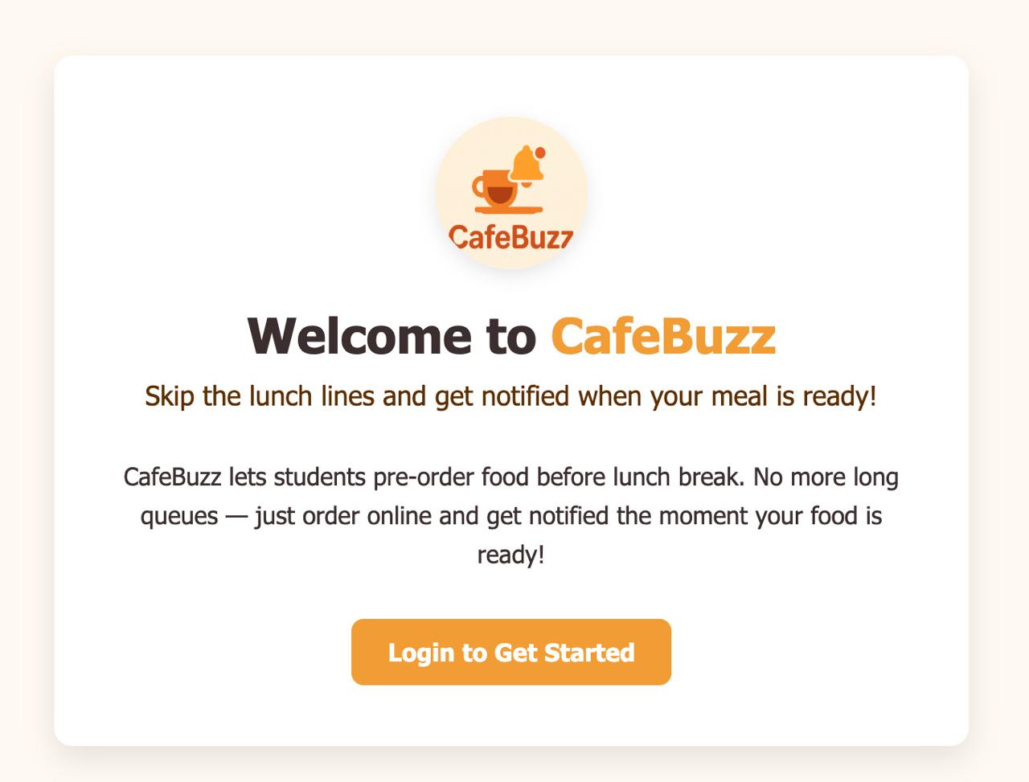

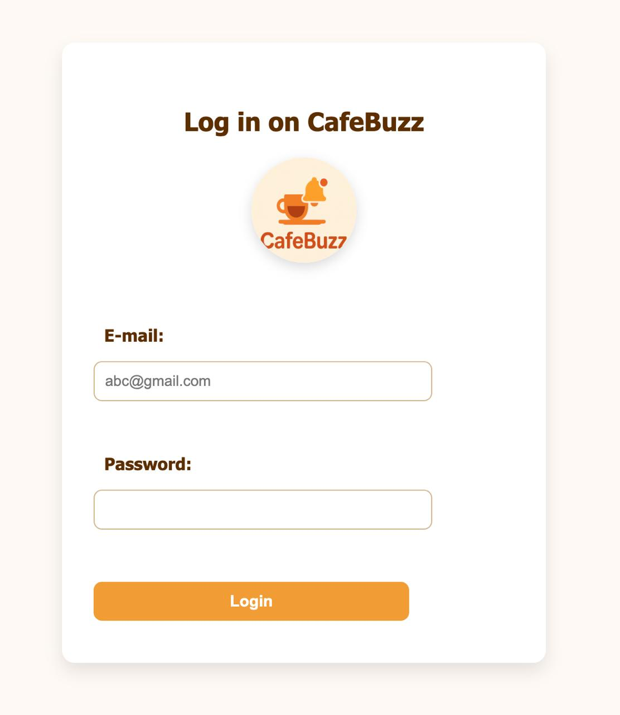

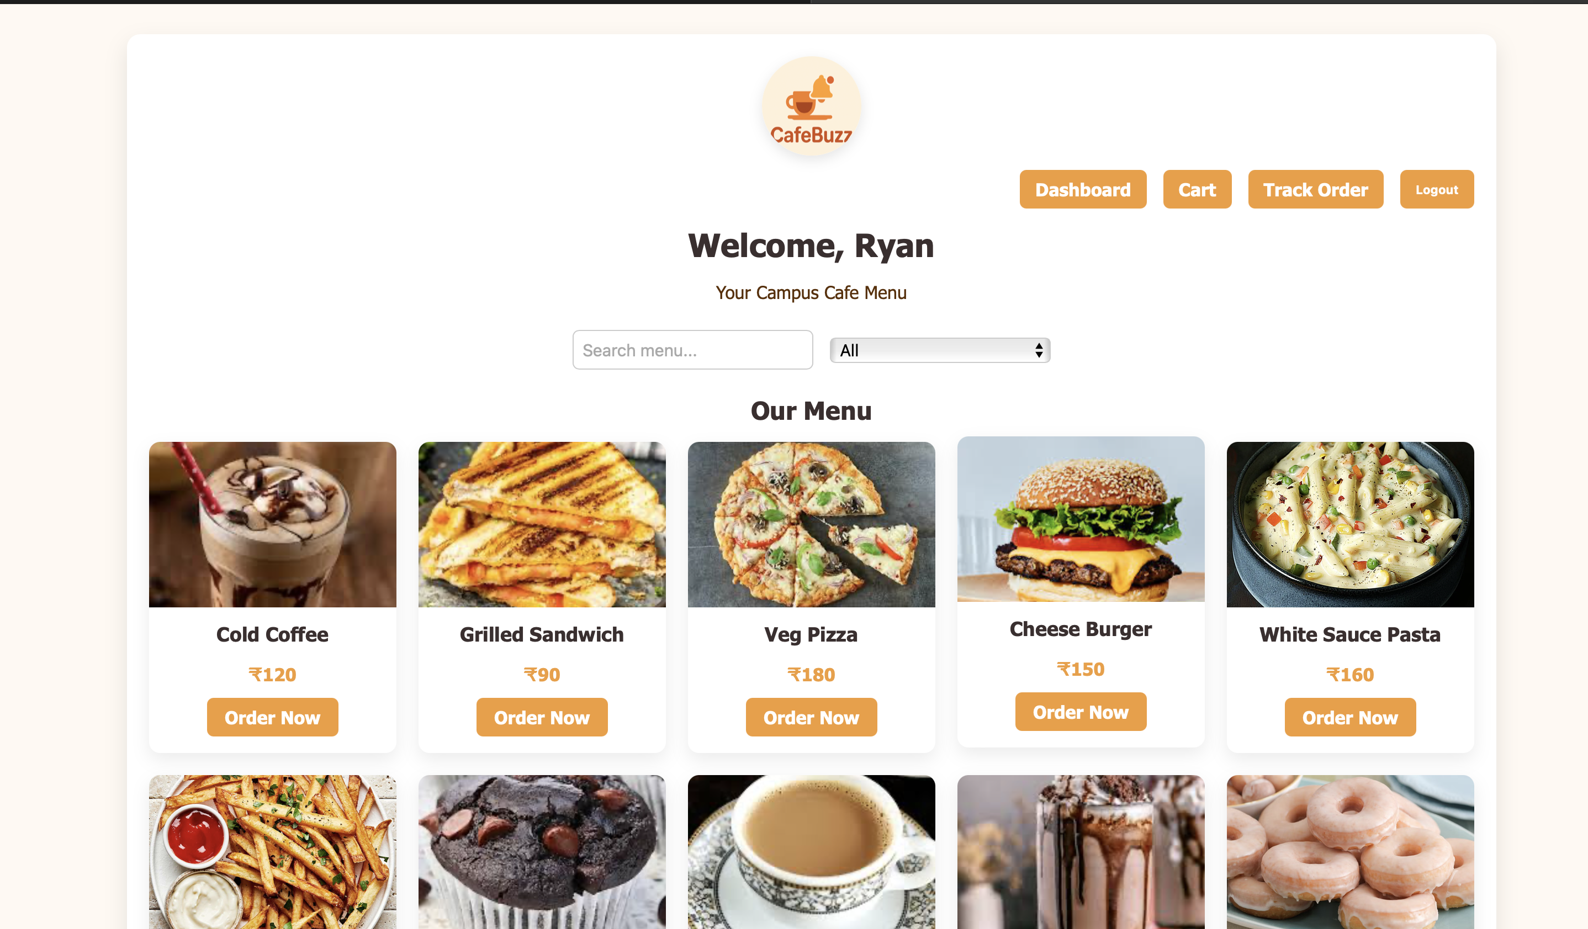

3) Non-Functional Requirements
- Performance: Orders processed quickly
- Security: Data encryption for credentials and payments
- Reliability: 99% uptime
- Usability: Simple, mobile-friendly UI
- Scalability: Handle 1,000+ users at peak time

4) Feasibility Analysis
Aspect | Details
Technical | Feasible using HTML/CSS for mobile and Node.js/Django for backend. Cloud-based hosting for scalability.
Economic | Low development cost, free open-source frameworks, basic hosting plan.
Operational | Fits into cafeteria workflow; minimal training for staff.
Schedule | Achievable within 10 weeks using Agile sprints.

5) Final Problem Statement
The current university cafeteria system suffers from inefficiencies due to manual ordering, resulting in long queues and mismanaged orders. The proposed app will provide an online platform for ordering, payment, and order tracking to reduce wait times and improve service quality.

6) User & System Requirements

User Requirements
- Register & login
- Browse menu & prices
- Place orders with customization
- Pay securely
- Receive real-time updates

System Requirements
- Secure database for users, orders, and menu
- Backend server for processing requests
- Payment gateway integration
- Notification system (push or SMS)
- Admin dashboard

7) Ambiguities, Inconsistencies & Incompleteness
- Handling sudden unavailability of menu items after payment
- Offline payment support for non-digital users
- Delivery to tables vs. only pickup
- Multi-language support for menus

8) Development Plan – 10 Weeks
Week | Task | Deliverables
1 | Requirement gathering, literature survey | Initial requirements document
2 | Case study analysis, scope definition | Final scope & feasibility report
3 | UI/UX wireframes | Wireframe designs
4 | Backend setup (database, APIs) | Functional backend skeleton
5 | Menu management module | Menu CRUD APIs & admin UI
6 | Order placement & customization module | Order APIs integrated
7 | Payment integration & notifications | Payment gateway working
8 | Testing – unit & integration | Test reports
9 | User Acceptance Testing (UAT) | UAT feedback
10 | Deployment & final documentation | Live app & final report

