CAN Bus Protocol

- The Controller Area Network (CAN bus) is the nervous system, enabling communication between all parts of the body.
- Similarly, ‘nodes’ are like muscles connected via the CAN bus, which acts as a central networking system. In turn, electronic control units (ECU) are like arms and legs.

Advantage of Can bus Communication

- Low cost: ECUs communicate via a single CAN interface, i.e. not direct analogue signal lines, reducing errors, weight, costs
- Centralized: The CAN bus system allows for central error diagnosis and configuration across all ECUs
- Robust: The system is robust towards electric disturbances and electromagnetic interference, making it ideal for e.g. vehicles
- Efficient: CAN frames are prioritized by ID - the top priority gets bus access, yet frames are not interrupted
- Flexible: Each CAN-connected ECU can receive all transmitted messages. It decides relevance and acts accordingly - this allows easy modification and inclusion of additional nodes (e.g. CAN bus data loggers) - cf. below figure
CAN FD (flexible data rate) :

- It is a advance version of CAN released in 2012.
- Classical CAN bus data transmission rate is 1Mbps.
- CAN FD data transmission rate is 8 Mbps.
- It allows data packets 64bytes (instead of 8bytes), improving the protocol efficiency.
- Increasing vehicle functionality means increas in data load of vehicle CAN bus.
- Hence CAN FD can only fulfill this demand.
- The 1st car using CAN FD will appear in 2019-2020 and CAN FD will replace step-by-step Clasical CAN.

CAN BUS FRAME: It is 8frame based CAN bus message

1bit 29bit 1bit 6bit 0-64bit 16bit 2bit 7bit
SOF(start of frame) | CAN ID (extended identifier) | RTR(remote transmissionrequest) | control | DATA | CRC(cyclic redundancy check) | ACK(acknoledge) | EOF(end of frame)

SOF: The start of Frame is a ‘dominant 0’ to tell the other node that a CAN node intend to talk.
CAN ID: Contains the frame identifier, lower values have higher priority.
RTR: it indicates whether a node sends data or requests dedicated data from other node.
Control: informs the length of data in bytes.
DATA: Contains the actual data which needs to be scaled or converted to be readable and ready for analysis.
CRC: is used to ensure data intigrity.
ACK:indicates if the node has recieved data correctly.
EOF: indicates the end of CAN frame.

CAN Architecture:

Application Layer (DATA)
Presantation layer (DATA)
Session Layer (DATA)
Transport Layer (Segments)
Network Layer (Packets)
Datalink Layer (Frames)
Physical Layer (Bits)

- Application Layer : It serves as a window for users and application processes to access network services. The common functions of the layers are resource sharing, remote file access, network management, electronic messages and so on.
- Presantation layer :The most important function of this layer is defining data formats such as ASCII text, EBCDIC text BINARY, BCD and JPEG. It acts as a translator for data into a format used by the application layer at the receiving end of the station.
- Session Layer : It allows to establishing, communicating and terminating sessions between processes running on two different devices performing security, name recognition and logging.
- Transport Layer : The transport layer ensures that messages are delivered error-free, in sequence, and without loss or duplication. It relieves the higher layer from any concern with the transfer of data between them and their peers.
- Network Layer : It provides end to end logical addressing system so that a packet of data can be routed across several layers and establishes, connects and terminates network connections.
- Datalink Layer : It packages raw data into frames transferred from physical layer. This layer is responsible for transferring frames from one device to another without errors. After sending the frame it waits for the acknowledgement from receiving device. Data link layer has two sub layers.

1. MAC (Medium Access Control) layer : It performs frame coding, error detection, signaling, serialization and de-serialization.

2. LLC (Logical Link Control) layer : The LLC sub layer provides multiplexing mechanisms that make it possible for several network protocols (IP, Decnet and Appletalk) to coexist within a multipoint network and to be transported over the same network medium. It performs the function of multiplexing protocols transmitted by MAC layer while transmitting and decoding when receiving and providing node-to-node flow and error control.

- Physical Layer : The physical layer transmits bit from one device to another and regulates the transmission of bit streams. It defines the specific voltage and the type of cable to be used for transmission protocols. It provides the hardware means of sending and receiving data on a carrier defining cables, cards and physical aspects.

Note :

CAN protocol uses lower two layers of OSI i.e. physical layer and data link layer. The remaining five layers that are communication layers are left out by BOSCH CAN specification for system designers to optimize and adapt according to their needs.

BUS VALUE :

· CAN define the logic “0” as dominant bit.
· CAN define the logic “1” as recessive bit.
In the CAN system dominant bit always overwrites the recessive bit.

SAE J1939 & CAN :
- J1939 is built on Extended CAN i.e., only 29-bit identifier will be used, where as CAN operates on 11 bit (Standard CAN) and 29 bit (Extended CAN)
- J1939 protocol is used for communicating b/w nodes as well as for diagnostics whereas CAN is used for communicating & doesn’t have its own Diagnostic Protocol because of which UDS (unified diagnostic service) & KWP(Keyword Protocol) protocols were used over CAN.
- J1939 used PDU(‎Protocol Data Units) format for determining whether the message can be transmitted with a destination address or if the message is always transmitted as a broadcast message whereas CAN bus is a broadcast type of bus. This means that all nodes can “hear” all transmissions. There is no way to send a message to just a specific node; all nodes will invariably pick up all traffic. The CAN hardware, however, provides local filtering so that each node may react only on the interesting messages

TELEMATICS :
LINK:https://www.embitel.com/blog/embedded-blog/tech-behind-telematics-explained-how-does-a-vehicle-telematics-solution-work

How deos a vehicle telematics solution works?
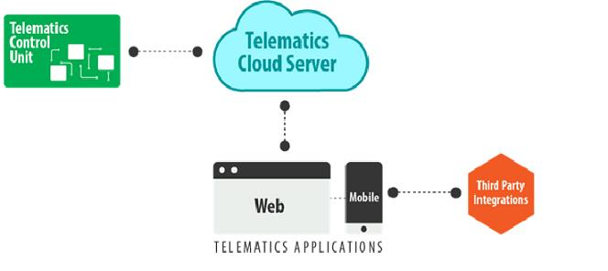
A:

TCU: The Telematics Control Unit (TCU), which is the central hardware module of the telematics device, has communication interfaces with the in-vehicle network (CAN Bus) and the back-end cloud server( GPRS) .
TCU collects the crucial vehicle data such as diagnostics data, real time location, and speed of the vehicle (through different interfaces) and sends them to the cloud server over wireless network such as GPRS/cellular/LTE , in a specific packaged format.

1.TCU Architecture :
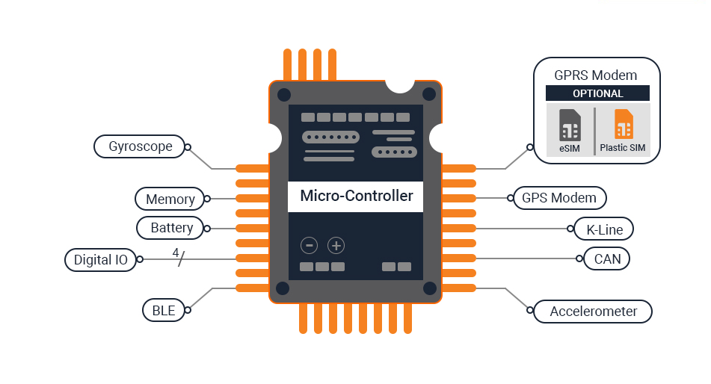

K-line: A telematics system may also use K/Line bus to alert the user about theft (by notifying the user if the vehicle is switched on by anyone), or to enable remote locking and unlocking of the vehicle.

2.Cloude telematic servers:
- Now the information collected by the TCU is sent to the cloud based telematics server through a GPRS/cellular network over HTTPS . But before the transmission, the data packets are encapsulated into MQTT messages.
- Once the data packets reach the cloud, data is extracted and stored into a database for further processing.
- The Cloud based telematics server consists of a web server, an application server, and a database.

