GAS LEAKAGE DETECTION SYSTEM DIAGRAM

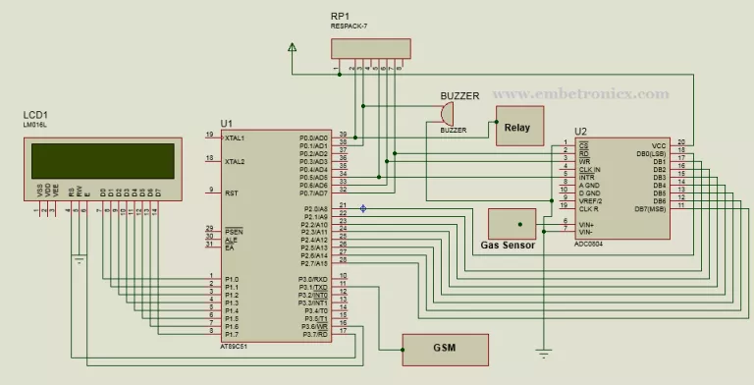

Circuit Diagram
LCD:
- RS – P3.7
- RW – GND
- EN – P3.6
- Data lines – P1
Gas Sensor:
- Output – ADC’s Vin (6th Pin)
ADC0804:
- RD – P0.7
- WR – P0.6
- INTR – P0.5
- CS – GND
- Data Lines – P2
GSM:
- GSM RX – P3.1
- GSM TX – P3.0
Buzzer: P0.1
Relay: P0.0

Explanation
- Gas sensor is used to detect the Gas, which is connected to 8051 micro controller through ADC0804.
- LCD is used to Display the Gas level and Relay status.
- GSM is used to send the message when it detects the Gas in room or home.
- Buzzer also make sound when controller detects any Gas.
- Relay also connected to Micro Controller. The house’s electricity power will go through this relay. When it detects gas leakage, the relay goes off. So house electricity will be off. It will prevent the other damages by electricity.

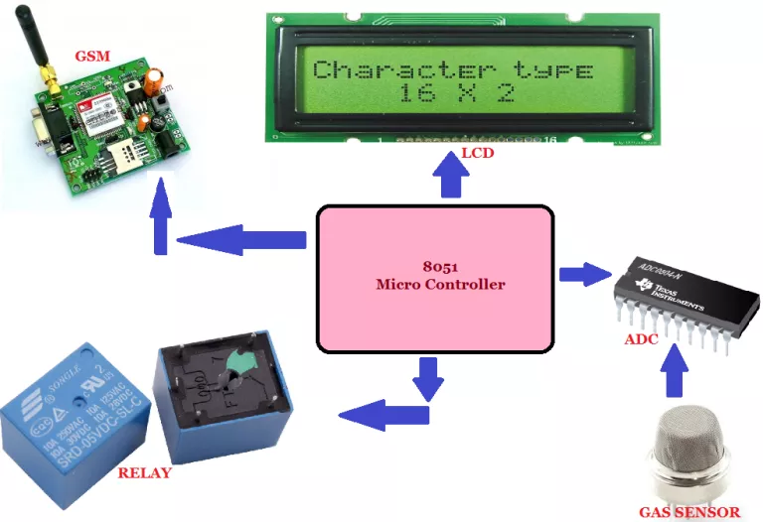
Components Required
- 8051 Development board
- LCD Module
- GSM Module
- Gas Sensor
- Buzzer
- ADC0804
- Relay

Software Required
- Keil IDE

Prerequisites
Before see the code, first you can see the basic interfacing tutorials of these components.
- LCD Interfacing with 8051
- GSM Interfacing with 8051
- Relay Interfacing with 8051
- ADC0804 Interfacing with 8051

Reference: https://embetronicx.com/projects/8051-projects/gas-leakage-detection-system-using-8051/

