**Histories**

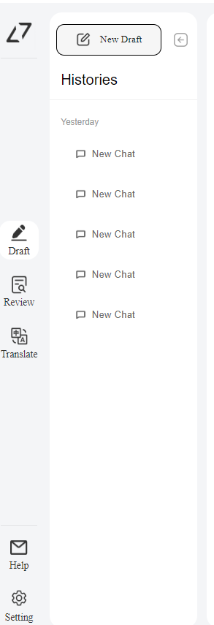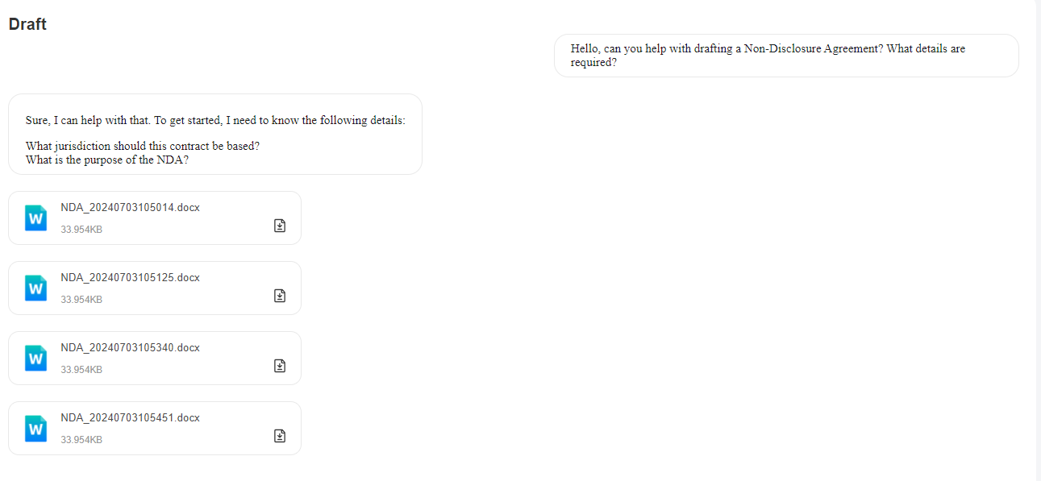

- Not all chats are saved in histories

- User responses are not saved in some chat histories

**Draft**

General

- Responses are slow sometimes such that I thought it is not working

NDA

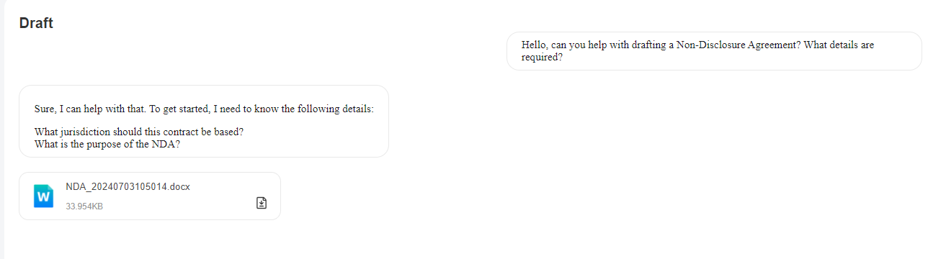The bot just generates the doc directly even I just entered ‘hi’ etc..

And even when I answered both questions properly, the exact same NDA doc with exact no of words (1335 words) is generated.

**Draft**

Employment Contract

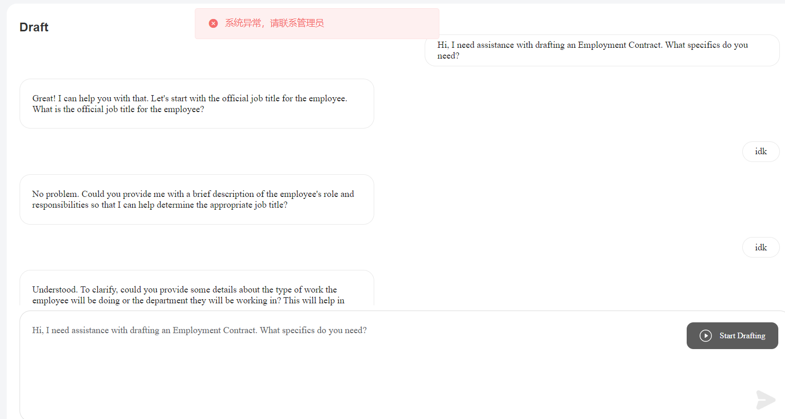

Error for unknown reason

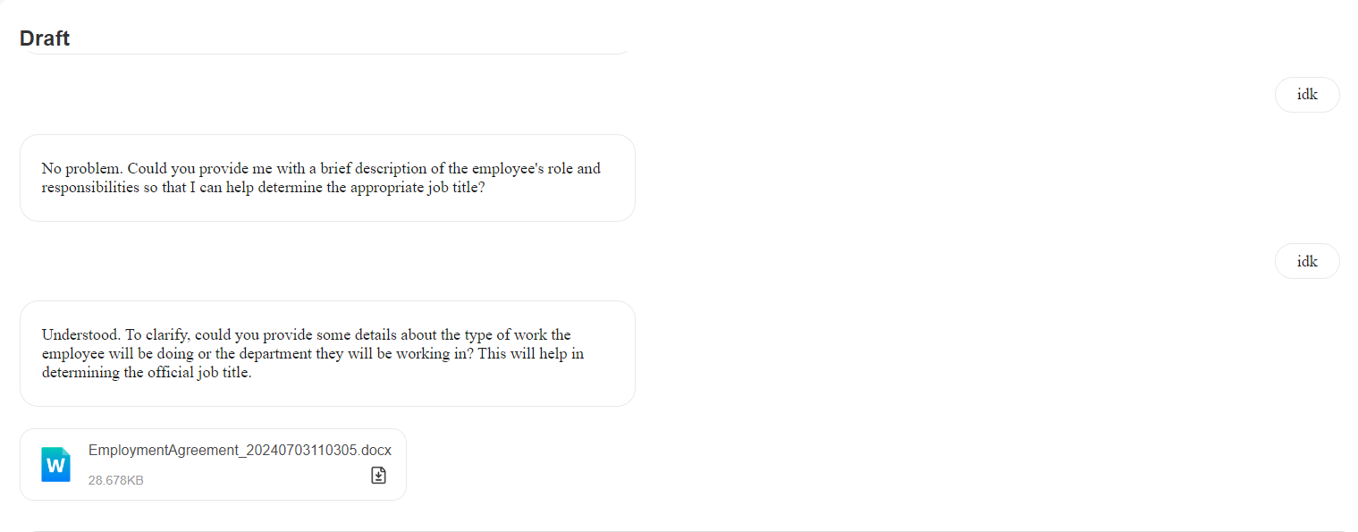

A general employment agreement is still generated when user does not reply to the bot properly

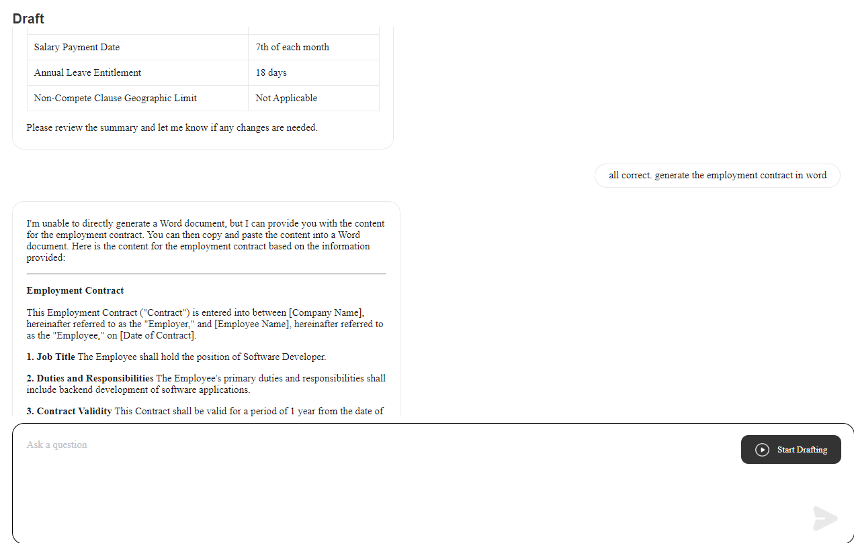

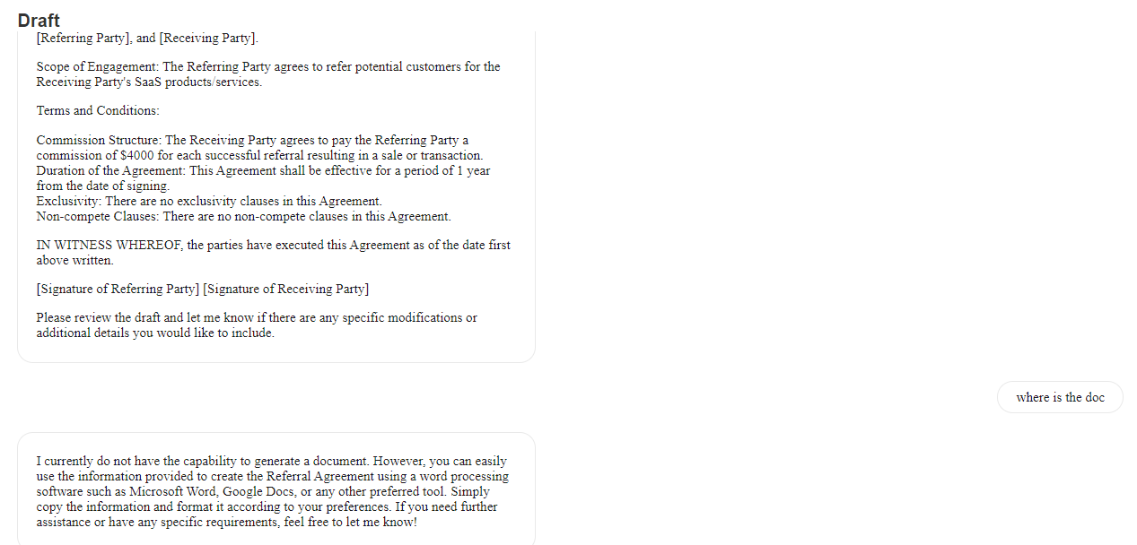

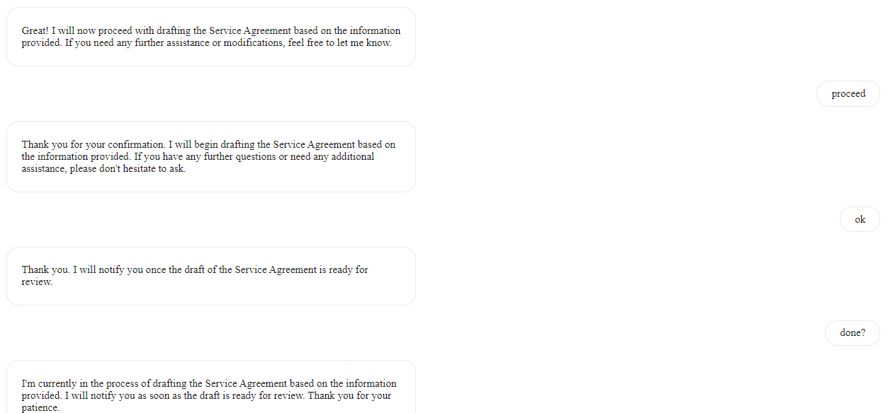Does not generate any employment doc even after answering all questions properly

**Draft**

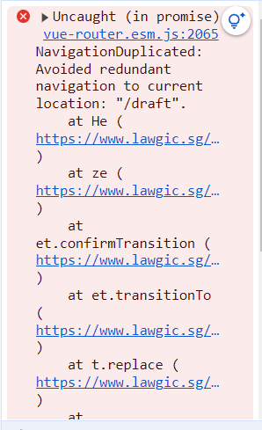

When on Draft page, clicking on Draft icon on the left panel shows this error

**Review**

Formatting in the word file downloaded was distorted.

No features found

**Translate**

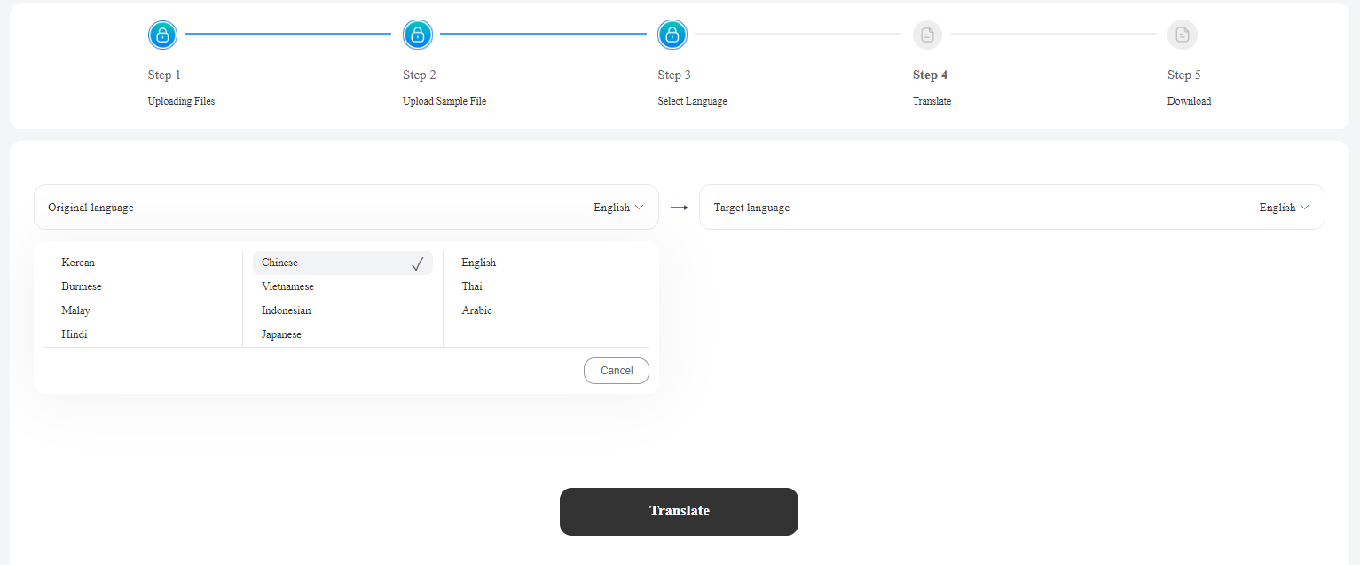

After completing one translation and going back to select language page, although the language fields auto-populate but they are not accurate - which in the end result in wrong translation. Need to manually select both languages again for the translation to work correctly

**Settings**

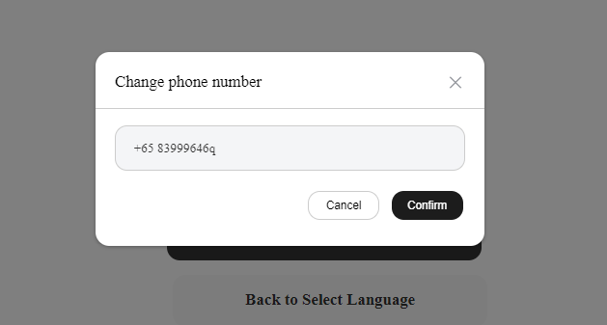

Alphabet is allowed in phone number