# Full Calendar Component based on the http://arshaw.com/fullcalendar/

The Full Calendar Component based on the Calendar Component by <http://arshaw.com/fullcalendar/>

Import the package fullCalendar.zip using the Package Manager <http://localhost:4502/crx/packmgr/>

Importing the package will create the following folders in the CRX

|  |  |
| --- | --- |
|  |  |
| /etc/designs/wpsm | Calendar Code Design |
| /etc/designs/wpsm/calendar/js/wpsm-detailCalendar.js | Java Script for the Full Calendar component |
| /apps/wpsm |  |
| /apps/wpsm/components/pagecontent/calendar | Calendar Code Component |
| /apps/wpsm/components/pagecontent/calendar/calendar.jsp | Calendar Component HTML |
| /apps/wpsm/components/pagecontent/calendar/calendar.json.jsp | Calendar Component JSON Feed code |
| /apps/wpsm/components/pages/eventpage | Sample Event page used by the Calendar component |
| /apps/wpsm/templates/eventpage | Sample Event page template |
| /apps/geometrixx/templates/eventcontentpage | Event page for Geometrix |
| /apps/geometrixx/components/eventcontentpage | Event page template for Geometrix |

# Using Full Calendar component in your sites pages

When using the Full Calendar component make sure jQuery  is loaded at the head of the page.

For example in the head.jsp of your page have a statement like

<head>

  <meta charset="utf-8">

  <meta http-equiv="X-UA-Compatible" content="IE=edge">

  <meta name="viewport" content="width=device-width, initial-scale=1">

  <title>Army VCE / <%= getTitle(xssAPI, currentPage) %></title>

<[cq:includeClientLib](http://cqincludeClientLib) js="apps.jquery.1.11.0"/>

  <[cq:includeClientLib](http://cqincludeClientLib) css="apps.yoursite"/>

..

..

</head>

# Using custom Event pages for your Site

Your custom event page, should have page properties of the Calendar Event tab, this is specified by /apps/wpsm/components/pages/eventpage/tab_event.

Copy the tab_event to your pages folder and then in the dialog items, have an entry as shown in the screen shot

Set the path to /apps/<your site>/components/pages/<even tpage>/tab_event.infinity.json

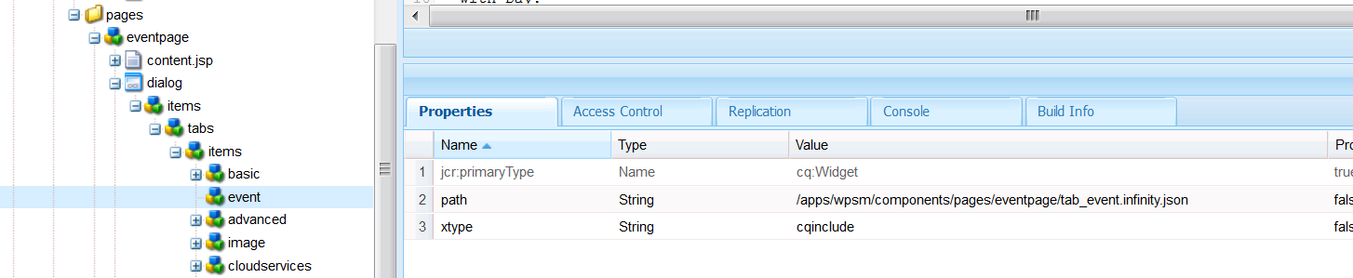

Then edit the /apps/wpsm/components/pagecontent/calendar/calendar.json.jsp  and set the variable cqTemplate to the template path of your sites event page.

By default it is set to

String cqTemplate="/apps/geometrixx/templates/eventcontentpage";

# Using it in Geometrix Demo Site

The Geometrix Sites design already loads a jQuery library in the /apps/geometrixx/components/page/headlibs.jsp at the head of the page.

The clientlib /etc/designs/geometrixx/clientlibs embed property is

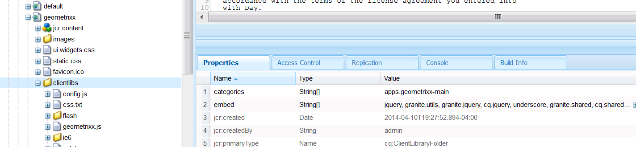

Create the events under a specific path like /content/geometrixx/en/calendar

1)      Use the page template  Event Content Page for Calendar

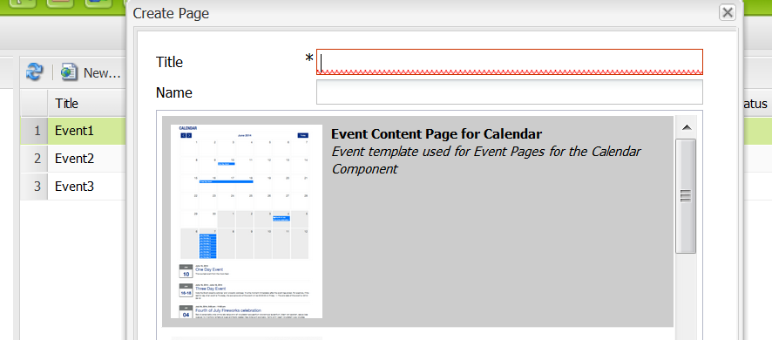

2)      Populate the following page properties

1. Basic =>Title (Event title)
2. Basic => Description ( Event description)
3. Calendar Event => Start Date (Required)
4. Calendar Event => End Date
5. Calendar Event => Link
6. Calendar Event => All day

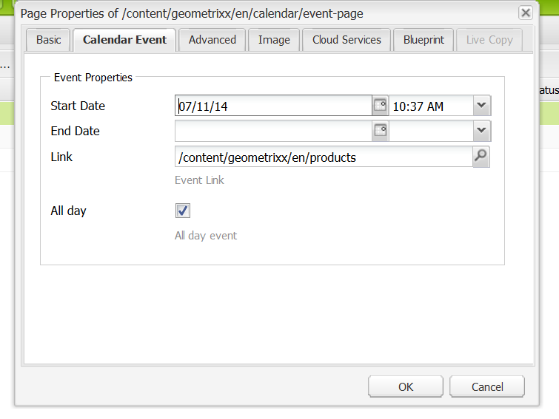

3)      On the page /content/geometrixx/en/calendar, put the component  Calendar => Full Calendar in the parsys. Edit the component dialog and populate the Events Path field with the path to where the event pages are located

