**Temporal trends in VV ECMO utilisation before and during the COVID-19 pandemic: an ELSO registry analysis**

Supplementary Appendix

Ryan Ruiyang Ling, Kollengode Ramanthan, Ying Chen, Ryan P Barbaro, Kiran Shekar, Daniel Brodie, Graeme MacLaren

Table of contents

Supplementary methods 2

Figure S1. STROBE inclusion flowchart 3

Table S1. Demographics, centre, and pre-ECMO characteristics across the three time periods 4

Table S2. Arterial blood gas before and after ECMO initiation 5

Table S3. Ventilatory parameters before and after ECMO initiation, across time periods 6

Table S4. Pre-ECMO adjunctive therapies 7

Table S5. Unadjusted survival estimates at 90 days after ECMO initiation across time periods, and annually 7

Table S6. Complications while receiving ECMO 8

# Supplementary methods

For continuous variables we reported median (25th-75th percentiles), and for numerical variables, we reported counts and percentages. We compared groups using the chi-squared test for discrete outcomes and the Kruskal-Wallis test for continuous outcomes. We estimated survival at 90 days for each era and year using the Kaplan-Meier method. We conducted the analysis using RStudio 4.2.2.

# Figure S1. STROBE inclusion flowchart

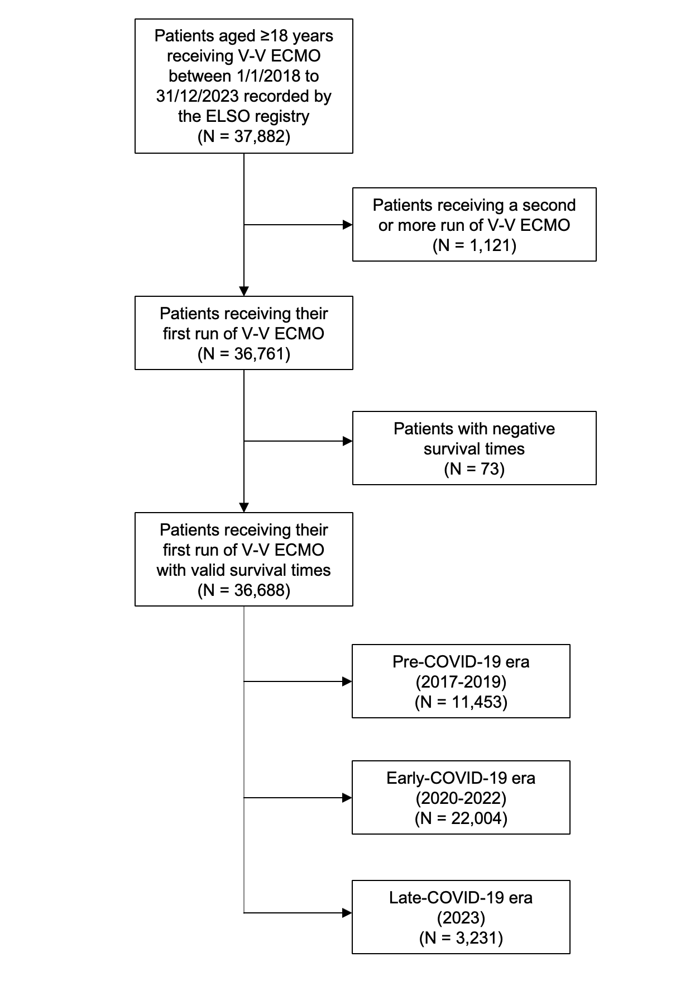

# Table S1. Demographics, centre, and pre-ECMO characteristics across the three time periods

|  |  |  |  |  |  |  |  |
| --- | --- | --- | --- | --- | --- | --- | --- |
| **Era** | **Pre-COVID-19** | **COVID-19** | **Post COVID-19** | **P-value** | **P-value**  **(A vs B)** | **P-value**  **(A vs C)** | **P-value**  **(B vs C)** |
| Participants | 11453 | 22004 | 3231 |  |  |  |  |
| Age (years) | 49.5 (35.6-60.5) | 48.1 (37.1-57.6) | 48.5 (34.2-60.6) | <0.0001 | <0.0001 | 0.15 | 0.12 |
| Weight (kg) | 84.0 (70.0-103.0) | 90.0 (75.8-109.0) | 84.9 (70.0-102.9) | <0.0001 | <0.0001 | 0.41 | <0.0001 |
| Height (cm) | 170.0 (162.6-178.0) | 170.2 (164.0-178.0) | 170.2 (163.0-178.0) | <0.0001 | <0.0001 | 0.10 | 0.18 |
| BMI (kg/m2) | 28.6 (24.2-34.6) | 30.9 (26.3-36.5) | 29.0 (24.5-34.5) | <0.0001 | <0.0001 | 0.13 | <0.0001 |
| **Sex (count [%])** | | | | |  |  |  |
| Female | 4341 (37.8%) | 7348 (33.4%) | 1232 (38.2%) | <0.0001 | <0.0001 | 0.98 | <0.0001 |
| Male | 7037 (61.4%) | 14647 (66.5%) | 1998 (61.8%) |
| **Centre characteristics** | | | | | | | |
| Number of centres | 425 | 546 | 382 |  |  |  |  |
| Centre volume | 20.67 (9.67-37.3) | 28 (15.67-52) | 15 (8-26) | <0.0001 | <0.0001 | <0.0001 | <0.0001 |
| **Pre-ECMO/ECMO characteristics** | | | | | | | |
| Time from admission to intubation | 0 (-18 to 32) | 0 (-48 to 70) | 1 (-14-56.5) | <0.0001 | <0.0001 | <0.0001 | <0.0001 |
| Time from intubation to ECMO | 26 (7-94) | 54 (12-133) | 21 (6-90.5) | <0.0001 | <0.0001 | <0.0001 | <0.0001 |
| Duration of ECMO | 7.7 (3.9-14.2) | 13.6 (6.0-27.7) | 7.0 (3.6-13.9) | <0.0001 | <0.0001 | 0.0066 | <0.0001 |
| Duration of survival time post-ECMO until final disposition or death | 8.8 (0.04-22.1) | 6.7 (0-21.0) | 8.1 (0.04-21.2) | <0.0001 | <0.0001 | 0.16 | <0.0001 |

# Table S2. Arterial blood gas before and after ECMO initiation

|  |  |  |  |  |  |  |  |
| --- | --- | --- | --- | --- | --- | --- | --- |
| **Era** | **Pre-COVID-19** | **COVID-19** | **Post COVID-19** | **P-value** | **P-value**  **(A vs B)** | **P-value**  **(A vs C)** | **P-value**  **(B vs C)** |
| **Pre-ECMO arterial blood gas\*** | | | | | | | |
| pH | 7.24 (7.15-7.34) | 7.28 (7.19-7.36) | 7.27 (7.17-7.35) | <0.0001 | <0.0001 | <0.0001 | <0.0001 |
| PaCO2 | 58.0 (47.0-75.0) | 60.0 (48.8-74.8) | 56.0 (45.4-70.0) | <0.0001 | <0.0001 | <0.0001 | <0.0001 |
| PaO2 | 67.0 (54.0-85.5) | 67.0 (56.0-84.0) | 70.0 (58.0-98.0) | <0.0001 | 0.12 | <0.0001 | <0.0001 |
| PaO2/FiO2 ratio | 70.5 (55.0-100.7) | 71.0 (57.0-94.0) | 75.0 (59.0-117.0) | <0.0001 | 0.63 | <0.0001 | <0.0001 |
| **Post-ECMO arterial blood gas\*\*** | | | | | | | |
| pH | 7.40 (7.35-7.44) | 7.40 (7.36-7.44) | 7.40 (7.36-7.44) | 0.0011 | 0.0042 | 0.65 | 0.020 |
| PaCO2 | 41.2 (37.0-46.7) | 44.0 (39.0-50.7) | 42.0 (37.0-47.0) | <0.0001 | <0.0001 | <0.0001 | 0.037 |
| PaO2 | 83.0 (68.0-111.2) | 77.0 (65.0-98.2) | 88.1 (71.0-122.0) | <0.0001 | <0.0001 | <0.0001 | <0.0001 |
| PaO2/FiO2 ratio | 172.6 (112.8-255.0) | 156.9 (102.5-222.5) | 185.0 (122.4-268.0) | <0.0001 | <0.0001 | <0.0001 | <0.0001 |

Abbreviations: PaO2: arterial partial pressure of oxygen, PaCO2: arterial partial pressure of carbon dioxide, FiO2: fraction of inspired oxygen

*Defined as the arterial blood gas closest to and not more than 6 hours before ECMO initiation

**Defined as the arterial blood gas drawn between 18 to 30 hours after ECMO initiation, closest to 24 hours after initiation of ECMO

# Table S3. Ventilatory parameters before and after ECMO initiation, across time periods

|  |  |  |  |  |  |  |  |
| --- | --- | --- | --- | --- | --- | --- | --- |
| **Era** | **Pre-COVID-19** | **COVID-19** | **Post COVID-19** | **P-value** | **P-value**  **(A vs B)** | **P-value**  **(A vs C)** | **P-value**  **(B vs C)** |
| **Pre-ECMO ventilatory parameters** | | | | | | | |
| Rate | 24.0 (18.0-28.0) | 26.0 (20.0-30.0) | 24.0 (18.0-28.0) | <0.0001 | <0.0001 | 0.92 | <0.0001 |
| PIP | 33.0 (29.0-38.0) | 33.0 (29.0-38.0) | 33.0 (28.0-37.8) | 0.0055 | 0.31 | 0.024 | 0.0036 |
| PEEP | 12.0 (10.0-15.0) | 12.0 (10.0-15.0) | 10.0 (8.0-14.0) | <0.0001 | 0.011 | <0.0001 | <0.0001 |
| Inflation pressure | 20.0 (16.0-26.0) | 20.0 (16.0-25.0) | 21.0 (16.0-26.0) | 0.0007 | 0.40 | 0.0007 | 0.0007 |
| **Post-ECMO ventilatory parameters** | | | | | | | |
| Rate | 12.0 (10.0-16.0) | 12.0 (10.0-16.0) | 12.0 (10.0-16.0) | 0.30 | 0.43 | 0.43 | 0.82 |
| PIP | 24.0 (20.0-28.0) | 24.0 (21.0-28.0) | 24.0 (20.0-27.0) | <0.0001 | 0.98 | <0.0001 | <0.0001 |
| PEEP | 10.0 (8.0-12.0) | 10.0 (10.0-12.0) | 10.0 (8.0-10.0) | <0.0001 | <0.0001 | <0.0001 | <0.0001 |
| Inflation pressure | 14.0 (10.0-18.0) | 13.0 (10.0-17.0) | 14.0 (10.0-17.0) | 0.27 | 0.31 | 0.66 | 0.66 |

Abbreviations: PIP: peak inspiratory pressure, PEEP: positive end-expiratory pressure

*Defined as the ventilatory parameters/settings closest to and not more than 6 hours before ECMO initiation

**Defined as the ventilatory parameters/settings between 18 to 30 hours after ECMO initiation, closest to 24 hours after initiation of ECMO

# Table S4. Pre-ECMO adjunctive therapies

|  |  |  |  |  |  |  |  |
| --- | --- | --- | --- | --- | --- | --- | --- |
| **Era** | **Pre-COVID-19** | **COVID-19** | **Post COVID-19** | **P-value** | **P-value**  **(A vs B)** | **P-value**  **(A vs C)** | **P-value**  **(B vs C)** |
| Nitric oxide | 2433 (25.6%) | 6180 (31.0%) | 780 (27.6%) | <0.0001 | <0.0001 | 0.043 | 0.0004 |
| Steroids | 1932 (20.4%) | 7584 (38.0%) | 793 (28.0%) | <0.0001 | <0.0001 | <0.0001 | <0.0001 |
| Bicarbonate or THAM | 1468 (15.5%) | 1869 (9.4%) | 441 (15.6%) | <0.0001 | <0.0001 | 0.91 | <0.0001 |
| CVVH | 1159 (12.2%) | 1474 (7.4%) | 291 (10.3%) | <0.0001 | <0.0001 | 0.0057 | <0.0001 |
| Neuromuscular blockade | 5554 (58.5%) | 13670 (68.5%) | 1524 (53.9%) | <0.0001 | <0.0001 | 0.038 | 0.028 |
| Vasodilators | 162 (1.7%) | 140 (0.7%) | 32 (1.1%) | <0.0001 | <0.0001 | <0.0001 | <0.0001 |
| Prone positioning | 1355 (14.3%) | 8551 (42.8%) | 489 (17.3%) | <0.0001 | <0.0001 | <0.0001 | <0.0001 |

Abbreviations: THAM: tris-hydroxymethylaminomethane, CVVH: continuous venovenous hemofiltration

# Table S5. Unadjusted survival estimates at 90 days after ECMO initiation across time periods, and annually

|  |  |  |
| --- | --- | --- |
| Covariate | Survival | 95%-CI |
| Pre-COVID-19 | 43.0 | 41.3-44.8 |
| COVID-19 | 39.9 | 38.9-40.9 |
| Post-COVID-19 | 41.8 | 38.4-45.4 |
| **By Year** | | |
| 2017 | 40.8 | 37.7-44.2 |
| 2018 | 44.3 | 41.4-47.4 |
| 2019 | 43.4 | 40.5-46.4 |
| 2020 | 37.1 | 35.5-38.9 |
| 2021 | 40.7 | 39.4-42.2 |
| 2022 | 43.6 | 41.2-46.2 |
| 2023 | 41.8 | 38.4-45.4 |

# Table S6. Complications while receiving ECMO

|  |  |  |  |  |  |  |  |  |  |  |
| --- | --- | --- | --- | --- | --- | --- | --- | --- | --- | --- |
| **Era** | **Pre-COVID-19** | | **COVID-19** | | **Post COVID-19** | | **P-value\*\*** | **P-value**  **(A vs B)** | **P-value**  **(A vs C)** | **P-value**  **(B vs C)** |
| Proportion | Rate* | Proportion | Rate* | Proportion | Rate* |
| Mechanical*** | 1995 (17.4%) | 0.91 | 6021 (27.4%) | 0.69 | 567 (17.5%) | 0.91 | <0.0001 | <0.0001 | 0.24 | <0.0001 |
| Haemorrhagic | 1634 (14.3%) | 0.75 | 3172 (14.4%) | 0.36 | 349 (10.8%) | 0.56 | <0.0001 | <0.0001 | <0.0001 | 0.015 |
| Renal | 3386 (29.6%) | 1.55 | 6440 (29.3%) | 0.73 | 901 (27.9%) | 1.44 | <0.0001 | <0.0001 | 0.47 | <0.0001 |
| Pulmonary | 801 (7.0%) | 0.37 | 2803 (12.7%) | 0.32 | 265 (8.2%) | 0.43 | <0.0001 | <0.0001 | 0.0029 | <0.0001 |
| Cardiovascular | 1606 (14.0%) | 0.74 | 2715 (12.3%) | 0.31 | 361 (11.2%) | 0.58 | <0.0001 | <0.0001 | 0.0003 | 0.19 |
| Metabolic | 834 (7.3%) | 0.38 | 1910 (8.7%) | 0.21 | 259 (8.0%) | 0.41 | 0.11 | 0.21 | 0.13 | 0.21 |
| Infectious | 428 (3.7%) | 0.20 | 315 (1.4%) | 0.04 | 28 (0.9%) | 0.04 | <0.0001 | <0.0001 | <0.0001 | 0.10 |
| Limb | 136 (1.2%) | 0.06 | 202 (0.9%) | 0.02 | 36 (1.1%) | 0.06 | 0.0010 | 0.0016 | 0.97 | 0.084 |

*Number of complications per 1000 hours of ECMO run.

**P-values in this table compare between the proportion of patients who suffer from a complication.

***Complications have been grouped into broad categories in accordance with the ELSO registry.