National Taiwan Normal University

Computer Programming (I) – Hw0304

Q: Describe that how to find n-value to verify the closest e constant

A: Run loop until n-value is calculated in program which is closest e constant.

Then, when n-value is 8,the answer is closest e constant.

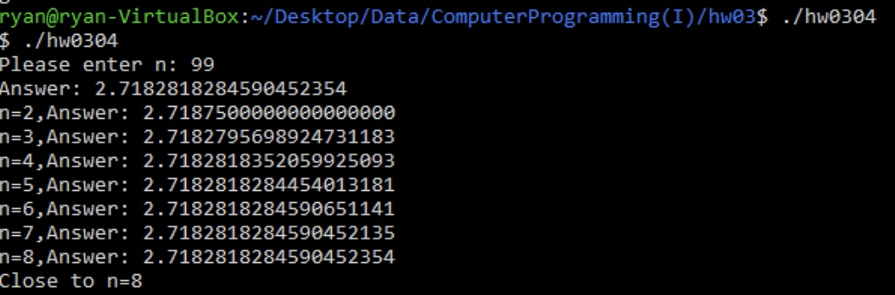

Student ID: 41047035S

Student Name: 林昕鋭

Teacher Name: 紀博文

Finish Date: 2021/11/16