OxAIMS
  - Founding partnership proposal
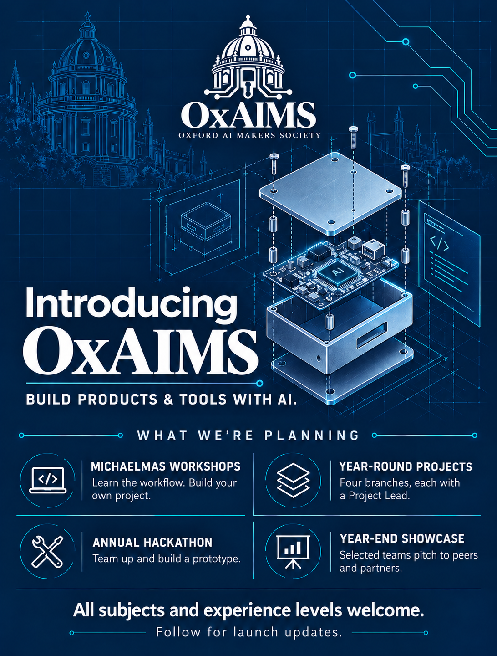

Oxford AI Makers Society
  - OxAIMS founding partnership proposal
We are seeking founding partners to help Oxford students turn subject knowledge into working software, physical prototypes and research tools using AI. OxAIMS combines a practical Michaelmas workshop programme with year-round project support, an annual hackathon and selected year-end pitches to partners.

The opportunity
A student may understand a scientific problem, a frustrating task or an idea for a game without knowing how to build a solution. Our aim is to help students cross that gap. We teach the workflow around AI: defining a task, organising files, using GitHub, testing the result and making something that other people can use.
This creates an opportunity for partners to meet new builders from across Oxford, see their tools applied to different subjects and follow promising work beyond a single event. Students can begin with no programming experience and choose the problem they want to tackle.

Four project branches
We plan to have four branches, each with its own Project Lead to coordinate teams and help projects progress.
Apps and Automation. Web and mobile apps, AI agents and tools for everyday tasks.
Games and Interactive Media. Games, simulations and interactive experiences.
Physical Design and Engineering. AI-assisted CAD, 3D printing, robotics and physical prototypes.
Research and Quantitative Finance. AI-assisted problem-solving in mathematics, science, finance and other research areas, including modelling, data analysis and quantitative research.

Potential that builds over time
Each cohort can contribute useful projects, practical experience and, where members choose to share them, reusable guides and workflows. Returning members can mentor the next cohort. We want sponsor support to help establish a community that keeps producing work as its members and tools change.

How students develop their projects

Michaelmas AI workshop programme
The programme runs once a year in Michaelmas term. Students learn a general building workflow and apply it to a project of their choice, individually or in teams. Sessions cover AI tools and skills, file organisation, GitHub, testing, connected services, domains and deployment.
Every participant must present a project at the end of Michaelmas. Presentations should show what works, explain how it was checked and identify limitations and next steps. This gives partners evidence of what students have learned and built.

Project support throughout the year
The four branches give students somewhere to continue after the workshops. Project Leads help teams find collaborators, share knowledge and seek technical feedback. Our starting point includes Quant, an existing AI-assisted software project intended as an early example in the Research and Quantitative Finance branch.

Annual Oxford AI Building Hack
Students form teams and build a prototype during a separate annual hackathon. Partners can suggest a challenge, provide tools and mentors, or help judge the work. Teams can continue developing their projects through the society afterwards.

Year end project showcase and pitches
Teams submit a short pitch explaining the problem, their approach, progress and what they need next. OxAIMS selects teams for a final presentation evening with peers, partners and industry guests. We plan to assess the clarity of the problem, evidence of progress and the practicality of the next steps.
Selected teams pitch and demonstrate their work, answer questions and meet partners afterwards. Interested partners can explore mentoring, pilots or investment directly with a team. Workshop participation and commercial potential are separate: a useful research result or creative project can be valuable without becoming a startup.

What a partnership offers
We want partners to work with students as they learn, build and improve their projects. The most useful contribution and return will depend on the organisation.

AI coding tools and app builders
Introduce your product in a practical session and support its use through a full project. Follow-up discussions can reveal setup difficulties, missing features and new use cases. With student permission, completed projects can become examples of what people from different subjects build with your tools.

Model providers and cloud platforms
Support the API usage, hosting and infrastructure behind working projects. See how students combine services, where they encounter technical problems and what support helps a prototype become usable. Agree feedback sessions and a summary of supported projects.

Engineering software and data partners
Work with the relevant branch on designs, physical prototypes or research questions. A partner can provide specialist tools, data or technical advice and see how students apply them, with opportunities for demonstrations and further collaboration.

Employers and venture partners
Mentoring, judging and demonstrations let you see how students solve problems, explain decisions and work together. Partners can share relevant roles and arrange introductions with students who opt in. The final showcase provides a focused opportunity to meet selected teams; any investment is a separate, voluntary agreement.

A proposed founding partnership
An initial package could support the Michaelmas cohort and continued project work, with one co-hosted workshop, two project feedback sessions and participation in the year-end showcase. We would agree the cash or in-kind contribution, resources, responsibilities and recognition before it begins. Partners can also support one branch or event.
We would agree measures such as participation, completed presentations, projects still active after Michaelmas and structured product feedback. A short report would record results against those measures, alongside spending and any project stories shared with permission. Sponsor recognition could include agreed event materials and society communications.

How we would use funding
Sponsorship helps students take an idea through to a project they can demonstrate and share. Funding covers building resources as well as the workshops, hackathon and presentations supporting that work.
Funding area | Examples of spending
AI tools and tokens | Model API credits, AI coding tools and shared usage allowances for building, debugging and testing projects during workshops and independently.
Hosting and deployment | Website hosting, cloud servers, databases and storage so students can publish working projects that other people can use.
Domains and connected services | Project domain names, email services, authentication, maps and other APIs needed to turn a prototype into a functioning application.
Specialist data | Financial data APIs for quantitative projects, including historical prices and company information, or other datasets needed by individual teams.
Hardware and materials | Microcontrollers, sensors, robotics parts, electronics, 3D-printing materials and fabrication access. Shared equipment can be reused by future teams.
Workshops and Michaelmas presentations | Rooms where needed, equipment hire, teaching materials, refreshments and presentation facilities for every workshop participant to demonstrate their project.
Hackathons and annual showcase | Venue costs, audiovisual equipment, signage, refreshments, prizes and demonstration facilities, including space for physical prototypes and the selected partner pitches.
Teaching and technical support | Preparing workflow guides and example projects, bringing in external instructors where needed, and reasonable speaker or mentor travel expenses.
Society operations | The society website, domain, email and shared systems for organising members, teaching resources and project submissions.

Allocating project funds
We could provide a small, capped allowance for approved project costs alongside shared tools and equipment. This lets students pursue different ideas while keeping spending within an agreed budget. Before a partnership begins, we would set the cohort capacity and resource allowances around the support available.
Partners can fund a particular resource, event or project, or support the society more broadly. Data access, API credits, licences, equipment loans and venue space are also useful. We can agree an itemised budget and provide a spending summary showing how the contribution was used.

