Answer the following multiple choice, true false and short answer questions using the formal terms and models that we have been studying.

Work alone to complete the questions. This test is an open book test.

Put your name on each page to be sure that I know who to give the grade to.

All questions are worth 4 points. The test, in total, is worth 120 points.

I GENERALLY DO NOT ANSWER QUESTIONS DURING TESTS because the nature of this work requires you to make assumptions. If you have questions during the test, state your assumption on your paper and follow it through in your answer. Credit may be given for stating and following your assumptions even if they are not what I was thinking when the test was written.
- You may add things to your models if necessary but you must you state your assumptions that go with your addition.
- You should not rewrite the problem…there is an answer/solution to each question as it is stated.
If there is a question about the test that is not solved by making assumptions, send me a note by email and I will see if I can help.

Some questions have multiple answers.

Write your expressions and draw your models in the manner that you are most comfortable with. Be sure to use the formal notation taught in the book or in class and be as complete as possible with your answers.

This test is easy to take if you print it out and use a pencil.
You may complete it on your computer if you would rather do that.

This test is due (in person or by email) no later than 3:30 PM on Tuesday February 25th, 2014.

The easiest way to turn in this test is to hand it to me at the beginning of class on Tuesday the 25th. (Don’t come in late….you have to hand it to me by 3:30. You may email it prior to 3:30 PM if you prefer to do that.

State your short answers to the following questions.

1. Using a formal schema construct, state the attributes of the STUDENT_ASSISTANT shown in the database in Figure 8.7 below. (Do it in this space above the figure.)

Percent_time, Major_dept, Salary, Ssn, Name, Sex, Address, and Birth_date are attributes of STUDENT_ASSISTANT, some of the attributes are inherited from superclass's.________________________________________________________

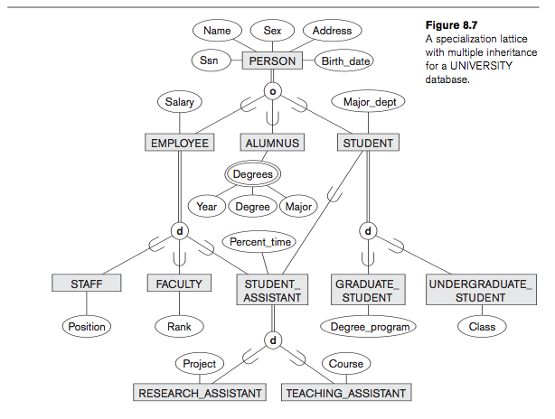

2. Looking at the Figure 8.1 below, name the superclass.

EMPLOYEE is the superclass______________________________________

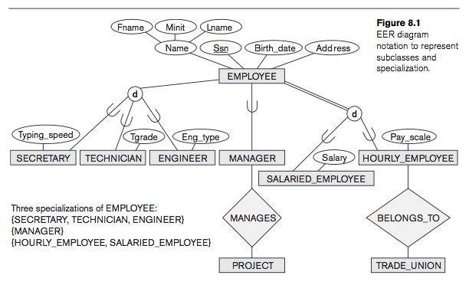
N
1
(0,1)
(0,1)
1
(0,n)
(0,n)
N
EMPLOYEE=SECRETARY
EMPLOYEE=TECHNICIAN
EMPLOYEE=ENGINEER
EMPLOYEE=MANAGER
EMPLOYEE=SALARIED
EMPLOYEE=HOURLEY

3. Add Cardinality and (min, max) constraints to figure 8.1 (above). Add them right on the diagram in the place where they should be.

4. State your assumptions for the cardinality that you added.
a MANAGER MANAGES N PROJECTS, a PROJECT is MANEGED by 1 MANAGER, an HOURLY_EMPLOYEE BELONGS_TO 1 TRADE_UNION, a TRADE_UNION BELONGS_TO N HOURLY_EMPLOYEES
EMPLOYEE can equal a SECRETARY, TECHNICIAN, or ENGINEER. EMPLOYEE can be a MANAGER. EMPLOYEE'S are HORLEY or SALARIED
__________________________________________________________________
__________________________________________________________________

5. State your assumptions for the (min, max) constraints that you added.
a MANAGER MANAGES N PROJECTS 0 to 1 times, a PROJECT is MANEGED by 1 MANAGER 0 to 1 times, an HOURLY_EMPLOYEE BELONGS_TO 1 TRADE_UNION 0 to n times, a TRADE_UNION BELONGS_TO N HOURLY_EMPLOYEES 0 to n times
__________________________________________________________________
__________________________________________________________________
__________________________________________________________________

6. Look at Figure 7.21, below.
On the diagram, add the (min, max) constraints for CUSTOMER in L-C if your assumption is that CUSTOMERS may or may not take a LOAN at the BANK-BRANCH and a customer is limited to a total of 3 LOANS at the BANK-BRANCH. Assume that the BANK-BRANCH only stores current LOAN information, not the history of all of its LOANS. (Add it directly to the figure in the proper place and using the proper notation.)

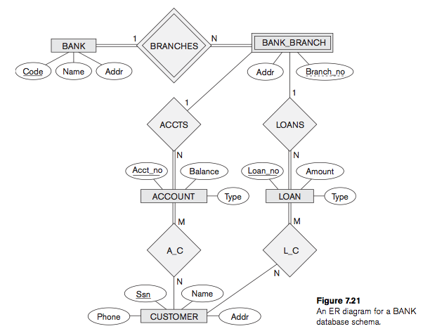
(0,3)
Ssn
Acct_no
Branch_no
(0,3)

7. Using proper notation, add the missing key(s) and foreign key(s) to figure 7.21. Do it right on the diagram above.

8. Why is BANK-BRANCH a weak entity in Figure 7.21?
Because it cannot exist without an initial BANK entity, its the branch of a current bank._______________________________________________________

9. Give the Cardinality shown in Figure 7.11, a recursive relationship.
An EMPLOYEE is SUPERVISED by 1 SUPERVISOR who is an EMPLOYEE, a SUPERVISOR who is an EMPLOYEE SUPERVISES N EMPLOYEES________

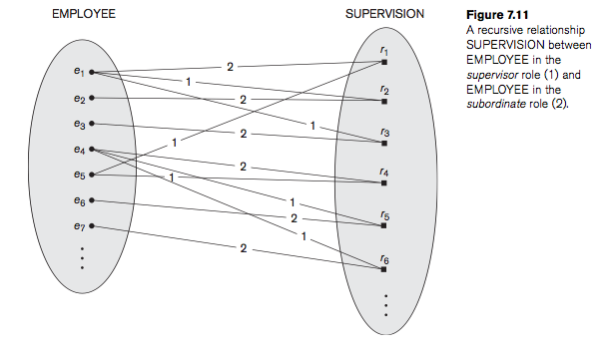

10. Who does e1 supervise in figure 7.11?
e1 supervises e2 and e3_____________________________________________

11. Who supervises e4 in figure 7.11?
e5 supervises e4________________________________________________

12. In figure 7.15, below, name a multivalued attribute(s).
Locations is a milt-valued attribute of DEPARTMENT_________________

13. In figure 7.15, below, name a composite attribute(s).
Name is a composite attribute of EMPLOYEE________________________

14. In figure 7.15 below, name a derived attribute(s).
Number_of_employees is a derived attribute of DEPARTMENT_________

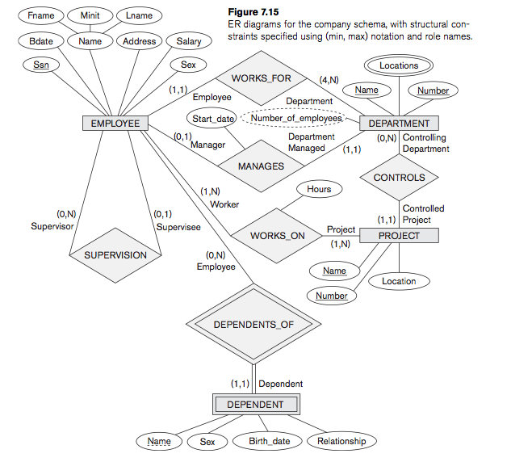

15. In figure 7.15, DEPARTMENT in WORKS_FOR is shown as having (4, n) (min, max) constraint. State the assumption(s) in your own words for this (min, max) constraint.
An EMPLOYEE WORKS_FOR a minimum of 4 DEPARTMENTS and can WORK_FOR a maximum of N DEPARTMENTS ________________

Indicate whether the following questions are true or false by circling your answer.

16. EER components of a model are designed to show the relationship between different real world entities.
TRUE FALSE

17. A weak entity type is denoted with double lines in its shape and is often referred to as the parent entity type.
TRUE FALSE

18. A truly object oriented database system has simple data and no queries.
TRUE FALSE

19. Graphical user interfaces allow you to click buttons or pictures to accomplish database tasks.
TRUE FALSE

20. A language in the DBMS that is used to specify views and their mappings is SDL.
TRUE FALSE

21. DML is used to model the structure of the database objects prior to data entry.
TRUE FALSE

22. In the 3-schema architecture model, the external schema describes the views of different user groups..
TRUE FALSE

23. An attribute whose domain matches the domain of a key in a related entity is called a primary key.
TRUE FALSE

24. The two choices I have for indicating generalization on the EER diagram in the circle are “d” for disjoint and “o” for overlapping.
TRUE FALSE

Choose the best answer for the question by circling the letter.

25. In order for a ternary relationship to work, I must be able to:
- Have the (min, max) and cardinality be identical for all entities in the relationship.
- Create a 1:1 cardinality among the entities involved
- Collect the same real world attributes for all of the entities involved.
- Have the (min, max) and cardinality constraints hold true for all paths through the relationship.

26. The 3-schema architecture model is
- A high-level conceptual model
- A representational/implementation model
- A physical model

27. Logical Data independence is
- The capacity to change the internal schema without having to change the conceptual schema.
- The capacity to change the conceptual schema without having to change external schemas or application programs.
- The process of transforming requests and results between levels
- The part of the database that a particular user group is interested in

28. Predicate-defined subclasses have
- An attribute in the parent class that determines membership in the subclass
- Boolean conditions that determine membership in the subclass
- Extra attributes to be added to the inherited attributes
- A and B
- None of the above

29. Total specialization is
- Indicated on the EER diagram with a double line connecting the superclass to the set circle symbol
- Using the Intersection symbol “I” in the circle
- Always specified individually for each entity by the user
- Accomplished only by using calculations in the computer.
Give a short answer:
30. What is the definition of data?
Known facts from the real world that can be recorded and that have implicit meaning._______________________________________

