The Mac OS 10.6 (Snow Leopard) and the Mac OS 10.7 (Lion) have a Cisco VPN client built in to the operating system.
Note: you will still need to log in to the VPN site https://itservices-web.ucdenver.edu/vpn and agree to the VPN policy before your account will be authorized to connect to VPN.
- Go to System Preferences and select Network.
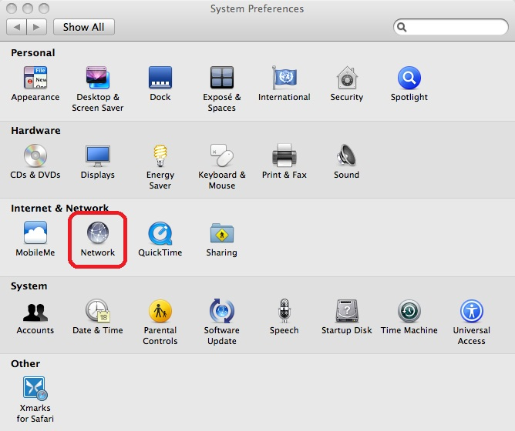
- Click the ”+” button to add a new network connection.
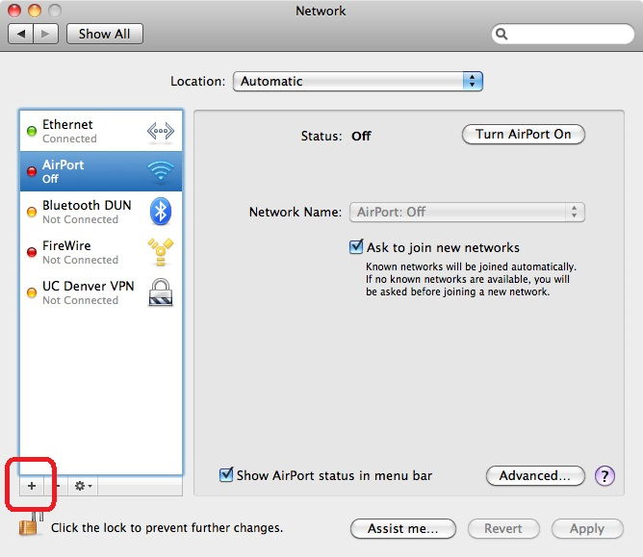
- For Interface: select VPN
- For VPN type: select Cisco IPSec
- The Service Name: will be the label on the connection, we suggest “UCDenver VPN”
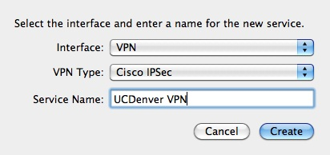
- For Server Address: enter either 140.226.8.209 (AMC), or 132.194.3.86 (DC)
- For Account Name: enter your domain account.
- Leave Password: blank
- Click Authentication Settings…
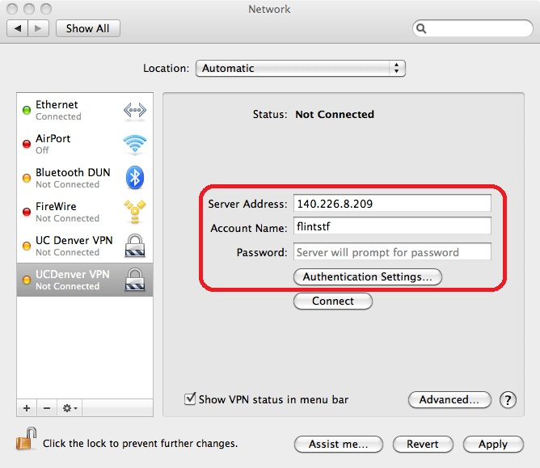
- Select Shared Secret and enter Ucd2420! (This is case sensitive)
- For Group Name: enter ciscovpn-radius (Also case sensitive)
- Click OK
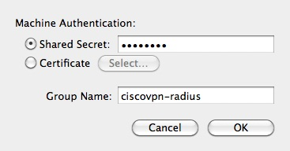
- Click Apply to save the connection.
- To connect, either click the Connect button in the Network System Preferences, or choose Connect UCDenver VPN under the VPN menu (Show VPN status in menu bar must be checked to see the menu)
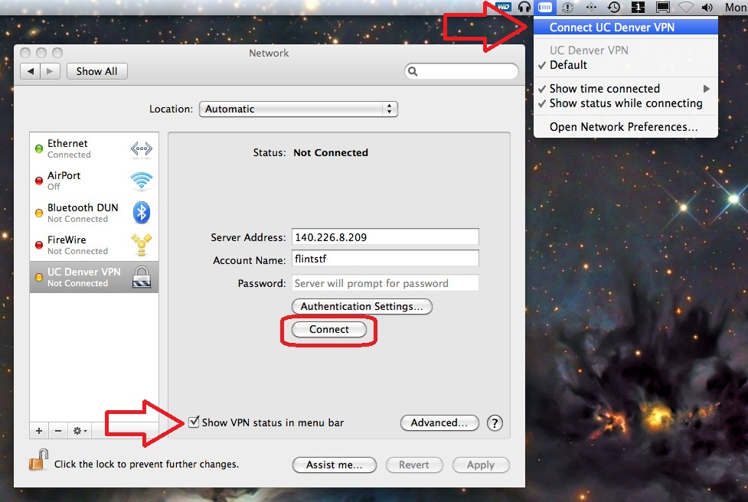
- Enter your domain username and password and hit OK.
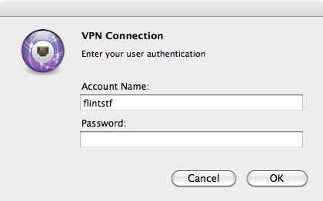
- If the connection was successful you will see a policy window. Click OK and you are connected to VPN.
