**Midterm II**

**Spring 2014**

**CSC3287 Database Systems Concepts**

**Instructions:**

Work alone to complete the questions. This test is an open book/open notes test. Cheating will be dealt with according to department policy.

Put your name on each page to be sure that I know whom to credit for the work.

The test, in total, is worth 100 points.

**I WILL NOT ANSWER QUESTIONS DURING TESTS** because the nature of this work requires you to make assumptions. If you have questions during the test, state your assumption on your paper and follow it through in your answer. Partial credit will be given for stating and following your assumptions even if they are not what I was thinking when the test was written. You may add things to your model if necessary but you must also state your assumptions that go with your addition.

Some questions have multiple answers.

Write your expressions and draw your models in the manner that you are most comfortable with. But be sure to use the formal notation taught in the book or in class and be as complete as possible with your answers.

If you finish early, check for completeness in your drawings and expressions. When you are convinced that you are done, deliver your test in one of two ways:

Email to [debra.parcheta@ucdenver.edu](mailto:debra.parcheta@ucdenver.edu)

Or

Hand it to me at class on 4/1/2014 at 3:30 PM

Verify that two Exhibits are attached:

Museum Database EER Diagram and

Airline Database System ER Diagram

1. (5 Points) Name an attribute from the Museum Database System that would be appropriate for building a primary index. Tell why you chose that attribute.

_______________________________________________________________________

_______________________________________________________________________

_______________________________________________________________________

_______________________________________________________________________

2. (5 Points) Name an attribute from the Museum Database System that would be appropriate for building a secondary (non-key) index. Tell why you chose that attribute.

_______________________________________________________________________

_______________________________________________________________________

_______________________________________________________________________

_______________________________________________________________________

3. (5 Points) Name an attribute from the Museum Database System that would be appropriate for building a clustering index. Tell why you chose that attribute.

_______________________________________________________________________

_______________________________________________________________________

_______________________________________________________________________

_______________________________________________________________________

4. (15 points) Assume that a B+ Tree has been built using consecutive integers as the values in each node, starting with the integer 1 and ending with the integer 122, where p = 6, n at the leaves is p-1, n for an internal node = p+2, and the tree is 70 to 80% full at the leaves. Calculate the efficient minimum number of block accesses in the resulting B+ tree to retrieve the set of records with values. {6, 18, 62, 100, 101, 106}. Assume that the actual retrieval takes one block access and that, when the record is retrieved, the search for the next record continues from the last visited node. State any other assumptions you make.

5. (10 points) Refer to the Museum Database exhibit.

Use formal relational mapping notation to describe 5 different constraints on the Museum Database. (Any 5 you like.)

_______________________________________________________________________

_______________________________________________________________________

_______________________________________________________________________

_______________________________________________________________________

_______________________________________________________________________

6. (5 points) Referring to the Museum Database exhibit, write the relational algebra expression that produces a list of the COLLECTIONs where the COLLECTION.Type was recorded as “Painting.”

7. (5 points) Refer to the Airline Database system. Name the entity(ies), if any, that would have a fixed record size. Tell why you would know that.

_______________________________________________________________________

_______________________________________________________________________

_______________________________________________________________________

_______________________________________________________________________

8. (5 points) Refer to the Museum Database exhibit. Specify the size of a record in the PERMANENT COLLECTION.

9. (5 points) Continue to refer to the Museum database. Given a block size of 1024, what is bfr for the records in ART_OBJECT.

10. (10 points)

a. Referring to the Airline Database Exhibit, tell me, for each entity what type of record blocking technique would be used and why.

_______________________________________________________________________

_______________________________________________________________________

_______________________________________________________________________

_______________________________________________________________________

_______________________________________________________________________

_______________________________________________________________________

_______________________________________________________________________

_______________________________________________________________________

_______________________________________________________________________

_______________________________________________________________________

_______________________________________________________________________

_______________________________________________________________________

_______________________________________________________________________

_______________________________________________________________________

_______________________________________________________________________

_______________________________________________________________________

_______________________________________________________________________

11. (5 points) Given the relational nature of the Airline database, what sort of file allocation would work best and why?

_______________________________________________________________________

_______________________________________________________________________

_______________________________________________________________________

_______________________________________________________________________

_______________________________________________________________________

_______________________________________________________________________

_______________________________________________________________________

_______________________________________________________________________

12. (5 points) Write the generic form of an aggregation statement using Relational Algebra notation.

13. (5 points) Write an actual aggregation statement using data from the Airline Database System. (Any aggregation that you can produce is fine.)

14. (15 points) Consider the two tables T1 and T2 shown in Figure 6.15 below. Show the results of the following operations on the tables. (Extra blank page provided for answers if needed.)

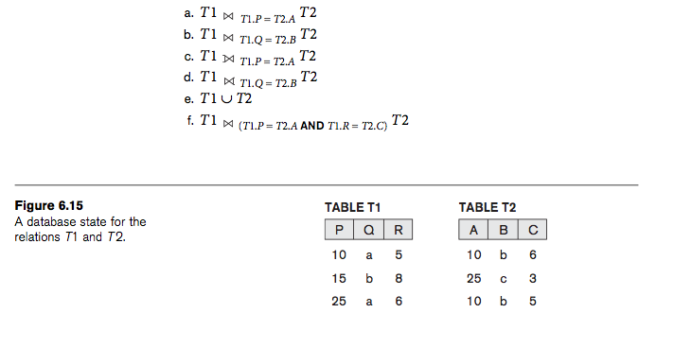

Question 12 answer space continued.

