**CSCI 2930: Practical System Administration**

**Test 1 Review**

**Spring 2014**

Chapter 1:

* Class definition for system administration: The act of creating, maintaining and operating a multiuser computer environment
* Typical Responsibilities:
  + Installing, maintaining and troubleshooting workstations, servers, OSs, software applications and other computing systems including networks
  + User account management
  + Storage administration
  + Physical and Network security
  + Disaster Recovery and Contingency Planning
  + Keep it COLD, CONNECTED and POWERED ON
* Organizational Role of System Administrators:
  + Support the efforts of the organization and staff
  + Provide a competitive advantage to the company
  + Be aware of who uses what systems how and when (i.e. don’t do system maintenance on the accounting server the nights that payroll runs)
  + Help to create business policies
  + Provide business continuity through disaster recovery planning

Chapter 2:

* Central processing unit (CPU) is the hardware within a computer that carries out the instructions of a computer program by performing the basic arithmetical, logical, and input/output operations of the system.
* 32bit vs 64bit CPU’s
  + Allows the system to address more memory
  + 32bit = 4GB of Memory
  + 64bit = 16 Exabytes (in principle) of Memory
* RISC CPU examples:
  + Sparc
  + ARM
  + Alpha
* CISC CPU Examples:
  + Intel
  + AMD (many designs and technical breakthroughs from DEC Alpha CPU and engineers)
  + Cyrix
* Chipsets:
  + Controls flow of data between CPU, Memory and Peripherals
  + Northbridge linked the CPU to main memory and the graphics controller
  + Southbridge linked to slower peripherals on PCI slots
  + Most Northbridge functions have been moved onto the CPU and so is no longer needed
* CPU Cache
  + Used by CPU to reduce access time to memory
  + Three levels of cache now standard…L1, L2, L3
* Memory
  + Current standard memory is DDR-SDRAM (Dual Data Rate SDRAM)
  + Error-correcting code memory (ECC memory) can detect and correct the most common kinds of internal data corruption
    - Caused by electrical and magnetic interference as well as cosmic rays
* System Bus:
  + Old
    - ISA
    - PCI
    - PCI-X
    - AGP
  + Current
    - PCI Express (written PCIe or PCI-E)
    - Labeled by number of data lanes x1 through x32
    - x1, x2, x4, x8, 16 and x32
    - x16 is the largest in common use
    - Smaller cards will work in larger slots as the buss will utilize only the lanes in use
* Graphics cards:
  + Three big manufacturers are Intel, Nvidia and AMD/ATI
  + SLI/CrossFire allows multiple cards to be linked together
* Motherboard:
  + Primary PCB (printed circuit board) that holds most of the critical components like CPU, memory, PCIe slots and peripheral connectors
* BIOS
  + Initializes and tests system hardware during POST (power on self test) and then loads operating system
* Power Supply Unit
  + Modular vs non modular -> Modular offers better airflow characteristics for the case by only plugging in cables ***to the power supply unit*** that are necessary
  + Efficiency ratings…higher efficiency = less heat and saves money
* Desktop Cooling methods
  + Fans/Heat Sinks
  + Heat Pipe
  + Liquid
  + Oil Submersion
  + Thermal compound fills air gaps between two surfaces (CPU and heatsink) with a thermally conductive substance
* Printers
  + Inkjet
    - Create image by propelling droplets of ink onto paper
  + Laser
    - Beam projects an image of the page to be printed onto an electrically charged rotating drum
    - Toner particles electrostatically picked up by the drum's charged areas
    - Drum prints the image onto paper by direct contact and heat, which fuses the ink to the paper

Chapter 3

* System Lifecycle: PPDIOO
  + Prepare: establish business requirements, develop strategy, proposing a high level conceptual architecture and identify technologies that can best support the architecture. Financial justification
  + Plan: identify system requirements, assess current sites and perform a gap analysis. Project plan helps manage tasks responsibilities critical milestones and resources required
  + Design: system design specialists take requirements from the planning phase and create a design specification document
  + Implement: implementation and verification begin after the design is signed off on. Attempt to integrate new system without interruptions to current systems and users
  + Operate: maintain system health through day to day operations. Fault detection and correction and performance monitoring that occur in daily operation are used in the optimize section of the lifecycle
  + Optimize: based on proactive management to identify and resolve issues before problems arise. Redesign if necessary
* Proof of Concept: Prototype vs Pilot
  + Prototype is a test system that tries to simulate the full system or part of it for viability and usefulness, typically in an isolated environment
  + Pilot is a full production system that is used by a subset of the general audience to get a better understanding of how the product will be used in a real world environment. Data collected during a pilot typically used for final refinements to the production system before final roll out.

Chapter 4

* Top three data center design considerations: Power, Space and cooling
* Power:
  + 120v – Desktops
  + 208v – Server/Network equipment and smaller HVAC
  + 480v – HVAC Equipment / Data center feeds
  + NEMA 5/L5 rated for 125volts
  + NEMA 6/L6 rated for 250volts (used for 208v and 240v)
  + Single Phase Watts = Volts * Amps * powerfactor (pf = 0.86)
    - 120v PSU running at 200Watts uses 1.93 amps
    - 208v PSU running at 200Watts uses 1.2 amps
* Space:
  + Standard racks are 42U high
* Cooling:
  + Typical server room temp between 68 and 72 deg F
  + Humidity should be between 40% and 50% non-condensing
  + AC units sold by capacity to cool (typical unit of measurement is Tons)
  + 1 Ton = 12000 BTU = 3516 Watts
  + Rack arrangement in Hot aisle/Cold aisle configuration allows for better efficiency
  + Cable Management
    - Run network and power cables at 90 degree angles when they need to be run near each other
  + Raised floor
    - Made up of solid and perforated tiles
    - Provides cold air distribution
    - Keeps equipment away from water leaks
    - Tiles have different Static loads and dynamic loads…when rolling a fully loaded rack make sure to verify the **dynamic load** of the tile can handle the weight
    - Perforated tiles much lower max load
  + Water drains – Make sure water runs towards them…
  + Fire suppression
    - Wet pipe (worst for data center)
      * Water is in the pipe under pressure
    - Dry pipe
      * Water is not present until the system is activated
      * Some delay but used in unheated areas
    - Pre-action (good when accidental activation is undesirable)
      * Similar to Dry pipe but requires a “preceding” fire detection event such as heat or smoke
    - Gas (best for data center)
      * Inert or active gas extinguishes the fire
      * Suffocation can result with some systems…be aware of oxygen mask locations and exits

Chapter 5

* Standard network models make system interconnection easier for developers and vendors
* TCP/IP Protocol Architecture
  + Defines collection of protocols that allow computers to communicate
  + 4 Layer
    - 4.) Application (Eg. HTTP, FTP, DNS)
    - 3.) Transport (TCP or UDP protocols)
    - 2.) Internet (IP)
    - 1.) Network Access (Ethernet, PPP, Frame Relay)
* Open System Interconnection (OSI) networking model
  + Used as a point of reference for discussing other protocol specifications
  + 7 Layer “All People Seem To Need Data Processing” OR “Please Do Not Throw Sausage Pizza Away”

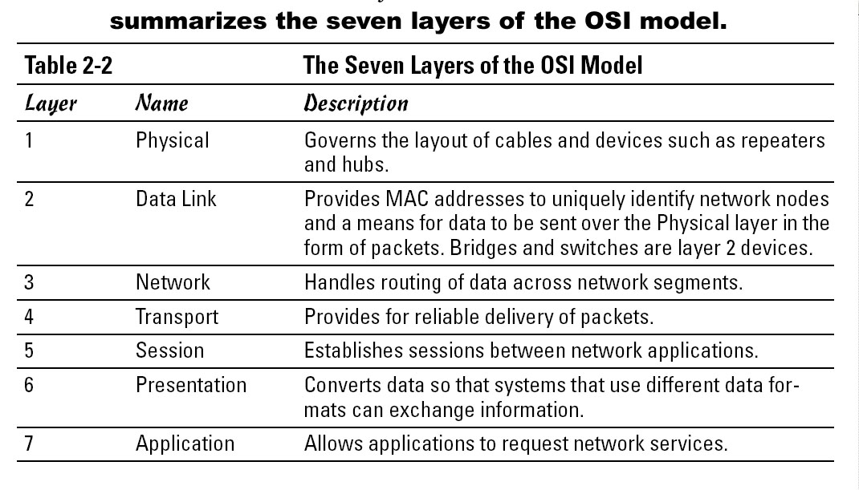

* + Breaking up into layers provides:
    - Less complexity
    - Standard interfaces between layers
    - Easier to develop
    - Multivendor interoperability
  + Subnetting (See: Lab 2)