CSE1010

1.11 The main goal of computer science is to use a problem scenario to create an algorithm that can solve or make the solution to the problem more efficient

1.12 An algorithm accepts an input and puts the input through processing to achieve a certain output or result

1.13 IDEs are used to create and test algorithms all in one application. This allows the algorithm to be debugged more efficiently and the programmer can have near instantaneous feedback whenever a line of code is typed in

1.14 An algorithm is usually organized in Pseudocode, so if an individual is fluent in the syntax of the selected language they ca easily translate the pseudocode into a functioning program

1.21 Theory of computation is a branch of computer science and mathematics that deals with problems that can be solved through the use of an algorithm

1.22 An algorithm is a collection of specific steps that are followed by a computer to solve a problem and a data structure is a location that stores and organizes data

1.23 programming methodology is the development process that is used to solve complex problems with a program or algorithm. Programming has many different languages, which all have different command names that perform the same thing. Some languages are Python, Javascript, C#, etc.

1.24 Computer architecture explains the design and integration of several components into a single unit. The primary elements are input devices, output devices, and internal devices

1.25 Human-Machine interaction is the study of how humans interact with computers and they design technologies that allow humans to further interact with computers. Machine machine interaction is the direct communication between devices to exchange data either wirelessly or through a wired connection

1.26 automata is a type of abstract machine which performs a predetermined sequence of operations automatically.

1.27 Artificial intelligence or AI is an intelligence that is displayed by machines, in which the machines will analyze their surroundings to attempt to replicate the natural intelligence of humans or animals that are near it or it is put into a scenario which allows it to slowly adapt to its surroundings and become intelligent.

1.28 Visual rendering is the process of generating an image from a 2d or 3d model through a program such as blender or unity engine. Auditory rendering is the final step in creating a digital form of an audio input

1.29 Building information technology is a process of creating a communications network, which allows data to be safeguarded and stored. Information Technology also build servers to host data storage and transfer

1.3 Computer science is a field of using algorithms to solve problems and combining logic and communication to make a process more efficient with a program or algorithm. Computer engineering is more focused on creating hardware for computers to make processes more efficient and powerful as well as developing software for these computers. IT is more focused around data storage and creating a system to exchange and transfer data as well as protecting sensitive data.

1.4 Some of the most common misconceptions about computer science are how it is one of the most profitable studies. Computer Science in fact, is not as profitable as other trades when an individual who studied it works for a company, however, they can potentially create a company in the same plane as Microsoft or Apple. “Computer Science is all about Programming” Computer science is in fact the study of computer hardware, software, and of course the creation of algorithms for problem solving.

1.5 An information society is a society in which the creation and distribution of information is the most significant economical activity. Computer Science’s role in this type of society is specifically in data storage and creation. Computer algorithms can allow the process of forming information ready for distribution far more efficient and can allow the distribution process to be sped up as well.

2.1 Algorithms are a process written by a programmer that a computer follows to achieve a specific result. Algorithms are used to solve problem scenarios or make work more efficient through a process of steps

2.2 incremental model has multiple development cycles taking place in which the code is developed, tested, then implemented. This cycle repeats multiple times. Waterfall model however is a single cycle in which it starts with design and development, and ends with deployment and maintenance

2.3 The SDLC model (pictured below) is a process for creating and deploying an informations system. It begins with a system investigation in which the developers consider if creating a completely new system is a good solution. Then the next phase is analysis, in which the developers determine what the problem currently is, which includes breaking down the system to determine what can be kept and what has to be remade from scratch. The third phase is design, where the design operations are all detailed and described as different modules. This phase is also where all of the desired systems are listed in detail. Next is environments, a controlled area where developers will build and install systems that will all serve a specific purpose in the system. Testing is the next phase, in which many tests such as integration testing and system testing take place. Operations and maintenance take place next, where the data of the organization is manipulated as things change within the organization. Finally there is evaluation, where the effectiveness of the system is measured and if it is no longer an efficient system, the process will start again.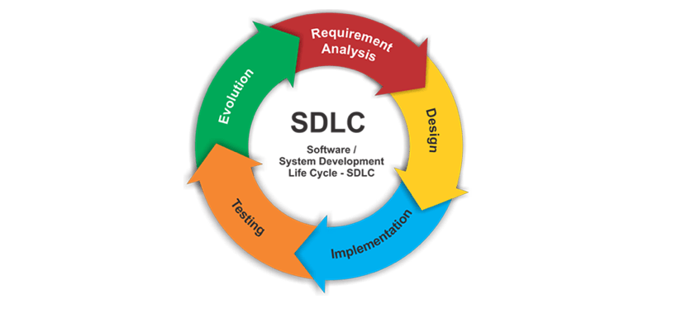

2.4

Accumulation:

Dog will bark whenever it’s fed a treat

Treat is fed to it whenever mouse is pressed

Counter is running in top corner, rises by one digit whenever dog is fed a treat

Determining the Mean:

5 random values are generated

The 5 values are added together

The 5 values are divided by 5

Mean is found

Determining maximums and minimums:

A ball is moving left and right but it is going out of view

The width of the view is 300 pixels

A minimum is set by locking X to a minimum of 0 pixels

A maximum is set by locking X to a maximum of 300 pixels

The ball will now move on the screen but will not exit the view

3.1 Structured programming is aimed at making the development process of a program more efficient and of higher quality through the use of decision making routines and repetition through while and for loops

3.2 goto instructions are a concept in programming where control over the process is transferred to the next line of code. This is a simpler way of writing code, however, it is not as versatile as writing IPO style code. GOTO also makes programs far more difficult to modify and patch for bugs

3.3 Sequential control structures are executions of code in which each line is executed and given control of the program separately and in order from top to bottom.

Decision control structure analyzes a Boolean expression (true or false statement) then will execute the corresponding block of statements

Iterative control structure is a block of code that is executed until a certain state has been achieved within the code. Examples of iterative commands include while and for loops.

4.1: Binary was initially used to represent data in the forms of 0s and 1s as bits. When bits are put together, they create sequences of 0s and 1s that the computer stores as data. Later on, for the purpose of code, forms of large data storage in programming include sets, and lists. Smaller data storage includes floats, integers and string values.

4.2.1: Programming languages such as python are intuitive to read. They are a simplified version of english, such as the “print” function as an output, as well as the “input” function to receive user input.

4.2.2 and 4.2.3: Coding has become increasingly complicated as hardware has evolved. Data science has become a core part of programming, as code has been able to process more information quicker. Since the ability to process code has gotten faster, the IPO approach to coding has become standard.

4.3: The implementation phase takes the algorithm from the design stage and develops it into usable code. One such example is a simple sorting algorithm, placing similar objects into the same group. The algorithm in the design stage creates the “list of steps” and the implementation is the creation and usage of the code.

5.



5.2:

Input: Input devices include buttons, keyboards, mice, as well as video and audio input devices

Control Unit: The control unit directs where the processor will focused and is an essential component of a CPU (Central Processing unit)

Logic Unit: A combinational circuit that performs arithmetic operations on integer numbers.

Memory Unit: a memory unit is used to store and release data on command and is organized by units ranging from a single Bit to a PetaByte (8e+15 Bits)

Output: Computer output devices include monitors for video output, headphones or speakers for audio output

5.3

Input --> arithmetic (logic) unit --> memory unit --> output

5 ---> 5x10=20 --> stored in memory and returned---> output

7.0

See under rubric