Big Mountain Resort is one of several ski resorts in the state of Montana. Interested in attracting more income, the resort has decided to install a new lift, but the lift will be costing the resort about $1,540,000 in regular maintenance. To help combat these new business costs, Big Mountain is trying to see if they can reasonably charge more for their tickets, as well as potentially reinvest in their facilities. After analyzing the data of ski resorts throughout the United States, I have come up with a plan on how Big Mountain can turn a larger profit.

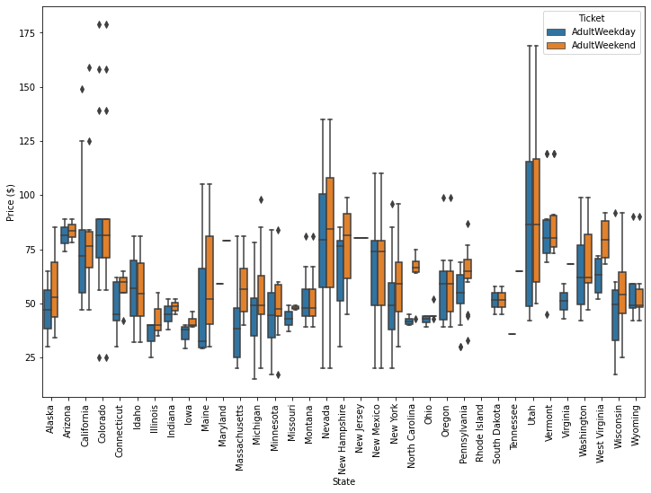 One potential problem with raising ticket prices is that while Big Mountain ticket prices are about average on a national level, they are the most expensive in the state. Montana resorts seem to consistently charge the same price for both weekday and weekend tickets, where Big Mountain sits at $81 per adult, an outlier compared to the median price of $50 for the state, as shown below.

Luckily, price isn’t the only variable in which Big Mountain scores highly compared to other Montana resorts. According to data we’ve collected and tested on, the five most impactful factors for a resort’s price are the number of fast quads they have, the number runs, the amount of snow making acreage, the height of their highest vertical drop, and the amount of skiable terrain. Out of these factors, Big Mountain ranks among the best in the country, as shown below. 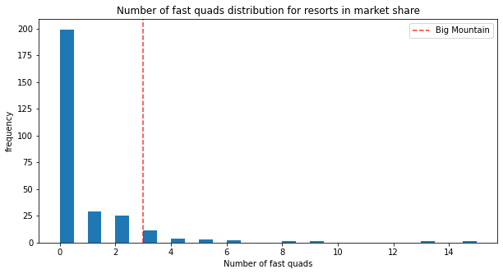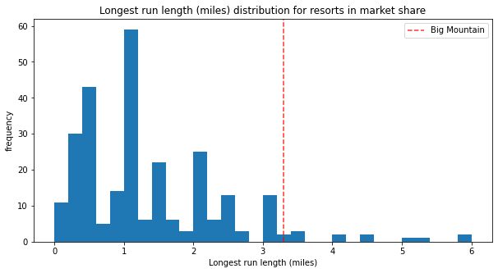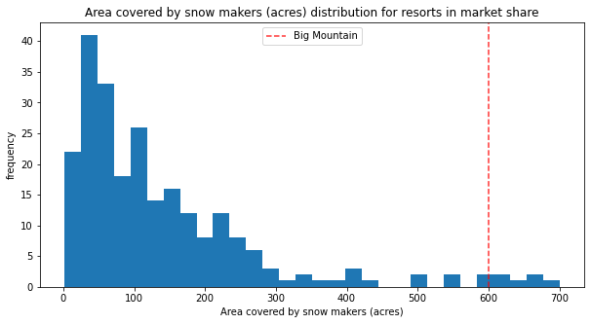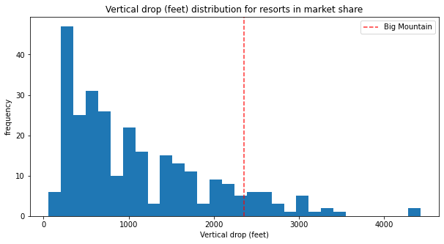 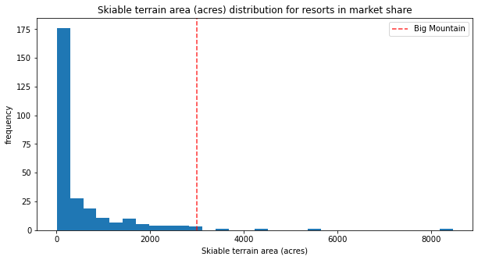

If Big Mountain has some of the best features in the nation, shouldn’t it have above-average prices? The short answer is yes. By running a predictive random forest model for price based on other variables, it is estimated Big Mountain should be charging about $95.87, with a mean average error of $10.39, and a cross validation accuracy score of 70.97% and standard deviation of 6.45%. In other words, they should be charging somewhere between $85.48 and $106.26, which is clearly more than the current ticket price of $81.00. The price we go with needs to at least cover the price of the new lift, but should shy away from the maximum, as a $25 spike in prices is more likely to drive away customers. Since Big Mountain is predicted to have around 350,000 customers this year, with the average customers using the resort for 5 days, the price needs to go up by at least 88 cents, although even the minimum recommended cost more than covers that. In addition, adding a new lift to the resort boosts the overall recommended price by a further 29 cents. The price range I would recommend based on these factors is $85.77 to $96.16. This is the range of minimum recommended to average recommended, plus the bonus from adding a lift, which keeps the price comparatively modest while still increasing profits by about $6,807,500 to $24,990,000 after the cost of the new lift.

Lastly, Big Mountain is willing to authorize a few changes to existing structures to reduce maintenance costs or further up the worth of a ticket. After running through some suggested tests, it looks like increasing the maximum vertical drop by 150ft, as well as shutting down one of the less popular runs would further increase the resort’s profits. Factoring those changes in, Big Mountain could stand to charge an additional $1.70 on tickets, or $87.47 to 97.86 total. Assuming the resort takes the price increase into account, I’d recommend shutting down the least popular run this year and waiting to boost the vertical drop until next year so that customers have more time to adjust.