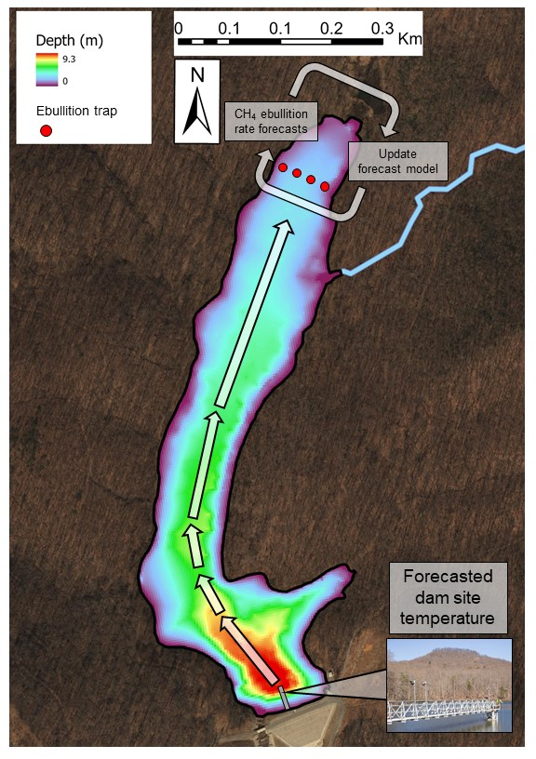

Figure 1. The bathymetry of Falling Creek Reservoir superimposed by a depiction of how our forecast workflow mapped spatially from the dam to the upstream site where CH4 ebullition rates were forecasted. Our forecast workflow used water temperature forecasts from the dam site in the reservoir (following Thomas et al. 2020). The water temperature forecasts were scaled to an upstream transect (denoted by red dots on map) to generate near-term iterative CH4 ebullition rate forecasts. Simultaneously, direct observations from ebullition traps used to iteratively update the forecast model via data assimilation.

Figure 2. Conceptual illustration of the workflow generating near-term, iterative CH4 ebullition forecasts. The data assimilation stage occurred when new ebullition rates were manually collected from the reservoir while the forecast generation occurred daily. The blue boxes represent processes, and the yellow and purple boxes represent the data products that resulted from each process. The yellow boxes are manually collected data products that were used to update models and the purple boxes represent forecasted data products.

Figure 3. A comparison of daily forecasted CH4 ebullition rates in ln(mg CH4 m-2 d-1) using an AR model with temperature as a covariate (A) and a persistence null model (B) from 27 May to 7 November 2019. The red circles represent the observed mean transect CH4 ebullition rate from four ebullition traps. The black lines represent the forecasted mean daily ebullition rate from the posterior predictions. The four varying shades of purple represent the 90%, 80%, 70%, and 60% posterior predictive intervals of the forecasts.

Figure 4. Panel A shows the comparison of the evaluated forecast bias between the AR model with temperature as a covariate and the persistence null model among all 24 forecast that were evaluated in 2019. Panel B represents the same range in forecast bias as Panel A but shows how bias changed from the first forecast that was evaluated on 27 May to the final forecast evaluated on 7 November between the AR and persistence null models.

Figure 5. The daily increase in total forecast variance over the course of the 10-day forecast horizons. Panel A shows the daily forecast variance for the AR model and Panel B represents daily forecast variance of the persistence null model. The colored circles over the boxplots represent the daily variance determined for all 24 forecast cycles that were evaluated during the forecast period.

Figure 6. Want to make sure you are OK with this figure before I start writing it up in greater detail. Honestly, a pretty cool figure if you think about it. ALSO – process might be low because it is trained on 3 years of observed ebullition?

Figure 7. Parameter estimates of $β_{0}$ (a), $β_{1}$ (b), $β_{2}$ (c), and $ε_{t}$ (d), of the HHM forecasting model. CH4 ebullition rate forecasts with data assimilation are represented by the grey lines (±1 S.D.).