Reciprocal Interactions Between the Microbiome and Viral Infection in Drosophila

Authors: Ryan M. Imrie*^{1,2}, Sarah K. Walsh^{1,2}, Mark Hanson¹, Xavier Harrison¹, Ben Longdon*¹

Affiliations:
¹ Centre for Ecology & Conservation, Faculty of Environment, Science, and Economy, University of Exeter, Penryn Campus, Penryn, United Kingdome
² MRC-University of Glasgow Centre for Virus Research, Glasgow, United Kingdom
* Corresponding authors. Email: ryan.imrie@glasgow.ac.uk, B.Longdon2@exeter.ac.uk

Abstract

1. Introduction

2. Materials & Methods

2.1 Fly Species
Laboratory stocks of 35 Drosophilidae host species (Supplementary Table 1) were maintained in multigeneration stock bottles at 22C under a 12-hour light-dark cycle. Each bottle contained 50ml of one of four media varieties, selected to optimize rearing conditions (recipes available at doi:10.6084/m9.figshare.21590724.v1). Although these diets differ in macronutrient composition, variation in laboratory media has been shown to have minimal influence on the outcome of viral infection in this system {Roberts.Longdon.2021}. To account for the possibility of diet affecting the reciprocal interactions between the microbiome and DCV, diet is included as a random effect in all models (see Statistical Modelling for details).
The host phylogeny used in this study was inferred in BEAST v1.10.4 {Suchard.Rambaut.2018} following steps described previously {Longdon.Jiggins.2015}. Briefly, publicly available sequences for the 28S, Adh, Amyrel, COI, COII, RPL32, and SOD genes were obtained from GenBank (see https://doi.org/10.6084/m9.figshare.13079366.v1 for a full list of accessions by species). Sequences were aligned in Geneious v9.1.8 (https://www.geneious.com/) using progressive pairwise global alignment with free end gaps and a 70% similarity IUB cost matrix. Default settings were used for gap opening, gap extension, and refinement iterations.
Phylogenetic reconstruction was performed in BEAST as the phylogenetic mixed models used for the statistical analysis of microbiome interactions require a tree with equal root-to-tip distances across taxa. Genes were partitioned into ribosomal (28S), mitochondrial (COI, COII), and nuclear (Adh, Amyrel, RPL32, SOD) groups. The mitochondrial and nuclear partitions were further divided by codon positions (1 + 2 and 3), with unlinked substitution rates and base frequencies across partitions. Each partition was fitted to a relaxed uncorrelated lognormal molecular clock model using random starting trees and four-category gamma-distributed HKY substitution models. Two independent BEAST runs were conducted with 1 billion MCMC generations each, sampling every 100,000 iterations with a birth-death process prior on the tree shape.
Model trace files were assessed for convergence, sampling efficiency and autocorrelation in Tracer v1.7.1 {Rambaut.Suchard.2018}. A maximum clade credibility tree (Supplementary Figure 1) was inferred from the posterior distribution after a 10% burn-in, showing topologies broadly consistent with Drosophilidae phylogenies based on larger gene sets {Kim.Petrov.2024}.

2.2 Inoculation
The isolate of DCV used in this study (DCV-Charolles; DCV-C) was kindly provided by Julien Martinez {Martinez.Jiggins.2019} and was previously verified to be free of contamination with other common Drosophila viruses via qRT-PCR {Imrie.Longdon.2025}. Before inoculation, 0-1-day-old male flies were collected and maintained in vials containing cornmeal media at 22C and 70% relative humidity under a 12-hour light-dark cycle. Each vial held between 8 and 12 flies (mean = 11.1). Flies were transferred to fresh media every two days until they reached 7-8 days of age, when they were anesthetized with CO₂ and either a) left anesthetized for 5 minutes (“no injection”); b) inoculated with Ringers (“saline injection”); or c) inoculated with DCV (“DCV infection”). Inoculations were performed by septic pinprick using a 12.5um diameter stainless steel needle (Fine Science Tools, CA, USA). Each needle was bent to a right angle approximately 250um from the tip to serve as a depth stop and inserted into the right lateral anespisternal cleft up to the angle, to provide a consistent inoculation depth. In total, 3,184 flies were inoculated across the experiment, organised into three biological replicate blocks (vials) per combination of host species and inoculation condition (Supplementary Table 2).
This inoculation method bypasses the gut immune barrier but avoids dosage variation associated with differences in feeding behaviour among host species {Landum.Teixeira.2021}. Only males were used to eliminate potential confounding effects of sex or mating status, both of which can introduce additional variation in pathogen susceptibility {Duneau.Lazzaro.2017; Schwenke.Lazzaro.2017; Short.Lazzaro.2010}. Previous studies have shown strong positive correlations between male and female DCV susceptibility in these host species {Roberts.Longdon.2023}.

2.3 RNA and DNA Extraction
After 2 additional days (+-2 hours), flies were snap frozen in liquid nitrogen then homogenized in Trizol using an Omni Bead Ruptor 24 (4 m/s for 15 seconds) with 0.2mm Zirconia beans (Thistle Scientific). The 2 dpi timepoint was selected based on previous work which showed this period was sufficient for interspecific variation in viral load to appear but not so long that infection-related mortality reduced within-vial sample sizes {Longdon.Jiggins.2015}. All samples underwent a dual RNA-DNA extraction process. First, total RNA was extracted using a standard Trizol chloroform-isopropanol extraction method. The remaining organic and lower aqueous phases were then mixed with a back extraction buffer (4M guanidine thiocyanate, 50mM trisodium citrate, 1M TRIS), producing a DNA-containing upper phase for collection. Isolated DNA was precipitated overnight in isopropanol at -20C, pelleted, and washed three times with 70% ethanol before resuspension in 8mM NaOH. After resuspension, DNA samples were pH neutralised with 1M HEPES.

2.4 Viral Load Measurement
qRT-PCR was carried out for DCV and the housekeeping gene RPL32 using the Sensifast Lo-Rox SYBR kit (Bioline) on an Applied Biosystems QuantStudio 3 (primer sequences and cycling conditions are provided in Supplementary Tables 3-5). Between-plate variation in Ct values was corrected for statistically using standard methods {Ruijter.Lamers.2006; Ruijter.Hoff.2015}. Product specificity was confirmed by melt curve analysis, using ±1.5 °C and ±3 °C inclusion thresholds for DCV and RPL32 amplicons respectively, and two technical replicates per sample were collected and averaged to obtain mean Ct values for DCV and RPL32.
To estimate the inoculation dose, eight vials of D. melanogaster (20 males per vial) were snap frozen immediately after DCV inoculation and processed as above. These values were used to infer the RPL32-normalized inoculation of other host species as:
$${ΔC}_{t:inoculation} = C_{t:DCV.dpi0.Dmel} - C_{t:RPL32.dpi0.Dmel}\left(\frac{C_{t:RPL32.dpi2}}{C_{t:RPL32.dpi2.Dmel}}\right)$$
Applying this approach to data from a previous study in which inoculation doses were measured separately for each species showed that the method accurately inferred normalized doses across species (R² = 0.92) {Imrie.Longdon.2025}. Fold changes in viral load for each biological replicate were then calculated using the 2⁻ΔΔCt method as ${ΔΔC}_{t}={ΔC}_{t:inoculation}-{ΔC}_{t:dpi2}$.

2.4 16S Sequencing
Bacterial 16S ribosomal RNA (rRNA) gene V3-V4 regions were amplified by conventional PCR (for cycle conditions see Supplementary Table 5) using the prokaryote universal primers 16S_341F (5’-CCTACGGGNGGCWGCAG-3’) and 16S_785R (5’-GGACTACHVGGGTATCTAATCC-3’). PCR clean-up was performed using AMPure XP Beads (Beckman Coulter), and amplicon libraries generated with the Nextera XT DNA Library Preparation kit (Illumina). Indexed libraries were purified with AMPure XP beads and eluted in 10 mM Tris pH 8.5. Library size was verified by Bioanalyzer (Agilent DNA 1000 kit), with the expected final product length of ~630bp. Library concentrations were measured using a Qubit dsDNA BR Assay kit (Invitrogen) and normalised to 4nM before pooling. Sequencing was performed on an Illumina MiSeq using a 300bp paired-read v3 600-cycle kit. The following controls were included in the sequencing run in addition to experimental samples: 6x negative extraction controls (nuclease-free water), 6x Microbial Community Standards (ZymoBIOMICS) and 6x Microbial Community DNA Standards (ZymoBIOMICS). Each control sample was spiked into Trizol and underwent RNA/DNA extraction, 16S PCR amplification, and library preparation in tandem with experimental samples.

2.5 Bioinformatics
Raw 16S reads were processed using Cutadapt {Martin.Martin.2011} to remove adaptor sequences, after which all subsequent quality filtering, trimming, denoising, and error correction were performed in R using the dada2 v1.26 pipeline {Callahan.Holmes.2016}. Reads were truncated to 240 bp (forward) and 225 bp (reverse) and filtered to retain only those with ≤2 expected sequencing errors. Error rates were learned independently for each read direction, and denoised reads were used to infer unique amplicon sequence variants (ASVs). ASVs were retained if their merged length matched the expected size range for the V3–V4 region and were assigned taxonomy using the SILVA v138.1 reference database {Chuvochina.Reimer.2025}. To infer an ASV phylogeny, unique V3–V4 sequences were aligned with MAFFT {Katoh.Standley.2013}, low-information regions were removed with trimAL {Gutierrez.Gabaldon.2009}, and an approximate maximum-likelihood tree was generated using FastTree 2 {Price.Arkin.2010}. Contaminants were removed in several steps: non-bacterial sequences (chloroplasts and archaea) were manually pruned, and technical contaminants were identified using a prevalence-based approach in decontam. Additionally, the mean abundances of ASVs in negative controls was used as a minimum threshold for inclusion in subsequent analyses. Samples were filtered to remove those with fewer than 1,350 reads remaining after processing, with this cut-off chosen as the highest value that prevented combinations of host species and infection condition falling below two biological replicates. Finally, low-prevalence taxa were filtered by retaining only ASVs present at ≥1 copy in at least 5% of remaining biological replicates {Knowles.Baltrūnaitė.2019}.

2.7 Statistical Modelling
All statistical analyses were performed in R using the MCMCglmm package {Hadfield.2010}. As 16S sequence data is compositional in nature, read counts were centre log ratio (CLR) transformed prior to analysis {Gloor.Egozcue.2017}. Alpha diversity metrics (richness, evenness, and Shannon diversity) were calculated using the phyloseq package {McMurdie.Holmes.2013}; and beta diversity explored by principal component analysis (PCA, stats package) and non-metric multidimensional scaling with an Aitchison distance metric (NMDS, vegan package). Due to the zero-inflated nature of the 16S data, models using CLR-transformed abundance as a response were fitted as multivariate models combining binary presence/absence modelled as a threshold trait with a probit link, and continuous CLR-transformed abundances modelled with a Gaussian error distribution. Random effects within each model followed one of three general structures: a structure intended to estimate phylogenetic heritability (1); a structure intended to estimate repeatability (2); and a structure with no phylogenetic component (3):
$y_{chig}=B_{1:cg}+u_{p:chg}+u_{s:chg}+u_{i}+e_{chig}$ (1)
$y_{chig}=B_{1:cg}+u_{p:chg}+u_{i}+e_{chig}$ (2)
$y_{chig}=B_{1:cg}+u_{i}+e_{chig}$ (3)
In these models, $y_{chig}$ is the response variable for the combination of injection condition c (uninjected, saline injected, DCV infected), in the ith biological replicate of host species h and bacterial genera g. The fixed effect $B_{1}$ is the intercept for each injection condition; the random effect $u_{p}$ represents the effect of host phylogeny under a Brownian model of evolution; $u_{s}$ represents a categorical host-species-specific effect that is independent of phylogeny and explicitly estimates the non-phylogenetic component of variance. Lastly, $u_{i}$ represents a random effect of biological replicate ID and $e$ is the model residuals, both of which also assumed Gaussian errors. For response variables that summarise across bacterial genera (e.g., alpha/beta diversities) g is absent from the model structure.
The proportion of among-host-species variation that can be explained by host phylogeny (equivalent to phylogenetic heritability or Pagel’s lambda) was calculated as $\frac{V_{p}}{V_{p}+V_{s}}$, where $V_{p}$ and $V_{s}$ are the phylogenetic and species-specific components of variance respectively, taken from model structure (1). The repeatability of measurements within-host-species after accounting for any phylogenetic variance was calculated as $\frac{V_{p}}{V_{p}+V_{e}}$, where $V_{p}$ and $V_{e}$ are the phylogenetic and residual variance components from model structure (2). In multivariate models, phylogenetic and non-phylogenetic covariance matrices were used to calculate correlation coefficients between conditions as ${cov}_{x,y}\sqrt{{var}_{x}×{var}_{y}}$ and regression slopes as $\frac{{cov}_{x,y}}{{var}_{x}}$. Intercepts for these correlations were calculated as $ȳ-β_{1}x̄$, where $β_{1}$ is the fixed-effect estimate of the across-species mean. For parameters on an unbounded scale (correlation coefficients, slopes), effects were considered significant when the 95% credible intervals (calculated here as 95% HPD intervals) did not include zero. For proportions of variance (heritability, repeatability), effects were considered non-zero when the lower bound of the 95% credible interval exceeded a value of 0.05. This threshold was chosen to avoid treating effects whose posterior distributions allocate a high probability mass near zero as meaningful.
Each model was run for 13,000,000 MCMC generations, sampled every 5,000 generations after a burn-in of 3,000,000 generations. Presented results are taken from models with parameter-expanded priors placed on the phylogenetic ($V_{p}$) and species-specific ($V_{s}$) covariance matrices, and inverse-gamma priors placed on the residual variances. Alternative models were also fitted with flat and inverse-Wishart priors, which provided qualitatively similar results. Full details on the structure of each individual model, and all scripts and data used in this analysis are available at https://github.com/ryanmimrie/Publications-2025-Drosophilidae-16S-Virus-Infection.

3. Results

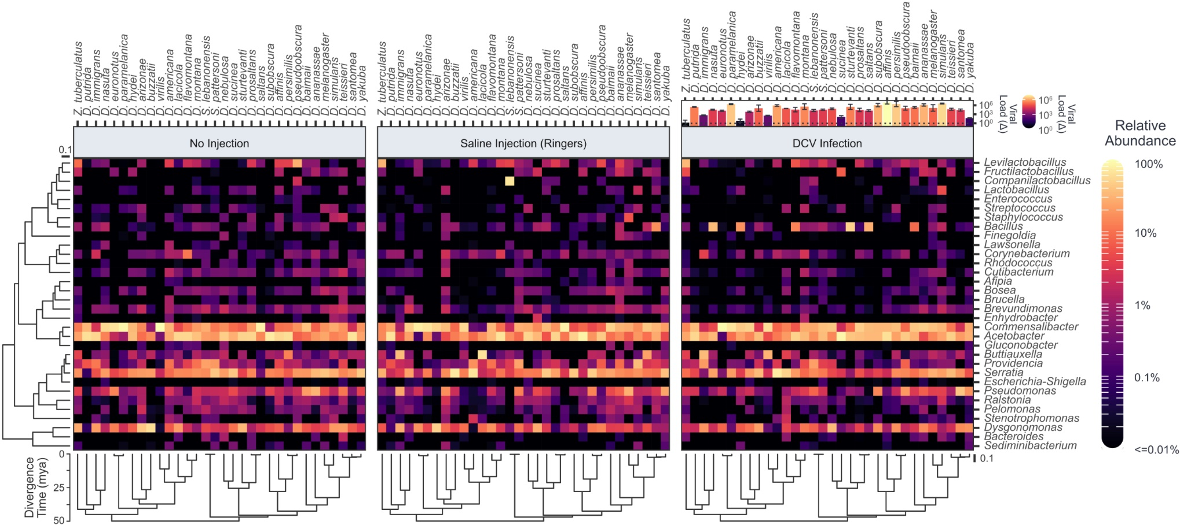
Figure 1: Relative abundances of bacterial genera across Drosophilidae host species and injection conditions. Heatmaps show the mean relative abundance of bacterial genera (rows) in different host species (columns) on a log₁₀ scale, faceted by injection condition. Maximum clade credibility phylogenies are presented for both bacterial genera (left) and Drosophilidae hosts (bottom) with a scale bar for the number of nucleotide substitutions per site. For the Drosophilidae phylogeny, the approximate age since divergence, based on estimates from {Kim.Petrov.2021} is shown in the axis at the bottom left. Above the DCV infection facet, bar height and colour show the mean change in viral load from 0 to 2 dpi on a log₁₀ scale, with error bars representing the standard error of the mean.

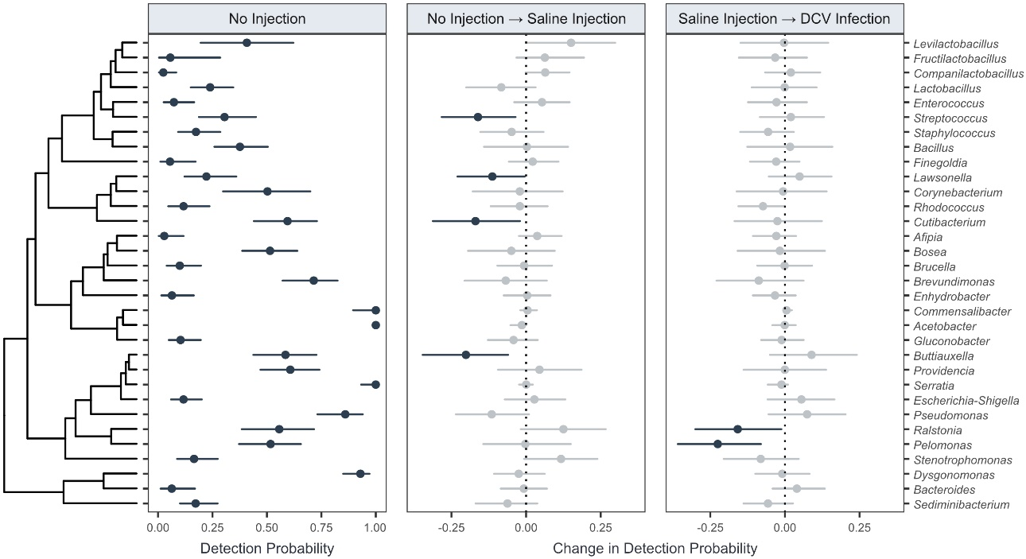
Figure 2: Changes in across-host-species detection probabilities of bacterial genera with injection and infection. Values for the across-host-species detection probability in uninjected flies (left facet) and the change in detection probability following septic injury (middle facet) and DCV infection (right facet). Points represent the mean and bars the 95% HPD intervals of the posterior distribution of each estimate taken from a model of structure (2). Estimates of the change in detection probability that do not include zero are highlighted in black.
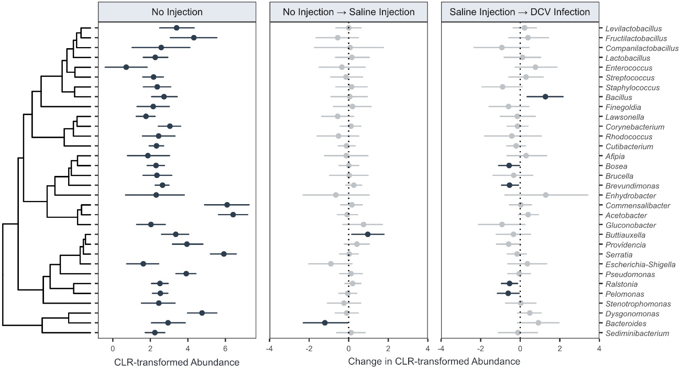
Figure 3: Changes in across-host-species abundance of bacterial genera with injection and infection. Values for the across-host-species CLR-transformed abundance in uninjected flies (left facet) and the change in abundance following septic injury (middle facet) and DCV infection (right facet). Points represent the mean and bars the 95% HPD intervals of the posterior distribution of each estimate taken from a model of structure (2). Estimates of the change in abundance that do not include zero are highlighted in black.
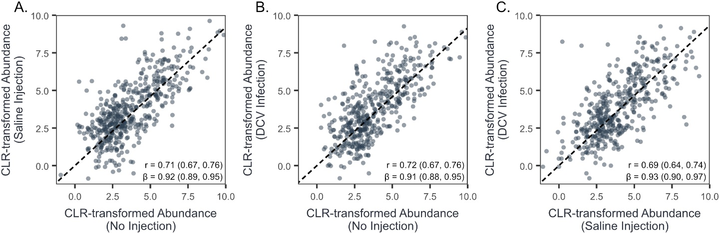
Figure 4: Correlations in abundance of bacterial genera between injection conditions. Correlations in CLR-transformed abundance between uninjected and saline injected flies (A); uninjected and DCV infected flies (B); and saline injected and DCV infected flies (C). Individual points represent the mean abundance for each Drosophilidae host species and bacterial genera. Correlation coefficients (r) and trendlines are taken from a non-phylogenetic mixed model of structure (3) as phylogenetic and species-specific covariance matrices from models of structure (1) and (2) contained very small (<0.01) proportions of total variance in bacterial abundance.

Figure 5: Correlations between viral load and bacterial genera presence before and during infection.

Figure 6: Correlations between viral load and bacterial genera abundance before and during infection.

