Supplementary Materials
The following document contains supplementary methods, tables, and figures for Imrie et al., Reciprocal Interactions Between the Microbiome and Viral Infection in Drosophila (2026).

Supplementary Tables
Species | Genus | Diet
D. affinis | Drosophila | Malt
D. americana | Drosophila | Malt
D. ananassae | Drosophila | Cornmeal
D. arizonae | Drosophila | Banana
D. baimaii | Drosophila | Cornmeal
D. buzzatii | Drosophila | Malt
D. euronotus | Drosophila | Cornmeal
D. flavomontana | Drosophila | Malt w. additional yeast
D. hydei | Drosophila | Cornmeal
D. immigrans | Drosophila | Malt w. additional yeast
D. lacicola | Drosophila | Malt
D. melanogaster | Drosophila | Cornmeal
D. montana | Drosophila | Malt w. additional yeast
D. nasuta | Drosophila | Cornmeal
D. nebulosa | Drosophila | Cornmeal
D. paramelanica | Drosophila | Cornmeal
D. persimilis | Drosophila | Malt
D. prosaltans | Drosophila | Propionic
D. pseudoobscura | Drosophila | Malt
D. putrida | Drosophila | Propionic
D. saltans | Drosophila | Propionic
D. santomea | Drosophila | Cornmeal
D. simulans | Drosophila | Cornmeal
D. sturtevanti | Drosophila | Cornmeal
D. subobscura | Drosophila | Cornmeal
D. sucinea | Drosophila | Cornmeal
D. teissieri | Drosophila | Cornmeal
D. virilis | Drosophila | Propionic
D. yakuba | Drosophila | Cornmeal
S. lebanonensis | Scaptodrosophila | Propionic
S. pattersoni | Scaptodrosophila | Banana
Z. tuberculatus | Zaprionous | Banana
Supplementary Table 1: Drosophilidae host species and rearing diets. Full recipes can be found at doi:10.6084/m9.figshare.21590724.v1. Some species were provided with additional dried yeast added to the top of their media once set.

 | Uninjected |  |  | Saline Injected |  |  | DCV Infected
D. affinis | 12 | 10 | 12 | 11 | 10 | 10 | 10 | 11 | 10
D. americana | 12 | 12 | 12 | 11 | 12 | 11 | 11 | 10 | 11
D. ananassae | 12 | 11 | 12 | 11 | 12 | 11 | 11 | 12 | 11
D. arizonae | 12 | 12 | 10 | 12 | 11 | 12 |  | 12 | 12
D. baimaii | 12 | 12 | 12 | 12 | 10 | 9 | 10 | 11 | 11
D. buzzatii | 10 | 11 | 9 | 10 | 11 | 9 | 12 | 11 | 9
D. euronotus | 12 | 10 | 12 | 12 | 12 | 9 | 11 | 11 | 11
D. flavomontana | 11 | 12 | 12 | 12 | 12 | 9 | 11 | 12 | 11
D. hydei | 12 | 12 | 12 | 12 |  | 12 | 12 | 12 | 9
D. immigrans | 12 | 11 | 11 | 10 | 12 | 11 | 12 | 11 | 12
D. lacicola | 10 | 12 | 11 | 12 | 11 | 11 | 11 | 11 | 11
D. melanogaster | 12 | 12 | 12 |  | 12 | 11 | 11 | 12 | 12
D. montana | 12 | 12 | 12 | 12 | 11 | 10 | 11 | 12 | 12
D. nasuta | 11 | 12 | 11 |  | 11 | 9 | 11 | 12 | 11
D. nebulosa |  | 12 | 12 | 11 | 10 | 8 | 10 | 11 | 10
D. paramelanica | 11 | 12 | 11 | 11 | 11 | 8 | 11 | 12 | 12
D. persimilis | 10 | 11 | 11 |  | 11 | 8 | 12 | 12 | 10
D. prosaltans | 12 | 12 | 12 | 11 | 11 | 10 | 12 | 11 | 12
D. pseudoobscura | 11 | 12 | 10 |  | 10 | 10 |  | 11 | 12
D. putrida | 12 | 12 | 12 | 12 | 12 | 11 | 10 | 10 | 11
D. saltans | 10 | 12 | 12 |  | 9 | 11 | 10 | 12 | 12
D. santomea | 12 | 12 | 12 | 11 | 12 | 11 |  | 11 | 11
D. simulans |  | 12 | 12 | 12 | 12 | 10 | 11 | 12 | 9
D. sturtevanti | 12 | 12 | 9 | 11 | 11 | 10 |  | 10 | 9
D. subobscura | 12 | 11 | 11 | 10 | 12 |  |  | 12 | 12
D. sucinea |  | 12 | 12 | 12 | 12 | 12 |  | 11 | 12
D. teissieri |  | 11 | 12 | 12 | 9 | 10 |  | 10 | 9
D. virilis | 12 |  | 12 | 12 | 11 | 11 | 12 | 9 | 12
D. yakuba | 12 | 11 | 10 | 10 | 12 | 8 | 11 | 11 | 8
S. lebanonensis | 11 | 12 | 12 |  | 10 | 12 | 10 | 10 | 12
S. pattersoni | 12 | 11 | 12 | 12 | 12 | 12 | 11 | 12 | 11
Z. tuberculatus | 12 | 12 | 11 | 12 | 12 | 11 | 12 | 11 | 10
Supplementary Table 2: Biological replicates (vials) and flies per vial by species and injection condition. Black boxes indicate replicates that were excluded from analysis, all of which were removed due to low 16S read count (<1,350).

Direction | Name | Sequence
Forward | DCV_F | GACACTGCCTTTGATTAG
 | RPL32_F-a | TGCCAAGTTGTCGCACAAATGG
 | RPL32_F-b | TGCTAAGTTGTCGCACAAATGG
 | RPL32_F-c | TGCCAAGCTGTCGCACAAATGG
 | RPL32_F-d | TGCTAAGCTGTCGCACAAATGG
 | RPL32_F-e | TGCGAAGTTGTCGCACAAATGG
 | RPL32_F-f | TGCGAAGCTGTCGCACAAATGG
Reverse | DCV_R | CCCTCTGGGAACTAAATG
 | RPL32_R-a | TGCGCTTGTTGGAACCGTAAC
 | RPL32_R-b | TGCGCTTGTTGGATCCGTAAC
 | RPL32_R-c | TGCGCTTGTTGGAACCATAAC
 | RPL32_R-d | TGCGCTTGTTGGAGCCGTAAC
 | RPL32_R-e | TGCGCTTGTTAGAACCGTAAC
 | RPL32_R-f | TACGCTTGTTGGAACCGTAAC
 | RPL32_R-g | TGCGCTTGTTGGAACCGTAGC
 | RPL32_R-h | TGCGCTTGTTCGATCCGTAAC
 | RPL32_R-i | TGCGCTTGTTGGAGCCATAAC
 | RPL32_R-j | TGCGCTTGTTTGATCCGTAAC
 | RPL32_R-k | TGCGCTTGTTTGAACCATAAC
 | RPL32_R-l | TACGCTTGTTGGAACCATAAC
 | RPL32_R-m | TACGCTTGTTGGAGCCGTAAC
 | RPL32_R-n | TGCGCTGGTTGGAACCATAAC
 | RPL32_R-o | TGAGCTTGTTCGATCCGTAAC
 | RPL32_R-p | TACGCTTGTTGGAGCCATAAC
 | RPL32_R-q | TGAGCTTGTTTGATCCGTAAC
 | RPL32_R-r | TAAGCTTGTTGGATCCGTAGC
 | RPL32_R-s | TCAGCTTGTTGGATCCATAGC
Supplementary Table 3: DCV and RPL32 q-PCR primers

Species | Forward | Reverse
D. affinis | F-a | R-i
D. americana | F-c | R-a
D. ananassae | F-f | R-a
D. arizonae | F-a | R-a
D. baimaii | F-a | R-r
D. buzzati | F-a | R-e
D. erecta | F-d | R-h
D. euronotus | F-a | R-g
D. flavomontana | F-c | R-a
D. hydei | F-a | R-a
D. immigrans | F-b | R-p
D. lacicola | F-c | R-a
D. melanogaster | F-d | R-h
D. montana | F-c | R-a
D. nasuta | F-b | R-f
D. nebulosa | F-b | R-c
D. paramelanica | F-a | R-g
D. persimilis | F-a | R-b
D. prosaltans | F-a | R-n
D. pseudoobscura | F-a | R-m
D. putridia | F-d | R-q
D. saltans | F-a | R-n
D. santomea | F-a | R-n
D. simulans | F-d | R-h
D. sturtevanti | F-a | R-l
D. subobscura | F-a | R-i
D. sucinea | F-b | R-k
D. teissieri | F-d | R-h
D. virilis | F-c | R-a
D. yakuba | F-d | R-h
S. lebanonensis | F-d | R-h
S. pattersoni | F-a | R-m
Z. tuberculatus | F-a | R-c
Supplementary Table 4: RPL32 Primer Combinations

Cycle step | Temp. | Time/rate | Cycles
Initial denaturation | 95˚C | 2 min | 1
Denaturation | 95˚C | 5 sec | ) 40
Annealing/Extension | 60˚C | 15 sec | ) 40
Melt curve | 60˚C - 95˚C | 0.1˚C/s | 1
Supplementary Table 5: q(RT)-PCR Cycle Conditions

Genus | Representative Species | Accession | Link
Acetobacter | fallax | NR_180984.1 | https://www.ncbi.nlm.nih.gov/nuccore/NR_180984.1
Afipia | dichlorophenoxyacetatis | NR_199405.1 | https://www.ncbi.nlm.nih.gov/nuccore/NR_199405.1
Bacillus | yunxiaonensis | NR_199426.1 | https://www.ncbi.nlm.nih.gov/nuccore/NR_199426.1
Bacteroides | faecalis | NR_180327.1 | https://www.ncbi.nlm.nih.gov/nuccore/NR_180327.1
Bosea | thiooxidans | NR_114668.1 | https://www.ncbi.nlm.nih.gov/nuccore/NR_114668.1
Brevundimonas | vitisensis | NR_181597.1 | https://www.ncbi.nlm.nih.gov/nuccore/NR_181597.1
Brucella | endophytica | NR_146362.2 | https://www.ncbi.nlm.nih.gov/nuccore/NR_146362.2
Buttiauxella | noackiae | NR_036919.1 | https://www.ncbi.nlm.nih.gov/nuccore/NR_036919.1
Commensalibacter | intestini | NR_116307.1 | https://www.ncbi.nlm.nih.gov/nuccore/636560247
Companilactobacillus | zhongbaensis | NR_180275.1 | https://www.ncbi.nlm.nih.gov/nuccore/NR_180275.1
Corynebacterium | mayonis | NR_199437.1 | https://www.ncbi.nlm.nih.gov/nuccore/NR_199437.1
Cutibacterium | modestum | NR_174227.1 | https://www.ncbi.nlm.nih.gov/nuccore/NR_174227.1
Dysgonomonas | termitidis | NR_178264.1 | https://www.ncbi.nlm.nih.gov/nuccore/NR_178264.1
Enhydrobacter | aerosaccus | NR_113385.1 | https://www.ncbi.nlm.nih.gov/nuccore/631252187
Enterococcus | larvae | NR_181559.1 | https://www.ncbi.nlm.nih.gov/nuccore/NR_181559.1
Escherichia | coli | NR_024570.1 | https://www.ncbi.nlm.nih.gov/nuccore/NR_024570.1
Finegoldia | magna | NR_113383.1 | https://www.ncbi.nlm.nih.gov/nuccore/NR_113383.1
Fructilactobacillus | ixorae | NR_153713.1 | https://www.ncbi.nlm.nih.gov/nuccore/NR_153713.1
Gluconobacter | potus | NR_181154.1 | https://www.ncbi.nlm.nih.gov/nuccore/NR_181154.1
Lactobacillus | mulieris | NR_180521.1 | https://www.ncbi.nlm.nih.gov/nuccore/NR_180521.1
Lawsonella | clevelandensis | NR_151867.1 | https://www.ncbi.nlm.nih.gov/nuccore/NR_151867.1
Levilactobacillus | enshiensis | NR_180638.1 | https://www.ncbi.nlm.nih.gov/nuccore/NR_180638.1
Pelomonas | nitida | NR_199501.1 | https://www.ncbi.nlm.nih.gov/nuccore/NR_199501.1
Providencia | rettgeri | NR_115880.1 | https://www.ncbi.nlm.nih.gov/nuccore/NR_115880.1
Pseudomonas | spirodelae | NR_199520.1 | https://www.ncbi.nlm.nih.gov/nuccore/NR_199520.1
Ralstonia | solanacearum | NR_118984.1 | https://www.ncbi.nlm.nih.gov/nuccore/NR_118984.1
Rhodococcus | ruber | NR_179575.1 | https://www.ncbi.nlm.nih.gov/nuccore/NR_179575.1
Sediminibacterium | soli | NR_181144.1 | https://www.ncbi.nlm.nih.gov/nuccore/NR_181144.1
Serratia | marcescens | NR_036886.1 | https://www.ncbi.nlm.nih.gov/nuccore/NR_036886.1
Staphylococcus | schweitzeri | NR_181985.1 | https://www.ncbi.nlm.nih.gov/nuccore/NR_181985.1
Stenotrophomonas | capsici | NR_199536.1 | https://www.ncbi.nlm.nih.gov/nuccore/NR_199536.1
Streptococcus | wuxiensis | NR_199547.1 | https://www.ncbi.nlm.nih.gov/nuccore/NR_199547.1
Supplementary Table 6: 16S gene sequence accessions used to infer the bacterial maximum-clade-credibility tree.

Supplementary Figures
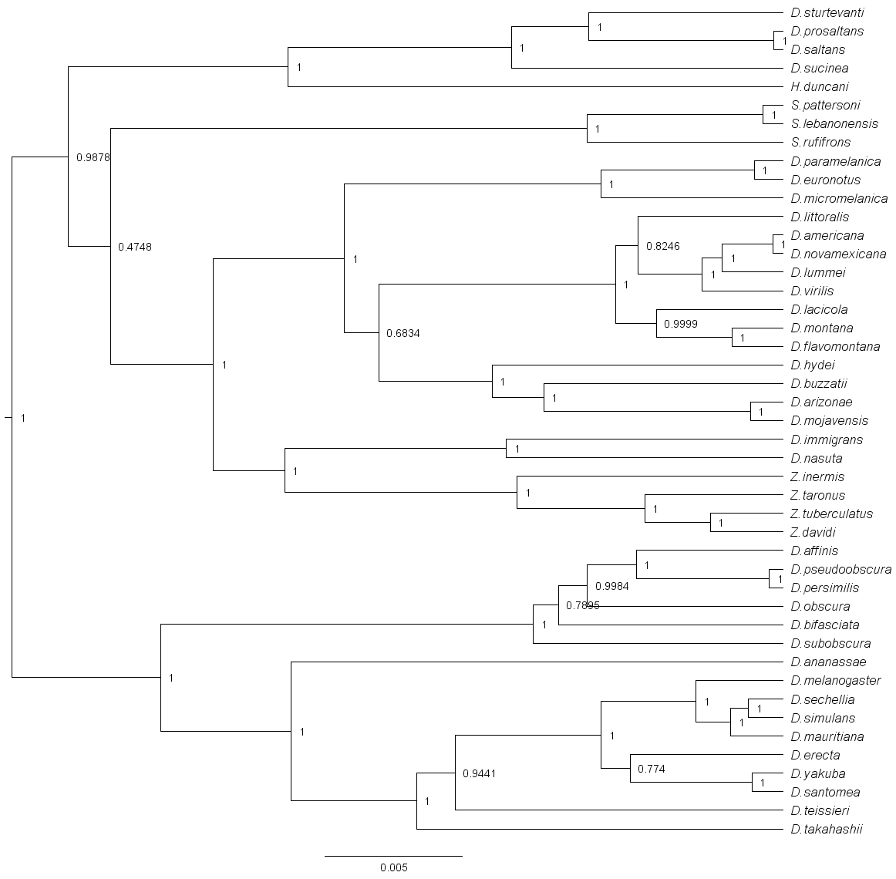
Supplementary Figure 1: Phylogeny of Drosophilidae host species. Evolutionary relationships are presented as a midpoint rooted, maximum clade credibility tree. Node labels are the posterior probabilities of each clade, and the scale bar represents nucleotide substitutions per site.

