**CMSC203 Assignment 0**

Programmer: Ryan Tran

Class: CMSC203

 Program: Assignment 0

Instructor: Professor

 Summary of Description: proof of installation of required programs for the course

 Due Date: 1/30/2023

 Integrity Pledge: I pledge that I have completed the programming assignment independently.

 I have not copied the code from a student or any source.

**Complete the following five parts of Assignment 0. Name your file as FirstInitialLastName_Assignment0.docx**

**Part1: Setup GitHub:** Provide the screen shots of your GitHub account with Assignment 0 file is uploaded on GitHub:

**Part 2 -Install JDK, Test java Application from Command Line**

Provide the screen shots from Step 1 and 2 here:

**Part 3 - Install Eclipse, Test Eclipse Java Application**

Provide the screen shots from Step 1 and 2 here:

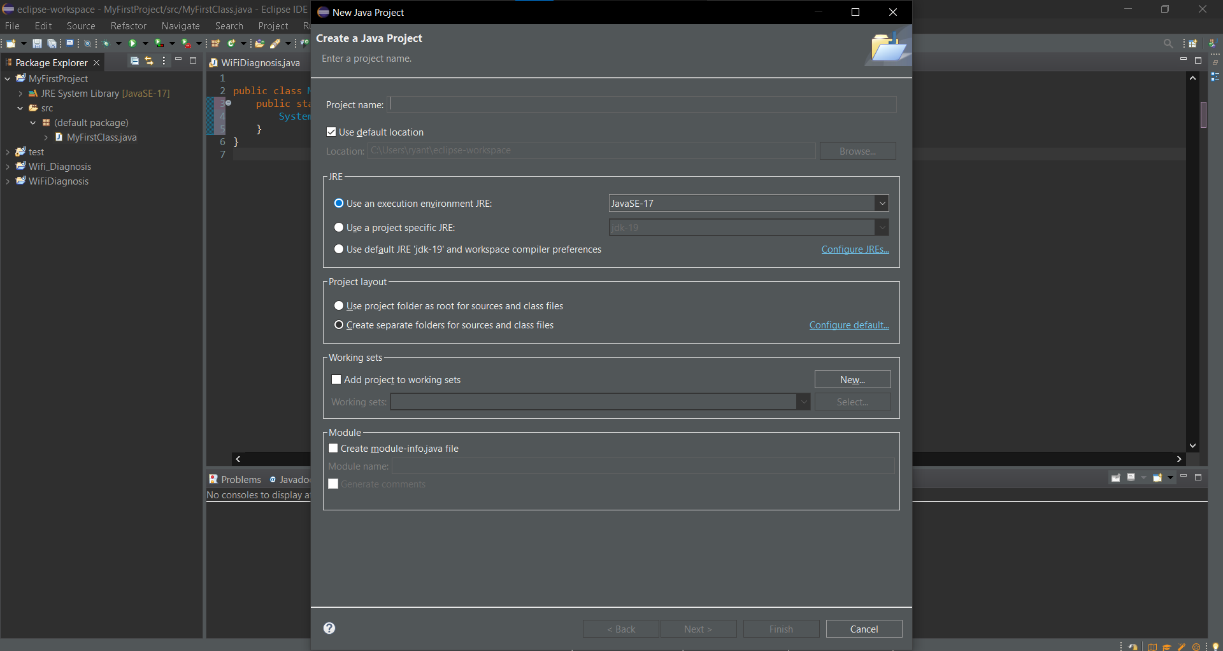

**Part 4 - Install, Setup, Test Junit Program.**

Provide the screen shots showing:

* 1. Eclipse with working JUnit Test example
  2. Project screenshot
  3. Running example screenshot

**Part 5 - Install, Setup, and Test JavaFX Application.**

Provide the screen shots showing:

1. JavaFX Project screenshot
2. Running example screenshot
3. Java Source Code File

**Lessons Learned** <Provide answers to the questions listed below>**:**

Write about your Learning Experience, highlighting your lessons learned and learning experience from working on this assignment.

What have you learned?

There are multiple running parts running that are essential for a compiler to be able to run correctly.

What did you struggle with?

Installing and navigating programs

What parts of this assignment were you successful with, and what parts (if any) were you not successful with?

I did good in setting but github but struggled with installing and navigating programs.

Provide any additional resources/links/videos you used to while working on this assignment.

**Check List:** <Provide answers to the column Y/N or N/A >**:**

|  |  |  |  |
| --- | --- | --- | --- |
| **#** |  | **Y/N** | **Comments** |
|  | **Assignment files:** |  |  |
|  | * FirstInitialLastName_Assignment0.docx/pdf | **Yes** |  |
|  | * Source java files | **Yes** |  |
|  | **Program compiles** | **Yes** |  |
|  | **Program runs with desired outputs related to a Test Plan** | **Yes** |  |
|  | **Documentation file: Screenshots of** |  |  |
|  | * Part1: Setup GitHub | **Yes** |  |
|  | * Part 2 -Install JDK, Test java Application from Command Line | **Yes** |  |
|  | * Part 3 - Install Eclipse, Test Eclipse Java Application | **Yes** |  |
|  | * Part 4 - Install, Setup, Test Junit Program | **Yes** |  |
|  | * Part 5 - Install, Setup, and Test JavaFX Application. | **Yes** |  |
|  | * Lessons Learned | **Yes** |  |
|  | * Checklist is completed and included in the Documentation | **Yes** |  |