Manual Test Plan

Ran Li

1. Install igraph, plotly and urllib for python3
2. Run python script view/visualization.py
3. The 3d interaction visualization will be in the pop up html:
   1. The basic GUI looks like:

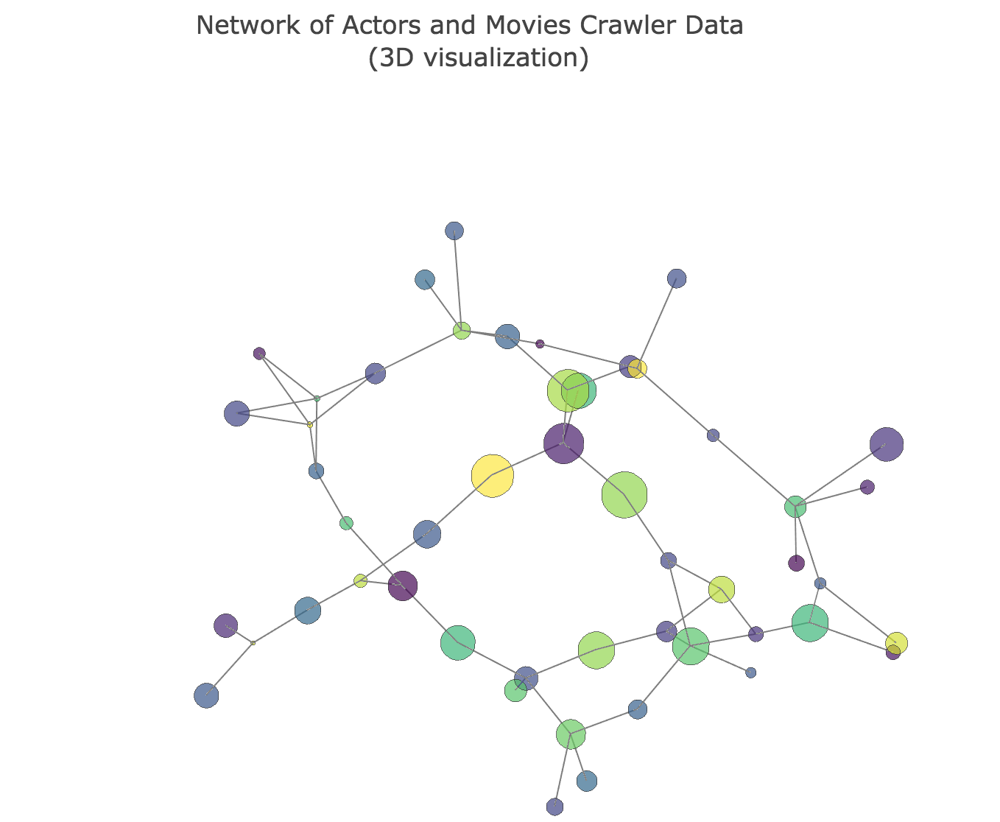

Where the darker nodes refer to actors and lighter nodes refer to movies

* 1. Drag the screen and change the view angle, scroll down or up to change the scale of visualization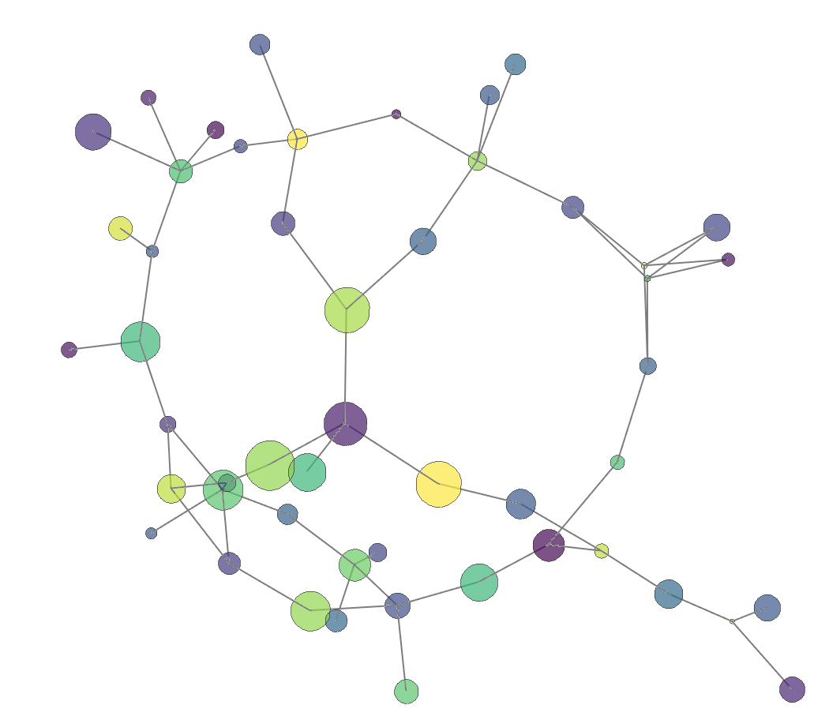
  2. The size of vertices is positive correlated to age (for actor) or grossing values (for movies).

