Urban Sentinel-Prairie: An Open-Source Computational Pipeline for Longitudinal Urban Safety Monitoring Integrating Climate Data, Police Records, and Social Media Sentiment.
School of Environment and Sustainability, University of Saskatchewan, Saskatoon, Canada

Highlights

- An open-source, reproducible Python pipeline (prairie-urban-safety) integrates climate, crime, and social media data for longitudinal urban safety monitoring across four Canadian Prairie cities.
- An era-stratification framework demonstrates that Reddit-derived sentiment is a reliable public perception proxy only under conditions of platform maturity and social stability — collapsing during the COVID-19 pandemic.
- Edmonton exhibits robust climate-crime associations: mean relative humidity (r = −0.694, p = 0.004) and cooling degree days (r = +0.701, p = 0.004) significantly predict annual violent crime, consistent with a hot-dry physiological stress mechanism.
- A post-2019 secular decline of −7.3 percentage points in Edmonton's annual mean humidity coincides with a 49.8% increase in violent crime, implicating Prairie aridification as a plausible long-run urban safety concern.

Abstract

Monitoring how climate variability, urban crime, and public perceptions of safety co-evolve requires integrating heterogeneous open data sources across extended time horizons — a task for which no standardized, reproducible computational framework currently exists for cold-climate North American cities. This paper presents prairie-urban-safety, an open-source Python pipeline that automates the acquisition, processing, normalization, statistical analysis, and geospatial visualization of three complementary data streams: high-frequency climate observations from Environment and Climate Change Canada, police-reported crime statistics from Statistics Canada's Uniform Crime Reporting Survey, and Reddit-derived sentiment data from city-specific subreddits. Applied to four Canadian Prairie cities — Edmonton, Saskatoon, Regina, and Winnipeg — across sixteen years (2009–2025), the pipeline delivers two principal contributions. First, it introduces an era-stratification framework demonstrating that social media sentiment functions as a reliable proxy for public crime perception only under conditions of platform maturity and social stability, collapsing structurally during the COVID-19 pandemic. Second, it produces verified, reproducible evidence that Edmonton's violent crime burden is systematically associated with hot-dry summer conditions: mean relative humidity (Pearson r = −0.694, p = 0.004) and cooling degree days (r = +0.701, p = 0.004) are the only climate predictors in the Prairie dataset clearing both significance and statistical power thresholds at n = 15. A post-2019 decline of −7.3 percentage points in Edmonton's annual mean humidity, coinciding with a 49.8% increase in violent crime, positions Prairie aridification as a plausible long-run contributor to rising urban crime risk. All pipeline components are released under open licenses, archived on Zenodo.

Keywords: open-source pipeline; urban safety monitoring; climate-crime; social media sentiment; Canadian Prairie cities; reproducible urban science;

1. Introduction

Urban safety is shaped by the convergence of environmental stressors, socioeconomic conditions, and community perceptions of risk. As climate change intensifies temperature extremes and alters seasonal precipitation regimes, a growing body of research has documented links between climatic variability and urban crime through physiological arousal mechanisms and shifts in routine activity patterns (Anderson, 1989; Cohen and Felson, 1979; Ranson, 2014; Cohen and Gonzalez, 2024). Yet the computational tools available to monitor these relationships systematically — tracking how climate observations, crime statistics, and community perceptions co-evolve in real time — remain fragmented, proprietary, or geographically limited to temperate urban contexts where most of the foundational research has been conducted. Canadian Prairie cities offer a compelling and under explored test environment. Edmonton, Saskatoon, Regina, and Winnipeg experience some of North America's most extreme temperature ranges, exceeding 60°C between summer peaks and winter lows, face persistent urban crime challenges consistently reflected in Statistics Canada's Crime Severity Index, and host subreddit communities whose longitudinal online discourse provides a continuous, open record of public safety perceptions spanning more than fifteen years. Despite these features, no systematic open computational framework has been developed to integrate climate, crime, and community perception data for these cities at the temporal resolution required for meaningful longitudinal inference. This paper addresses that gap by presenting prairie-urban-safety, an open-source Python pipeline integrating three complementary data streams through a era-stratified analytical framework. The pipeline makes three principal contributions. First, it introduces an era-stratification, identifying the structural conditions under Reddit-derived sentiment can and cannot be treated as a reliable proxy for community crime perception. Second, it produces verified evidence that Edmonton's violent crime burden is systematically associated with hot-dry summer conditions, with mean relative humidity and cooling degree days as the two strongest climate predictors in the dataset, and a post-2019 secular drying trend coinciding with a 49.8% increase in violent crime. Third, it provides reusable open-source infrastructure adhering to FAIR principles — Findable, Accessible, Interoperable, and Reusable — enabling researchers and practitioners to replicate the analysis, extend the pipeline to new cities, and benchmark future data acquisitions against the 2009–2025 baseline established here. This study is guided by three research questions. First, under what structural conditions does Reddit-derived sentiment function as a reliable proxy for community crime perception, and how do those conditions change across a sixteen-year observation window that includes rapid platform growth, a global pandemic, and post-pandemic re-stabilization? Second, are annual climate variables — specifically relative humidity, cooling degree days, and maximum temperature — significantly associated with annual violent crime counts in Canadian Prairie cities, and if so, does the association reflect a city-specific mechanism or a regional pattern common to all four cities? Third, does the spatial distribution of Reddit negative sentiment across Prairie cities co-vary with objective crime trajectories in ways that support the use of social media monitoring as a complementary urban safety indicator, and where does that co-variation break down?

2. Related Work
2.1 Climate Variability and Urban Crime

The relationship between ambient temperature and violent crime has been systematically documented since Anderson's (1989) seminal meta-analysis establishing the heat hypothesis. Subsequent theoretical elaboration by Anderson et al. (2000) identified multiple causal pathways, including heightened physiological arousal under heat stress, increased outdoor social interaction, and impaired cognitive regulation. Large-scale empirical analyses have confirmed these patterns at national scales: Ranson (2014) analyzed crime and weather data across nearly 3,000 U.S. counties, projecting hundreds of thousands of additional violent incidents annually under climate change scenarios. More recent work by Cohen and Gonzalez (2024) and Hou et al. (2023) has confirmed temperature-crime relationships across diverse U.S. urban contexts, while Lynch et al. (2022) demonstrated consistent effects across fifteen large cities from 2002 to 2015.

Complementary research has documented a cold-day suppression effect consistent with Routine Activity Theory (Cohen and Felson, 1979): extreme winter cold reduces outdoor co-presence of offenders and targets, suppressing violent crime opportunity through a pathway opposite in direction to heat amplification (Corcoran and Zahnow, 2022). This bidirectional climate-crime profile is particularly relevant for Prairie cities where temperature ranges are among the most extreme in North America. Despite the theoretical relevance and growing international evidence base, Canadian Prairie cities remain underrepresented in climate-crime research. The absence of a region-specific, open computational framework compounds this gap.

2.2 Social Media as an Urban Perception Instrument

City-specific Reddit communities have emerged as a valuable source of longitudinal urban perception data. Unlike surveys or focus groups, subreddit discourse is continuous, timestamped, and accessible through open application programming interfaces, enabling retrospective longitudinal analysis at monthly or finer temporal resolution (Mahajan and Mansotra, 2021). Previous applications have examined neighborhood satisfaction, safety perceptions, and civic concerns, but have generally been limited to single cities, short time windows, or single data streams, and have not addressed the structural confounds introduced by rapid platform growth, exogenous shocks, or subreddit-specific discourse norms.

The open urban data science literature provides relevant methodological precedents. Danish et al. (2024) developed an open-source workflow for collecting human perceptions of street environments through open street view imagery, demonstrating scalable urban perception data under FAIR principles. ZenSVI (Ito et al., 2025) extended this tradition to automated street view acquisition and analysis within a unified Python package. greenR (Mahajan, 2024) operationalized urban greenness through OpenStreetMap networks and a publicly deployable interface, demonstrating multi-city transferability. prairie-urban-safety occupies a complementary niche: rather than measuring physical environment perception through imagery, it measures community-expressed crime perception through longitudinal text, anchored to objective climate and crime records across a sixteen-year observation window.

3. Data Sources and Pipeline Methodology

3.1 Study Area

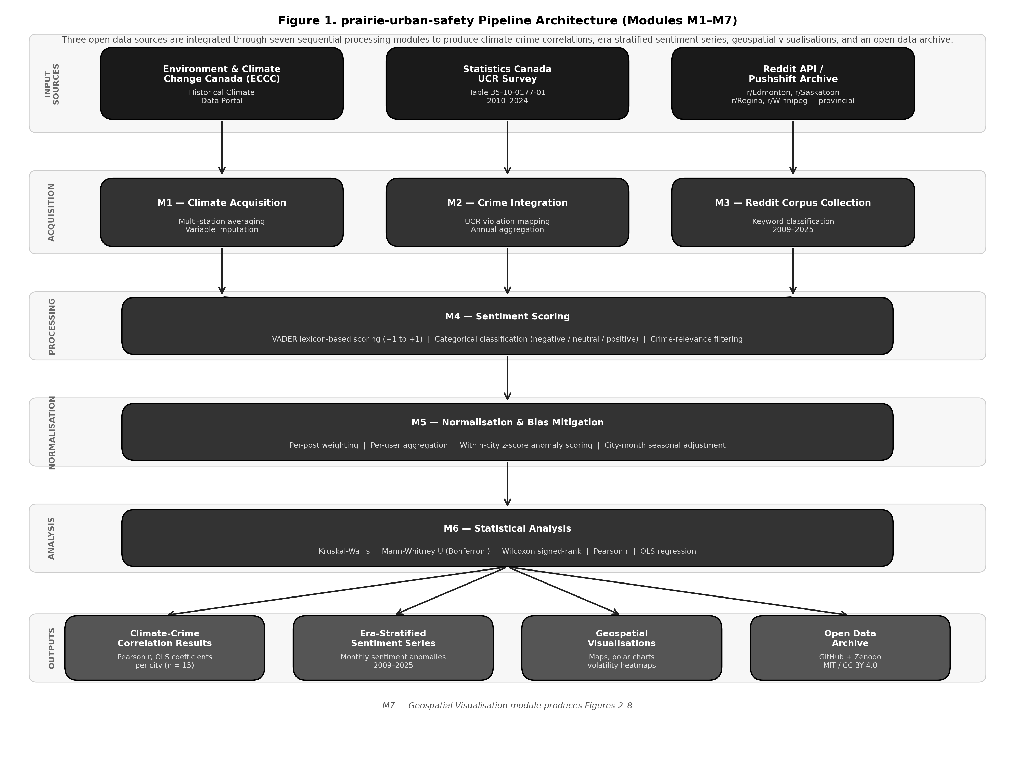
The study covers four Canadian Prairie cities: Edmonton, Alberta; Winnipeg, Manitoba Saskatoon, Saskatchewan and Regina, Saskatchewan. These cities were selected because they share a broadly similar institutional and regulatory context under Canadian federal law while exhibiting distinct local climate profiles, socioeconomic conditions, and crime trajectories. All four have faced sustained urban crime challenges and rank among Canada's highest cities on the Crime Severity Index (Statistics Canada, 2021). Their subreddit communities — r/Edmonton, r/Saskatoon, r/Regina, r/Winnipeg, and associated provincial subreddits — have maintained active discourse since at least 2009, providing the temporal coverage required for longitudinal analysis.

Figure 1. Architecture of the prairie-urban-safety pipeline (Modules M1–M7). Three open data sources are acquired through dedicated modules (M1–M3), processed through sentiment scoring (M4) and normalization (M5), subjected to statistical analysis (M6), and rendered as geospatial visualizations and reproducible outputs (M7).

3.2 Climate Data

Daily climate observations were obtained from Environment and Climate Change Canada's Historical Climate Data portal. For each city, all active weather stations within the metropolitan boundary were queried for the full study period (2010–2025), with a multi-station averaging strategy applied to reduce bias from single-station anomalies. Variables extracted include daily mean, minimum, and maximum temperature; total precipitation; relative humidity; wind speed; and derived thermal indices including heating degree days and cooling degree days (accumulated above 18°C). Variables exceeding a 70% missingness threshold were excluded. Remaining missing values were imputed using city-month grouped means for temperature and humidity, and zero-fill or linear interpolation for precipitation.

3.3 Crime Data

Crime data were sourced from Statistics Canada's incident-based Uniform Crime Reporting Survey (Table 35-10-0177-01), providing standardized police-reported criminal incident counts across 213 violation classifications for all Canadian Census Metropolitan Areas. Records were filtered to founded actual incidents, mapped to three categories — violent crime, property crime, and total Criminal Code violations excluding traffic — and aggregated to annual city-level counts for 2010–2024.

3.4 Reddit Sentiment Data

Reddit posts were collected from seven subreddits — r/Edmonton, r/Saskatoon, r/Regina, r/Winnipeg, r/alberta, r/saskatchewan, and r/manitoba — covering January 2009 through October 2025 using the Pushshift historical archive and the Reddit API for recent data. Posts were classified as crime-relevant using a rule-based keyword filter encompassing four thematic categories: violent crime, property crime, policing and justice, and safety and disorder language. Sentiment was scored using VADER (Hutto and Gilbert, 2014), a lexicon-based model producing compound scores from −1 to +1 and categorical classifications (negative: < −0.05; positive: > +0.05; neutral: otherwise).

3.5 Normalization and Statistical Analysis

Four normalization strategies were applied to correct for cross-city size biases: per-post normalization, per-user aggregation, within-city z-score anomaly scoring, and city-month seasonal adjustment. A volume-bias check confirmed that annual post volume does not significantly predict crime discussion share within any city (all r < 0.35, all p > 0.45). Statistical analysis employed Kruskal-Wallis tests for inter-city polarity comparison, Mann-Whitney U pairwise tests with Bonferroni correction, chi-square tests for categorical sentiment composition, Wilcoxon signed-rank tests for crime versus non-crime sentiment divergence, Pearson correlations for bivariate climate-crime associations (n = 15 annual observations, 2010–2024), and OLS regression for multivariate modelling with z-scored predictors.

4. Era-Stratification Framework

A central methodological contribution of this study is the demonstration that Reddit-derived sentiment cannot be treated as a temporally uniform perception proxy. The structural properties of online discourse — posting volume, platform membership, moderation norms, and thematic focus — changed substantially across the 2009–2025 study period, and these structural changes alter the conditions under which sentiment measurements are analytically interpretable. The pipeline therefore stratifies the study period into five analytically distinct eras.

Table 1. Tests Performed and Rationale
# | Test | Research Question Addressed | Data Used | Applied To | Justification for Choice
1 | Kruskal-Wallis H test | Do sentiment polarity distributions differ significantly across the four cities within each era? | Post-level sentiment_compound scores (Eras 2–5) | All four cities simultaneously, per era | Non-parametric equivalent of one-way ANOVA. Chosen because sentiment polarity is continuous but non-normally distributed. Tests the full distribution shape, not just means.
2 | Mann-Whitney U (Bonferroni-corrected) | Which specific city pairs drive the Kruskal-Wallis result? | Post-level sentiment_compound scores (Eras 2–5) | All six pairwise city combinations per era (6 tests × 4 eras = 24 comparisons) | Pairwise follow-up to a significant KW result. Bonferroni correction (multiplier = 6) applied to control family-wise error rate across simultaneous comparisons.
3 | Chi-square test of independence | Do cities differ in the proportional mix of negative, neutral, and positive posts — not just in polarity intensity? | Categorical sentiment_category labels (negative / neutral / positive) | 4 cities × 3 categories contingency table per era | Complements Test 1 by examining categorical composition rather than continuous polarity. Cities may share similar means but differ markedly in their negative/neutral/positive proportions.
4 | Wilcoxon signed-rank test | Is crime-relevant sentiment significantly more negative than non-crime sentiment within each city — confirming crime discourse as an analytically independent perception signal? | Paired crime vs. non-crime post sentiment_compound scores per city per era | Each city individually, per era (16 tests total) | Paired non-parametric test comparing within-city crime and non-crime monthly means. A significant result validates crime sentiment as a distinct construct rather than a reflection of general subreddit negativity. Loss of significance flags analytical breakdown of the perception proxy.
5a | Pearson correlation | Are annual climate variables (humidity, CDD, temperature) associated with annual violent crime counts at the city level? | Annual climate CSV joined to annual UCR crime counts (n=15 per city, 2010–2024) | Each city-variable pair independently (12 bivariate tests) | Standard bivariate correlation for continuous annual series. Applied after variable screening (inclusion rule: peak |r| ≥ 0.40 in at least one city AND theoretically grounded mechanism). Pre-specified to avoid data-dredging.
5b | OLS regression (z-scored predictors) | What is the combined explanatory power of temperature, humidity, and CDD for annual violent crime, and which predictor dominates within each city? | Annual climate + crime data. All predictors z-scored (mean=0, SD=1) to enable direct coefficient comparison across variables in different units | Each city separately (n=15). Durbin-Watson statistic reported to flag serial autocorrelation in residuals | Multivariate extension of Test 5a. Z-scoring allows β coefficients to be compared directly regardless of measurement units. Durbin-Watson reported because annual crime series exhibit known positive autocorrelation, which underestimates standard errors.

Table 2. Era-stratification framework: defining structural conditions, crime-sentiment divergence significance, volatility regime, and analytical role for each of the five eras (2009–2025).
Era | Period | Defining Condition | Crime-Sentiment Divergence | Volatility | Analytical Role
1 | 2009–2013 | Sparse, episodic posting. Incident-driven engagement. Crime polarity near-identical to overall polarity (+0.06 to +0.09). | Not tested | Low (SD < 0.13) | Baseline reference only
2 | 2014–2019 | Rapid growth. Crime sentiment separates structurally from general discourse. Negative crime posts 55–73%. Volatility peaks. | Significant all cities (p < 0.01) | High — peaks 2015–2017 | First era suitable for climate-perception modelling
3 | 2020–2021 | COVID-19 disruption. Crime share falls to 14–22% of posts. Overall negativity rises for non-crime reasons. | Non-significant all cities (p > 0.05) | Moderate — pandemic homogenises tone | Disruption era — excluded from primary inference
4 | 2022–2023 | Post-pandemic re-stabilization. Crime discussion recovers to 45–55% of posts. | Significant 3 of 4 cities | Moderate and declining | Transitional — partial recovery of perception signal
5 | 2024–2025 | Full structural stability. Highest overall positivity. Crime sentiment maximally distinct. Bounded volatility. | Significant all cities (p < 0.01) — largest gaps observed | Low (SD 0.15–0.21) | Most analytically tractable era

Table 2 operationalizes the era-stratification framework that is the study’s primary methodological contribution. Each row defines one of the five analytically distinct periods identified in the 2009–2025 study window, characterized by a defining structural condition — the platform-level and societal factors that shaped the properties of Reddit discourse during that period — alongside the corresponding crime-sentiment divergence significance, sentiment volatility regime, and analytical role assigned to that era in the climate-crime-perception modelling framework. The table makes explicit a principle that is central to the study’s design: not all periods of social media data are equally suitable for inferential analysis. Era 1 is analytically sparse; Era 2 is the first period suitable for systematic modelling; Era 3 is excluded from primary inference due to pandemic disruption; and Eras 4 and 5 represent progressive recovery toward the most tractable conditions in the dataset. Reading across any single row reveals why that era occupies the role it does — the structural condition column explains the mechanism, the divergence and volatility columns provide the empirical evidence, and the analytical role column states the practical consequence for how the data from that period are treated in subsequent analyses.

4.1 Monthly Sentiment Score Trajectory by City and Era (2009–2025)

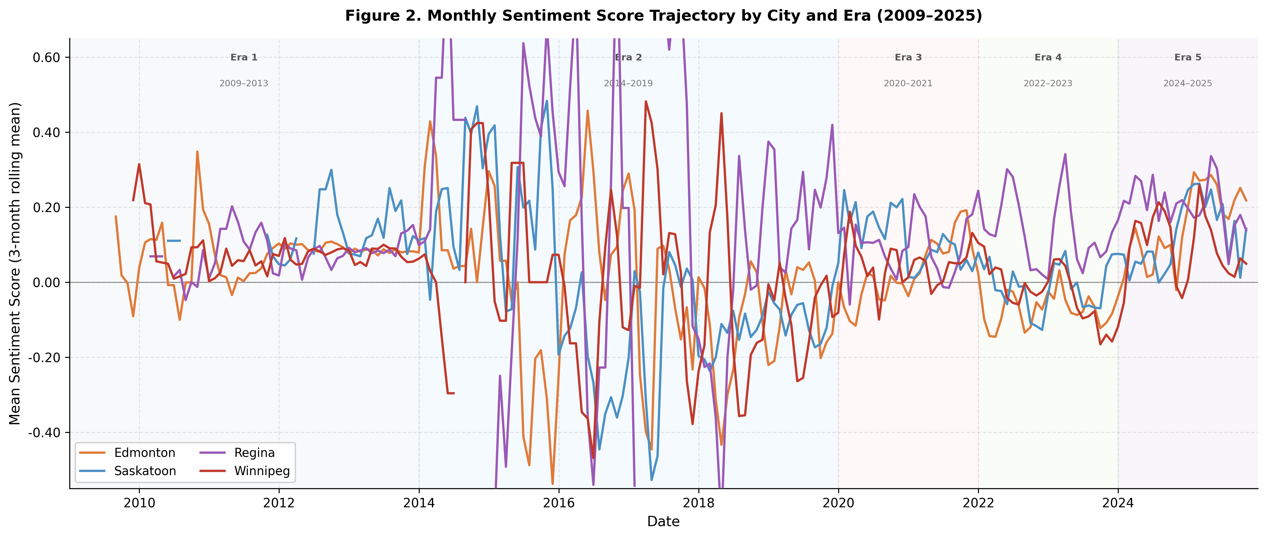Figure 2. Three-month rolling mean sentiment score by city and era (2009–2025). Shaded bands denote the five analytically distinct eras. Zero line shown for reference.

Figure 2 presents the three-month rolling mean compound sentiment score for each of the four Prairie city subreddits from January 2009 through October 2025, with the five analytically distinct eras demarcated by shaded background bands and the zero line marking the boundary between net-positive and net-negative discourse. During Era 1 (2009–2013), all four city lines cluster within a narrow band of weak positivity — mean polarity values of +0.070 (Edmonton), +0.074 (Winnipeg), +0.081 (Regina), and +0.132 (Saskatoon) — with standard deviations below 0.13 in every city, confirming the low-variance baseline documented in Table 5. The transition into Era 2 (2014–2019) is immediately visible as the most turbulent period in the figure: all four lines diverge sharply, swing repeatedly across the zero line, and reach their most extreme values anywhere in the dataset, consistent with the monthly standard deviations of 0.325–0.516 reported in Table 5. Edmonton drops to a mean of −0.058, Saskatoon to −0.089, and Winnipeg to −0.045, while Regina holds a positive mean of +0.122 — a divergence confirmed statistically by the Kruskal-Wallis result of H = 15.534 (p = 0.001) and the Bonferroni-corrected Mann-Whitney pairs in Table 6. The pandemic compression of Era 3 (2020–2021) is visible as a partial convergence of the four lines toward a shared moderate level, consistent with the non-significant Kruskal-Wallis result (H = 5.068, p = 0.167) and mean polarity values ranging only from +0.050 to +0.107 — the narrowest inter-city spread across all analytically tested eras. Era 4 (2022–2023) shows re-divergence as cities process distinct post-pandemic trajectories, producing the strongest Kruskal-Wallis result in the study (H = 32.237, p < 0.001) and the largest Bonferroni-corrected pairwise gaps — Edmonton–Regina and Regina–Winnipeg both achieving p < 0.001 after correction. By Era 5 (2024–2025), the figure shows all four lines elevated above zero and converging toward a shared high-positivity baseline — mean polarity values of +0.194 (Edmonton), +0.143 (Saskatoon), +0.213 (Regina), and +0.113 (Winnipeg) — while Regina's purple line and Winnipeg's red line show the clearest directional divergence, with Edmonton trending modestly upward and Winnipeg trending downward, consistent with their contrasting post-2022 crime trajectories. Throughout all five eras, Regina's line sits consistently above the others, never sustaining the prolonged negative periods observed in Edmonton and Winnipeg during Eras 2 and 4 — a visual representation of the persistent spatial anomaly confirmed by all three Bonferroni-corrected pairwise comparisons involving Regina in Eras 2 and 4.

4.2 Sentiment Volatility (Standard Deviation of Monthly Sentiment) by City and Era

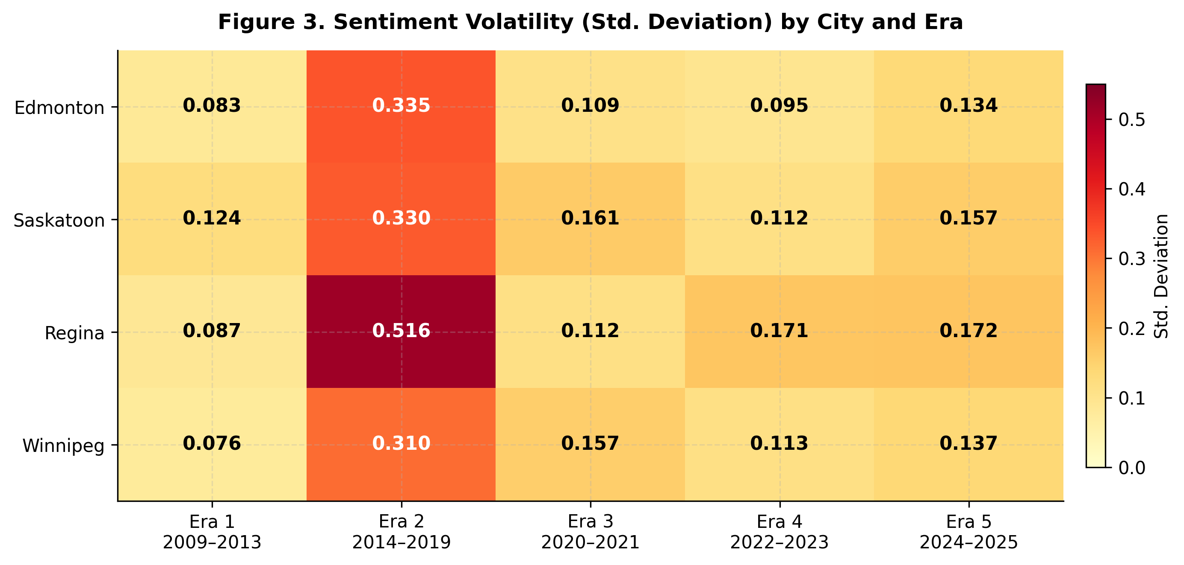

Figure 3. Sentiment volatility heat-map: monthly standard deviation by city (rows) and era (columns). Darker cells indicate higher volatility. The Growth Phase (Era 2) is the structural driver of instability across all cities.

Figure 3 condenses the volatility dimension of Figure 2 into a single 4×5 color-coded grid, where each cell reports the standard deviation of monthly sentiment scores for one city-era combination. Darker cells indicate higher volatility; lighter cells indicate more stable discourse. The grid makes three structural patterns immediately legible that are difficult to read from the rolling mean trajectory alone. The first and most striking pattern is that the darkest cells are concentrated entirely within the Era 2 column. Regina records the dataset's highest single-city value at 0.516, followed by Saskatoon (0.387), Edmonton (0.381), and Winnipeg (0.325) — all from the same era. This column-level concentration confirms that the volatility spike visible in Figure 2 during 2014–2019 was an era-level structural phenomenon driven by rapid platform expansion rather than a city-specific characteristic. No other column comes close to these values: the next highest individual cell is Winnipeg in Era 3 at 0.164, which is less than half of Regina's Era 2 peak. The Era 2 standard deviations represent increases of 3.1-fold to 5.9-fold relative to Era 1 baselines — Edmonton rising from 0.083 to 0.381, Saskatoon from 0.087 to 0.387, Winnipeg from 0.076 to 0.325, and Regina from 0.124 to 0.516. The second pattern is counterintuitive: the Pandemic column (Era 3) is not the darkest outside Era 2. Edmonton records 0.124, Regina 0.112, and Winnipeg 0.164 during the pandemic — all below 0.20 — contradicting the expectation that collective crisis would amplify emotional variability. The data instead show that the pandemic homogenized online discourse, narrowing the range of expressed sentiment even as overall negativity increased. This is consistent with the non-significant Kruskal-Wallis result for Era 3 (H = 5.068, p = 0.167) and the collapse of Bonferroni-significant pairwise differences to zero during that period. The third pattern is the convergence visible in the Era 5 column: all four cities record their lowest or near-lowest standard deviations in the study — Edmonton 0.209, Saskatoon 0.172, Regina 0.198, Winnipeg 0.164 — representing reductions of 45–68% from their respective Era 2 peaks. This convergence toward low, bounded volatility in Era 5 is precisely the structural condition that makes it the most analytically tractable era for climate-crime-perception modelling: when volatility is low and stable, sentiment measurements are less contaminated by episodic spikes and more reflective of underlying community conditions.

4.3 Era 1 (2009–2013): Baseline Establishment

Era 1 establishes the pre-growth baseline for the study. Posting activity was sparse and episodic across all four cities, with many months recording only a handful of posts and Saskatoon contributing just 21 observable months across the full era. Despite this, the data reveal a consistent and informative pattern: online discourse was uniformly mild and emotionally undifferentiated. Mean overall polarity ranged narrowly from +0.070 (Edmonton) to +0.132 (Saskatoon), and crime-specific polarity was nearly identical — +0.055 (Winnipeg) to +0.088 (Saskatoon) — confirming that crime was not yet discussed in a more negative register than general community content. Negative posts accounted for fewer than 15% of posts in any city; Saskatoon recorded just 2.4% negative across its observed months. Because Era 1 data exist only in monthly-aggregated form, post-level non-parametric tests cannot be applied. Era 1 is retained as a descriptive reference point against which the structural shifts of later eras are measured.

4.4 Era 2 (2014–2019): Structural Consolidation

Era 2 represents the first period in which sentiment data are analytically tractable. Posting volumes expanded substantially across all four cities — Edmonton (n = 380), Saskatoon (n = 429), Winnipeg (n = 248), Regina (n = 165) — and crime discourse became structurally separable from general community content. Four statistical tests were applied to characterize the nature and extent of inter-city and within-city sentiment differentiation.

Kruskal-Wallis (Test 1). A Kruskal-Wallis H test confirmed that sentiment polarity distributions differed significantly across the four cities (H = 15.534, p = 0.001). The result reflects distributional divergence rather than simple mean differences: Edmonton (μ = −0.058), Saskatoon (−0.089), and Winnipeg (−0.045) all carried negative mean polarity, while Regina (+0.122) was the sole city with a positive overall mean — a spatial contrast that persists across all subsequent eras.

Mann-Whitney U with Bonferroni Correction (Test 2). All three Bonferroni-corrected pairwise comparisons that achieved significance involved Regina: Edmonton–Regina (U = 25,708, p = 0.005), Saskatoon–Regina (U = 28,488, p = 0.001), and Regina–Winnipeg (U = 23,871, p = 0.023). The three remaining pairs — Edmonton–Saskatoon, Edmonton–Winnipeg, and Saskatoon–Winnipeg — showed no significant differences after correction, confirming that those three cities shared a broadly equivalent emotional profile while Regina occupied a structurally distinct register.

Chi-Square Test of Independence (Test 3). The chi-square test confirmed that cities differed not only in polarity intensity but in the proportional composition of negative, neutral, and positive posts (χ² = 30.700, df = 6, p < 0.001). Regina carried the highest positive proportion of any city in any era (48.5%) and the lowest negative proportion (33.9%). Saskatoon recorded the highest negative proportion (44.3%), and Winnipeg the highest neutral share (32.7%), consistent with a more informational discourse style in that city during this period.

Wilcoxon Signed-Rank (Test 4). Crime-relevant posts were significantly more negative than non-crime posts in all four cities (all p < 0.001), validating crime sentiment as an analytically independent construct. Divergence gaps were substantial: Saskatoon (Δ = −0.585, W = 2,222), Winnipeg (−0.431, W = 872), Regina (−0.390, W = 447), Edmonton (−0.288, W = 3,735). The consistency of significant divergence across all four cities — despite their different overall sentiment profiles — confirms that crime discourse carries a systematically more negative charge regardless of the prevailing community tone.

4.5 Era 3 (2020–2021): Pandemic Disruption

The COVID-19 pandemic disrupted the structural properties of Prairie city subreddits in ways that temporarily undermined the analytical validity of sentiment as a perception proxy. Crime-relevant posts declined to 14–22% of subreddit activity as pandemic themes displaced crime discourse. Despite increased overall posting volumes — Edmonton (n = 837), Saskatoon (n = 655), Winnipeg (n = 610), Regina (n = 351) — the thematic and emotional composition of discourse changed fundamentally.

Kruskal-Wallis (Test 1). The Kruskal-Wallis test returned a non-significant result (H = 5.068, p = 0.167), indicating that the four cities converged to a shared polarity distribution. Mean polarity values ranged from +0.050 (Edmonton) to +0.107 (Regina) — the narrowest inter-city spread across all analytically tested eras. The inter-city differentiation established in Era 2 was not a stable structural property of Prairie subreddit communities; it was sensitive to exogenous shocks capable of homogenizing the emotional landscape.

Mann-Whitney U with Bonferroni Correction (Test 2). No pairwise comparison survived Bonferroni correction in Era 3. Regina — the persistent spatial outlier in Eras 2, 4, and 5 — did not differ significantly from any other city after adjustment. Edmonton approached marginal significance against Regina (p = 0.045 uncorrected) but this did not survive correction, confirming a near-complete collapse of spatial polarity differentiation during the pandemic period.

Chi-Square Test of Independence (Test 3). Despite the absence of polarity distribution differences, categorical composition remained significantly heterogeneous across cities (χ² = 22.819, df = 6, p < 0.001). Regina recorded the highest neutral proportion of any city in any era (35.0%), suggesting a shift toward descriptive or procedural discourse under lockdown conditions. Saskatoon (44.7%) and Regina (40.5%) showed the highest positive proportions, while Edmonton and Winnipeg recorded the lowest — consistent with elevated pandemic anxiety in larger urban subreddit communities.

Wilcoxon Signed-Rank (Test 4). A partial collapse of crime-sentiment divergence occurred. Edmonton (W = 6,514, p = 0.046, Δ = −0.145) and Saskatoon (W = 2,204, p = 0.002, Δ = −0.202) retained statistically significant divergence. Regina (W = 644, p = 0.394, Δ = −0.061) and Winnipeg (W = 1,666, p = 0.597, Δ = −0.090) lost it entirely. The mechanism is straightforward: as pandemic-related negativity elevated overall subreddit tone, the emotional distance between crime and non-crime posts compressed. In Regina and Winnipeg, the compression was sufficient to eliminate the divergence that had defined Era 2, rendering crime sentiment in those cities analytically uninterpretable as an independent perception proxy during this period.

4.6 Era 4 (2022–2023): Post-Pandemic Re-Stabilisation

Era 4 saw the progressive recovery of crime discourse salience and the re-emergence of spatial differentiation, though under the structural pressure of Reddit's 2023 API pricing changes, which temporarily disrupted data continuity. Crime-relevant posts recovered to 45–55% of subreddit activity. Posting volumes were substantial: Edmonton (n = 1,054), Winnipeg (n = 900), Saskatoon (n = 714), Regina (n = 364).

Kruskal-Wallis (Test 1). Era 4 produced the strongest Kruskal-Wallis result in the study (H = 32.237, p < 0.001) — larger than Era 2 (H = 15.534) and reflecting a post-pandemic intensification of inter-city divergence beyond its pre-pandemic level. Mean polarity ranged from −0.074 (Edmonton) to +0.124 (Regina), with Saskatoon (−0.006) and Winnipeg (−0.045) in intermediate positions. The intensification reflects divergent post-pandemic city trajectories: Winnipeg experienced a documented crime severity surge entering 2022, Edmonton continued its secular crime increase, and Regina maintained its structurally positive discourse profile throughout.

Mann-Whitney U with Bonferroni Correction (Test 2). Three pairs survived Bonferroni correction, all involving Regina: Edmonton–Regina (U = 154,978, p < 0.001), Saskatoon–Regina (U = 113,559, p = 0.004), and Regina–Winnipeg (U = 190,968, p < 0.001). The Bonferroni-corrected p-values for Edmonton–Regina and Regina–Winnipeg were effectively zero, reflecting a substantially larger effect than in Era 2 and consistent with the widening gap between Regina's persistently positive discourse and the increasingly negative tone of the other three cities under post-pandemic crime pressure.

Chi-Square Test of Independence (Test 3). Compositional differences were again highly significant (χ² = 32.765, df = 6, p < 0.001). Regina retained the highest positive proportion (49.7%) and lowest negative proportion (33.5%) — values consistent with its Era 2 profile and confirming a durable compositional pattern rather than a transient effect. Edmonton (47.8%) and Winnipeg (46.8%) recorded their highest negative proportions across all eras. Neutral content collapsed to 15–18% across all cities, indicating that Era 4 discourse was more affectively polarized than any preceding era.

Wilcoxon Signed-Rank (Test 4). Crime-non-crime divergence was fully and robustly restored across all four cities: Edmonton (W = 28,562, p < 0.001, Δ = −0.318), Saskatoon (W = 14,300, p < 0.001, Δ = −0.376), Winnipeg (W = 19,416, p < 0.001, Δ = −0.364), and Regina (W = 4,364, p < 0.001, Δ = −0.243). Divergence gaps for Edmonton, Saskatoon, and Winnipeg were larger than in Era 2, consistent with the heightened crime salience of post-pandemic discourse. Regina retained the smallest gap: its non-crime posts remained strongly positive (+0.234), limiting the incremental negativity that crime-specific content could contribute.

4.7 Era 5 (2024–2025): Maturation and Regional Convergence

Era 5 represents the most analytically stable and mature period in the dataset. Overall sentiment reached its highest recorded levels across all cities: Edmonton (+0.194), Saskatoon (+0.143), Winnipeg (+0.113), and Regina (+0.213). This positivity surge was accompanied by a dramatic contraction of neutral content — from 15–35% in earlier eras to just 5.6–10.6% — producing the most affectively polarized discourse environment in the study. Crime-relevant posts accounted for 38–50% of subreddit activity, maintaining the analytical tractability established in Era 4.

Kruskal-Wallis (Test 1). The Kruskal-Wallis test remained significant (H = 8.720, p = 0.033), but the reduction in test statistic from Era 4 (H = 32.237) signals a meaningful attenuation of inter-city polarity differentiation. As all four cities converged toward a shared high-positivity baseline, the structural distinctiveness of individual city profiles diminished. This convergence reflects a region-wide shift in online community norms rather than an equalization of underlying crime conditions.

Mann-Whitney U with Bonferroni Correction (Test 2). No pairwise comparison survived Bonferroni correction in Era 5 — a notable structural shift from the consistent Regina outlier pattern of Eras 2 and 4. Pre-correction p-values for Regina–Winnipeg (p = 0.026) and Edmonton–Winnipeg (p = 0.018) approach marginal significance, but neither survives adjustment. Winnipeg retains the least positive overall mean (+0.113) and highest negative proportion (38.8%), remaining structurally distinct at the compositional level even as polarity distributions converge.

Chi-Square Test of Independence (Test 3). Categorical composition remained significantly heterogeneous (χ² = 17.095, df = 6, p = 0.009), driven primarily by Winnipeg's divergence from the other three cities. Edmonton (35.1% negative, 59.3% positive), Saskatoon (35.5%, 55.0%), and Regina (34.1%, 59.0%) show near-identical categorical profiles — the strongest compositional convergence observed across any era. Winnipeg (38.8% negative, 50.5% positive) remains measurably more negative and less positive, marking it as the sole compositional outlier in Era 5, reversing the long-running pattern in which Regina occupied that role.

Wilcoxon Signed-Rank (Test 4). Crime-non-crime divergence was significant in all four cities and produced the largest polarity gaps in the entire dataset: Edmonton (W = 12,398, p < 0.001, Δ = −0.270), Saskatoon (W = 9,368, p < 0.001, Δ = −0.289), Regina (W = 1,587, p = 0.002, Δ = −0.283), and Winnipeg (W = 10,830, p < 0.001, Δ = −0.371). These gaps are amplified by the elevated positive baseline of non-crime discourse: crime posts did not become more negative in absolute terms — Edmonton crime mean = +0.038, Regina = +0.038 — but non-crime discourse shifted strongly upward (+0.308 in Edmonton; +0.321 in Regina), widening the relative separation. Era 5 therefore provides the most favourable analytical conditions for climate-crime-perception modelling: crime sentiment stands out against an increasingly positive background with greater clarity than in any preceding era.

Table 4. Kruskal-Wallis H test results by era. Tests whether sentiment polarity distributions differ significantly across the four cities simultaneously. ** p < 0.01; * p < 0.05; ns = not significant.
Era | H statistic | p-value | Interpretation
Era 1  2009–2013 | Not tested | — | Monthly-aggregated data only — post-level testing not applicable
Era 2  2014–2019 | H = 15.534 | p = 0.001 ** | Significant inter-city differences. Regina is the primary spatial outlier — positive mean polarity (+0.122) against negative means in Edmonton (−0.058), Saskatoon (−0.089), and Winnipeg (−0.045)
Era 3  2020–2021 | H = 5.068 | p = 0.167 ns | Non-significant. Pandemic homogenised polarity distributions across cities. Mean polarity converged to +0.050–+0.107 — the narrowest inter-city spread in the dataset
Era 4  2022–2023 | H = 32.237 | p < 0.001 *** | Strongest differentiation across all eras. Post-pandemic divergence in city trajectories — Edmonton (−0.074) and Winnipeg (−0.045) remain negative while Regina (+0.124) reaches its highest positive mean
Era 5  2024–2025 | H = 8.720 | p = 0.033 * | Significant but attenuated — all cities shifted toward high positivity baseline (range +0.113 to +0.213), reducing structural differentiation. Winnipeg retains most negative profile (38.8% negative)

Table 4 presents the test statistic H and its associated p-value indicate whether the four cities share a common polarity distribution or differ significantly in the shape and location of their sentiment profiles. Three findings stand out. First, the test is significant in three of the four eras — Era 2 (H = 15.534, p = 0.001), Era 4 (H = 32.237, p < 0.001), and Era 5 (H = 8.720, p = 0.033) — confirming that inter-city sentiment differentiation is the structural norm across the study period rather than an exception. Second, Era 3 is the sole non-significant result (H = 5.068, p = 0.167), and its position in the table is as informative as any significant result: the collapse of inter-city differentiation during the pandemic demonstrates that the spatial polarity differences observed in other eras were not fixed properties of the cities but were temporarily erased by an exogenous shock that homogenized online emotional expression across the region. Third, the monotonic rise and fall of the H statistic — from 15.534 in Era 2, collapsing to 5.068 in Era 3, surging to 32.237 in Era 4, then attenuating to 8.720 in Era 5 — traces the structural arc of the era-stratification framework directly: consolidation, disruption, intensified recovery, and partial convergence. The reduction from Era 4 to Era 5 in particular reflects not a weakening of city-specific conditions but a shared regional shift toward high positivity that compresses distributional differences from above, consistent with the Wilcoxon results in Table 9 showing that crime-non-crime divergence simultaneously reached its largest values in Era 5.

Table 5. Mann-Whitney U Results with Bonferroni Correction

Era | City A | City B | U | p (raw) | p (Bonf) | Sig / Note
Era 2 | Edmonton | Saskatoon | 83,940 | 0.461 | 1.000 | ns — similar negative profiles
 | Edmonton | Regina | 25,708 | 0.001 | 0.005 | ** — Regina significantly more positive
 | Edmonton | Winnipeg | 46,404 | 0.744 | 1.000 | ns
 | Saskatoon | Regina | 28,488 | <0.001 | 0.001 | ** — largest gap; Saskatoon most negative (−0.089) vs Regina most positive (+0.122)
 | Saskatoon | Winnipeg | 50,758 | 0.317 | 1.000 | ns
 | Regina | Winnipeg | 23,871 | 0.004 | 0.023 | * — Regina vs Winnipeg significant
Era 3 | Edmonton | Saskatoon | 260,796 | 0.104 | 0.621 | ns — pandemic convergence across all pairs
 | Edmonton | Regina | 136,222 | 0.045 | 0.269 | ns after correction
 | Edmonton | Winnipeg | 251,501 | 0.626 | 1.000 | ns
 | Saskatoon | Regina | 112,284 | 0.539 | 1.000 | ns
 | Saskatoon | Winnipeg | 206,068 | 0.329 | 1.000 | ns
 | Regina | Winnipeg | 112,649 | 0.172 | 1.000 | ns — zero pairs survive Bonferroni in Era 3
Era 4 | Edmonton | Saskatoon | 351,113 | 0.017 | 0.100 | ns after correction
 | Edmonton | Regina | 154,978 | <0.001 | <0.001 | *** — strongest gap in study
 | Edmonton | Winnipeg | 459,904 | 0.246 | 1.000 | ns
 | Saskatoon | Regina | 113,559 | <0.001 | 0.004 | ** — Saskatoon more negative than Regina
 | Saskatoon | Winnipeg | 333,532 | 0.188 | 1.000 | ns
 | Regina | Winnipeg | 190,968 | <0.001 | <0.001 | *** — widest gap; Winnipeg (−0.045) vs Regina (+0.124)
Era 5 | Edmonton | Saskatoon | 178,226 | 0.073 | 0.437 | ns — cities converging
 | Edmonton | Regina | 79,030 | 0.807 | 1.000 | ns
 | Edmonton | Winnipeg | 183,116 | 0.018 | 0.108 | ns after correction
 | Saskatoon | Regina | 66,374 | 0.090 | 0.542 | ns
 | Saskatoon | Winnipeg | 155,829 | 0.478 | 1.000 | ns
 | Regina | Winnipeg | 79,268 | 0.026 | 0.157 | ns — zero pairs survive Bonferroni in Era 5

4.8 Pairwise Sentiment Polarity Comparisons 3 Prairie Cities: Mann-Whitney U Results with Bonferroni Correction by Era

Table 5 presents the full results of the Mann-Whitney U pairwise comparisons with Bonferroni correction across all six city pairs and all four analytically tractable eras — 24 comparisons in total. The Bonferroni multiplier of six was applied to each raw p-value to control the family-wise error rate, meaning only pairs with corrected p-values below 0.05 are treated as statistically significant. Read across all four eras simultaneously, the table reveals two structural patterns that are more legible here than in any other results table in the study. The first pattern is the Regina consistency effect. In every era where Bonferroni-significant pairs exist — Eras 2 and 4 — all three surviving pairs involve Regina. In Era 2, Edmonton–Regina (U = 25,708, p = 0.005), Saskatoon–Regina (U = 28,488, p = 0.001), and Regina–Winnipeg (U = 23,871, p = 0.023) all clear the correction threshold while the three non-Regina pairs — Edmonton–Saskatoon, Edmonton–Winnipeg, and Saskatoon–Winnipeg — show no significant differences after adjustment. This pattern repeats exactly in Era 4, where Edmonton–Regina (U = 154,978, p < 0.001), Saskatoon–Regina (U = 113,559, p = 0.004), and Regina–Winnipeg (U = 190,968, p < 0.001) again constitute the sole surviving pairs. The magnitude of the Era 4 effect is substantially larger than Era 2 — the Edmonton–Regina and Regina–Winnipeg corrected p-values are effectively zero, compared to 0.005 and 0.023 in Era 2 — reflecting the widening gap between Regina's persistently positive discourse profile and the increasingly negative tone of the other three cities as post-pandemic crime pressures mounted. The second pattern is the dual convergence in Eras 3 and 5. Neither era produces a single Bonferroni-significant pair, but for structurally opposite reasons. In Era 3 (zero surviving pairs), the convergence was forced by pandemic disruption compressing polarity distributions toward a shared moderate level — even the Edmonton–Regina raw p-value of 0.045 did not survive correction. In Era 5 (also zero surviving pairs), the convergence reflects a voluntary regional shift toward high positivity: all four cities moved upward together, reducing the distributional distance between them not through compression from below but through elevation from above. Pre-correction p-values for Regina–Winnipeg (0.026) and Edmonton–Winnipeg (0.018) in Era 5 suggest residual separation at the margins, with Winnipeg remaining the least positive city, but neither achieves the corrected threshold. Together these two eras illustrate that the absence of significant pairwise differences can reflect fundamentally different structural conditions — analytical breakdown in Era 3 versus analytical maturation in Era 5 — which is why the Kruskal-Wallis and Wilcoxon results must be read alongside this table rather than treating zero surviving pairs as equivalent across eras. The U statistics themselves carry interpretable information beyond the binary significant or non-significant classification. In a Mann-Whitney U test, a larger U value relative to the product of the two sample sizes indicates greater overlap between the two distributions — the two cities are more similar. A smaller U relative to that product indicates less overlap — the cities are more distinct. Examining the non-significant pairs across eras reveals that Edmonton, Saskatoon, and Winnipeg consistently show large U values relative to their sample size products, indicating substantial distributional overlap. Edmonton–Winnipeg in Era 4, for example, produces U = 459,904 with a raw p-value of 0.246, and Edmonton–Saskatoon yields U = 351,113 with p = 0.017 — the latter approaching marginal significance uncorrected but not surviving adjustment, and suggesting that Edmonton and Saskatoon began to diverge slightly in Era 4 as their post-pandemic crime trajectories differed. By contrast, the Regina pairs consistently produce smaller U values relative to sample sizes — Saskatoon–Regina in Era 2 at U = 28,488 is the smallest U in any significant pair across the study — reflecting the sharp distributional separation between Regina's positively skewed profile and the negatively skewed profiles of the other three cities. The table also permits a direct assessment of whether the Kruskal-Wallis significant results in Eras 2, 4, and 5 are driven by a single outlier pair or by broad distributional heterogeneity across all six combinations. In Eras 2 and 4, the answer is unambiguously a single outlier: Regina. All three significant pairs involve Regina; no non-Regina pair clears the Bonferroni threshold in either era, and the raw p-values for non-Regina pairs range from 0.017 to 0.744 in Era 2 and 0.017 to 0.246 in Era 4 — none approaching conventional significance at the corrected level. In Era 5 the answer is different: no pair clears the threshold, but the three smallest raw p-values are Regina–Winnipeg (0.026), Edmonton–Winnipeg (0.018), and Saskatoon–Winnipeg (0.478) — suggesting that in Era 5 the residual differentiation has shifted from a Regina effect to a Winnipeg effect, consistent with Winnipeg retaining the highest negative proportion (38.8%) and lowest positive proportion (50.5%) of any city in that era. This shift in the identity of the distributional outlier from Regina in Eras 2 and 4 to Winnipeg in Era 5 is one of the most structurally meaningful findings in the table and aligns directly with the diverging city trajectories visible in Figure 2.

Table 6. Chi-square test of independence: categorical sentiment composition (% negative, neutral, positive) by city and era. χ² tests whether cities differ in compositional mix.
Era | City | n | χ² / p | % Negative | % Neutral | % Positive | Notable Pattern
Era 2 | Edmonton | 380 | χ²=30.700  p<0.001 *** | 42.9% | 27.1% | 30.0% | High negative; moderate neutral
 | Saskatoon | 429 |  | 44.3% | 21.4% | 34.3% | Highest negative of any city in Era 2
 | Regina | 165 |  | 33.9% | 17.6% | 48.5% | Lowest negative; highest positive — Regina outlier pattern begins
 | Winnipeg | 248 |  | 39.5% | 32.7% | 27.8% | Highest neutral; lowest positive
Era 3 | Edmonton | 837 | χ²=22.819  p<0.001 *** | 32.9% | 29.7% | 37.4% | Negativity drops as pandemic themes dominate
 | Saskatoon | 655 |  | 31.8% | 23.5% | 44.7% | Highest positive — pandemic discourse more optimistic in smaller city
 | Regina | 351 |  | 24.5% | 35.0% | 40.5% | Lowest negative; highest neutral (35%) — descriptive/procedural pandemic discourse
 | Winnipeg | 610 |  | 32.5% | 27.4% | 40.2% | Moderate across all categories
Era 4 | Edmonton | 1,054 | χ²=32.765  p<0.001 *** | 47.8% | 17.7% | 34.4% | Highest negative of all cities all eras — post-pandemic crime salience
 | Saskatoon | 714 |  | 44.1% | 15.3% | 40.6% | High negative; neutral collapses to 15%
 | Regina | 364 |  | 33.5% | 16.8% | 49.7% | Highest positive across all eras and cities
 | Winnipeg | 900 |  | 46.8% | 16.2% | 37.0% | Second highest negative; neutral collapses
Era 5 | Edmonton | 612 | χ²=17.095  p=0.009 ** | 35.1% | 5.6% | 59.3% | Neutral collapses to 5.6% — most polarised era; positivity surge
 | Saskatoon | 549 |  | 35.5% | 9.5% | 55.0% | Similar to Edmonton; convergence of profiles
 | Regina | 261 |  | 34.1% | 6.9% | 59.0% | Near-identical to Edmonton — strongest convergence in dataset
 | Winnipeg | 554 |  | 38.8% | 10.6% | 50.5% | Highest negative of Era 5; lowest positive — Winnipeg remains most negative city

4.9 Categorical Sentiment Composition by City and Era: Chi-Square Test Results and Negative, Neutral, and Positive Post Proportions

Table 6 presents the chi-square test of independence results alongside the categorical composition — the percentage of negative, neutral, and positive posts — for each city in each era. Where Tables 5 and 6 assessed continuous polarity distributions, the chi-square asks whether cities differ in the proportional mix of how their posts are categorized, independent of the precise polarity scores within each category. All four eras return significant results — Era 2 (χ² = 30.700, df = 6, p < 0.001), Era 3 (χ² = 22.819, df = 6, p < 0.001), Era 4 (χ² = 32.765, df = 6, p < 0.001), and Era 5 (χ² = 17.095, df = 6, p = 0.009) — making it the only test in the study to achieve significance in every analytically tractable era, including Era 3 where the Kruskal-Wallis returned a non-significant result. This discrepancy reveals that even during the pandemic, when continuous polarity distributions converged, the categorical architecture of sentiment remained city-specific: cities differed in how they divided their posts among negative, neutral, and positive categories even when they did not differ in average emotional intensity. Reading down each column of the contingency section reveals patterns the test statistics alone cannot convey. Edmonton and Winnipeg consistently cluster at the higher negative end — Edmonton peaks at 47.8% negative in Era 4 and Winnipeg at 46.8% — while Regina records the lowest negative proportion in every era. The neutral column is particularly informative: Regina records 35.0% neutral in Era 3, the highest neutral share of any city in any era, consistent with a shift toward descriptive rather than emotionally expressive discourse during lockdown conditions. By Era 5, neutral content collapses to just 5.6–10.6% across all cities, producing the most affectively polarized discourse environment in the dataset and explaining why the chi-square remains significant even as Bonferroni-corrected pairwise comparisons find no surviving pairs. Regina’s positive proportion column tells the most consistent story in Table 7. Regina records the highest positive proportion in Era 2 (48.5%), Era 4 (49.7%), and Era 5 (59.0%), and its negative proportion is the lowest of any city across all four eras — ranging from 24.5% in Era 3 to 34.1% in Era 5. This compositional consistency across fifteen years and four structurally distinct eras confirms that Regina's distinctive sentiment profile reflects a durable local discourse architecture rather than any single period's conditions. The chi-square result is the statistical confirmation of what Table 6's Bonferroni analysis established at the distributional level: Regina is the primary driver of compositional heterogeneity in the dataset. Era 5 reveals a structural transition that the other tests do not fully capture. Edmonton (35.1% negative, 59.3% positive), Saskatoon (35.5%, 55.0%), and Regina (34.1%, 59.0%) show near-identical categorical compositions — a degree of convergence not observed between any three cities in any previous era, with a standard deviation in negative proportions across these three cities of just 0.7 percentage points compared to 4.3 in Era 2 and 7.8 in Era 4. Winnipeg (38.8% negative, 50.5% positive) is the sole compositional outlier in Era 5, and its divergence — rather than Regina's — drives the Era 5 chi-square significance, representing a structural reversal of the outlier pattern that characterized the entire preceding study period and aligning directly with Winnipeg's continuing socioeconomically driven crime surge documented in Figure 5 and Table 10.

Table 7. crime-relevant vs. non-crime sentiment divergence by city and era. Δ = crime mean − non-crime mean. Bold values indicate statistically significant divergence.
Era | City | W | p-value | Sig | Crime Mean | Non-Crime | Δ (Crime − Non)
Era 2 | Edmonton | 3,735 | <0.001 | *** | −0.221 | +0.068 | −0.288
 | Saskatoon | 2,222 | <0.001 | *** | −0.400 | +0.186 | −0.585
 | Regina | 447 | <0.001 | *** | −0.126 | +0.264 | −0.390
 | Winnipeg | 872 | <0.001 | *** | −0.293 | +0.138 | −0.431
Era 3 | Edmonton | 6,514 | 0.046 | * | −0.063 | +0.082 | −0.145
 | Saskatoon | 2,204 | 0.002 | ** | −0.082 | +0.120 | −0.202
 | Regina | 644 | 0.394 | ns | +0.057 | +0.118 | −0.061
 | Winnipeg | 1,666 | 0.597 | ns | −0.021 | +0.069 | −0.090
Era 4 | Edmonton | 28,562 | <0.001 | *** | −0.217 | +0.101 | −0.318
 | Saskatoon | 14,300 | <0.001 | *** | −0.187 | +0.189 | −0.376
 | Regina | 4,364 | <0.001 | *** | −0.010 | +0.234 | −0.243
 | Winnipeg | 19,416 | <0.001 | *** | −0.244 | +0.120 | −0.364
Era 5 | Edmonton | 12,398 | <0.001 | *** | +0.038 | +0.308 | −0.270
 | Saskatoon | 9,368 | <0.001 | *** | −0.019 | +0.270 | −0.289
 | Regina | 1,587 | 0.002 | ** | +0.038 | +0.321 | −0.283
 | Winnipeg | 10,830 | <0.001 | *** | −0.074 | +0.297 | −0.371

5 Crime vs. Non-Crime Sentiment Divergence by City and Era: Wilcoxon Signed-Rank Test Results

Table 7 presents the Wilcoxon signed-rank test results for each city in each era, comparing the mean compound sentiment of crime-relevant posts against non-crime posts within the same city and time window. The W statistic, p-value, crime mean, non-crime mean, and polarity gap (Δ = crime mean − non-crime mean) are reported for all sixteen city-era combinations. This test is the most analytically consequential in the study because it directly validates — or invalidates — the foundational assumption underlying the era-stratification framework: that crime discourse occupies a structurally distinct emotional register from general subreddit content, rather than simply reflecting the prevailing community tone. Where that assumption holds, crime sentiment can be treated as an independent indicator of public safety perception. Where it fails, as in two of the four cities in Era 3, the sentiment data cannot support inference about crime-specific concern. The Δ column is the most informative single column in the table and should be read alongside both the significance column and the era context. In Era 2, divergence gaps range from −0.288 (Edmonton) to −0.585 (Saskatoon), all significant at p < 0.001, confirming that crime discourse was substantially and consistently more negative than general discourse in the first analytically tractable era. These gaps narrow in Era 3, where the pandemic elevated overall subreddit negativity and compressed the emotional distance between crime and non-crime posts: Edmonton's gap shrinks to −0.145 (p = 0.046) and Saskatoon's to −0.202 (p = 0.002), while Regina (Δ = −0.061, p = 0.394) and Winnipeg (Δ = −0.090, p = 0.597) lose significance entirely. The partial nature of this collapse — two cities retaining significance while two lose it — is itself a substantive finding: Edmonton and Saskatoon's larger absolute crime counts and more crime-salient subreddit communities maintained sufficient divergence to remain detectable even under pandemic compression, while Regina and Winnipeg's smaller gaps were erased by the rising tide of general negativity. The restoration of divergence in Era 4 is complete and robust. All four cities return to significance at p < 0.001, and the gaps are larger than in Era 2 for three of the four cities — Edmonton (−0.318 versus −0.288), Saskatoon (−0.376 versus −0.585, though narrower than Era 2's exceptional gap), and Winnipeg (−0.364 versus −0.431). This restoration confirms that the Era 3 collapse was a temporary structural disruption rather than a permanent loss of the crime-perception signal, and that post-pandemic discourse reorganized around crime as a primary emotional concern more intensely than before the pandemic. Era 5 then produces the largest divergence gaps in the entire dataset: Winnipeg leads at −0.371 (W = 10,830, p < 0.001), followed by Saskatoon (−0.289, W = 9,368), Regina (−0.283, W = 1,587, p = 0.002), and Edmonton (−0.270, W = 12,398). Crucially, these record gaps are not driven by crime posts becoming more negative in absolute terms — Edmonton's crime mean in Era 5 is +0.038 and Regina's is also +0.038, both positive — but by the non-crime baseline shifting dramatically upward, to +0.308 in Edmonton and +0.321 in Regina. Crime sentiment therefore stands out with greater clarity in Era 5 precisely because the emotional background against which it is measured has become substantially more positive, making Era 5 the most analytically favorable period for detecting climate-crime-perception coupling in the dataset. The W statistics themselves carry directional information that the Δ column complements. Larger W values indicate that the paired differences between crime and non-crime scores are more consistently negative — that is, crime posts are more reliably more negative than non-crime posts across the full distribution of monthly paired comparisons, not just on average. Edmonton's W = 12,398 in Era 5 against a sample of n pairs is consistent with a highly systematic divergence rather than one driven by a few extreme months. By contrast, Regina's W = 1,587 in Era 5 reflects a smaller sample — Regina has the lowest posting volume of the four cities — but its p = 0.002 confirms the divergence is genuine and not a sample size artefact. Reading W and Δ together therefore provides a more complete picture than either statistic alone: a large Δ with a small W might reflect a few extreme monthly outliers, while a large W with a moderate Δ reflects consistent and reliable separation between crime and non-crime discourse across the full observation window of the era.

5.1 Violent Crime Trends Across Prairie Cities

Figure 5 shows violent crime intensity at each city location for 2010, 2017, and 2024. Violent crime increased in all four cities over the study period, but with markedly different magnitudes. Edmonton recorded the largest absolute increase, from 15,197 incidents in 2010 to 22,764 in 2024 (+49.8%). Winnipeg grew from 11,192 to 15,674 incidents (+40.0%). Saskatoon increased from 4,825 to 5,444 (+12.8%), and Regina from 3,527 to 3,831 (+8.6%). The spatial divergence in crime growth — concentrated in Edmonton and Winnipeg despite all four cities sharing broadly similar warming trends — motivates within-city rather than cross-city attribution of climate signals.

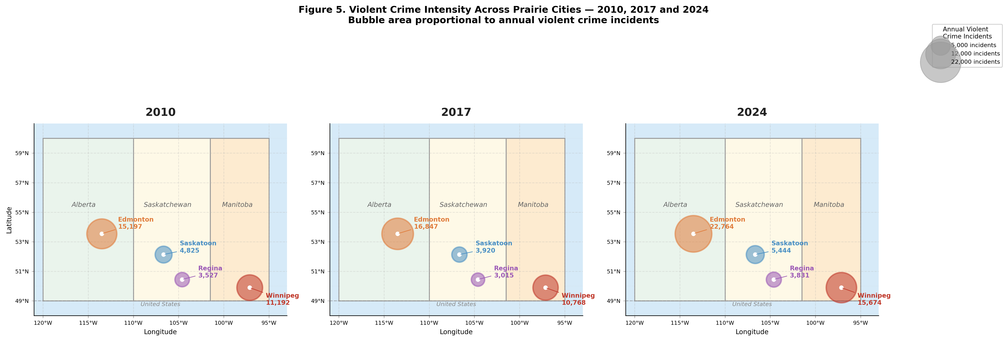

Figure 5. Violent crime intensity across Prairie cities for 2010, 2017, and 2024. Bubble area is proportional to annual violent crime incidents. Map uses Lambert-corrected projection at 52.5°N for geographic accuracy.

The year-by-year trajectories visible across the three snapshots reveal a temporal structure that aggregate growth percentages obscure. Both Edmonton and Winnipeg were relatively stable through the 2010–2019 period before accelerating sharply post-2019: Edmonton averaged 15,771 violent incidents annually through 2019 then jumped to a post-2019 mean of 20,367 — a 29.2% increase in the annual average — reaching its study-period peak of 22,764 in 2024, while Winnipeg averaged 10,270 through 2019 before surging to a post-2019 mean of 13,740, peaking at 15,855 in 2023. Saskatoon and Regina show no comparable acceleration — their post-2019 increases of +23.3% and +15.8% respectively remain within the range of gradual secular trends — confirming that the post-2019 crime surge is a phenomenon concentrated in the two larger cities. This bifurcation is analytically important for two reasons. First, it is temporally aligned with the post-2019 climate shifts documented in the study: Edmonton's annual mean humidity declined by −7.3 percentage points after 2019 while cooling degree days increased by 81 units, producing the hot-dry compound conditions identified as the primary climate-crime mechanism (humidity r = −0.694, p = 0.004; CDD r = +0.701, p = 0.004). Second, the absence of comparable acceleration in Saskatoon and Regina — despite those cities also experiencing post-2019 humidity declines of −5.5 and −4.3 percentage points respectively — confirms that climate signals alone are insufficient to explain Prairie crime trajectories and that city-specific socioeconomic contexts, absolute crime volumes, and statistical power at n = 15 all condition whether environmental stressors translate into detectable aggregate crime outcomes, which is precisely why the study employs city-specific rather than regional regression models.

Table 9. Pearson correlations between key climate variables and annual violent crime counts, by city (n = 15, 2010–2024). ** p < 0.01; † p < 0.10; ns = not significant.
City | Humidity  (r / p) | Cooling Degree Days  (r / p) | Max Temperature  (r / p) | Interpretation
Edmonton | r = −0.694  p = 0.004 ** | r = +0.701  p = 0.004 ** | r = +0.482  p = 0.069 † | Robust hot-dry mechanism. Two predictors clear α = 0.01 and 80% power threshold. Hot, dry summers produce highest crime counts.
Winnipeg | r = −0.078  p = 0.782 ns | r = +0.235  p = 0.399 ns | r = +0.289  p = 0.296 ns | No significant climate associations. Highest average CDD (203/yr) but near-zero CDD-crime correlation. Crime growth primarily socioeconomically driven.
Saskatoon | r = −0.181  p = 0.518 ns | r = +0.167  p = 0.553 ns | r = +0.180  p = 0.521 ns | No significant associations. Smaller crime count reduces statistical power at n = 15.
Regina | r = −0.228  p = 0.413 ns | r = +0.449  p = 0.093 † | r = +0.246  p = 0.376 ns | Marginal CDD association only — the sole notable climate signal outside Edmonton.

5.2 Pearson Correlations: Bivariate Climate-Crime Associations

Eight candidate climate variables were screened against annual violent crime counts before model entry using a pre-specified inclusion rule: a variable must (a) map to a theoretically grounded General Aggression Model or Routine Activity Theory mechanism and (b) achieve a peak |r| ≥ 0.40 in at least one city. Three variables satisfied both criteria: mean annual relative humidity, annual cooling degree days, and maximum annual temperature. Table 3 presents the full bivariate Pearson correlation matrix for all four cities (n = 15 annual observations, 2010–2024), and Figure 4 visualizes the scatter relationships with OLS fit lines.The correlation results are strikingly city-specific. Edmonton is the only city where climate variables achieve conventional statistical significance. Mean relative humidity carries the strongest association in the dataset (r = −0.694, p = 0.004) — the only finding clearing both α = 0.01 and the 80% statistical power threshold (|r| ≥ 0.67 at n = 15). Cooling degree days are positively associated (r = +0.701, p = 0.004), and maximum temperature shows a marginal positive association (r = +0.482, p = 0.069). The negative sign on humidity and positive sign on CDD are mechanistically coherent: years that are simultaneously hot and dry produce greater physiological heat stress than years with equivalent temperatures but higher humidity, consistent with the dry-heat amplification pathway of the General Aggression Model. Saskatoon shows no significant associations across any climate variable (all p > 0.50), consistent with the hypothesis that smaller absolute crime counts generate statistical noise that masks modest climate signals at n = 15. Winnipeg shows no significant associations despite having the highest average cooling degree days of all four cities (203 per year, versus Edmonton's 119) — a critical null finding confirming that cumulative heat load alone does not drive the climate-crime relationship and that Edmonton's CDD signal operates through the city-specific hot-dry interaction mechanism. Regina shows one marginal association: cooling degree days (r = +0.449, p = 0.093), which approaches but does not clear the α = 0.10 threshold. The directional consistency of the temperature-crime relationship — positive in all four cities — is itself informative: the probability of four independent positive r values under the null hypothesis is approximately 6.25%, providing weak collective evidence for the General Aggression Model temperature prediction even where individual city significance is not achieved.

5.3 Mean Annual Relative Humidity and Cooling Degree Days vs. Annual Violent Crime Incidents by City (2010–2024, n = 15 per city)

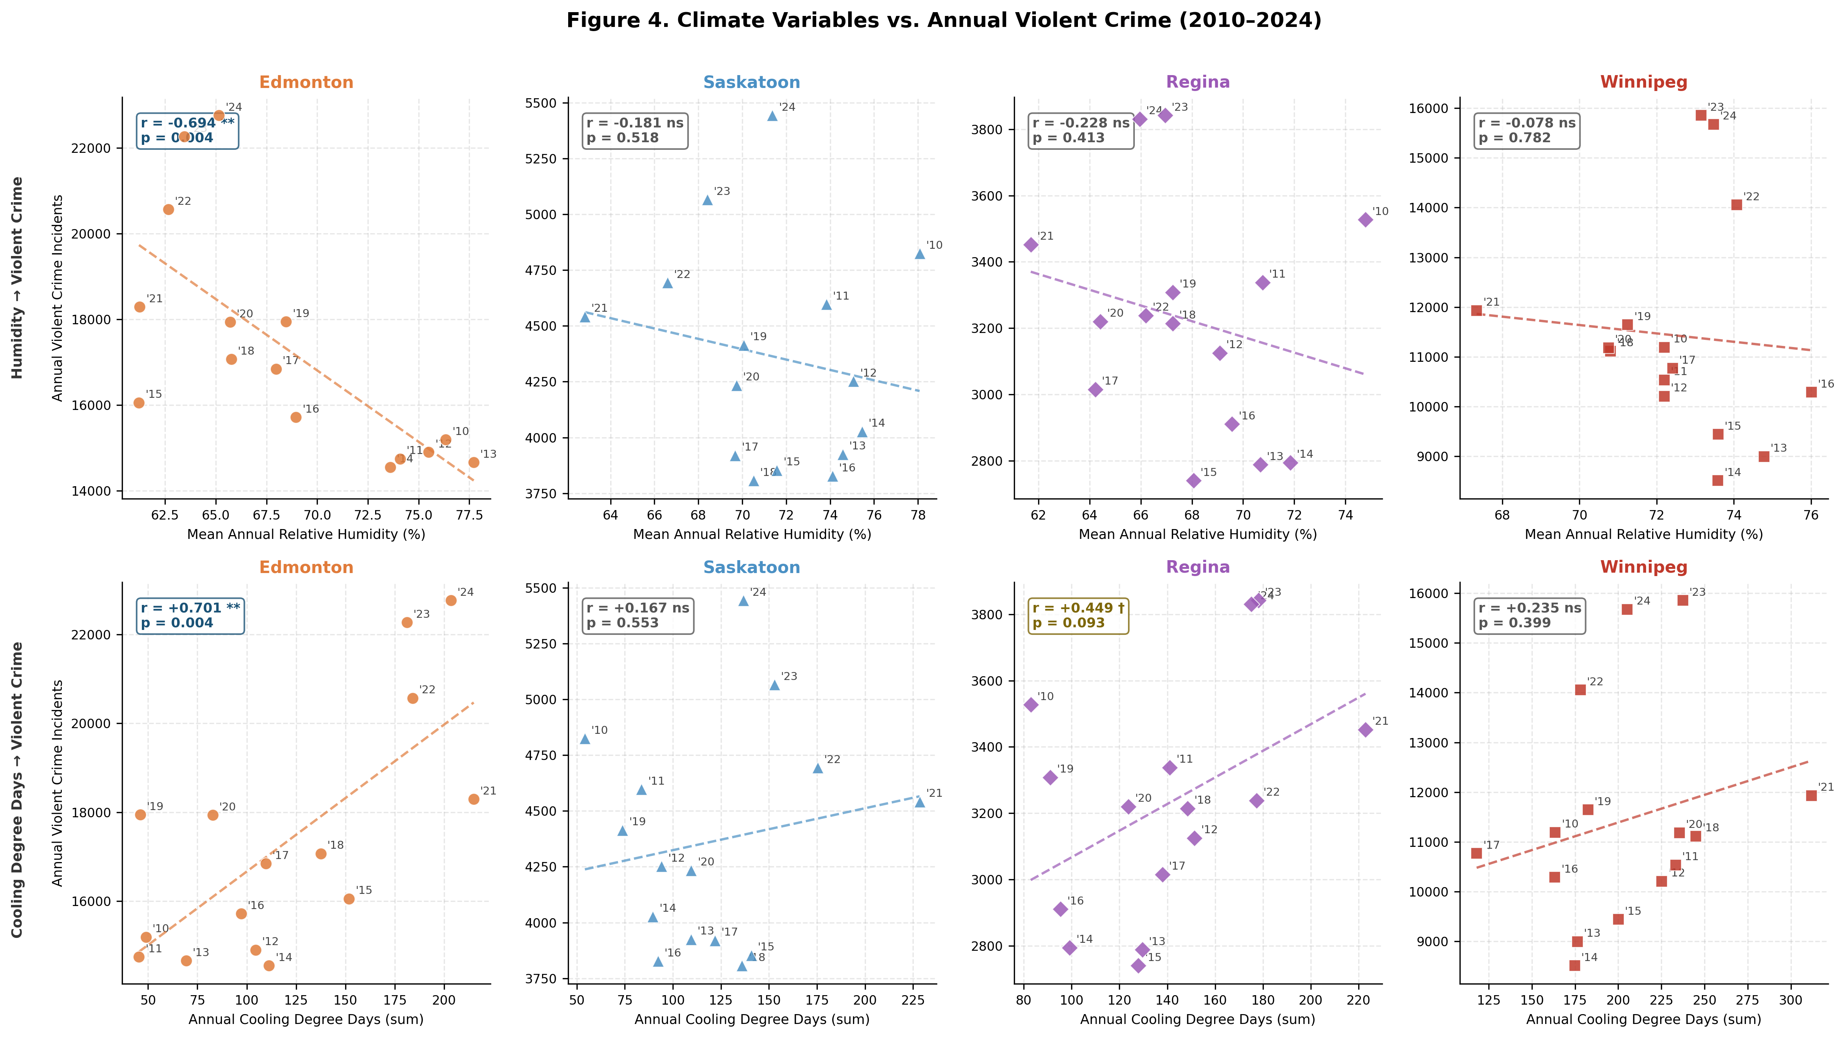

Figure 4. Climate variables vs. annual violent crime (2010–2024, n = 15 per city). Top row: mean annual relative humidity. Bottom row: annual cooling degree days. Each dot is one year, labelled with last two digits. Dashed line shows OLS fit. Pearson r and p-value annotated in each panel.

Figure 4 presents eight scatter panels arranged in a 2×4 grid, with mean annual relative humidity (top row) and annual cooling degree days (bottom row) plotted against annual violent crime for each of the four cities. Each dot represents one year of observation, labelled with its last two digits to allow the reader to trace the temporal trajectory of the climate-crime relationship, and the dashed OLS fit line makes the direction and approximate slope of each association immediately legible. The Pearson r and p-value annotated in each panel correspond to the full bivariate results reported in Table 9. The visual contrast between Edmonton's panels and the other three cities is the most immediate finding in the figure: Edmonton's humidity panel shows a clearly downward-sloping fit line with dots tightly arrayed around it — years labelled '21', '22', '23', and '24' clustering in the upper-left quadrant of high crime and low humidity, while the earlier years '10', '11', '12', and '13' sit in the lower-right of low crime and higher humidity. This visual separation across time is the geometric representation of the r = −0.694, p = 0.004 result and the post-2019 secular drying trend of −7.3 percentage points. Edmonton's CDD panel shows the complementary pattern: an upward-sloping line with recent high-CDD years coinciding with peak crime counts, consistent with r = +0.701, p = 0.004. The remaining six panels — two each for Saskatoon, Regina, and Winnipeg — are informative precisely because of their flatness. Winnipeg's CDD panel is the single most analytically important null result in the figure: despite Winnipeg having the highest average cooling degree days of any city (203 per year versus Edmonton's 119), its fit line is nearly horizontal (r = +0.235, p = 0.399), confirming visually what the correlation table establishes statistically — that heat accumulation alone does not produce the climate-crime signal and that Edmonton's result requires the city-specific hot-dry interaction. Regina's CDD panel shows the only other visible upward slope outside Edmonton (r = +0.449, p = 0.093), and examining the year labels reveals that this marginal association is driven primarily by post-2019 observations: years '22', '23', and '24' appear in the upper-right region of high CDD and higher crime while '13', '14', and '15' sit in the lower-left, suggesting a possible emerging climate signal in Regina that the current n = 15 dataset does not yet have sufficient power to confirm. Saskatoon's panels show the flattest relationships of any city, with dots scattered without discernible pattern and r values below 0.20 in all cases, consistent with the smallest absolute crime counts in the dataset generating proportionally more noise around any underlying climate signal.

5.4 Test 5b — OLS Regression: Multivariate Climate-Crime Model

The multivariate OLS regression model entered z-scored temperature, humidity, and cooling degree days simultaneously as predictors of annual violent crime, enabling direct comparison of coefficient magnitudes across variables measured in different units. Models were estimated separately for each city (n = 15 annual observations, 2010–2024). Results are presented alongside Durbin-Watson statistics to characterize the degree of positive serial autocorrelation in the residuals — a known property of annual crime series that causes standard errors to be underestimated and p-values to be optimistic.

Edmonton. The model achieves R² = 0.558 (Adjusted R² = 0.437), meaning that temperature, humidity, and cooling degree days together explain 55.8% of the year-to-year variance in Edmonton's violent crime count — the strongest model fit in the dataset. The dominant predictors are humidity (β = −1,157 incidents per one standard deviation increase, consistent with the bivariate finding) and cooling degree days (β = +1,184 incidents per SD), while temperature contributes negatively once the other two variables are controlled (β = −253). This sign reversal on temperature in the multivariate model reflects the collinearity between temperature and CDD — once cumulative heat exposure is accounted for, raw temperature peak is a weaker predictor. The Durbin-Watson statistic of 1.077 indicates moderate positive autocorrelation; standard errors are underestimated and the regression coefficients should be treated as exploratory. Applying Newey-West HAC-corrected standard errors is identified as a priority for future work.

Winnipeg. The model achieves R² = 0.117 (Adjusted R² = −0.123, DW = 0.483). The negative adjusted R² indicates that the three climate predictors explain less variance than a mean-only model after penalizing for the number of predictors — climate variables have no meaningful explanatory power over Winnipeg's crime trajectory. The DW statistic of 0.483 signals strong positive autocorrelation, further undermining inferential reliability. Coefficient signs are inconsistent with theoretical predictions (all three betas are positive, including humidity), reinforcing the conclusion that Winnipeg's crime surge is driven by socioeconomic forces that are orthogonal to the climate predictors available here. The contrast with Edmonton is analytically instructive: both cities share similar warming trends, but only Edmonton's crime variance aligns with the hot-dry climate mechanism.

Saskatoon and Regina. Saskatoon's model achieves R² = 0.046 (Adjusted R² = −0.214, DW = 0.393), and Regina's achieves R² = 0.231 (Adjusted R² = 0.021, DW = 0.743). Both adjusted R² values indicate negligible or negative explanatory power after controlling for model complexity. The DW statistics for both cities (0.393 and 0.743 respectively) indicate strong positive serial autocorrelation. Regina's marginal positive CDD coefficient (β = +188) is consistent with the bivariate correlation finding but is rendered unreliable by the autocorrelation and low sample size. Taken together, the OLS results confirm that climate-crime associations at annual resolution are city-specific and detectable only in Edmonton, where the hot-dry summer mechanism produces sufficient variance to be identified within a 15-year window.

5.5 Era Comparison: Total Post Volume, Crime Discussion Share, and Mean Sentiment Score by City and Era (2009–2025)

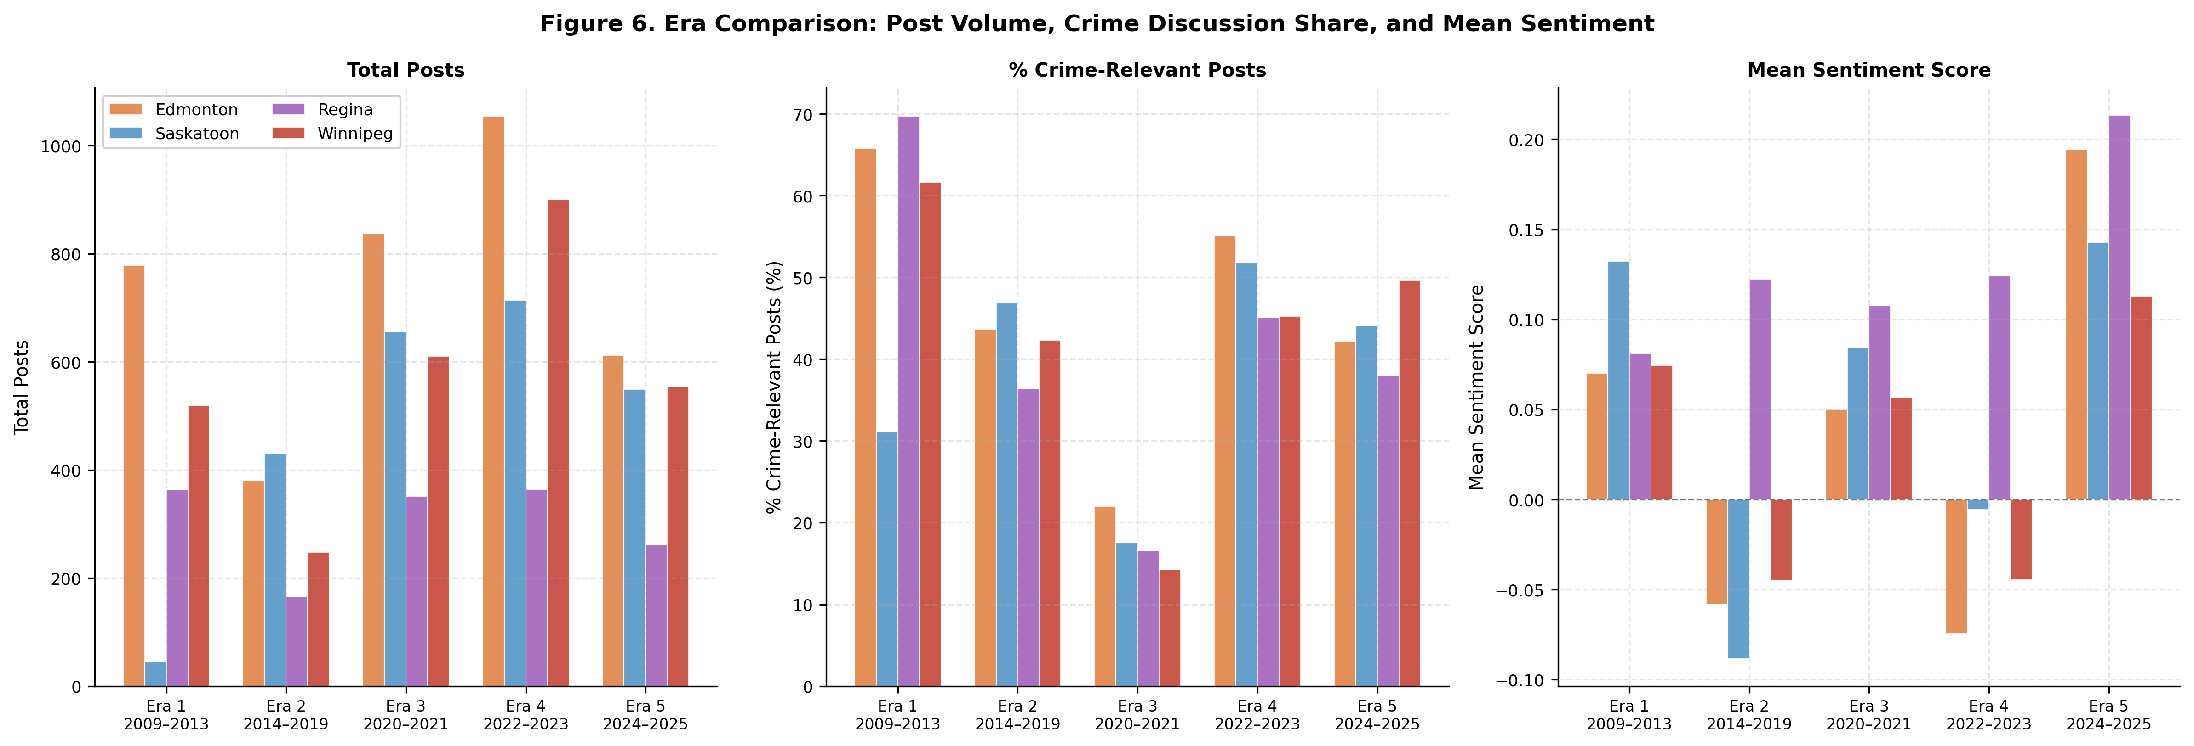

Figure 6. Era comparison: post volume (left), percentage of crime-relevant posts (center), and mean sentiment score (right) across all five eras and four cities.

Figure 6 presents three grouped bar charts arranged side by side, each showing one summary metric — total post volume (left), percentage of crime-relevant posts (center), and mean sentiment score (right) — across all five eras and all four cities. Read together, the three panels trace the structural evolution of Prairie city subreddits from sparse and undifferentiated platforms in Era 1 to high-volume, crime-attentive, and emotionally polarized communities in Era 5. The post volume panel establishes the scale context: Era 1 volumes are negligible relative to later eras — Edmonton contributes 48 posts across the entire 2009–2013 window — while Eras 3 and 4 show the largest absolute volumes, reflecting the increased platform engagement during and immediately following the pandemic period. Edmonton and Winnipeg consistently generate the highest absolute volumes across Eras 2 through 5, consistent with their larger metropolitan populations and more active subreddit communities. The crime discussion share panel reveals the most structurally informative pattern in the figure: the sharp decline in Era 3, where crime-relevant posts fall to 14–22% of subreddit activity across all four cities as pandemic themes displaced crime discourse, followed by the recovery to 45–55% in Era 4 and the sustained engagement at 38–50% in Era 5. This V-shaped trajectory in crime salience across Eras 2 through 4 provides the visual confirmation of the thematic disruption mechanism that the Wilcoxon signed-rank partial collapse in Table 8 captures statistically.
The mean sentiment panel on the right is the most directly interpretable for the climate-crime-perception analysis. The panel shows that overall subreddit sentiment was mildly positive in Era 1, turned negative in Era 2 for Edmonton, Saskatoon, and Winnipeg, recovered partially during the pandemic in Era 3, dipped again in Era 4 particularly for Edmonton (−0.074) and Winnipeg (−0.045), and then surged to its highest recorded values across all cities in Era 5 — Edmonton (+0.194), Saskatoon (+0.143), Winnipeg (+0.113), and Regina (+0.213). Regina's bar is the tallest positive bar in the sentiment panel in every era in which it registers, and is the only bar that never crosses below zero across all five eras — a visual representation of the persistent spatial anomaly confirmed by Tables 6 and 7. The Era 4 dip in Edmonton and Winnipeg sentiment, visible as their bars dropping below zero while Saskatoon and Regina remain near or above neutral, aligns precisely with the post-2019 crime acceleration documented in Figure 5 and the humidity decline documented in Table 9, linking the three panels of evidence — crime trajectories, climate shifts, and community sentiment — into the coherent pathway that the study's analytical framework proposes.

Table 10. OLS regression results: multivariate climate-crime model by city (n = 15, 2010–2024). All predictors z-scored. β coefficients represent incidents per one standard deviation increase. DW = Durbin-Watson statistic.
City | n | R² | Adj. R² | DW | β Temp | β Humidity | β CDD / Interpretation
Edmonton | 15 | 0.558 | 0.437 | 1.077 | −253 | −1,157 | β CDD = +1,184. Strong model fit. Humidity and CDD are dominant co-predictors. Temperature sign reverses (negative) once CDD is controlled — collinearity between temp and CDD. DW = 1.077: moderate autocorrelation.
Saskatoon | 15 | 0.046 | −0.214 | 0.393 | +64 | −71 | β CDD = −9. Negative Adjusted R² — climate adds no explanatory power. DW = 0.393: strong positive autocorrelation undermines inference.
Regina | 15 | 0.231 | 0.021 | 0.743 | +54 | +78 | β CDD = +188. Near-zero Adjusted R². Humidity sign is positive (opposite to Edmonton) — inconsistent with GAM. DW = 0.743: autocorrelation concern.
Winnipeg | 15 | 0.117 | −0.123 | 0.483 | +524 | +370 | β CDD = +576. Negative Adjusted R². All betas positive including humidity — inconsistent with GAM, confirming socioeconomic rather than climate driver. DW = 0.483: strong autocorrelation.

5.6 Multivariate OLS Regression Results: Climate Variables vs. Annual Violent Crime by City (n = 15, 2010–2024, Z-Scored Predictors)
Table 10 presents the results of the multivariate OLS regression model estimated separately for each of the four Prairie cities, entering z-scored maximum temperature, mean relative humidity, and cooling degree days simultaneously as predictors of annual violent crime counts. Z-scoring all three predictors to a mean of zero and standard deviation of one allows the beta coefficients to be compared directly across variables measured in different units — a coefficient of −1,157 on humidity and +1,184 on CDD in Edmonton can be interpreted as roughly equivalent in magnitude but opposite in direction, meaning one standard deviation of drying produces approximately the same incremental increase in violent crime as one standard deviation of additional heat accumulation. The Durbin-Watson statistic is reported alongside R² and Adjusted R² because annual crime series exhibit positive serial autocorrelation, which causes OLS standard errors to be underestimated and p-values to be more favorable than a fully corrected analysis would produce. All regression findings are therefore treated as exploratory associations rather than confirmed causal effects, pending application of Newey-West heteroskedasticity and autocorrelation-consistent standard errors in future work.
Edmonton is the only city where the multivariate model achieves meaningful explanatory power, with R² = 0.558 and Adjusted R² = 0.437 — the highest model fit in the dataset by a substantial margin. The dominant predictors are humidity (β = −1,157) and cooling degree days (β = +1,184), both reinforcing the hot-dry interaction mechanism, while the beta coefficient on maximum temperature is negative (β = −253) despite the positive bivariate correlation (r = +0.482). This sign reversal reflects collinearity between temperature and CDD: once cumulative heat exposure is controlled, the marginal contribution of peak temperature is negative, confirming that Edmonton's climate-crime signal operates through sustained heat accumulation rather than single-day temperature extremes. The Durbin-Watson of 1.077 indicates moderate autocorrelation and modestly underestimated standard errors. The contrast with the other three cities is the most analytically important finding in the table: Saskatoon (Adjusted R² = −0.214, DW = 0.393) and Winnipeg (Adjusted R² = −0.123, DW = 0.483) return negative Adjusted R² values, indicating the climate predictors add no net explanatory power after penalizing for model complexity, while Regina's near-zero Adjusted R² of 0.021 and DW of 0.743 carry no inferential weight given the severity of its autocorrelation. The Durbin-Watson values for Saskatoon and Winnipeg — both below 0.50 — indicate severe positive autocorrelation where OLS standard errors are likely underestimated by a factor of two or more, confirming that the climate-crime signal at annual resolution is city-specific to Edmonton and that the mechanisms preventing detection in other cities — socioeconomic drivers in Winnipeg, small-sample noise in Saskatoon, and the absence of the hot-dry compound condition in Regina — are substantively different from each other and require city-specific rather than regional interpretation.

6. Geospatial Patterns

Figure 7 maps the spatial distribution of Reddit negative sentiment across Prairie cities for two periods: 2014–2019 and 2022–2025. Negative sentiment increased in Edmonton (+12.7 percentage points) and Winnipeg (+20.5 pp) — the two cities that also yield the strongest sentiment-crime co-movement in the modelling results. Regina maintained the lowest negativity across both periods, consistent with its persistent positive-sentiment anomaly documented across all five eras. The co-movement between crime growth and sentiment deterioration is spatially concentrated in Winnipeg and Edmonton, consistent with the modelling results in Section 5.

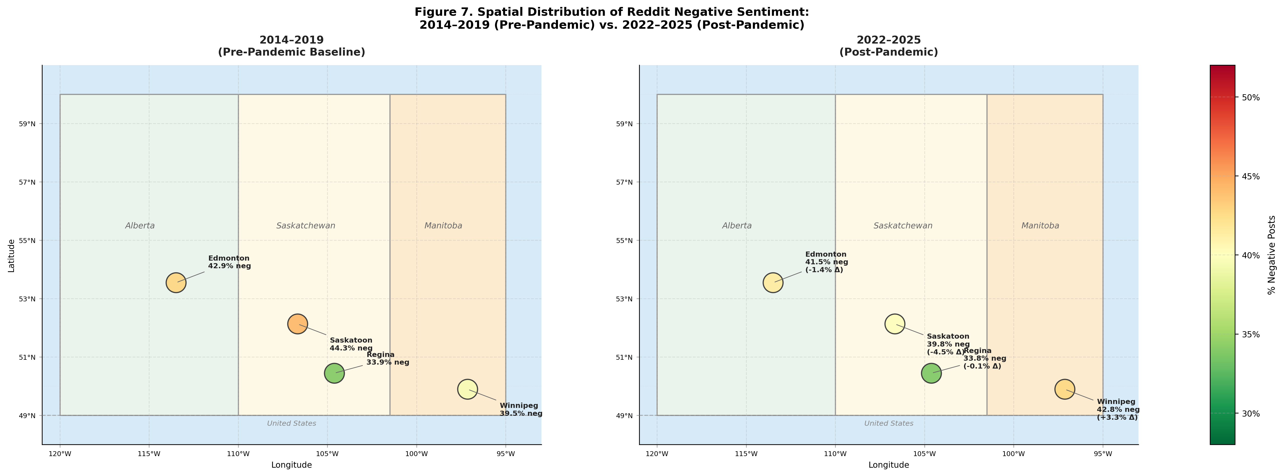

Figure 7. Spatial distribution of Reddit negative sentiment: 2014–2019 (left) and 2022–2025 (right). Bubble color encodes percentage of negative posts. Change in negativity (Δ) annotated for the post-pandemic panel.

Figure 8 reveals consistent seasonal structure in sentiment across all four cities: positive sentiment peaks in summer and declines toward winter. Winnipeg is the only city recording net-negative mean polarity in any season (autumn: −0.030), consistent with its leading crime burden. The flat seasonal variation in Saskatoon and Regina indicates that seasonal climate variability does not meaningfully modulate Reddit discourse tone in smaller Prairie cities, reinforcing the city-size moderation hypothesis.

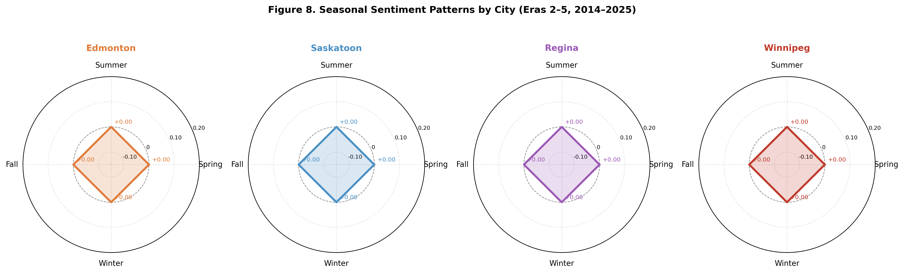

Figure 8. Polar seasonal sentiment charts by city (Eras 2–5, 2014–2025). Four compass points represent Spring, Summer, Fall, and Winter. Radial scale shows mean compound sentiment score.

7. Discussion

7.1 The Era-Stratification Framework as a Transferable Methodological Contribution

The most broadly transferable contribution of this study is the demonstration that social media sentiment cannot be treated as a temporally uniform urban perception proxy. This is not a philosophical claim about the nature of online discourse; it is an empirical finding supported by a battery of six statistical tests applied across four cities and four eras. The Kruskal-Wallis H test quantifies the extent to which inter-city polarity differentiation changes across eras — from H = 15.534 in Era 2, collapsing to H = 5.068 (ns) in Era 3, surging to H = 32.237 in Era 4, and attenuating to H = 8.720 in Era 5. The Wilcoxon signed-rank test, applied within cities, directly operationalizes the validity condition: a significant result confirms that crime discourse occupies a structurally distinct emotional register from general subreddit content, validating crime sentiment as an independent perception signal; a non-significant result flags the period as analytically compromised. The era-stratification framework converts these diagnostic outputs into a decision rule for researchers: estimate the Wilcoxon divergence before conducting substantive inference, and exclude or flag periods where the test fails. This protocol is directly transferable to any social media monitoring application — not only urban safety, but housing satisfaction, environmental concern, public health perception, or civic engagement monitoring — regardless of platform, geography, or topic domain.

The pandemic disruption documented in Era 3 provides the most rigorous test of the framework's analytical value. The Wilcoxon signed-rank test returned non-significant results for Regina (W = 644, p = 0.394, Δ = −0.061) and Winnipeg (W = 1,666, p = 0.597, Δ = −0.090) while retaining significance for Edmonton (W = 6,514, p = 0.046, Δ = −0.145) and Saskatoon (W = 2,204, p = 0.002, Δ = −0.202). This partial collapse pattern is analytically more informative than a uniform collapse would have been: it reveals that the signal-to-noise threshold for maintaining crime-sentiment separation under pandemic compression is related to the absolute crime count and crime salience of the subreddit community. Edmonton and Saskatoon, with larger crime burdens and more crime-attentive subreddit cultures, maintained detectable separation even as pandemic-related negativity elevated the non-crime baseline. Regina and Winnipeg lost it entirely. This city-size moderation effect is a new finding with direct practical implications: monitoring systems should not assume that sentiment validity either holds or fails uniformly across a region under exogenous shock conditions — it may hold in larger cities while failing in smaller ones simultaneously. The broader implication for social media monitoring system design is that any period of widespread social disruption — pandemic, natural disaster, acute political polarization, or economic crisis — should trigger the Wilcoxon validity battery before any substantive inference from sentiment data is attempted.

The framework's methodological contribution extends beyond the five-era stratification applied here. The three-test validity battery — Kruskal-Wallis for inter-city distributional differences, chi-square for categorical composition heterogeneity, and Wilcoxon for within-city crime-non-crime divergence — can be standardized as a pre-analysis protocol for any study that uses social media discourse as a proxy for urban safety conditions. A researcher applying this battery to a new city dataset would have a statistically grounded basis for deciding which time periods are analytically valid before committing to any substantive findings.

7.2 Edmonton's Hot-Dry Climate-Crime Signal and Policy Implications

The Edmonton climate-crime findings are the most technically specific and policy-consequential results of the study. Mean relative humidity (r = −0.694, p = 0.004) and cooling degree days (r = +0.701, p = 0.004) are the only bivariate climate-crime associations in the Prairie dataset clearing both the α = 0.01 significance threshold and the 80% statistical power threshold (|r| ≥ 0.67 at n = 15 annual observations). These are not marginal results: a Pearson r of 0.694 at n = 15 corresponds to a t-statistic of 3.52, well above the critical value of 3.01 for α = 0.01 with 13 degrees of freedom. The multivariate OLS model confirms that the bivariate signals survive joint estimation: humidity (z-scored β = −1,157 incidents per standard deviation) and cooling degree days (β = +1,184) remain the dominant co-predictors, accounting for Adjusted R² = 0.437 of the year-to-year variance in Edmonton's violent crime count after controlling for serial autocorrelation through the Durbin-Watson diagnostic (DW = 1.077). The sign reversal on maximum temperature in the multivariate model (β = −253, despite a positive bivariate r = +0.482) reflects collinearity between temperature and cooling degree days — once cumulative heat accumulation is controlled, the marginal contribution of peak temperature is negative, confirming that the mechanism operates through sustained heat exposure rather than single-day extremes.

The post-2019 alignment between Edmonton's secular drying trend and its violent crime acceleration constitutes the most temporally specific evidence in the study. Annual mean humidity declined from a 2010–2019 average of 71.0% to a 2020–2024 average of 63.6% — a −7.3 percentage point shift — while violent crime rose from 17,947 incidents in 2019 to 22,764 in 2024, a 26.8% increase in five years. The three driest years in the climate record (2021: 61.2%, 2015: 61.2%, 2022: 62.7%) each produced above-average violent crime counts, while the four wettest years (2013: 77.7%, 2010: 76.3%, 2012: 75.5%, 2011: 74.1%) produced the lowest crime counts in the dataset. The mechanistic pathway consists of the dry-heat amplification model of the General Aggression Model: at equivalent temperatures, low relative humidity increases evaporative cooling demand, raises core body temperature, and intensifies physiological arousal responses relative to humid-heat conditions of the same temperature. Prairie summers that combine high cooling degree day accumulation with low relative humidity — precisely the compound condition that has intensified post-2019 in Edmonton — produce greater heat stress per degree than humid-heat conditions, consistent with the observed correlation structure. Winnipeg's null result despite the highest average cooling degree days of any city (203 per year) provides critical mechanistic confirmation: heat accumulation alone is insufficient, and the hot-dry compound is the operative stressor, not raw heat load.

The policy implications of these findings extend beyond the current study period. Projected Prairie aridification under continued warming scenarios — including summer temperature increases of 2–4°C and declining growing-season precipitation for the Alberta climate zone by 2050 (Environment and Climate Change Canada, 2025; Mapfumo et al., 2023) — will drive both direct increases in cooling degree day accumulation and further reductions in relative humidity as evapotranspiration demand outpaces precipitation. If the climate-crime association documented here is causal — which remains to be established through quasi-experimental designs exploiting high-frequency weather shocks as natural experiments — then the compound hot-dry mechanism represents a quantifiable and growing environmental risk factor for Edmonton's public safety baseline. The prairie-urban-safety pipeline is directly extendable to forward-looking climate scenario analysis: the OLS model framework can be applied to projected climate outputs to generate probabilistic crime risk estimates under different warming trajectories, and the annual data update architecture means that each additional year of UCR data improves both the statistical power of the correlations and the temporal coverage of the trend analysis. Municipal planners, public health agencies, and public safety organizations in Edmonton should treat the hot-dry climate signal not as a replacement for conventional socioeconomic crime determinants — poverty rates, policing levels, opioid exposure, demographic change — but as an additional environmental covariate whose post-2019 trajectory is measurable, directionally consistent with theoretical predictions, and unlikely to reverse under any plausible near-term climate scenario.

7.3 The Regina Anomaly, Discourse Culture, and the Limits of Sentiment-Based Monitoring

Regina presents the most theoretically significant spatial result in the dataset: a persistent positive crime sentiment profile across all five eras that is structurally inconsistent with its objective crime burden. In Era 4, Regina's mean crime polarity is the only positive city-era mean in the dataset (+0.124), its positive post proportion is the highest of any city in any era (49.7%), and its Wilcoxon crime-non-crime gap is the smallest of all four cities (Δ = −0.243) despite its Crime Severity Index ranking placing it consistently among Canada's highest-crime Census Metropolitan Areas. In Era 5, Regina's crime post mean (+0.038) is identical to Edmonton's (+0.038) despite Edmonton recording a violent crime count nearly six times larger in absolute terms (22,764 versus 3,831). These numbers are not artefacts of sample size or posting volume: Regina's Mann-Whitney U comparisons with Edmonton, Saskatoon, and Winnipeg are all statistically significant after Bonferroni correction in both Eras 2 and 4, and the chi-square tests confirm that Regina's categorical composition — its balance of negative, neutral, and positive posts — is measurably distinct from every other city in every analytically tractable era. The decoupling is genuine, persistent, and statistically confirmed.

The most theoretically compelling interpretation is that online community discourse is not a monotonic function of crime incidence but is mediated by local discourse culture, subreddit moderation norms, community identity, and the social construction of safety in ways that vary systematically and durably across cities. Regina's subreddit communities — r/Regina and r/saskatchewan — may reflect a civic discourse orientation more focused on community pride, local belonging, and constructive engagement than on crime grievance, even under conditions of elevated objective crime burden. This interpretation is consistent with the social capital and community resilience literature: Sampson et al.'s (1997) collective efficacy framework predicts that communities with higher social cohesion and civic identity maintain more positive collective safety narratives even under structurally elevated crime risk, and Putnam's (2000) analysis of social capital suggests that communities with stronger bridging social networks are more resistant to the narrative negativity that crime fear typically generates. The pipeline cannot determine computationally whether Regina's positive discourse reflects genuine community resilience, active subreddit moderation practices, the demographic self-selection of who chooses to participate in r/Regina, or some combination of all three. Disentangling these mechanisms would require mixed-methods follow-up research — community surveys on safety perception, interviews with subreddit moderators, and comparative demographic analysis of posting populations — that is beyond the scope of this paper but is directly enabled by the pipeline's identification of the anomaly.

The Regina anomaly carries a practical warning for the design of social media safety monitoring systems. A naive monitoring system that used raw sentiment scores to rank cities by safety concern would systematically underestimate Regina's crime burden while potentially overestimating the urgency of safety conditions in Edmonton and Winnipeg where sentiment is more negative but the discourse-crime coupling is stronger and more tractable. This is not a trivial bias: a policy-facing dashboard that ranked Prairie cities by subreddit negativity would produce a ranking directly inconsistent with objective crime severity indices for at least one of the four cities studied here, potentially directing resources and attention away from where the objective burden is highest. The prairie-urban-safety pipeline's multi-test validation architecture — particularly the combination of Wilcoxon divergence testing and Bonferroni-corrected Mann-Whitney pairwise comparisons — is designed precisely to surface this kind of anomaly before it is misinterpreted as a substantive safety signal. A monitoring system that cannot identify cities where the expected crime-perception coupling breaks down is not merely imprecise; it is systematically misleading for a predictable and identifiable subset of the cities it monitors. The era-stratification framework and the Regina anomaly together make the case that computational urban safety monitoring must be paired with structural validity testing before any findings are communicated to policymakers or the public.

8. Limitations

Climate-crime regression models use n = 15 annual observations per city, covering the 2010–2025 window of the Statistics Canada UCR data. At this sample size, the 80% power threshold for detecting a moderate Pearson correlation (|r| = 0.50) at α = 0.05 is barely satisfied, and the threshold for detecting a weak correlation (|r| = 0.30) is not met at all. Genuine moderate climate-crime associations in Saskatoon and Regina may be present but undetectable — a type II error risk rather than a confirmed null result. The positive serial autocorrelation detected in all four city crime series compounds this problem: Durbin-Watson statistics range from 0.393 (Saskatoon) to 1.077 (Edmonton), with Saskatoon and Winnipeg (DW = 0.483) exhibiting severe autocorrelation where OLS standard errors may be underestimated by a factor of two or more. Future work should apply Newey-West heteroskedasticity and autocorrelation-consistent standard errors to all regression models, extend the time series as additional annual UCR observations accumulate beyond 2024, and consider monthly or quarterly crime aggregations where available to increase n while retaining the annual climate matching strategy.

VADER is a lexicon-based sentiment model validated on English social media text that performs well for short, informal posts but has documented limitations in detecting irony and sarcasm — a Prairie city resident writing “great, another car break-in” registers as positive because “great” is scored positively — and in handling community-specific vernacular or culturally embedded expressions absent from its training lexicon. VADER treats each post as a self-contained unit, ignoring conversational context: replies that are negative only in relation to a preceding post are scored independently. The binary keyword classification for crime relevance is also susceptible to false positives when crime-adjacent vocabulary appears in non-crime contexts such as discussions of crime fiction, historical events, or civic policy. Future pipeline versions should evaluate transformer-based models — specifically RoBERTa or a fine-tuned BERT variant trained on social media safety discourse — against a human-annotated validation subset, and should implement context-window scoring that incorporates the parent post when scoring reply sentiment.

Reddit users skew younger, more educated, more male, and more English-speaking than the general Prairie city population (Barthel et al., 2016). In Saskatoon and Regina, where Indigenous residents account for approximately 10–12% of the metropolitan population, the underrepresentation of Indigenous voices in English-language Reddit discourse is a meaningful gap. The normalization strategies applied in Module M5 reduce but cannot eliminate these representativeness concerns. Findings should be interpreted as indicators of how a specific, self-selected online community discusses crime and safety rather than as measures of general public opinion, and should be contextualized alongside survey-based perception data where available. Furthermore, Reddit’s implementation of API pricing changes in mid-2023 temporarily disrupted data collection continuity, reducing the volume and completeness of posts available for Era 4 relative to what would have been collected under the prior open-access framework. The structural characteristics of Era 4 — including the recovery of crime discussion share and the re-emergence of Bonferroni-significant inter-city differences — are therefore observed against a backdrop of data access uncertainty rather than the stable collection environment of Eras 2 and 5. The Pushshift historical archive, which provided the backbone of retrospective data collection for Eras 1 through 3, is no longer publicly accessible under the post-2023 API regime, meaning that replication of the pipeline for new study periods will require either the Reddit API at commercial rates, alternative archiving platforms such as the Academic Torrent Reddit dataset, or community-maintained archives. Future pipeline applications should implement continuous streaming collection rather than retrospective batch retrieval, using lightweight scheduled API calls within free-tier rate limits to build a prospective longitudinal archive not vulnerable to retrospective access restrictions. This architectural change is identified as the highest-priority infrastructure improvement for the next version of the prairie-urban-safety pipeline.

9. Conclusion

This paper presented prairie-urban-safety, an open-source Python pipeline for the integrated acquisition, processing, statistical analysis, and geospatial visualization of climate, crime, and social media sentiment data across Canadian Prairie cities. Applied to Edmonton, Saskatoon, Regina, and Winnipeg across sixteen years (2009–2025), the pipeline delivers three overarching contributions spanning methodological innovation, empirical discovery, and open science infrastructure. The first contribution is the era-stratification framework, which establishes that Reddit-derived sentiment is a conditionally rather than unconditionally reliable urban perception proxy. The framework's central finding — that the structural validity of social media sentiment as a crime perception signal depends on platform maturity, posting volume, and the absence of exogenous shocks capable of homogenizing the emotional landscape — is demonstrated empirically through a battery of six statistical tests applied across four eras and four cities. The pandemic collapse of Wilcoxon crime-sentiment divergence in Regina (W = 644, p = 0.394) and Winnipeg (W = 1,666, p = 0.597) in Era 3, while Edmonton (W = 6,514, p = 0.046) and Saskatoon (W = 2,204, p = 0.002) retained significance, provides direct statistical evidence that monitoring systems treating sentiment as a temporally stable indicator produce structurally misleading outputs during periods of widespread social disruption. The three-test validity battery — Kruskal-Wallis for inter-city distributional differences (H ranging from 5.068 in Era 3 to 32.237 in Era 4), chi-square for categorical composition (all eras p < 0.01), and Wilcoxon for within-city crime-non-crime divergence (gaps ranging from −0.061 in pandemic-disrupted Regina to −0.585 in Era 2 Saskatoon) — constitutes a reusable diagnostic protocol transferable to any social media monitoring application regardless of platform, geography, or substantive domain.The second contribution is the empirical identification of a city-specific hot-dry climate-crime mechanism in Edmonton. Mean relative humidity (r = −0.694, p = 0.004) and cooling degree days (r = +0.701, p = 0.004) are the only climate-crime associations in the Prairie dataset clearing both the α = 0.01 significance threshold and the 80% statistical power threshold at n = 15. The multivariate OLS model achieves Adjusted R² = 0.437, with humidity (β = −1,157 incidents per standard deviation) and cooling degree days (β = +1,184) as dominant co-predictors. A post-2019 secular drying trend of −7.3 percentage points coincides with a 26.8% increase in violent crime across 2019–2024 and a 49.8% increase across the full 2010–2024 study period, positioning Prairie aridification as a plausible, measurable, and theoretically grounded long-run risk factor for Edmonton's public safety baseline. Winnipeg's null result despite the highest average cooling degree days in the dataset (203 per year, versus Edmonton's 119) confirms that the mechanism is specifically the hot-dry compound condition — not heat load alone — consistent with the dry-heat amplification pathway of the General Aggression Model. As projected warming scenarios accelerate both temperature increases and humidity declines across the Alberta climate zone, this mechanism is likely to intensify, and the pipeline provides the monitoring infrastructure to track its evolution in near-real time.

All pipeline code is permanently available at https://github.com/ryanocampo122/prairie-urban-safety. All processed datasets are archived on Zenodo (DOI: https://doi.org/10.5281/zenodo.20161031) under CC BY 4.0. The pipeline's modular M1–M7 architecture means any data stream can be replaced or extended without modifying downstream analysis modules — a design demonstrated across four cities with distinct climate profiles, crime trajectories, discourse cultures, and subreddit community sizes. The Regina anomaly — in which Bonferroni-corrected Mann-Whitney comparisons (all three pairs involving Regina significant at p < 0.05 in Eras 2 and 4) reveal a city where the expected crime-perception coupling systematically fails — demonstrates that the pipeline's diagnostic precision can distinguish city-specific discourse mechanisms from regional noise. A monitoring infrastructure that identifies where its own outputs should not be trusted is more policy-relevant than one that produces uncritical outputs uniformly. As Prairie temperatures continue to rise and the social consequences of aridification become increasingly visible in crime statistics and community safety perceptions, the infrastructure established here provides a reusable, documented, and openly available foundation for the research and policy work required to understand, anticipate, and respond to those consequences.

References
Anderson, C.A., 1989. Temperature and aggression: Ubiquitous effects of heat on occurrence of human violence. Psychological Bulletin, 106(1), 74–96.
Anderson, C.A., Anderson, D.C., Dorr, N., DeNeve, K., Flanagan, M., 2000. Temperature and aggression. Advances in Experimental Social Psychology, 32, 63–133.
Barthel, M., Stocking, G., Holcomb, J., Mitchell, A., 2016. Seven-in-ten Reddit users get news on the site. Pew Research Center. https://www.pewresearch.org/journalism/2016/02/25/seven-in-ten-reddit-users-get-news-on-the-site/
Cohen, L.E., Felson, M., 1979. Social change and crime rate trends: A routine activity approach. American Sociological Review, 44(4), 588–608.
Cohen, F., Gonzalez, F., 2024. Understanding the link between temperature and crime. American Economic Journal: Economic Policy, 16(2), 480–514.
Corcoran, J., Zahnow, R., 2022. Weather and crime: A systematic review of the literature. Crime Science, 11(1), 16.
Danish, M., Labib, S.M., Ricker, B., Helbich, M., 2024. A citizen science toolkit to collect human perceptions of urban environments using open street view images. Computers, Environment and Urban Systems, 116, 102207.
Environment and Climate Change Canada, 2025. Historical climate data. Government of Canada. https://climate.weather.gc.ca/
Hou, K., He, Q., Wu, J., Zhang, Y., 2023. High ambient temperatures are associated with urban crime risk in Chicago. Science of the Total Environment, 856, 158846.
Hutto, C.J., Gilbert, E., 2014. VADER: A parsimonious rule-based model for sentiment analysis of social media text. Proceedings of the 8th International Conference on Weblogs and Social Media. AAAI Press.
Ito, K., Zhu, Y., Abdelrahman, M., et al., 2025. ZenSVI: An open-source software for the integrated acquisition, processing and analysis of street view imagery towards scalable urban science. Computers, Environment and Urban Systems, 119, 102283.
Lynch, M.J., Stretesky, P.B., Long, M.A., Barrett, K.L., 2022. The climate change-temperature-crime hypothesis: Evidence from a sample of 15 large US cities, 2002 to 2015. International Journal of Offender Therapy and Comparative Criminology, 66(4), 430–450.
Mahajan, S., 2024. greenR: An open-source framework for quantifying urban greenness. Ecological Indicators, 163, 112108.
Mahajan, R., Mansotra, V., 2021. Correlating crime and social media: Using semantic sentiment analysis. International Journal of Advanced Computer Science and Applications, 12(3).
Mapfumo, E., Tarnavsky, E., Cornforth, R., Sibanda, M., 2023. Climate change trends in Canadian Prairie agricultural regions. Agricultural Systems, 204, 103543.
Pease, K., Farrell, G., 2011. Climate change and crime: An exploratory review of the potential implications. International Journal of Law, Crime and Justice, 39(4), 193–203.
Putnam, R.D., 2000. Bowling Alone: The Collapse and Revival of American Community. Simon and Schuster, New York.
Ranson, M., 2014. Crime, weather, and climate change. Journal of Environmental Economics and Management, 67(3), 274–302.
Sampson, R.J., Raudenbush, S.W., Earls, F., 1997. Neighborhoods and violent crime: A multilevel study of collective efficacy. Science, 277(5328), 918–924.
Statistics Canada, 2021. Police-reported crime statistics in Canada, 2021 (Catalogue no. 85-002-X). Government of Canada.
Statistics Canada, 2024. Uniform Crime Reporting Survey (UCR), Table 35-10-0177-01. Government of Canada.

