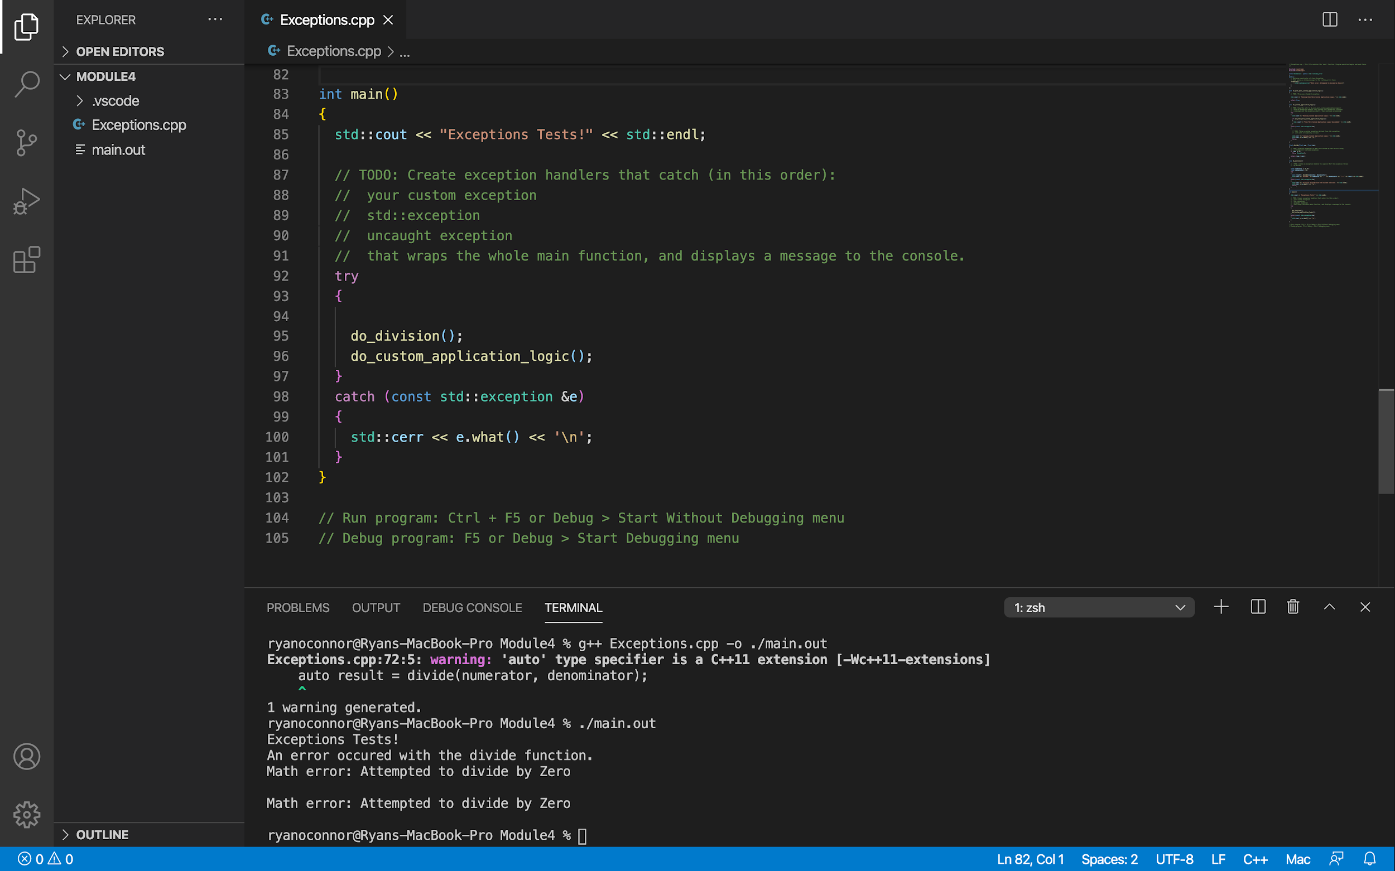

I added a try catch statement that attempts to perform the division but fails with an error message that tells the user not to divide by zero.