**SQL Injection Activity**

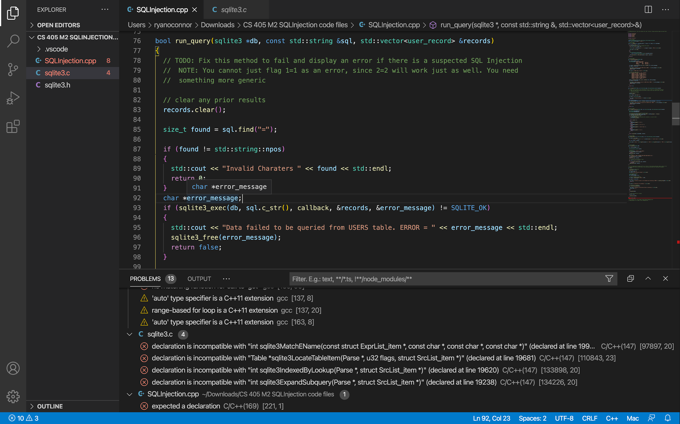

I added a command to check for the ‘=’ character. If the code detects this character is exits with a message to the user.