Russell Yanofsky
Felix Ramon Candelario

Unless otherwise specified for the experiments in this report, our system is set up with the following configuration

4096 #block size in bytes
0.3 #block transfer time in milliseconds
5.6 #average rotational latency in milliseconds
10 #average seek time in milliseconds
512 #number of blocks in the buffer

The three middle parameters should be typical for a normal 5400 RPM hard disk. The block size is 4096 bytes which big enough to hold a few records in a relation or many pointers in a B+ tree or hash table. The total buffer size is 512*4096 = 2 megabytes, which is big enough to have a significantly aid performance on the size databases that we experiment on. (None of our experimental databases are bigger than a few megabytes).

Buffer Manager Algorithm

Our buffer manager algorithm is implemented in a class called BufferManager the bufferman.hpp file. The class holds information about each block in the buffer in an array. Each block holds a disk sector number, a priority value, and a read number. The disk sector numbers are set to -1 at the beginning of the simulation to signify that they are empty. When a request to read a disk sector occurs and the disk sector is not already loaded into the buffer, then a search is started to find a block that is either empty or has a very low priority. When such a block is found, the block’s sector number is set to disk sector number that is being read, the priority is set to the priority value of the read, and read number is set to the serial number of the current “read” command. After that, the elapsed time value of the simulation is incremented by the amount of time it would take to read that block off of the disk. When a request to read a disk sector is made and the disk sector is already present in the buffer, the block’s read number is set to the newer read number, and the priority number is set to the new priority number if the new priority number is greater than the old one. Since the block is already in memory, no physical read is necessary and the elapsed simulation time does not increase.

The search procedure used to find a block with a low enough priority is very simple. It starts on the buffer block immediately following the most recently loaded block (the block which was returned by the previous search and loaded with data from the disk) and proceeds linearly through the buffer (possibly wrapping around at end to the beginning) until it finds a block which is either empty, or has a priority number lower than the priority of the current read. Every block with a read serial number, different than the number of the current read command has its priority value decremented by 10 before the priority comparison takes place. This action is needed to search from infinitely looping and never returning.

To improve performance (of the simulation), a mapping from sector numbers to block numbers is maintained. This way it is possible to quickly determine whether a disk sector is already loaded into the buffer without doing a linear search on the buffer array.

The algorithm is good because it favors keeping sectors in memory that have been recently read and have higher priorities. It has a number of weak points, though, some of which are apparent in our experimental results.

Experiments

The experiments are described in detail in this section. Each experiment has a python script that carries it out in an automated fashion. The scripts are located in the tests/ folder.

Sanity Checks

1a) Many lookups performed when the relation and index sizes combined are smaller than the buffer size.

In the following database, the relation is 128 blocks long and the index is 5 blocks long

1 #database file number
relation #database file type
256 #record size in bytes
1024 #number of records
0.5 #average fraction of each block containing data records
-1 #sentinel value

2 #database file number
index #database file type
secondary #conceptual index type
4 #attribute/key size in bytes
4 #pointer size in bytes
b+tree #physical index type
0.69 #average slot occupancy in the B+tree
-1 #sentinel value

Here is access pattern used, 3000 index lookups

3000
1 lookup 2

The results show that after a large number of lookups the cumulative time eventually stops increasing,

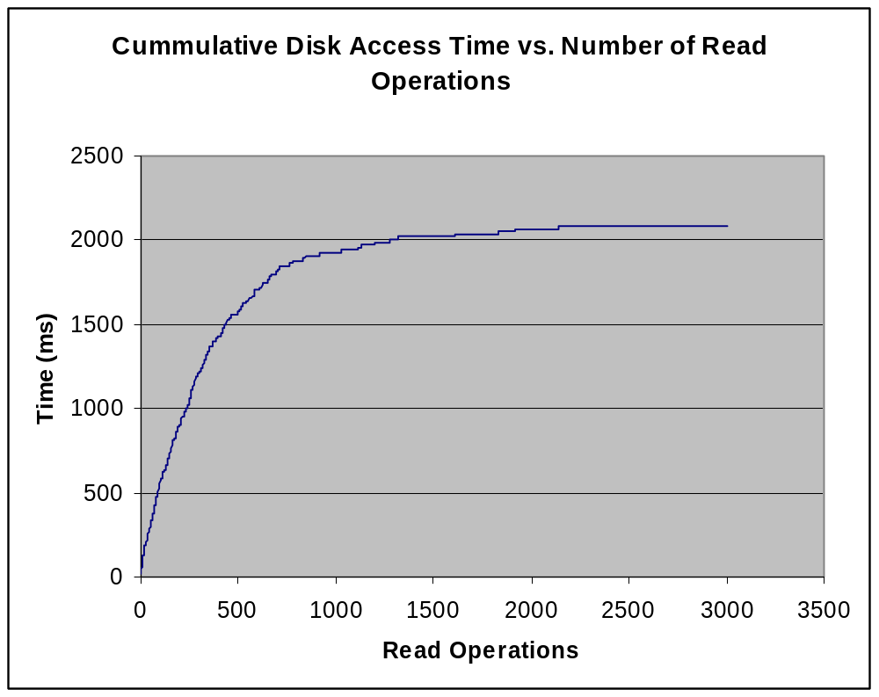
1b) We use the same database and access patterns as before, except that we set the number of records to 10,000 and the number of lookups to 10000. In this chart the times are plotted at intervals of 1000 read operations. The best fitting line is shown to make it easy to see that access time increases linearly with the number of read operations, instead of falling off as in the previous case.
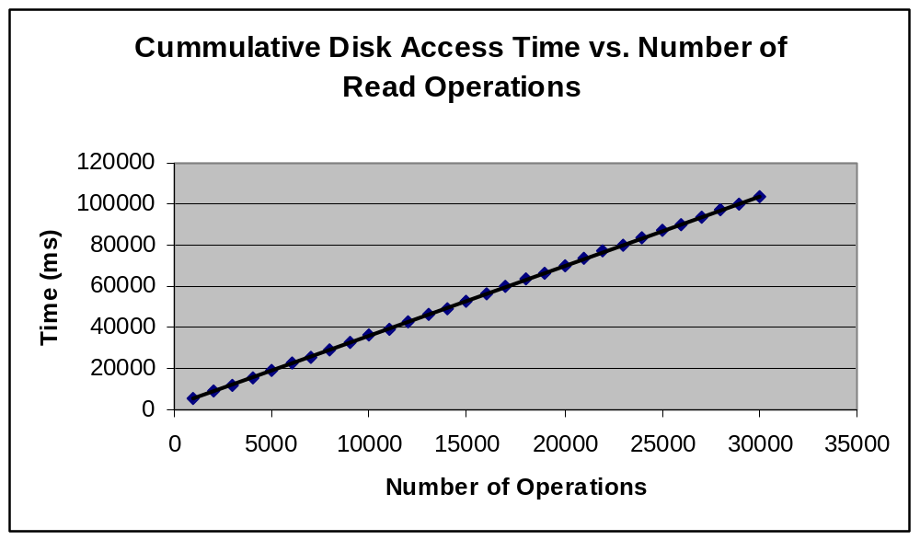
2) A nested blocks join, each relation takes up 1024 blocks (on average there are two records per block)

1 #database file number
relation #database file type
1024 #record size in bytes
2048 #number of records
0.5 #average fraction of each block containing data records
-1 #sentinel value

2 #database file number
relation #database file type
1024 #record size in bytes
2048 #number of records
0.5 #average fraction of each block containing data records
-1 #sentinel value

Here is access pattern used, a single block join

1
1 lookup 1 2 0.5 0.5

The inner relation will have to be read (1024 blocks in outer relation / 256 blocks in inner relation) = 4 times. So the total number of blocks read should be 1024 + 1024 * 4 = 5120

Given this pattern our buffer manager print this number on the standard error output:

Total number of physical disk reads: 5120

3) For this experiment we use the following database setup:

1 #database file number
relation #database file type
1024 #record size in bytes
64 #number of records
0.5 #average fraction of each block containing data records
-1 #sentinel value

2 #database file number
relation #database file type
1024 #record size in bytes
4096 #number of records
0.5 #average fraction of each block containing data records
-1 #sentinel value

3 #database file number
index #database file type
secondary #conceptual index type
8 #attribute/key size in bytes
4 #pointer size in bytes
hash #physical index type
0.39 #average fraction of each bucket in hash table occupied
-1 #sentinel value

For the block join we use the following access pattern

1
1 indexloop 1 3 0.1

And for the index join we use

1
1 block 1 2 0.5 0.5

The output from the python script is

Total number of physical disk reads: 2080
Total number of physical disk reads: 65
Nested block time is 624.0
Index loop time is 534.3

Even though the database setup is heavily skewed towards better performance on an indexed join with 64 times more records in the inner table than the outer table and only a 10% chance of finding a match on the inner table, the running times for the two types of joins are remarkably close. Even though the indexed join required a much smaller number of disk reads, it paid a large penalty because the reads it made were not sequential. Still the index loop won out in this case as it should have.

4x) For this experiment we use the following database setup:

1 #database file number
relation #database file type
1024 #record size in bytes
128 #number of records
0.5 #average fraction of each block containing data records
-1 #sentinel value

2 #database file number
relation #database file type
1024 #record size in bytes
1024 #number of records
0.5 #average fraction of each block containing data records
-1 #sentinel value

3 #database file number
index #database file type
secondary #conceptual index type
8 #attribute/key size in bytes
4 #pointer size in bytes
hash #physical index type
0.39 #average fraction of each bucket in hash table occupied
-1 #sentinel value

with a buffer size of 128 blocks, and access patterns that look like

1
1 block 1 2 0.5 0.5

1
1 indexloop 1 3 4.5

The results are:

Total number of physical disk reads: 1280
Total number of physical disk reads: 2303
Nested block time is 477.6
Index loop time is 32592.9

So, when there are a large number of matches, the index loop join is slower than the nested block join.

Buffer Tuning

In this experiment we varied the buffer size from 64 to 512 blocks and we used the following database configuration:

1 #database file number
relation #database file type
1024 #record size in bytes
64 #number of records
0.5 #average fraction of each block containing data records
-1 #sentinel value

2 #database file number
relation #database file type
1024 #record size in bytes
128 #number of records
0.5 #average fraction of each block containing data records
-1 #sentinel value

3 #database file number
index #database file type
secondary #conceptual index type
8 #attribute/key size in bytes
4 #pointer size in bytes
hash #physical index type
0.39 #average fraction of each bucket in hash table occupied
-1 #sentinel value

4 #database file number
relation #database file type
128 #record size in bytes
4096 #number of records
0.5 #average fraction of each block containing data records
-1 #sentinel value

5 #database file number
index #database file type
primary #conceptual index type
8 #attribute/key size in bytes
4 #pointer size in bytes
b+tree #physical index type
0.39 #average fraction of each bucket in hash table occupied
-1 #sentinel value

The first two tables can be joined either with indices or with nested blocks. They are the types of tables in a database, which have relatively large rows sizes, but relatively few rows. The fifth table has smaller rows sizes but many more rows. These are the access patterns used:

100
.1 scan 4 0.5
.8 lookup 5
.05 block 1 2 0.5 0.5
.05 indexloop 1 3 2
"""

100
.1 scan 1 0.5
.8 lookup 3
.05 block 1 2 0.5 0.5
.05 indexloop 1 3 2"""

100
.8 scan 1 0.5
.1 lookup 3
.05 block 1 2 0.5 0.5
.05 indexloop 1 3 2"""

All three patterns do a minimal amount of joining, so that joins do not take up a disproportional amount of time. The first pattern does a lot of lookups on the table with narrow rows, and the second pattern does a lot of lookups on the table with wide rows. The third pattern is identical to the second, except it scans the wide table instead of doing lookups.

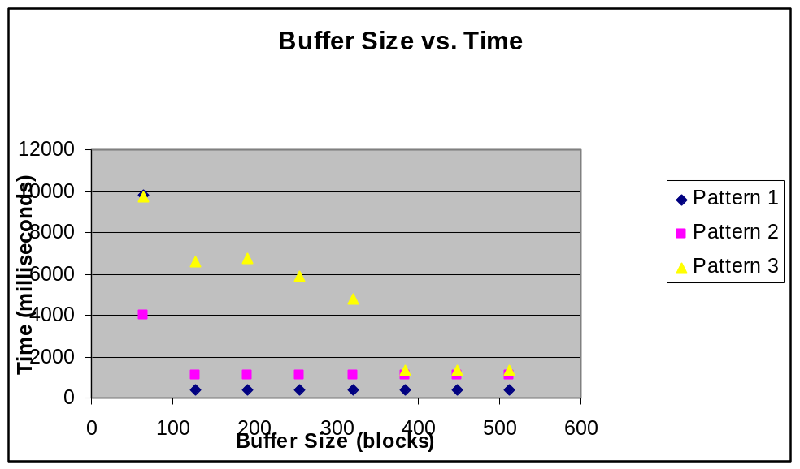
Once the buffer size is greater than 64, it doesn’t have any affect on the lookups for either type of table in Patterns 1 or 2. But when it is less than some threshold between 64 and 128, those lookups take many times as much time. The buffer size had a much more gradual affect on the third pattern which mostly consisted of table scans.

Algorithm Tuning

123

Thrashing

123

Numbers taken from an IBM white paper called Hard Drive Performance at http://www.storage.ibm.com/hdd/technolo/7200rpm.htm

