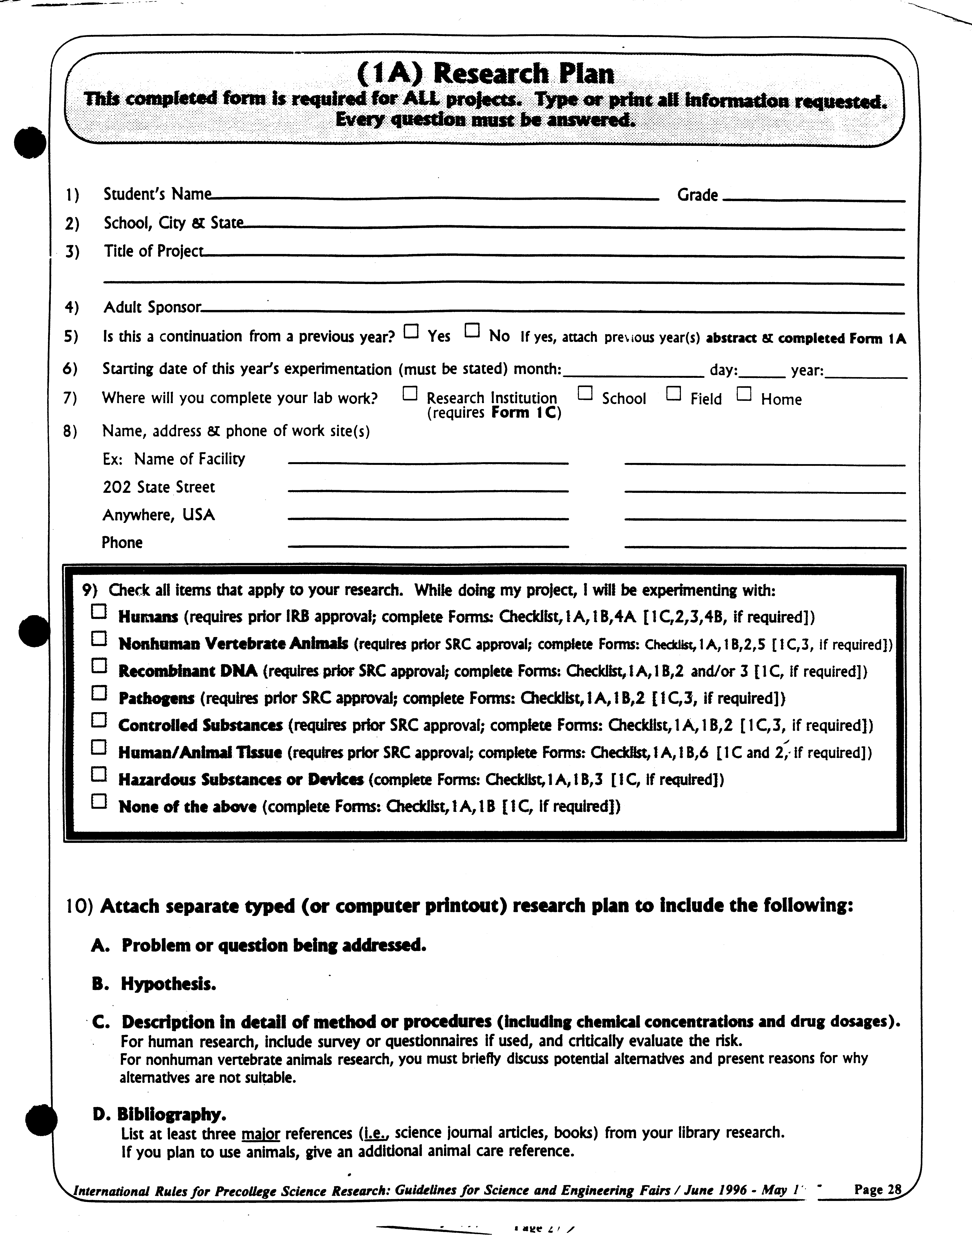
Russell Yanofsky 11
Cumberland Valley High School, Mechanicsburg, PA
Simplifying Graphics Procedures in the Windows Application Programming Interface
Mr. Yeager
ü
ü
ü
February 2 1998
Cumberland Valley High School
6746 Carlisle Pike
Mechanicsburg, PA 17055
(717) 766-0217
Russ Yanofsky (home)
120 Pelham Road
Camp Hill, PA 17011
(717) 761-8207
ü

