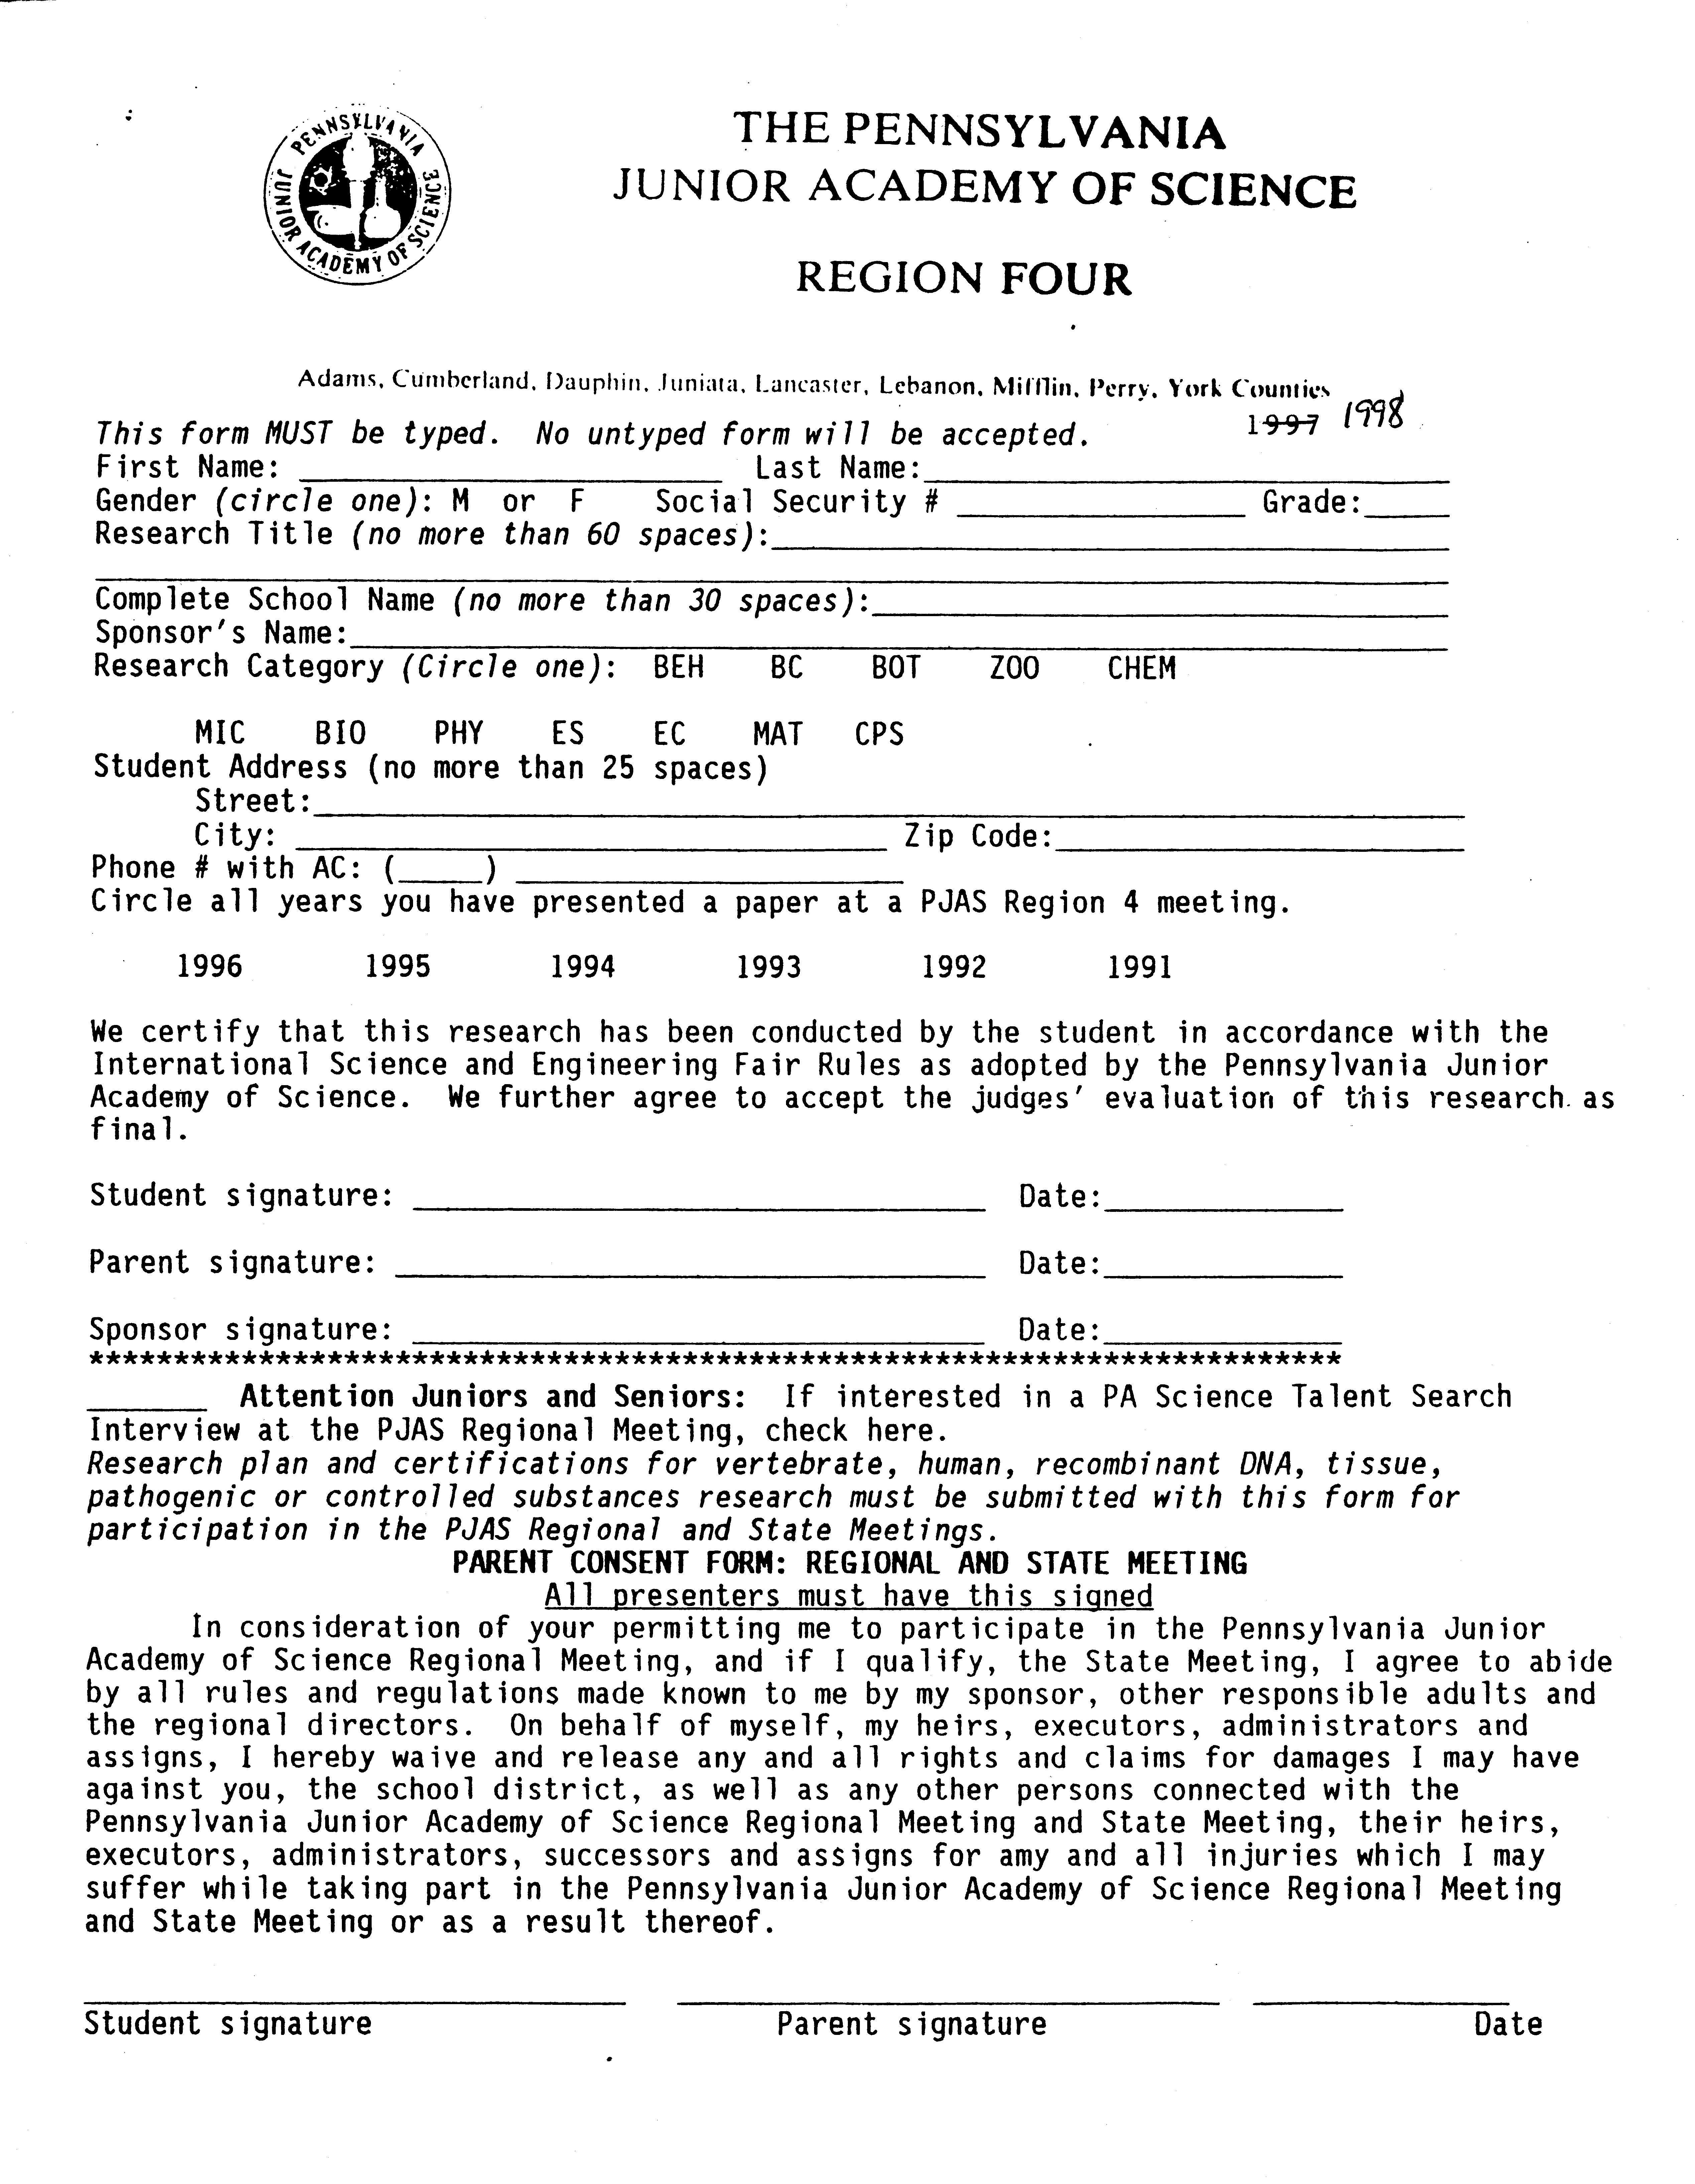

Russell

Yanofsky
172-66-7860
11

Simplifying Graphics Procedures in the Windows

Application Programming Interface

Cumberland Valley High School

Mr. Yeager

120 Pelham Road

Camp Hill 17011

717 761-8207

