Coordinate System

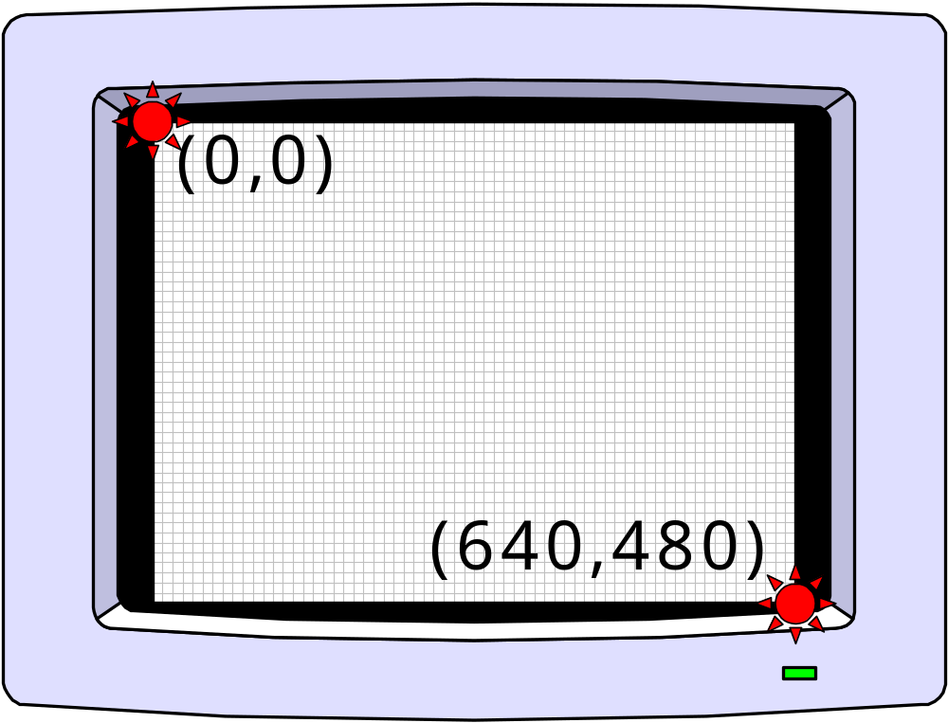

Drawing Shapes

COLOR 10 ‘ 10 represents the color green
LINE(0,0)-(640,480) ‘ draws the line

COLOR 12 ‘ 12 represents the color red
CIRCLE(320,240),100 ‘ draws circle with center
‘ (320,240) and Radius 100

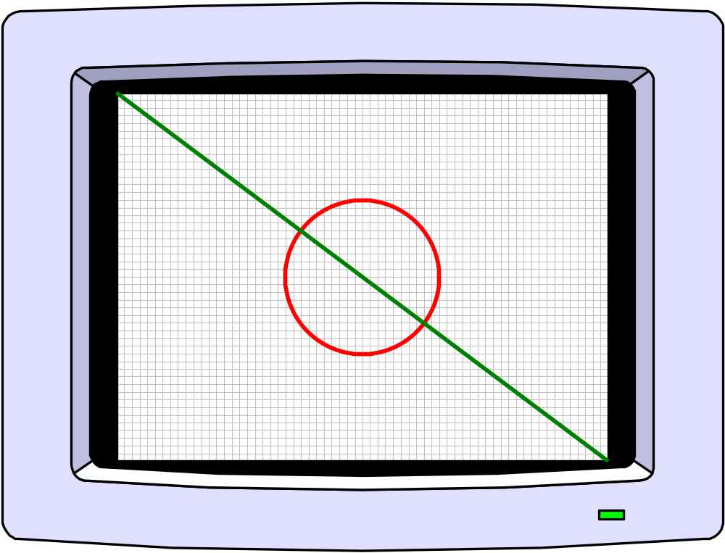

Compare

QuickBasic | 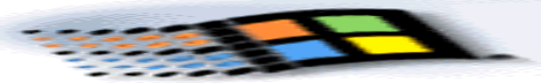
COLOR 10  LINE(0,0)-(640,480)  COLOR 12  CIRCLE(320,240),100 | DC := getDC(Hwindow);  Pen := createpen(0,0,RGB(85,255,85));  OldPen := Selectobject(DC, Pen);  Moveto(DC,0,0);  Lineto(DC,640,480);  Pen := Selectobject(DC, Oldpen);  Deleteobject(Pen);  Pen := Createpen(0,0,RGB(255,85,85) );  OldPen := Selectobject(DC, Pen);  Brushstyle.lbstyle:=BS_HOLLOW;  Brush:=CreateBrushIndirect(brushstyle)  OldBrush := Selectobject(DC, Brush);  Ellipse(DC,220,140,420,340);  Brush := Selectobject(DC, OldBrush);  Deleteobject(Brush);  Pen := Selectobject(DC,Oldpen);  Deleteobject(Pen);  ReleaseDC(Hwindow,DC);
4 Lines  0 Handles  3 Commands | 18 Lines  5 Handles  9 Commands


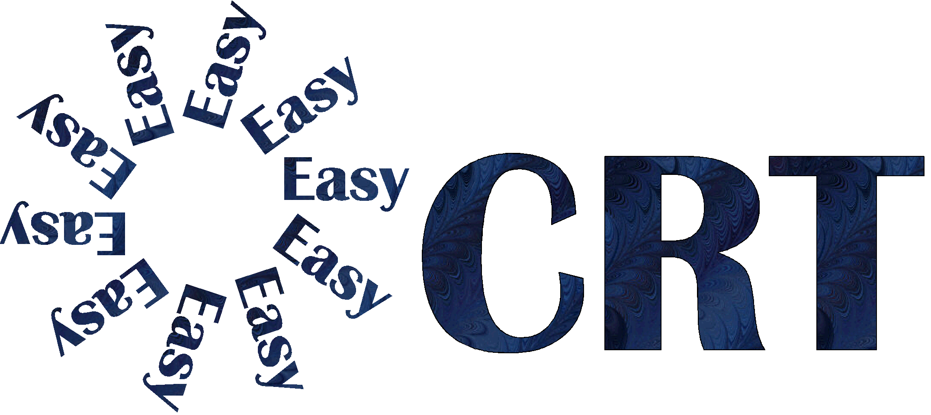
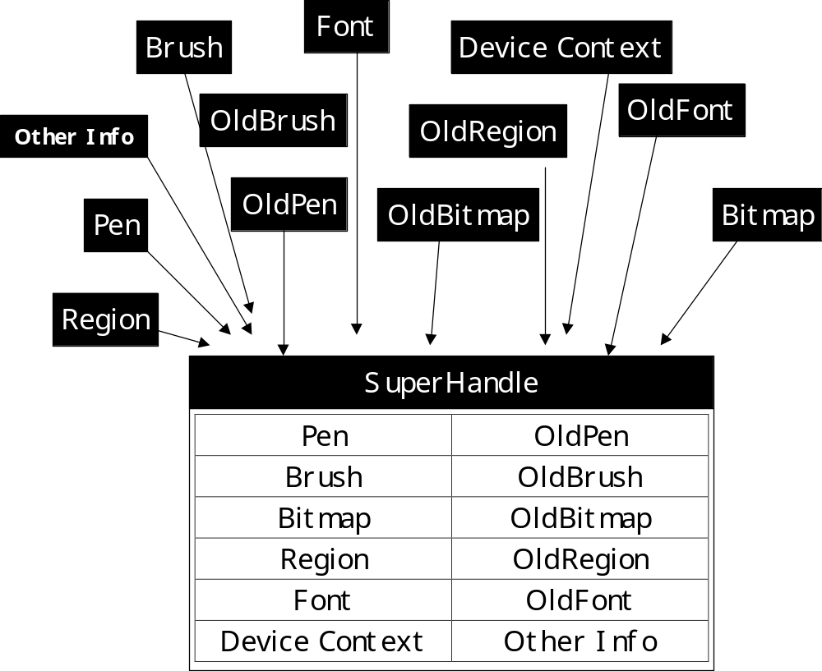

Compare


TheDC := makeDC(Hwindow,0);  Asetpen(TheDC,color[10],0,0);  aqline(TheDC,0,0,640,480);  asetpen(TheDC,color[12],0,0);  asetbrush(TheDC,-1,0,0);  aqcircle(TheDC,320,240,100,100);  killdc(thedc); | DC := getDC(Hwindow);  Pen := createpen(0,0,RGB(85,255,85));  OldPen := Selectobject(DC, Pen);  Moveto(DC,0,0);  Lineto(DC,640,480);  Pen := Selectobject(DC, Oldpen);  Deleteobject(Pen);  Pen := Createpen(0,0,RGB(255,85,85) );  OldPen := Selectobject(DC, Pen);  Brushstyle.lbstyle:=BS_HOLLOW;  Brush:=CreateBrushIndirect(brushstyle)  OldBrush := Selectobject(DC, Brush);  Ellipse(DC,220,140,420,340);  Brush := Selectobject(DC, OldBrush);  Deleteobject(Brush);  Pen := Selectobject(DC,Oldpen);  Deleteobject(Pen);  ReleaseDC(Hwindow,DC);
7 Lines  1 Handles  5 Commands | 18 Lines  5 Handles  9 Commands

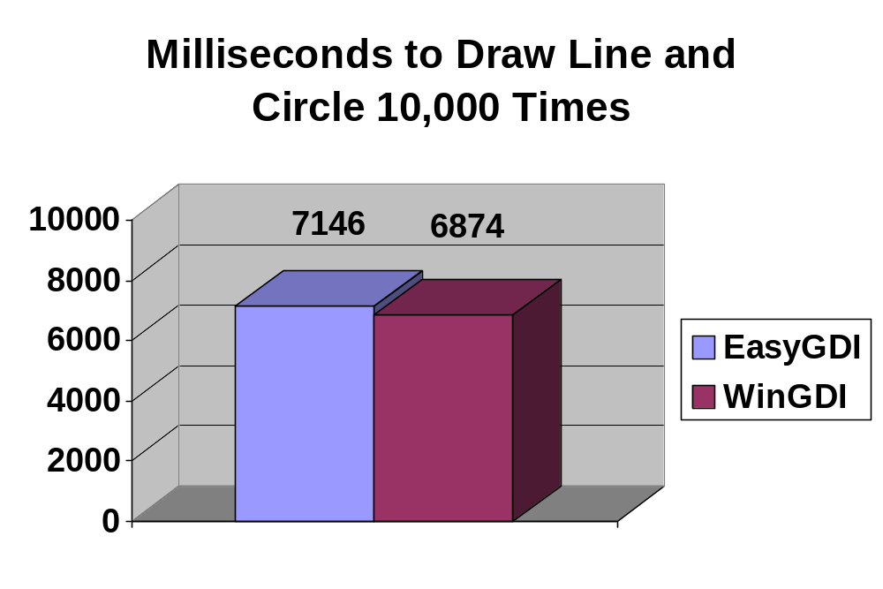
EasyGDIWinGDIWinGDI % FasterTrial 17117 ms6843 ms4.00%Trial 27180 ms6892 ms4.18%Trial 37142 ms6886 ms3.72%Avg.7146 ms6874 ms3.97%
procedure InitWinCrt;
procedure DoneWinCrt;
procedure WriteBuf(Buffer: PChar; Count: Word);
procedure WriteChar(Ch: Char);
function KeyPressed: Boolean;
function ReadKey: Char;
function ReadBuf(Buffer: PChar; Count: Word): Word;
procedure GotoXY(X, Y: Integer);
function WhereX: Integer;
function WhereY: Integer;
procedure ClrScr;
procedure ClrEol;
procedure CursorTo(X, Y: Integer);
procedure ScrollTo(X, Y: Integer);
procedure TrackCursor;
procedure InitWinCrt;
procedure DoneWinCrt;
procedure WriteBuf(Buffer: PChar; Count: Word);
procedure WriteChar(Ch: Char);
function KeyPressed: Boolean;
function ReadKey: Char;
function ReadBuf(Buffer: PChar; Count: Word): Word;
procedure GotoXY(X, Y: Integer);
function WhereX: Integer;
function WhereY: Integer;
procedure ClrScr;
procedure ClrEol;
procedure CursorTo(X, Y: Integer);
procedure ScrollTo(X, Y: Integer);
procedure TrackCursor;

procedure setpen(color: longint; linestyle, width: integer);
procedure setbrush(color,bcolor:longint; style: integer);
procedure box(x1,y1,x2,y2,x3,y3:integer);
procedure qcircle(xpos,ypos,radiusw,radiush:integer);
procedure qline(x1,y1,x2,y2:integer);
procedure qarc(xpos,ypos,radiusw,radiush,angle1,angle2,way:integer);
procedure connectdots(var pointarray; count:integer);
procedure shape(var pointarray; count,method: integer);
procedure pset(xpos,ypos: integer; color:longint);
function pixel(xpos,ypos:integer):longint;
procedure fill(xpos,ypos:integer; colorinfo:longint; filltype:integer);
procedure setfont(fontface:string; size,weight,italic,underline,strikeout:integer;angle:real );
function getlng(text:string):longint;
procedure txt(x,y,align:integer; color:longint; text:string);
procedure drawbmp(x,y: integer; bmpname: bmp; stretched,width,height:integer);
procedure maskbmp(x,y: integer; themask,thepic: bmp; stretched,wth,ht:integer);
procedure drawpicture(x,y:integer; filename:string);
procedure unfreeze;
procedure delay(milliseconds:longint);
procedure startdelay(var t: longint);
procedure finishdelay(milliseconds,t:longint);
function FileOpen(path,ftype,wildcards: string):string;
function FileSave(path,ftype,wildcards: string):string;
function apppath: string;
procedure showcursor;
procedure hidecursor;
procedure settitle(lbl:string);
function gettitle: string;
procedure minimize;
procedure maximize;
procedure restore;
procedure show;
procedure hide;
procedure setpos(x,y: integer);
procedure setsize(w,h: integer);
function getpos(index:integer):integer;
procedure setborder(index,setting: integer);
procedure resetkeys;
function inkey:word;
function inkeyasc:char;
function mousex: integer;
function mousey: integer;
function dchandle: thandle;
function windowhandle: thandle;
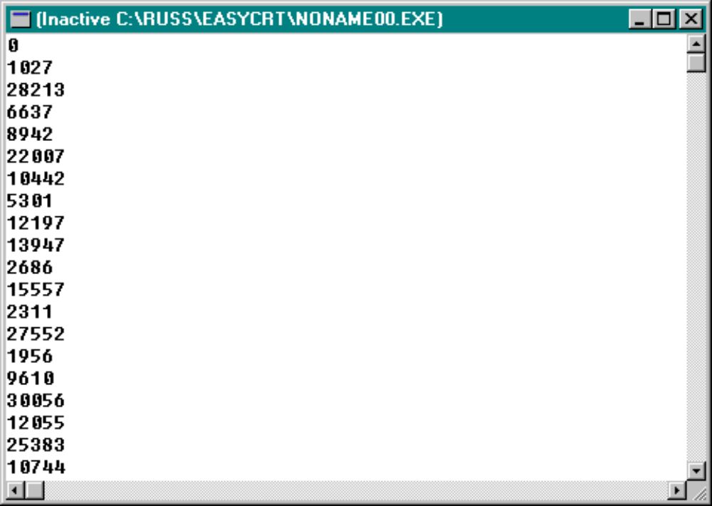
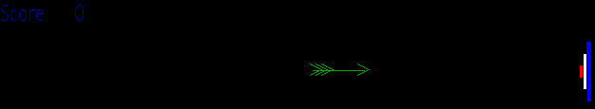
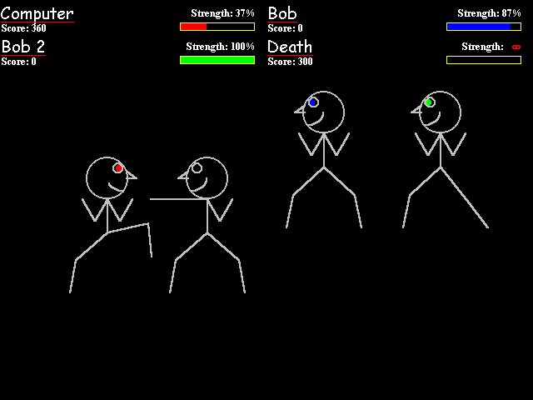
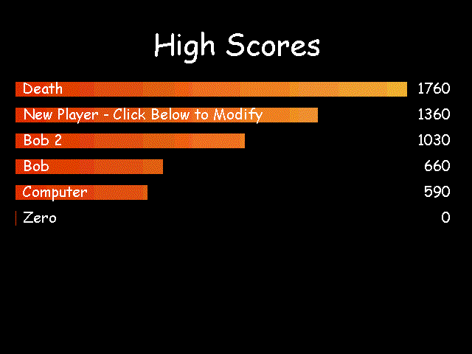
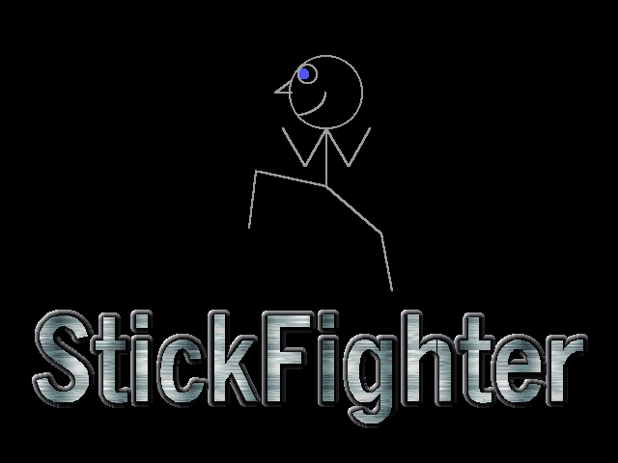
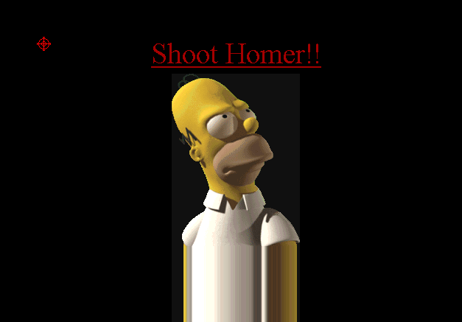
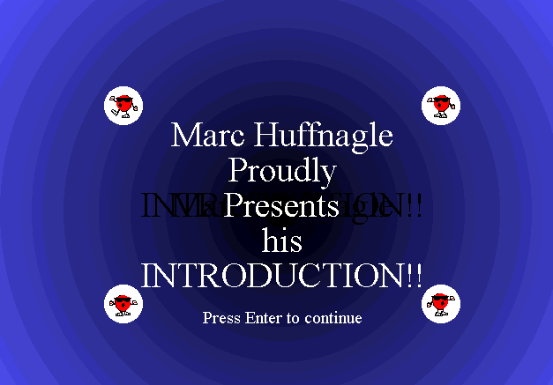
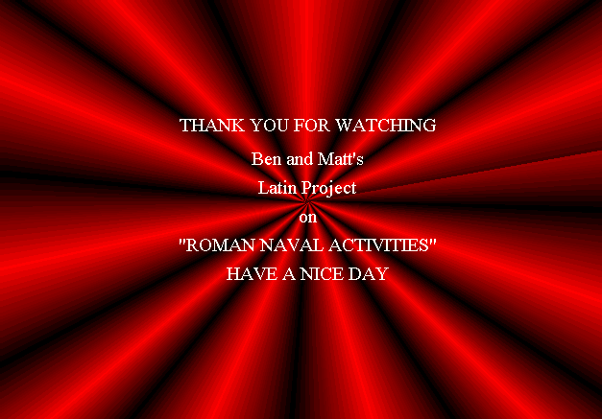
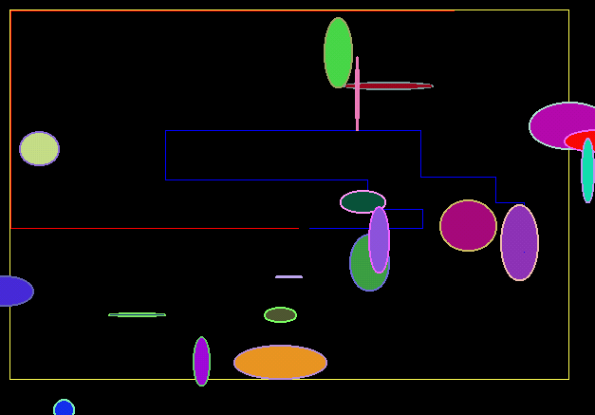
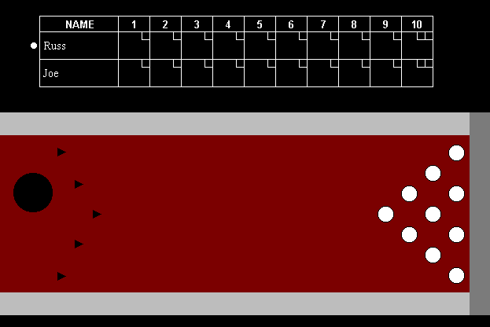
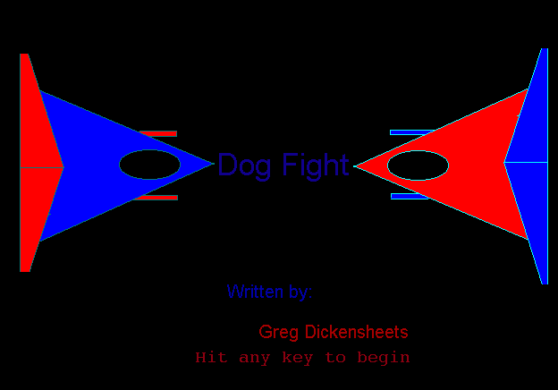

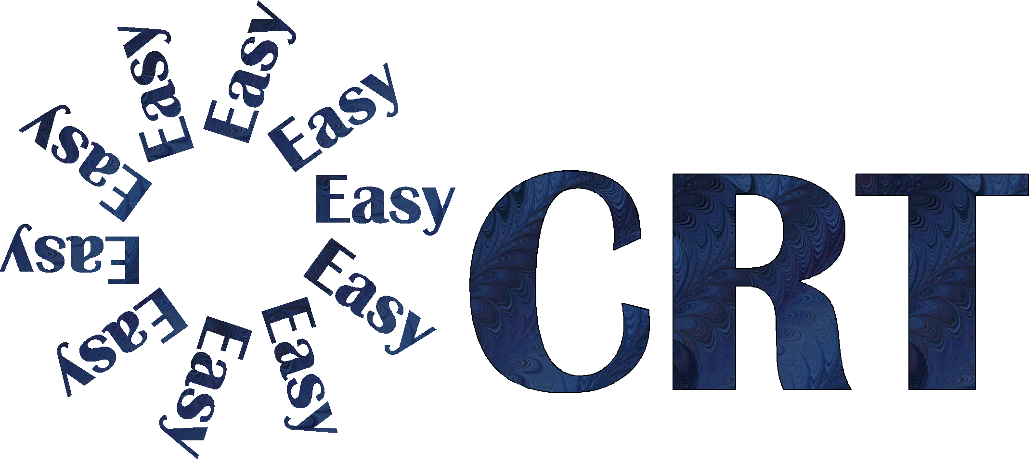
Screen Shots

