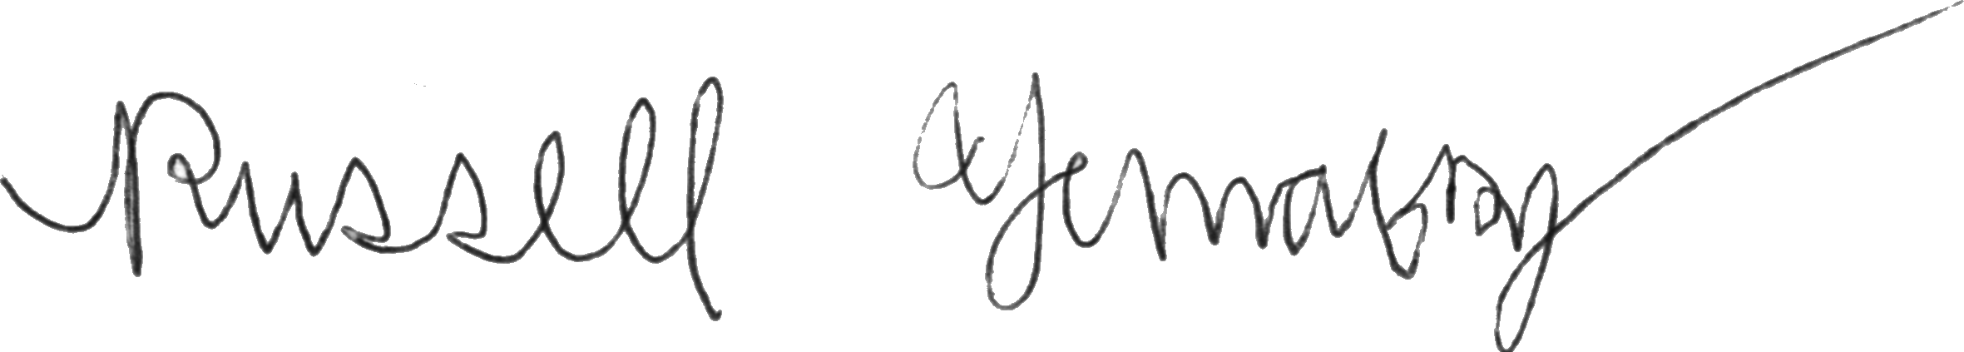
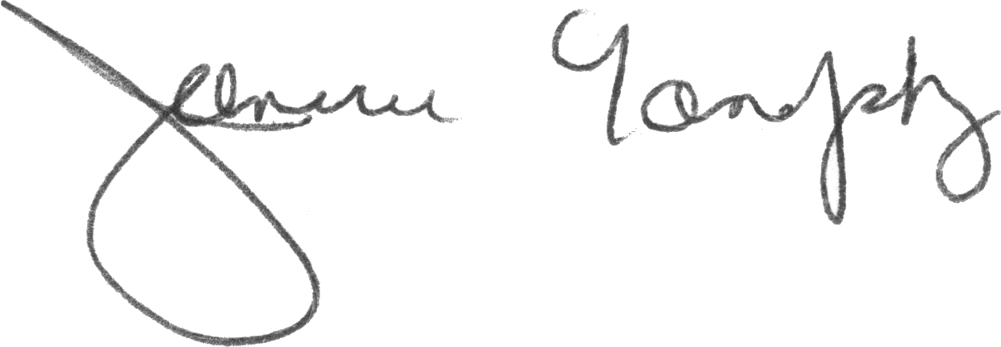
Charles and Janice Yanofsky 761-8207
Yanofsky Russell E 11 16
120 Pelham Road Camp Hill 17011
Cumberland Valley High School 766-0217
1 7 2 6 6 7 8 6 0
Simplifying Graphics Procedures in the Windows Application Programming Interface

The majority of graphics in Windows are made through built in commands in the Windows Graphical Device Interface (GDI) which draw to the screen. However, these commands are often difficult to use and learn for many reasons. The goal of this project is to make new commands which simplify the old commands without losing any functionality. The new commands will eliminate the problems and can be used in place of and alongside normal GDI commands. The project will include an application of the commands, a demo program, and complete documentation. More information can be found in the abstract.

ü

