Version | Date | Author | Summary
A01
A02
A03
A04
A05 | 04/02/2025 | Chris A Talley | Implement Gibson Feedback
A06 | 05/22/2025 | Noor Coenen | Adjust SWP Template update
A07 | 5/29/2025 | Jodi Cray | Gibson final validation complete
A08
Z01

Table of Contents
Icon Glossary 2
Overview 3
Set-up 4
Process 12
Appendix A - Gibson Glossary 18
Terms and Acronyms 18
Production 18
Guitars 19
Departments 19
Guitar Orientation and Terminology 20
Appendix B - 5S Workstation 23
Tools 24
Materials 25
Revision History 26
Proposed Change Approvals 27

Icon Glossary
 | Warning! Watch out for possible personal injury.
 | Caution! Watch for possible guitar damage.
 | Specifications/Best Practices: For extra direction when measurement or special details are to be called out.
 | Eco-Friendly: For calling out opportunities in which material can be recycled, reused, or reduced.
 | Quality/Goals: For quality callouts and when listing the goals/objectives of a process.
 | Variation: For directing the user to skip ahead to the process variation that is relevant to the build they are working on, also to list the known variations.
 | Testing: For a process that may need repeated with minor adjustments until specification achieved.
 | Step Complete

 | Overview
 | The material received from the Glue Press is to be processed through the Rough Mill Body:  - Band saw to be cut into guitar body blanks.  Once the guitar body blanks are cut, the blanks will be stacked and staged to be processed at the CNC Routers.  It is estimated that a trained band saw operator can process 375 guitar body blanks in a shift. |  |  |  |  | 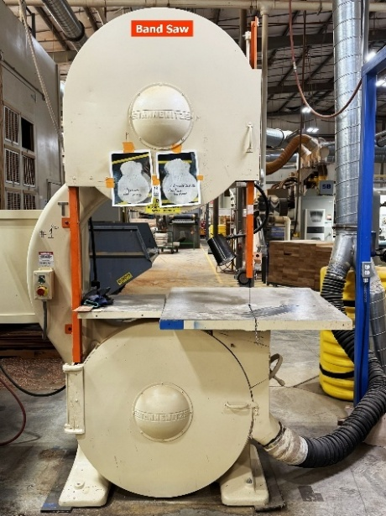
 |  |  |  |  | Warning! Always wear safety glasses on the production floor.
 |  |  |  |  | Warning! Wear fingerless and/or latex protective gloves to protect the palm of your hands.
 |  |  |  |  | Warning! Band saw band is in constant motion. Take heed as gloves and fingers can get caught which may result in an injury.
 |  | Set-up
 |  | - The guitar body templates are in the guitar body template crate. |  |  | 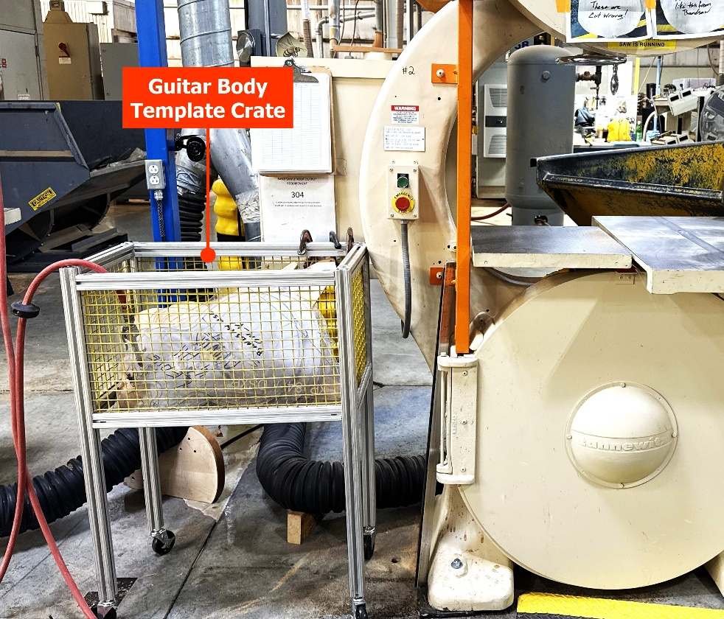
 |  |  |  |  | Note: If a guitar body template is not inside the crate, talk with Team Leader.  These various guitar body templates are used to trace the profiles of the guitar body blanks that are to be cut using the band saw.
 |  | - Guitar body blanks are to be received from the glue press on pallets. |  |  | 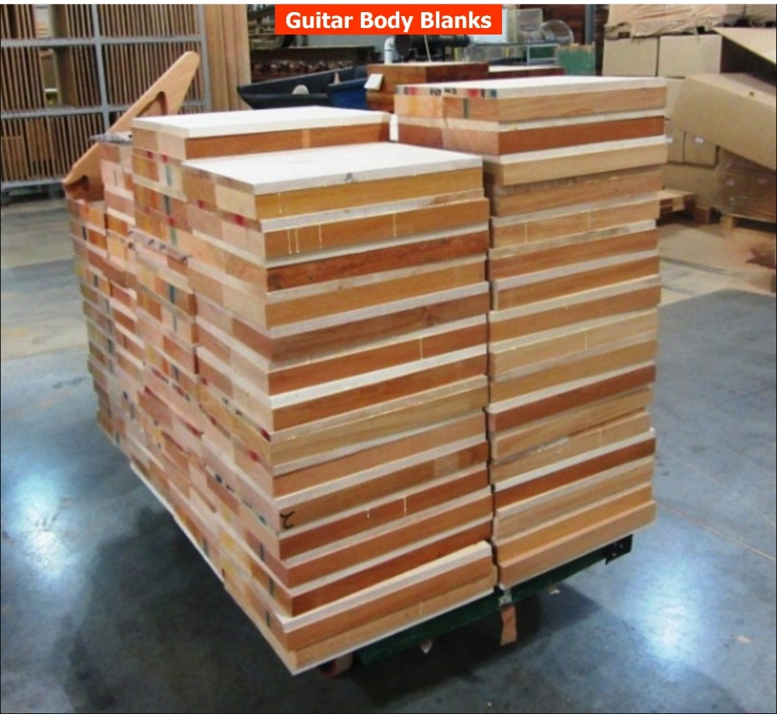
 |  |  |  |  | Note: Guitar body blanks maybe received preformed from a vendor.
 |  | - Select a stack of guitar body blanks from the pallet of guitar body blanks that are to be processed. |  |  | 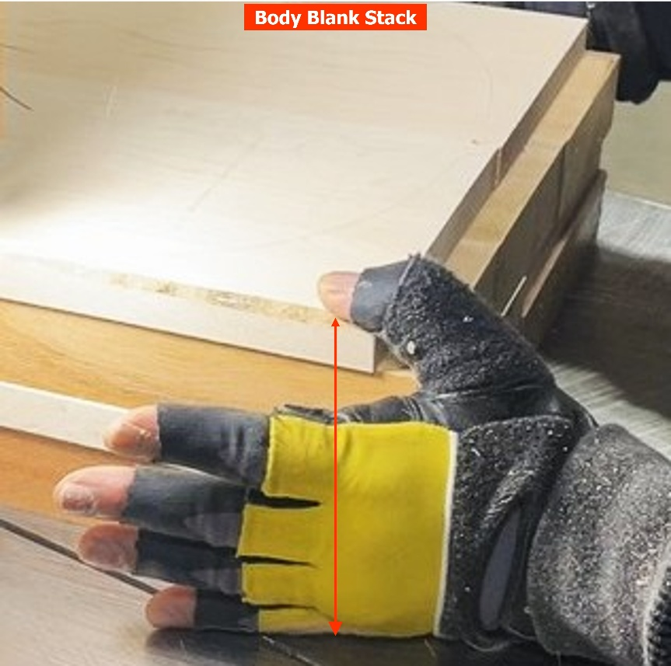
 |  |  |  |  | Warning! Use your hand as a guide. The quantity of guitar bodies should be able to fit in the palm of your hand between a bent thumb and pinky finger (as pictured.) This will give the operator maximum control when processing more than guitar body at a time.
 |  |  |  |  | Warning! If operator does not have maximum control of the stack, the band saw may whip and result in possible injury.
 |  | - Unlock the band saw blank height adjuster using the height adjuster lock. |  |  | 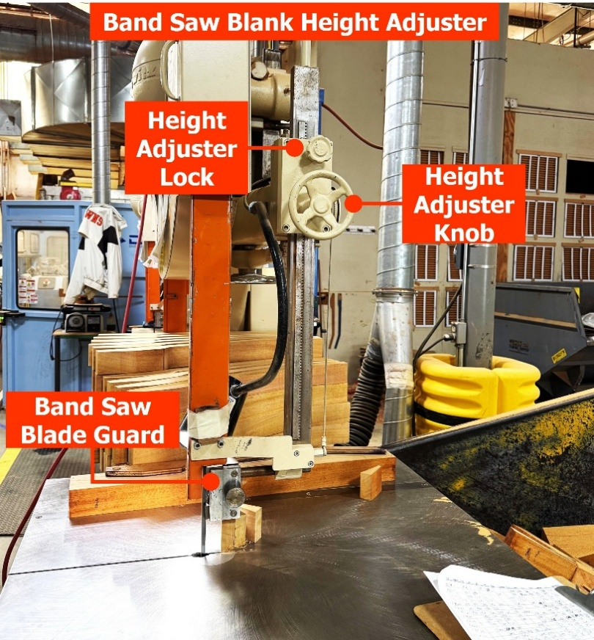
 |  | - Using the height adjuster knob, adjust the band saw blade guard to approximately ½” above guitar body stack.
 |  | - Lock the band saw blank height adjuster in position using the height adjust lock.
 |  |  |  |  | Warning! Not adjusting the band saw blade to the approximate clearance height can cause the band saw blade to become unstable which could result in injury.
 |  |  | - Set the band saw blade tension adjuster in accordance with the width of the band saw blade.  - Example: 1/2” band saw blade width corresponds to the ½” blade width scale setting. | 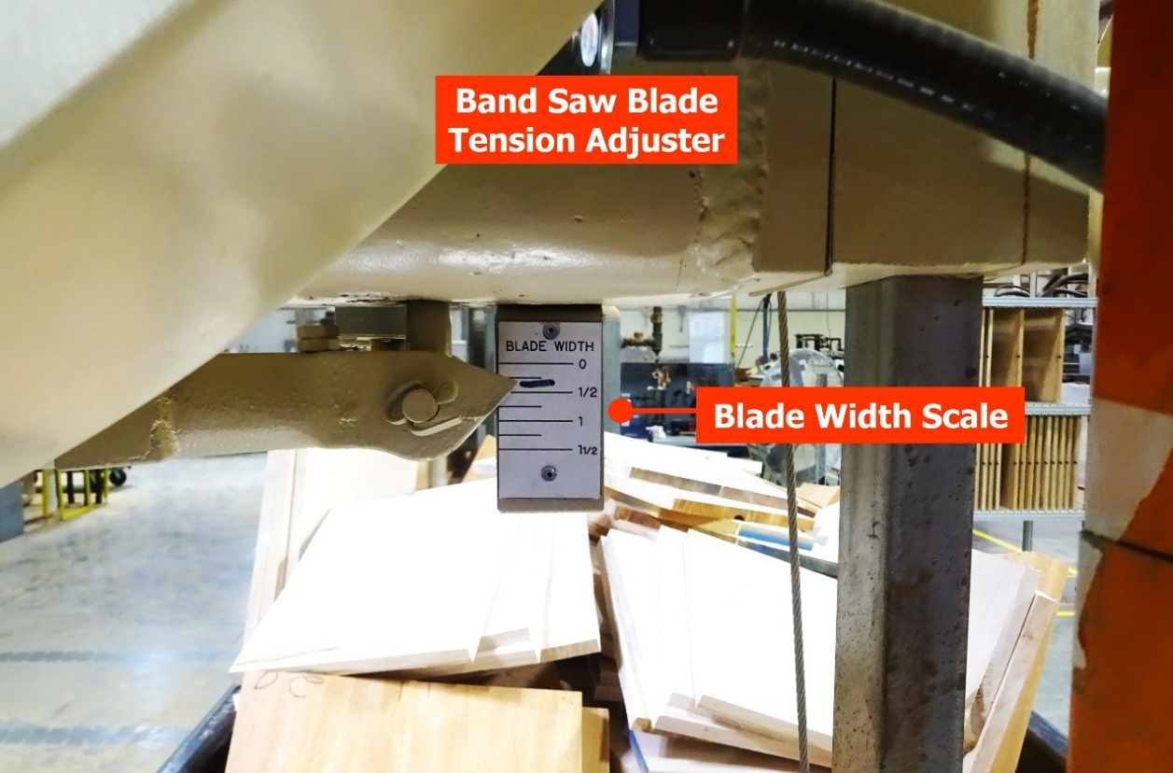
 |  |  |  | Warning! Not adjusting the band saw blade tension can cause the band saw blade to become unstable which could result in injury.

 | - Condition the band saw worktable by rubbing paraffin wax over the surface of worktable. | 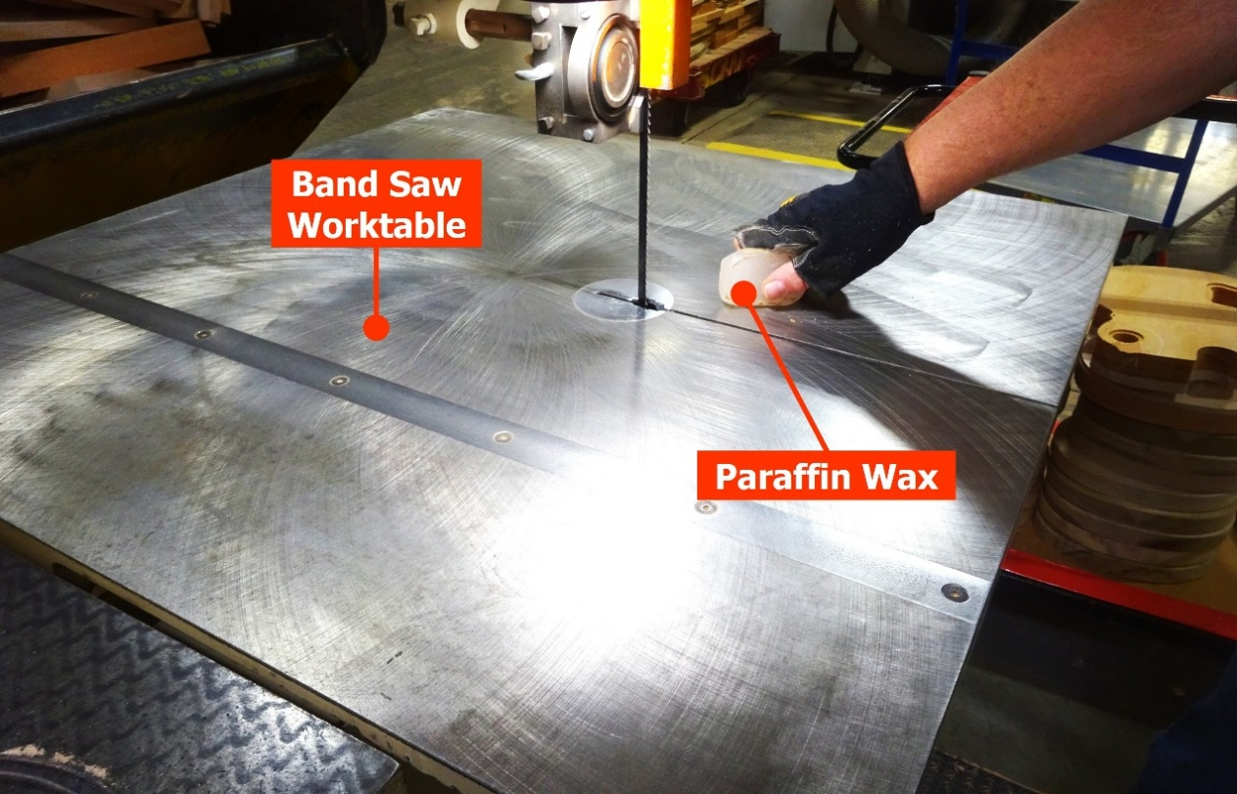

 | Process
 |  | - Select the appropriate guitar body template as communicated or as marked on the guitar body blank. |  | 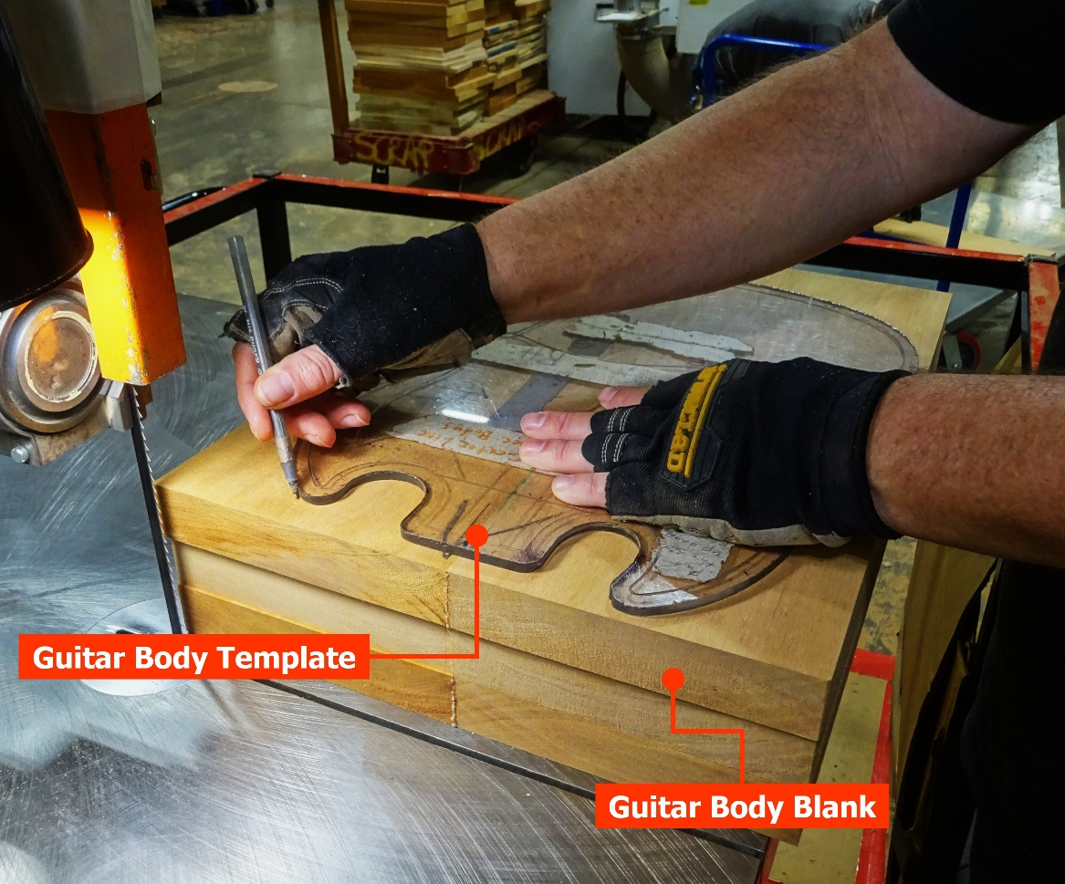
 |  | - Using a pencil, pen or wood crayon, trace the outline of the guitar body profile.
 |  | - Turn on the band saw blade using the green “Saw Start” button located just to the left of the band saw blade table when facing unit. | 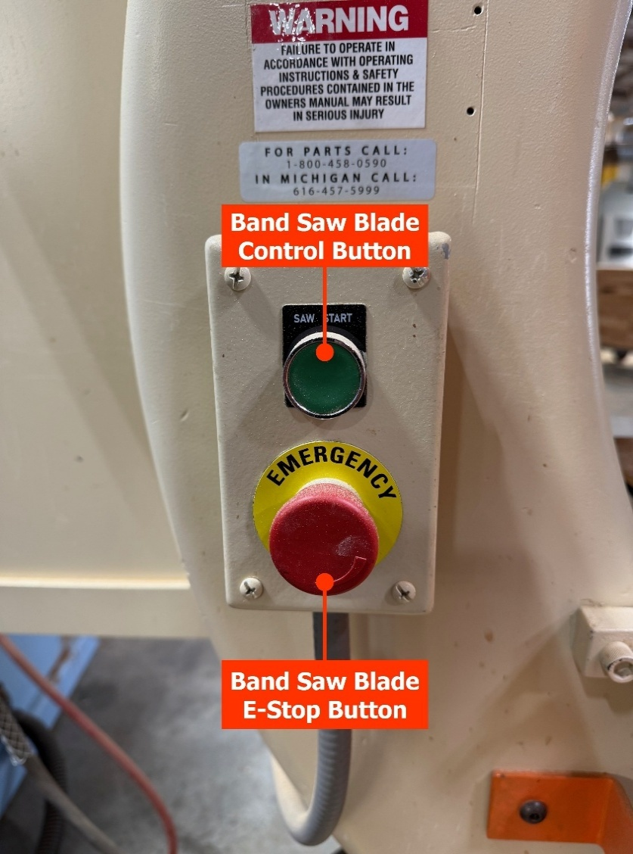
 |  | - Using both hands to firmly grasp the stack of guitar body blanks, carefully trace the outline of the guitar body profile leaving approximately ½ inch of material just outside the outline. | 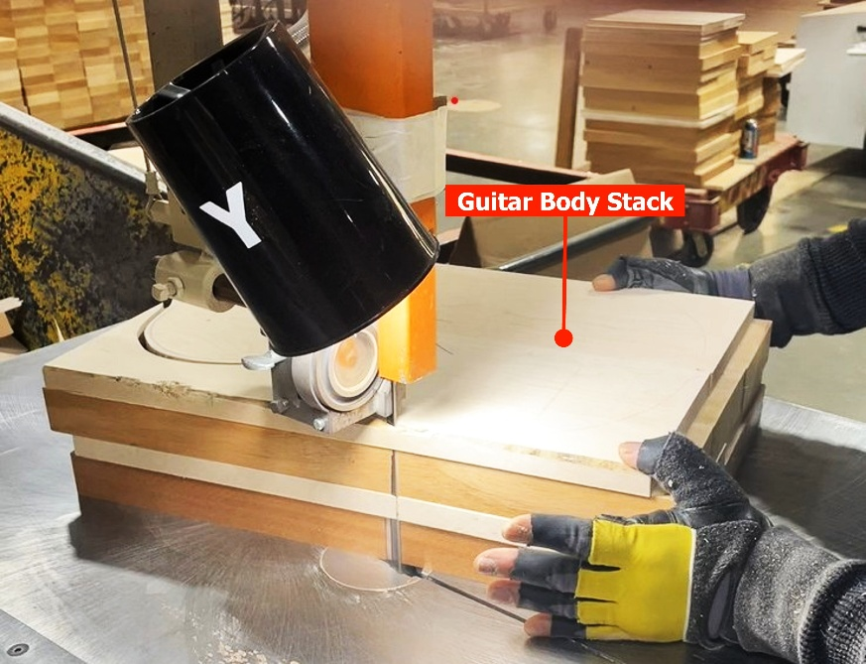
 |  |  |  |  | Warning! Use your strong hand to gently but forcefully push the stacked guitar body blanks into the saw blade.
 |  |  |  |  | Warning! Use your off hand to help stabilize the guitar body blanks through the cutting process
 |  |  |  |  | Warning! Be careful as the band saw blade is active and can cause injury.
 | - Turn off band saw blade pushing the E-stop button. |  |  |  | 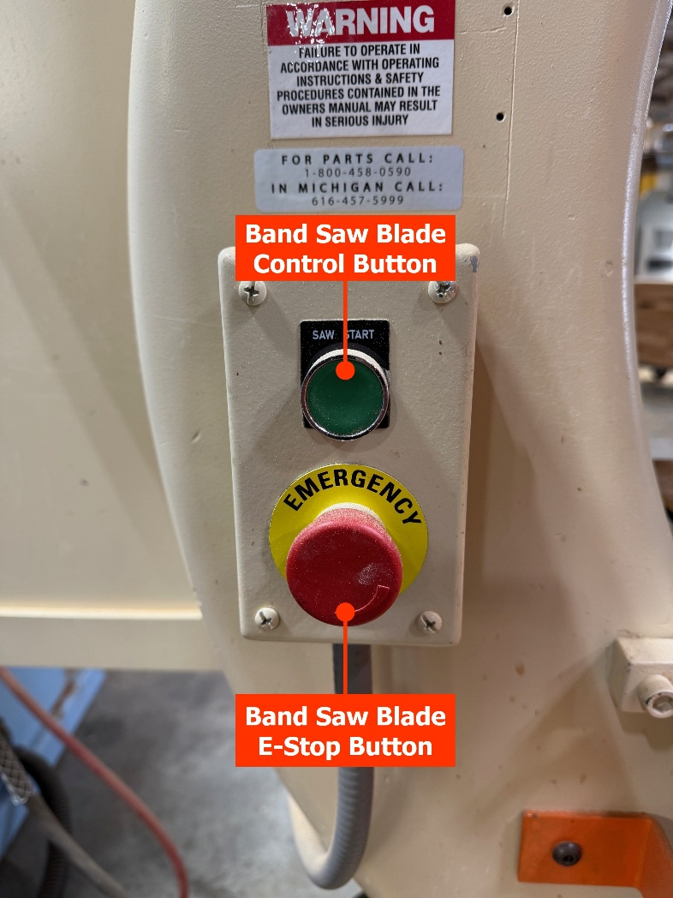
 | - Stack cut guitar body blanks onto a pallet or rolling cart. |  |  |  | 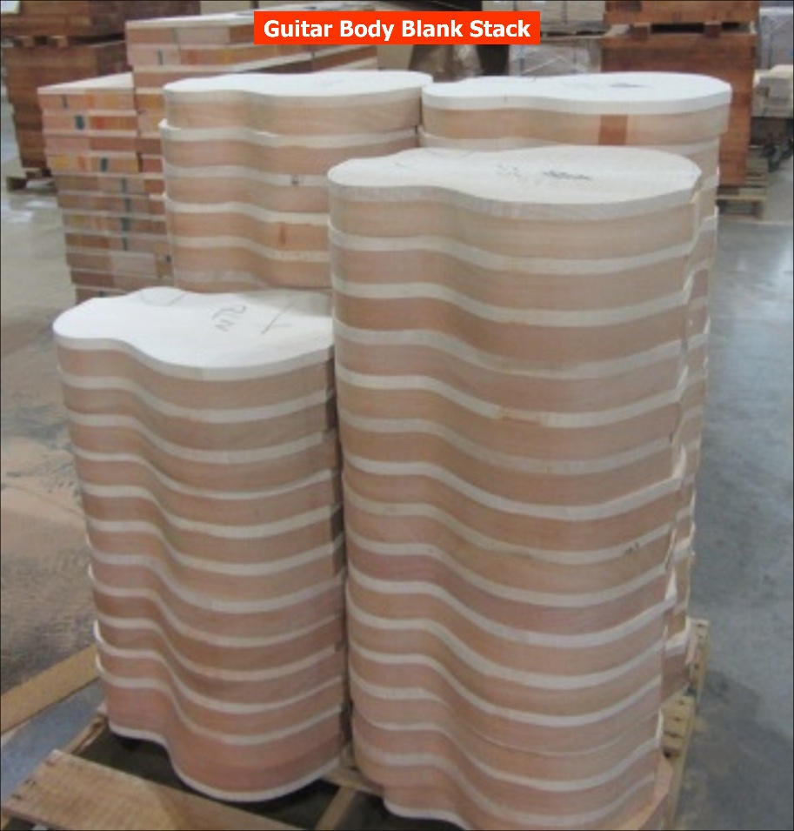
 | - Return to Step 7 and complete the process until lot is complete or pallet or rolling cart has reached its maximum capacity.
 | - Guitar bodies are ready to be transported to CNC routers.
 |  |  |  |  | Step Complete

 | Appendix A - Gibson Glossary
The Gibson Glossary consists of two parts:
- List of common terms and acronyms used in production, relating to guitars, and department titles.
- Diagram of guitar orientation with associated terminology.
 | Terms and Acronyms
 | Production
Acronym |  | Definition | Acronym | Definition
ADH |  | Adherence | MRB | Material Review Board
CER |  | Capital Expense Request | NPI | New Product Introduction
CDV |  | Check Do Verify | OTD | On time Delivery
ECN |  | Engineering Change Notice | PD | Product Development
ECR |  | Engineering Change Request | PPR | Pre-Production Run
EOD |  | End of Day | PVR | Process Validation Run
EOL |  | End of Line | QC | Quality Control
ELT |  | Extended Leadership Team | RAF | Report as Finished
ESTAT |  | Electrostatic Lacquer Line | SCH | Schedule
FAI |  | First Article Inspection | SQDC | Safety Quality Delivery Cost
GLT |  | Gibson Leadership Team (C Suite) | WIP | Work in Process
KPI |  | Key Performance Indicator
 | Guitars
Acronym |  | Definition | Acronym | Definition
LP |  | Les Paul | NT | NUT
SG |  | Solid Guitar | TSFB | Top Side Fingerboard
ES |  | Electric Spanish | NK | Neck
EXP |  | Explorer | BSFB | Bottom Side Fingerboard
Vs (Vees) |  | Flying V | FB | Fingerboard
DS |  | Designer Series | BK | Back
PHF |  | Peghead Face | TP | Top
PHB |  | Peghead Back
 | Departments
Acronym |  | Definition | Acronym | Definition
RM |  | Rough Mill (Mill Room) | CL | Color Line
BL |  | Body Line | ESTAT | Electrostatic Lacquer Line
WW |  | White Wood | TC | Top Coat
FGBL |  | Fingerboard Line | NP | Neck Prep
NL |  | Neck Line | FA (Final) | Final Assembly
CP |  | Color Prep | DC | Distribution Center (Back Dock)

 | Guitar Orientation and Terminology
Player View  Body Front, Body Top Side (Bass Side), Peghead Face, Peghead Top Side, Fingerboard Face, Top of Neck, Top Rim of Body, Top Binding. |  | 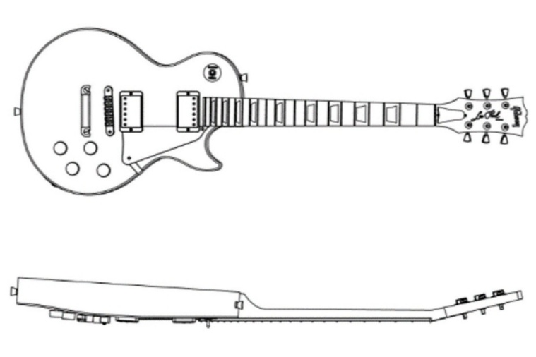
Non-Player View  Body Back, Body Bottom Side (Treble Side), Back of Peghead, Back of Neck, End of Peghead, Bottom Side of Peghead, Bottom Rim, Butt Rim, inside of guitar, Bottom Binding. |  | 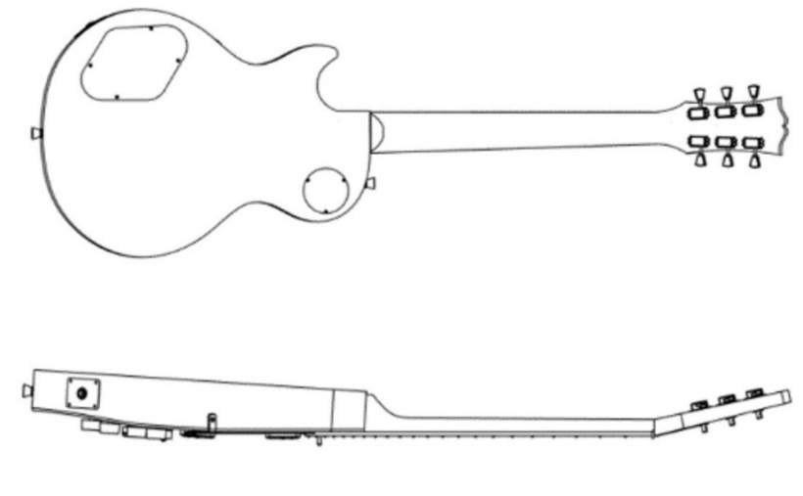
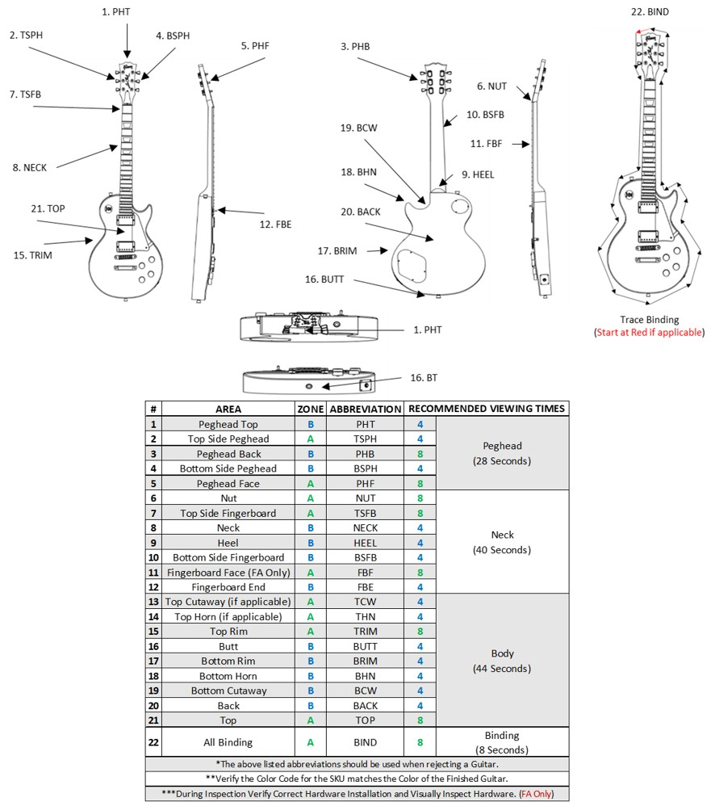



Appendix B - 5S Workstation
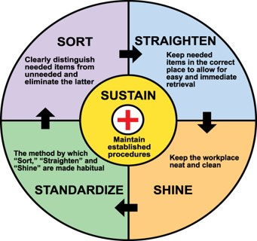
Sort, straighten, and shine your workstation at the beginning and ending of your shift.
Standardize: Manage and maintain consistent methods and procedures. Following established methods and precedures contributes to repeatable outcomes and performance results.
Sort: Separate unnecessary (not needed for daily work) from necessary items (needed for daily work). Remove unnecessary items from work area.
Straighten: Stow all tools and parts in their correct locations.
Shine: Clean your workstation and it is clear of debris and is wiped down.
Sustain: Each time a procedure is used, verify procedure is correct and the latest version. Flag any needed changes.

 | Revision History
Revision |  | Effective Date | Changed By | Reason for Change

 | Proposed Change Approvals
Revision |  | Print Name | Signature

