I can edit the a attribute to add decent looking tabs:

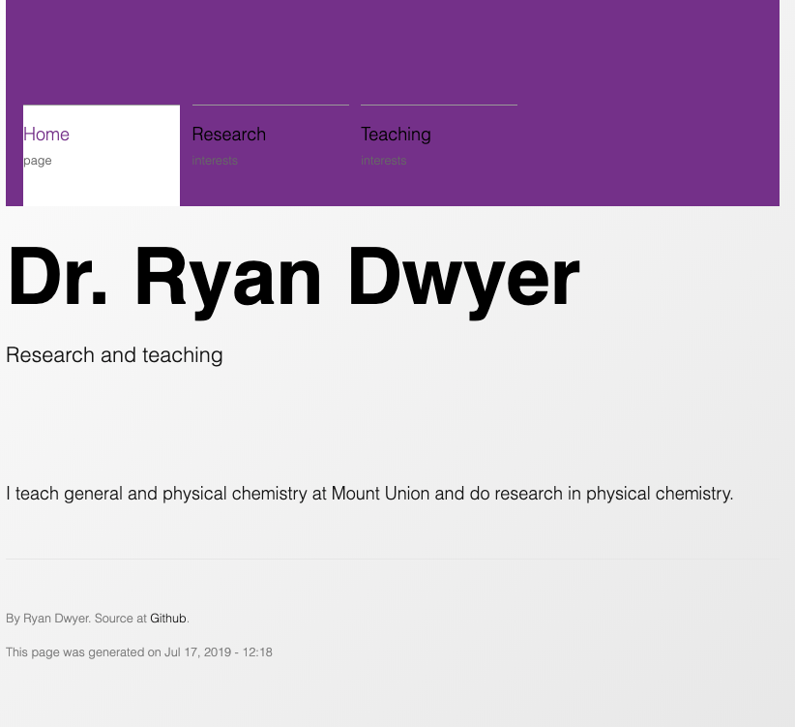

This is a new nav div, background-color: $mupurple, followed by setting the active link element to a background-color of #fff, and setting the active link text color to $mupurple. Might make sense to move h1 above the nav bar?