**CHE 120 Lab: Opening Avogadro on Mac for the first time**

If you try to open Avogadro normally, you get a scary-looking dialog box:

Here’s how to fix it.

1. After installing the application, use a Finder window to go to the Applications folder.
2. Right-click (two fingers or Ctrl+click) on the Avogadro icon and choose Open from the menu:A screenshot of a social media post

   Description automatically generated
3. In the resulting pop-up window, choose Open:

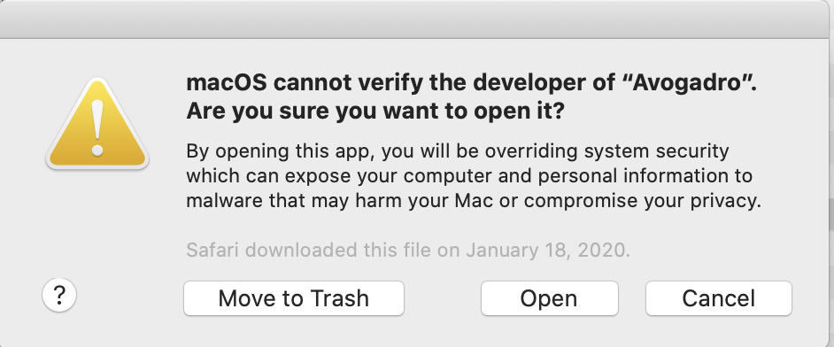

1. The next time you launch Avogadro, you can open it normally.