**Refining conservation unit boundaries of a sentinel stream-breeding frog (*Rana boylii*) using population genomics**

Ryan A. Peek 1,2

Sean O’Rourke 2

Michael R. Miller 1,2

1Center for Watershed Sciences, University of California, Davis, CA, 95616

2Department of Animal Science, University of California, Davis, CA, 95616

**ABSTRACT**

*Rana boylii* is an imperiled frog species native to California and Oregon, currently petitioned as candidate for Federal (USFWS) and State (CDFW) listing under Endangered Species Acts. As a lotic breeding amphibian, *R. boylii* is tied closely to the local hydrology within the watersheds it inhabits. It is particularly sensitive to alterations to flow regimes. Conservation of genetic diversity in this species will require several components, including refining potential conservation units (i.e., distinct population segments) and quantifying genetic diversity and genetic diversity trajectories across the species range. We provide genomic data on over 600 samples from 89 localities across the range of the species, identify six genomically-distinct groups, as well as population subdivisions at local watershed scales. In particular, we identify the Feather watershed as a distinctive group. Quantification and comparison of genomic variation across populations indicates populations in the southern coast, southern Sierra Nevada, and Northern Sierra/Feather basin in California should have high prioritization in conservation efforts due to low genomic diversity and trajectories of diversity loss. More broadly, our results demonstrate both the critical need for regional conservation in a sentinel river species and the utility and power of genetic methods for assessing and monitoring sensitive species.

**Keywords:** *genomics, frogs, rivers*

**INTRODUCTION**

Modern genomic sequencing technology has permitted much higher resolution analyses of both geographic and ecological patterns in populations (Nunziata et al. 2017, Hendricks et al. 2018, Barbosa et al. 2018). Reduced representation sequencing methods such as restriction site-associated DNA sequencing (RADSeq) (Miller et al. 2007, Baird et al. 2008, Ali et al. 2016) provide a powerful means to address ecological genomics questions at scales that were previously impossible using traditional field methods. Furthermore, new methods such as RAD Capture (Rapture) (Ali et al. 2016) adapt RADSeq to target desired loci and allow highly efficient genotyping of thousands of individuals at once. Because historical and future landscape changes can influence species demography and migration patterns (Burkey 1989, Anderson and Beer 2009, Barbosa et al. 2018), these genomic tools are increasingly valuable for assessing critical factors for long-term persistence of sensitive populations or species.

Freshwater biota are rapidly declining globally (Ricciardi and Rasmussen 1999), and conservation efforts require assessment of the adaptive capacity of populations to rapid environmental change. Given limited resources available for conservation, it is important to define and establish clear geographic boundaries for conservation units such as distinct population segments across a species’ range. Delineation of distinct population segments can be used for prioritizing objectives in conservation management. Furthermore, quantification and comparison of relative genetic diversity within and among populations can provide additional information as a benchmark for assessment of conservation actions. Thus, quantifying and linking landscape change with genetic diversity metrics allows tracking of how sensitive populations respond to future environmental change (through reduced adaptive potential) as well as evaluating whether restoration efforts are effective (i.e., increasing genetic connectivity, diversity, effective breeder/population size).

Amphibians are particularly sensitive to changes in the ecosystem due to their physiology and ontogeny (Davidson et al. 2002, Beebee and Griffiths 2005); thus the ability to utilize environmental variables as life history cues can be especially important. In highly dynamic riverine environments, organisms must constantly adapt to temporal and spatial changes. One such sentinel stream-breeding species is the foothill yellow-legged frog (*Rana boylii*), a native to California and Oregon which historically occurred in lower elevation (0-1500m) streams and rivers from Southern Oregon to northern Baja California west of the Sierra-Cascade crest (Stebbins 2003). As a lotic breeding amphibian, *R. boylii* is tied closely to the local hydrology in watersheds it inhabits, and therefore it is particularly sensitive to alterations to flow regimes (Kupferberg 1996, Lind et al. 1996, Kupferberg et al. 2012).

As with many amphibians in California, there have been significant population declines across the former range of this species (Davidson 2004, Vredenburg and Wake 2007, Peek 2010, Kupferberg et al. 2012, Thomson et al. 2016). Particularly in southern California and the Sierra Nevada, *R. boylii* has been extirpated from approximately 50 percent of its historical range (Jennings and Hayes 1994, Davidson et al. 2002). *Rana boylii*, currently designated as a species of special concern (CDFW) in the state of CA, has been petitioned as candidate for listing under the federal (USFWS) Endangered Species Act (USFWS 2014) as well as the state (CDFW) Endangered Species Act.

Effective conservation management of this species will need to consider and prioritize maintenance of genetic diversity as part of any listing decision because it is closely related to the evolutionary capacity for adaptation to environmental changes (Lande and Shannon 1996) . Thus, utilizing genetic data provides a potentially informative process for identifying the impacts of anthropogenic and environmental change on the process of adaptation. Establishing high-resolution genetic boundaries for populations across the species range as well as quantification of genomic metrics (i.e., genomic diversity, population connectivity) would help managers prioritize conservation actions.

A recent study by McCartney-Melstad et al. (2018) identified five major clades in *R. boylii* with strong geographically structured genetic subdivision across its range in California and Oregon. Here we provide an additional population genomic analysis across the range of this declining sentinel stream species that is currently a candidate for listing. We provide additional geographic and genetic resolution to McCartney-Melstad et al. (2018), as well as quantify genetic diversity metrics across subpopulations and clades as both a reference and assessment of the potential for long-term persistence across the species’ range.

# MATERIALS AND METHODS

## Sampling and DNA extraction

A total of 1103 individual tadpole tail clips, buccal swabs, or tissue samples were compiled, collected between 1992 and 2016 across the range of *R. boylii.* Field sampling was conducted following methods in Heyer et al. (1994) under CDFW SCP Permit #0006881, with IACUC protocol #19327. Individual post-metamorphic frogs were buccal-swabbed following established protocols (Goldberg et al. 2003, Pidancier et al. 2003, Broquet et al. 2007). Each post-metamorphic individual was comprehensively swabbed underneath tongue and cheek for approximately one minute. Swabs were air dried for approximately five minutes and placed in 1.5 mL microcentrifuge tubes while in the field. Samples were stored in the laboratory at -80°C until DNA extraction. Where possible, tail clips from tadpole larvae were collected, and tadpoles greater than 15 mm total length were targeted (Wilbur and Semlitsch 1990, Parris et al. 2010). One clip was taken per individual tadpole and dried on Whatman filter paper (grade 1) and stored at room temperature. Some older tissue samples consisted of toe clips placed in 100% ethanol for storage, and DNA extraction from these samples used Qiagen DNeasy kits following the manufacturer’s protocol. Buccal swabs and tail clip DNA were extracted using an Ampure magnetic bead-based protocol (Ali et al. 2016). DNA samples were stored at -20°C.

## Generating high-quality sequencing data

To produce a high-quality genomic resource for frog species with large genome sizes, we interrogated a significant fraction of the *R. boylii* genome using a SbfI restriction enzyme and high-density RAD sequencing on an Illumina HiSeq (Miller et al. 2007, Baird et al. 2008). Paired-end sequence data were generated using 24 *R. boylii* individuals (Table S1). RAD libraries were constructed following the protocol described in Ali et al. (2016). *De novo* loci discovery and contig extension were carried out via custom PERL scripts (Miller et al. 2012), the alignment program Novoalign and the genome assembler PRICE (Ruby et al. 2013). This pipeline resulted in a set of 77,544 RAD contigs ranging from 300 to 800 bp which served as a de novo partial genome reference for all subsequent downstream analyses (Supplemental File S2). Using these data, we filtered data to loci with 4 or fewer SNPs, and randomly selected 10,000 loci from this subset. Using these RADSeq data, 8,533 RAD capture baits (120bp) were designed by Arbor Biosciences from the de novo alignment (Supplemental File S3). The number of polymorphic loci identified across all *R. boylii* study samples was 44,406. RAPTURE was then used to identify putative high-quality SNPs.

Three different sequencing runs on an Illumina HiSeq were merged together, filtered, and duplicates were removed using ANGSD and Samtools (Li et al. 2009). Sampled individuals were aligned against the de novo partial genome reference using the BWA-MEM algorithm (Li and Durbin 2010, Li 2013) and saved to BAM format. To generate SNP (segregating site) data, a probabilistic framework was used for all population genetic analyses as it does not require calling genotypes and is suitable for low-coverage sequencing data (Korneliussen et al. 2013, Fumagalli et al. 2013). Estimates of per site minor allele frequencies (MAF), genotype probabilities and SNP discovery were conducted using ANGSD and NGStools (Fumagalli et al. 2014, Korneliussen et al. 2014). Genomic sites were designated as polymorphic only if MAFs were greater than 0.05 and the probability of the site not being polymorphic was less than 10-12. ANGSD analyses were conducted following methods from Prince et al. (2017), with a minimum mapping quality score (minMapQ) of 10, a minimum base quality score (minQ) of 20, the genotype likelihood model (GL 1), and only sites represented in at least 50% of the included samples (minInd) were used (Li 2011).

**Quantifying genetic structure**

To characterize and quantify genetic population structure within and among watersheds, we conducted principal component analysis (PCA) using data subsampled to different alignment thresholds (e.g., all individuals with a minimum of 100,000 alignments) to determine the amount of data needed for population analyses. For downstream analysis, we selected individuals that had greater than 100,000 alignments. To assess population structure and coancestry, ANGSD was used to generate PCA and NGSadmix was used to estimate admixture. Settings used in ANGSD for PCA to identify polymorphic sites included a SNP_pval of 1e-6, inferring major and minor alleles (doMajorMinor 1), estimating allele frequencies (doMaf 2)(Kim et al. 2011), retaining SNPs with a minor allele frequency of at least 0.05 (minMaf), estimation of genotype posterior probabilities using a uniform prior (doPost 2), specifying the RAPTURE bait locations using the -sites flag, calculating the PCA matrix with the -doIBS 1 and -doCov 1 options, and limiting the analysis to higher quality alignment data (-minMapQ 10, -minQ 20). Principal components (PC) summarizing population structure were derived from classic eigenvalue decomposition and visualized using the ggplot2 package in R (R Core Team 2017). To assess admixture in *R. boylii*, genotype likelihood data (-GL 2 and -doGLF 2) was generated in ANGSD with the same settings as above. We then used NGSadmix (Skotte et al. 2013) to infer ancestry proportions in *R.* *boylii* individuals. NGSadmix is a robust admixture method that can be applied to low-depth NGS data, and does not require called genotypes, thus reducing error associated with potential ascertainment and uncertainty in the data (Skotte et al. 2013).

**Genetic differentiation and diversity estimates**

*Rana boylii* are cryptic, and often occur in low densities within the study area. Thus, we retained a minimum of three individuals per locality for estimates of genetic diversity and FST. With genomic data, population genetic parameters can be accurately estimated from even low sample numbers (Hotaling et al. 2018), and genomic analyses in non-model organisms often use fewer loci (Narum et al. 2013).To quantify genetic variation and differentiation, pairwise population differentiation (FST) was calculated and scaled [mean FST / (1-mean FST)] to examine the relationship between genetic differentiation and geographic distance between populations (Wright 1943, Weir and Cockerham 1984, Rousset 1997). FST was estimated by first calculating a folded site frequency spectrum (SFS) for each population from site allele frequencies (SAF) in ANGSD (doSaf 1, fold 1, minMapQ 10, minQ 20, GL 2) and specifying the Rapture bait locations using the -sites flag (Nielsen et al. 2012). The two-dimensional SFS between each population pair were then estimated from folded SAF.idx files using a maxIter of 100 with realSFS (Korneliussen et al. 2014). FST statistics were then calculated from two-dimensional SFS (2DSFS) for each possible pairwise combination of unique collection locations using an estimator preferable for small sample sizes implemented in ANGSD (-whichFst 1). These values were plotted in R.

We summarized patterns of genetic variation using two estimators of θ (4N𝛍): Tajima’s θ (θ𝜋) is based on the average number of pairwise differences (Tajima 1983) and Watterson’s θ (θS) is based on the number of segregating sites (Watterson 1975). These estimators are influenced by the demographic history of a population and provide information on the trajectory of changes in genetic diversity. When genetic diversity has been stable, these estimates are generally equal; but when genetic diversity has been increasing, θ𝜋 > θS; and when genetic diversity has been decreasing, θS > θ𝜋.

To calculate θ statistics from Rapture data, we used folded SFS in ANGSD with -GL 2, -doThetas 1, -doSaf 1 -fold 1, and -pest. Outputs were used to calculate each statistic for each site using thetaStat with make_bed and then do_stat. These data were averaged over the sites to obtain a single “genome-wide” value for each statistic for each locality (Korneliussen et al. 2013).

# RESULTS

A total of 1,103 individual samples were sequenced using Rapture. For principal components analysis (PCA) and admixture, we selected samples that had greater than 100,000 alignments and had 1 or more individuals per sampling locality. For localities with greater than ten individuals, we randomly sampled a maximum of 10 samples, yielding 480 total samples from 89 distinct localities across the range of the species (Figure 1, Table 1). These localities overlap many of the localities used in McCartney-Melstad et al. (2018), with a few notable differences. There were more individuals available for analyses at most of the localities (Table 1), there was higher resolution sampling in certain areas (i.e., the northern coast of California, the Feather watershed), and a two additional localities fall outside of the clades delineated by McCartney-Melstad et al. (2018) (i.e., Locality 1 in the SF American basin in El Dorado County, and Locality 4 in the Honey-Eagle Lakes basin in Lassen County; Figure 1).

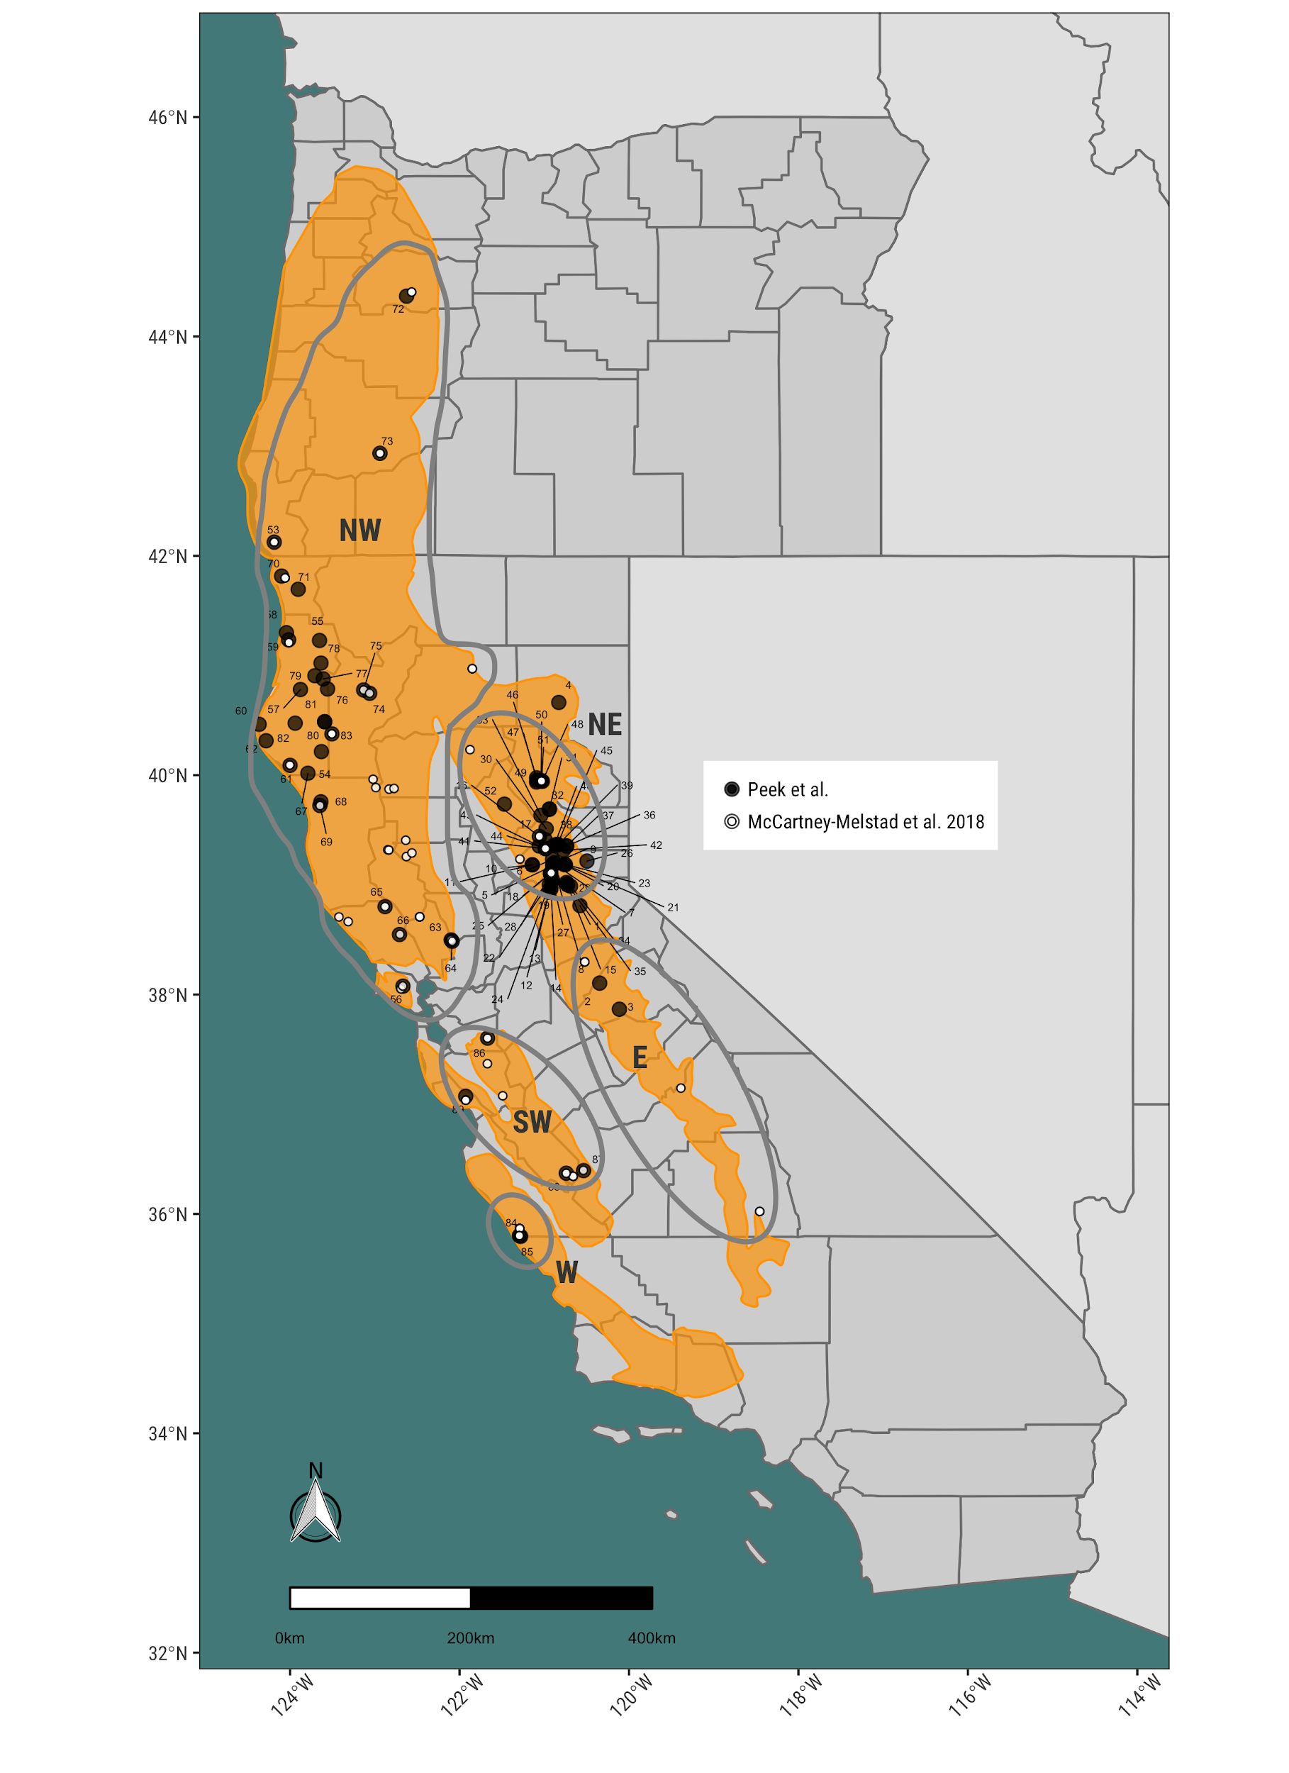

Figure 1. Map comparing sampling localities between the recent *R. boylii* study of McCartney-Melstad et al. (2018) and the current study with a simplified historical range (yellow) of *R. boylii* (adapted from USFS 2011, Thomson et al 2016). Clades identified by McCartney-Melstad et al. (2018) are circled.

## PCA and Admixture shows strong separation between California ecoregions

To compare and assess population structure patterns across the range of *R. boylii*, PCA were used to provide a dimensionless comparison of genetic variation. The patterns of genetic differentiation largely conformed to the clades described by McCartney-Melstad et al. (2018) (North-West [NW], South-West [SW], West [W], North-East[NE], and East [E]), but some notable differences were observed. We used regional names for clades, thus the North Coast=NW, the Central Coast=SW, the South Coast=W, the Northern Sierra=NE, the Southern Sierra=E (Figure 2). The main difference evident in the PCA was the presence of a distinct group previously part of the Northern Sierra, comprised of samples from the Feather basin. Additional subdivision was evident in the Central/Southern coastal region (two groups which match SW and W clades), and the Sierra Nevada (two groups, matching the NE and E clades), yielding seven total distinct structured groups. Interestingly, a small cluster of individuals from the North Fork (NF) Feather River consistently clustered along intermediate axes between the North Coast and Northern Sierra/Southern Sierra groups. These individuals were consistently intergrades between the larger Feather group and the Northern Coastal group, regardless of the PC axes.

A single sampling locality from Lassen National Forest near Eagle Lake (Locality 4, Table 1) clustered with the Northern Sierra group, suggesting the geographic boundary for this genetic group should be extended (Figure 2). Furthermore, individuals from the South Fork (SF) American basin clustered with the Southern Sierra (East) group, which would extend the boundary delineated by McCartney-Melstad et al. (2018).

To assess how strongly the Feather and Southern/Central coastal samples may have affected PCA structure, we ran several additional separate *post-hoc* PCA analyses where all Feather samples were excluded, and all Southern/Central coastal samples were excluded. Patterns remained consistent with those observed when all samples were used, regardless of which samples were excluded or retained. We conclude there is significant congruence with the McCartney-Melstad et al. (2018) genetic clades, but an additional group appears distinct from the original five delineated, the Feather watershed, and boundaries should be expanded to include the SF American basin in the Southern Sierra, and the Honey-Eagle Lakes basin in the Northern Sierra.

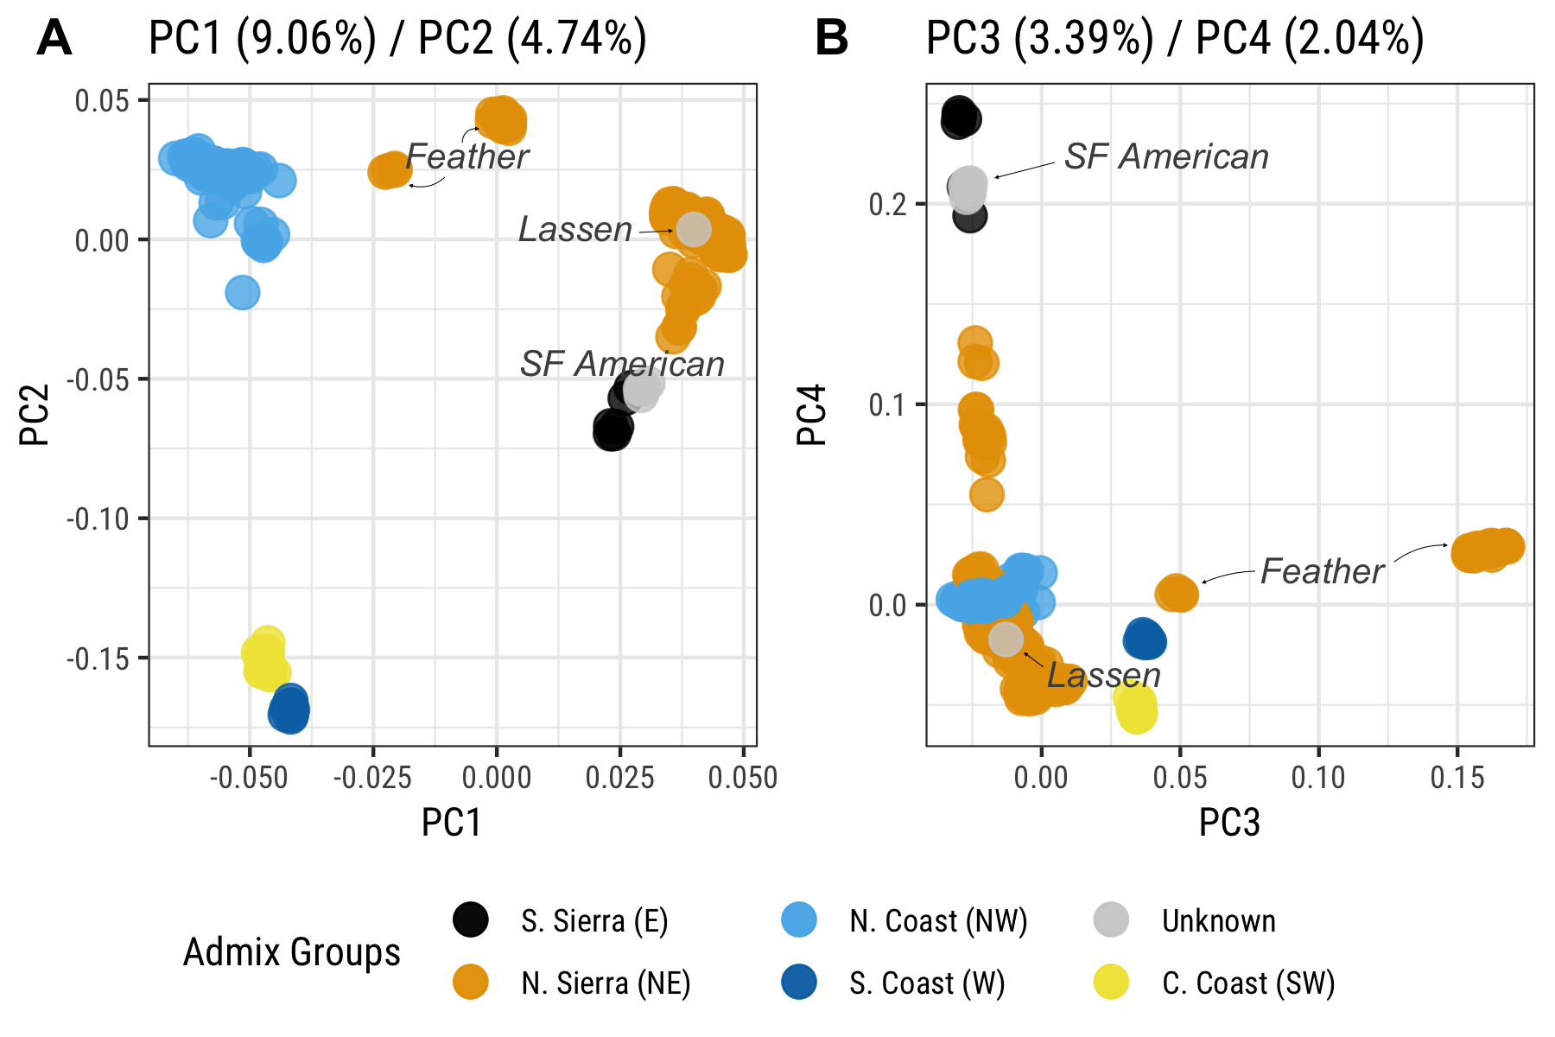

Figure 2. Principal component analysis of Rapture data colored by genetic groups (in parentheses) from McCartney-Melstad et al. (2018). A) PC1 vs. PC2; B) PC3 vs. PC4. Note, samples from South Fork American River and Lassen County (gray) were not previously studied and thus had no assigned clade. *Rana boylii* in the Feather basin were assigned as part of the Northern Sierra (NE) clade by McCartney-Melstad et al. (2018).

To further evaluate population structure across the range of *R. boylii*, we used NGSAdmix estimate the proportion of coancestry among individuals (admixture) from genome-wide SNPs. We used a range of k-values to evaluate the number of potential groups based on genetic ancestry and found strong patterns of divergence which largely matched the patterns observed in the PCA. While the northern and central coastal (SW and W) groups showed strong divergence from all other groups, they did not separate into distinct groups until k=9 (Figure 3). At k=3 through k=8, the N. Sierra and N. Coast groups continued to show patterns of subdivision, while other groups like the N. Sierra-Feather remained strongly distinct with little or no admixture observed. At k=9, the Central Coast and South Coast split into distinct groups, with additional patterns of substructure and admixture observed in the N. Sierrae (NE) and the N. Coast (NW) groups (Figure 3). While the Central/Southern Coastal populations are clearly distinct from all other clades, our NGSadmix analysis of our data shows weaker support for delineating Central (SW) and Southern (W) groups as distinct. 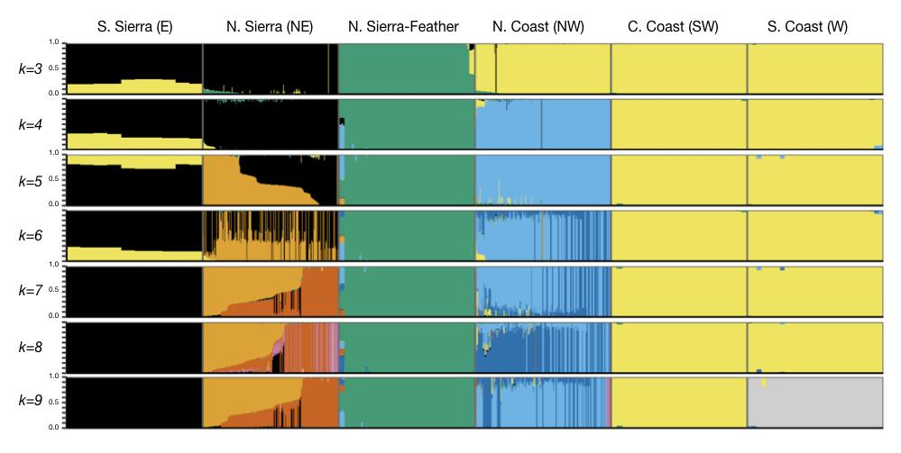Figure 3. NGSAdmixture for k=3 through k=9 for *R. boylii* across major geographic groupings (adapted from McCartney-Melstad et al. (2018)). The two Central/Southern Coastal groups did not differentiate until a k=9.

Sampling localities were then updated with genetic groups identified from admixture and PCA analyses to delineate geographic boundaries for these clades, building on McCartney-Melstad et al. (2018) (Figure 4). In summary, we identified *R. boylii* from the Feather basin as a unique genetic group, the Southern Sierra (East) clade should therefore extend to include the South Fork American basin in El Dorado County (Locality 1), and the Northern Sierra (North-East) clade should be expanded to include Honey-Eagle Lakes basin in Lassen County (Locality 4, see Figure 1 and Figure 4).

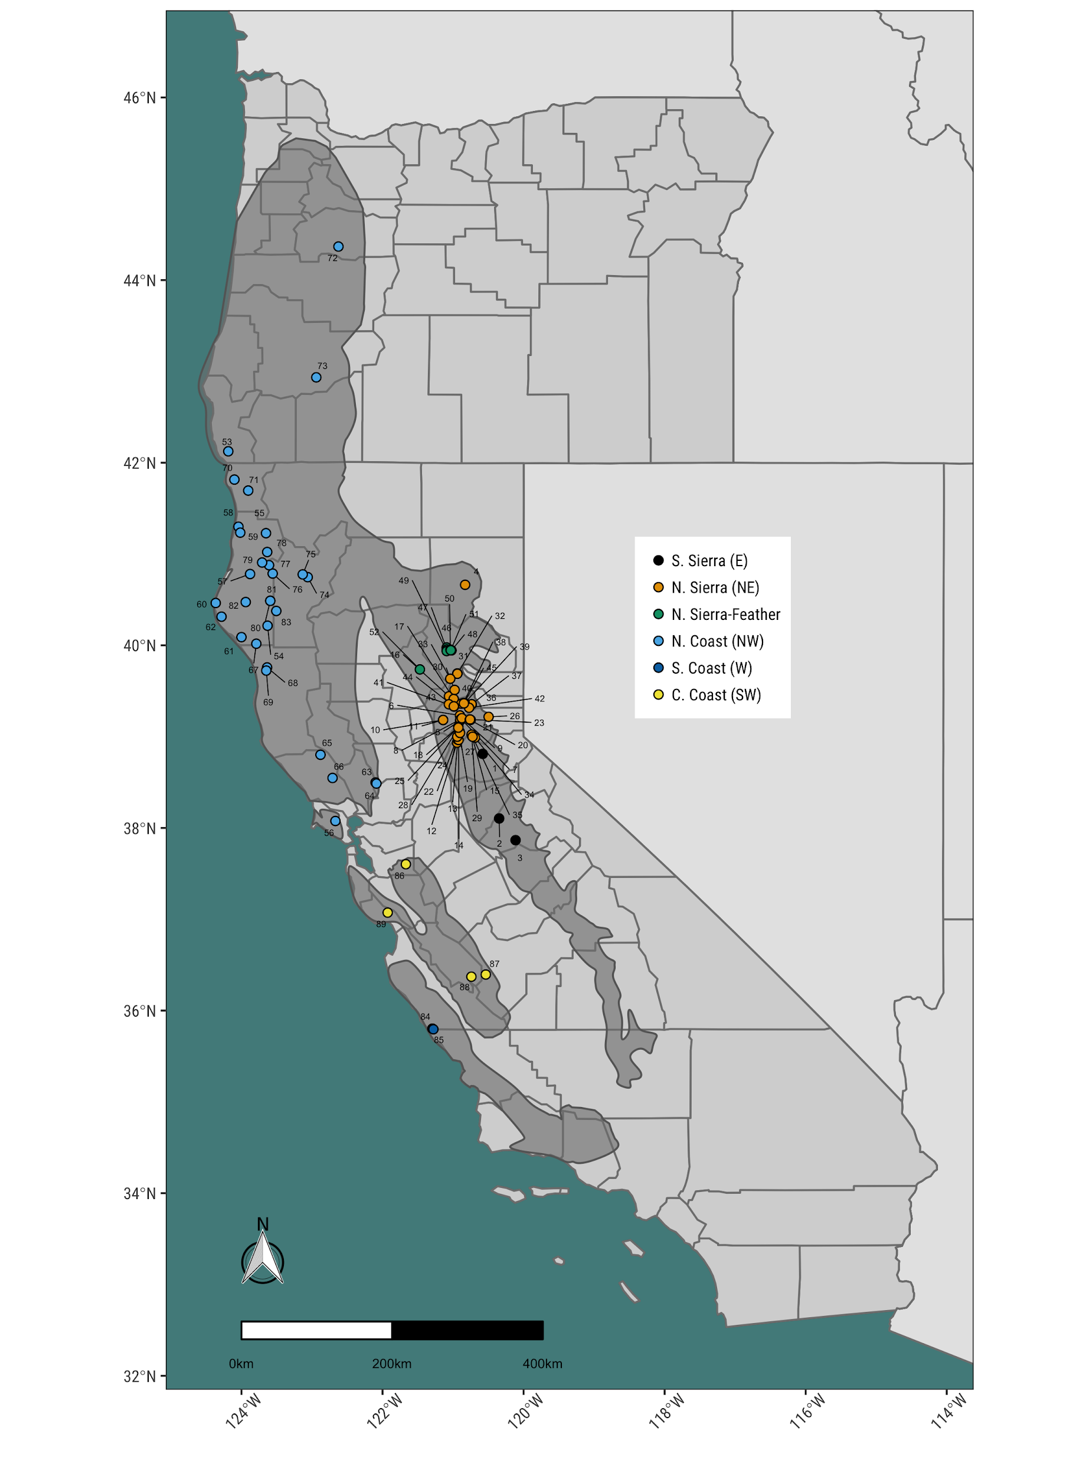

Figure 4. Map of localities colored by genetic groupings. The Northern Sierra-Feather group adds an additional genetically distinct group, the Feather Basin to previous clades; Locality 1 extends the boundary for the Southern Sierra (E) genetic clade up to the SF American basin in El Dorado County, and Locality 4 extends the Northern Sierra (NE) clade into Lassen County.

## FST shows strong divergence across regions

To assess how distinct *R. boylii* populations were across the range of the species using FST and genetic diversity metrics, we selected all samples that had greater than 100,000 alignments from localities with at least three individuals, yielding a total of 630 individuals from 63 localities for analysis (Table 2). Pairwise FST was calculated between each population pair (total combinations = 1,953), values ranged from 0 to 0.646. Extremely high FST values were observed between Central/South Coastal (SW/W) localities and all other localities from other regions, indicating the coastal regions are strongly divergent from *R. boylii* in other parts of the species’ range (Figure 5A). Comparison of pairwise FST values against geographic distance showed higher FST values between clades than within. Furthermore, largest geographic distances between locality pairs (i.e., between Southern Coastal localities and Northern Coastal localities in Oregon) correlated with higher FST values. However, the highest FST values were not associated with the greatest geographic distances, as the Sierra (NE/E) and Southern Coast (SW/W) comparisons had the greatest pairwise FST values (> 0.6) of any pairwise comparison (Figure 5B).

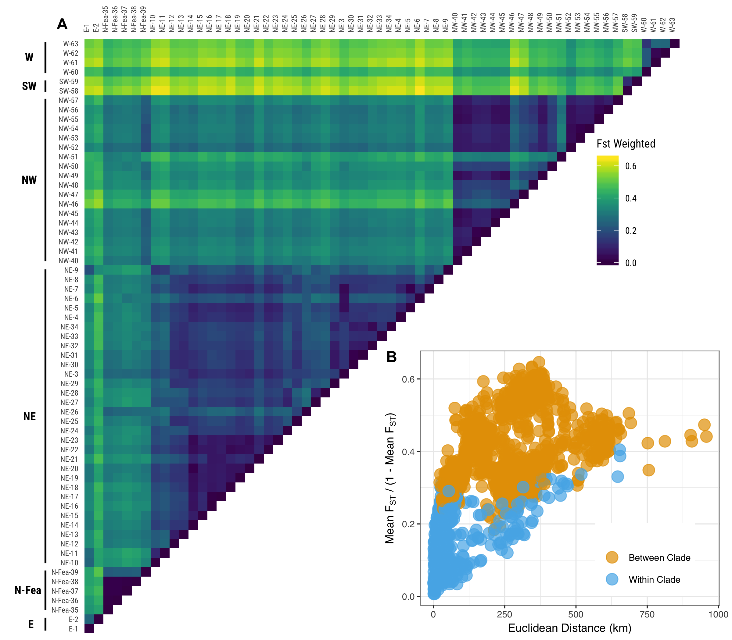

Figure 5. Plots of FST for all localities sampled, A) comparison of pairwise FST for all localities grouped by *R. boylii* clades; and B) pairwise FST comparisons between and within clades vs. geographic distance between localities.

## Genetic variation is highest in the North-West and lowest in the East/ South-West clades

Genetic diversity (θ) estimates for each region showed *R. boylii* from the North Coast (NW) group had the greatest range in genetic variation, with both the most diverse and least diverse θ estimates (Figure 6). Populations from the Southern Sierra (E) and Central Coast (SW) had the lowest mean Tajima’s θ𝜋 (0.0064) and Watterson’s θW (0.0059 = E, 0.0060 = SW), but both these groups also had the lowest number of sampling localities. Δθ was positive across all groups except the North Coast exhibiting the lowest value and the Central Coast (SW) and Southern Sierra (E) estimates being highest. Both coastal groups (SW and W) had wide ranges of Δθ estimates in different locations. With the exception of the North Coast, which contains the greatest genetic diversity and a trajectory of increasing genetic diversity, overall genetic diversity data for *R. boylii* show a trajectory of genetic diversity loss, with many locations exhibiting positive Δθ (Figure 6D).

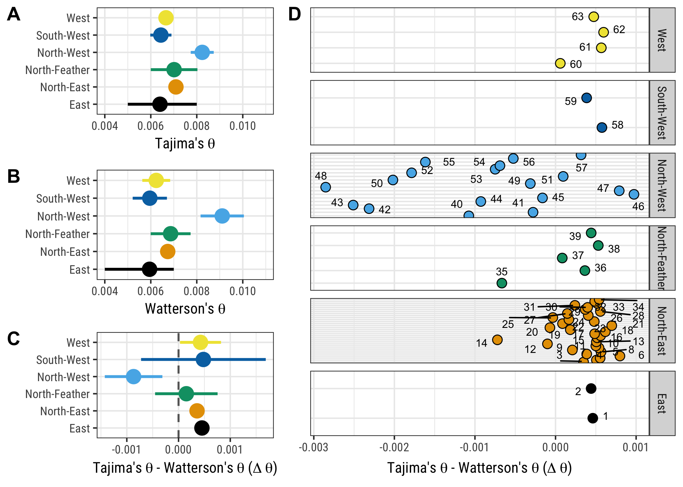

Figure 6. Tajima’s θ𝜋 and Watterson’ θS diversity estimates for *R. boylii* by clade groups (adapted from McCartney-Melstad et al. 2018) with 95% CI. A) Tajima’s θ𝜋 by clade; B) Watterson’ θS by clade; and θ𝜋 - θS  aggregated by clade C) and for each locality within clades D).

# DISCUSSION

As a species with a broad geographic range, *Rana boylii* utilizes a wide array of landscapes throughout California and Oregon. However, our study indicates there are strong patterns of geographic structure and substantial differences in patterns of genetic diversity across the species’ range. The more comprehensive sampling provided by this data set complements a recent genomic study of *R. boylii* (McCartney-Melstad et al. 2018)and largely supports the same clades identified using a different RADSeq method. Moreover, our PCA and admixture results are congruent with the five major clades identified in McCartney-Melstad et al. (2018), with the exception of an additional novel group from the Feather Basin. This congruence indicates these clades are important units which should be considered carefully in planning conservation actions (i.e., such as translocation, recolonization, and habitat restoration) for the species.

We also show that genetic data can provide resolution to prioritize populations and regions at multiple scales. Evaluating the efficacy of potential restoration actions can be difficult, particularly with rare and cryptic species. Genetics provides a tool that can more effectively track changes in population connectivity or genetic trajectories (i.e., low diversity, high FST) which correspond to the potential for long-term population persistence. Populations in the Northern Coastal clade contained the greatest amount of genetic variation, yet pairwise comparisons with populations from Central and Southern Coast localities showed extremely high FST values, indicating these groups are genetically very distinct. In addition, the Central/Southern Coast groups have relatively low genetic diversity and trajectories of genetic diversity loss).

Recent sampling has largely occurred in the North Coast, Northern Sierra, and Northern Sierra-Feather localities. The limited number of sampling localities from the southern extent of the range of *R. boylii* correlates with population declines (Davidson 2004, Adams et al. 2017). Thus, conservation actions should prioritize protecting sites in the Central/Southern Coast and Southern Sierra clades, as these represent both the most genetically divergent and distinct *R. boylii*, and simultaneously the most at-risk populations. Extremely high FST values between populations from the same species as well as strong phylogeographic structuring suggest limited gene flow through biogeographic barriers (Spinks et al. 2010, O’Connell et al. 2017). This suggests conservation management should consider these clades as distinct, and future actions that include translocation or captive breeding should utilize genetic data to assess potential impacts such as outbreeding depression in locally adapted populations.

*R. boylii* is an important sentinel stream species—not only as link between both aquatic and riparian ecosystems—but also as a sensitive gage of how altered hydrology affects riverine environments. The impacts of regulated hydrology on *R. boylii* populations have been well documented (Kupferberg 1996, Lind et al. 1996, Yarnell et al. 2012, 2016, Kupferberg et al. 2012, Catenazzi and Kupferberg 2013). For populations in regulated streams, genetic monitoring may be a crucial component for assessing flow management actions on the probability of long-term persistence (via maintenance of genetic diversity), as well as tracking population responses (i.e., using metrics like FST and genetic diversity θ) to restoration actions.

## Acknowledgements

Many thanks to all who helped collect/prepare samples: Corey Luna, Rick Wachs, and Sarah Mussulman. This research could not have been conducted without access to specimens from Brad Shaffer at the Krebb Museum at UCLA, and field samples from Caren Goldberg and Mallory Bedwell at Washington State University.

# CITATIONS

Adams, A. J., A. P. Pessier, and C. J. Briggs. 2017. Rapid extirpation of a North American frog coincides with an increase in fungal pathogen prevalence: Historical analysis and implications for reintroduction. Ecology and evolution 7:10216–10232.

Ali, O. A., S. M. O’Rourke, S. J. Amish, M. H. Meek, G. Luikart, C. Jeffres, and M. R. Miller. 2016. RAD Capture (Rapture): Flexible and Efficient Sequence-Based Genotyping. Genetics 202:389–400.

Anderson, J. J., and W. N. Beer. 2009. Oceanic, riverine, and genetic influences on spring chinook salmon migration timing. Ecological applications: a publication of the Ecological Society of America 19:1989–2003.

Baird, N. A., P. D. Etter, T. S. Atwood, M. C. Currey, A. L. Shiver, Z. A. Lewis, E. U. Selker, W. A. Cresko, and E. A. Johnson. 2008. Rapid SNP discovery and genetic mapping using sequenced RAD markers. PloS one 3:e3376.

Barbosa, S., F. Mestre, T. A. White, J. Paupério, P. C. Alves, and J. B. Searle. 2018. Integrative approaches to guide conservation decisions: Using genomics to define conservation units and functional corridors. Molecular ecology.

Beebee, T. J. C., and R. A. Griffiths. 2005. The amphibian decline crisis: A watershed for conservation biology? Biological conservation 125:271–285.

Broquet, T., L. Berset-Braendli, G. Emaresi, and L. Fumagalli. 2007. Buccal swabs allow efficient and reliable microsatellite genotyping in amphibians. Conservation genetics 8:509–511.

Burkey, T. V. 1989. Extinction in Nature Reserves - the Effect of Fragmentation and the Importance of Migration between Reserve Fragments. Oikos 55:75–81.

Catenazzi, A., and S. J. Kupferberg. 2013. The importance of thermal conditions to recruitment success in stream-breeding frog populations distributed across a productivity gradient. Biological conservation 168:40–48.

Davidson, C. 2004. DECLINING DOWNWIND: AMPHIBIAN POPULATION DECLINES IN CALIFORNIA AND HISTORICAL PESTICIDE USE. Ecological applications: a publication of the Ecological Society of America 14:1892–1902.

Davidson, C., H. B. Shaffer, M. R. Jennings - Conservation Biology, and 2002. 2002. Spatial tests of the pesticide drift, habitat destruction, UV‐B, and climate‐change hypotheses for California amphibian declines. Conservation biology: the journal of the Society for Conservation Biology 16:1588–1601.

Fumagalli, M., F. G. Vieira, T. S. Korneliussen, T. Linderoth, E. Huerta-Sánchez, A. Albrechtsen, and R. Nielsen. 2013. Quantifying population genetic differentiation from next-generation sequencing data. Genetics 195:979–992.

Fumagalli, M., F. G. Vieira, T. Linderoth, and R. Nielsen. 2014. ngsTools: methods for population genetics analyses from next-generation sequencing data. Bioinformatics 30:1486–1487.

Goldberg, C. S., M. E. Kaplan, and C. R. Schwalbe. 2003. From the frog’s mouth: buccal swabs for collection of DNA from amphibians. Herpetological review 34:220–221.

Hendricks, S., E. C. Anderson, T. Antao, L. Bernatchez, B. R. Forester, B. Garner, B. K. Hand, P. A. Hohenlohe, M. Kardos, B. Koop, A. Sethuraman, R. S. Waples, and G. Luikart. 2018. Recent advances in conservation and population genomics data analysis. Evolutionary applications.

Heyer, W. R., M. A. Donnelly, R. W. McDiarmid, L.-A. C. Hayek, and M. S. Foster. 1994. Measuring and monitoring biological diversity. Standard methods for amphibians. Smithsonian Institution Press, Washington DC.

Hotaling, S., C. C. Muhlfeld, J. J. Giersch, O. A. Ali, S. Jordan, M. R. Miller, G. Luikart, and D. W. Weisrock. 2018. Demographic modelling reveals a history of divergence with gene flow for a glacially tied stonefly in a changing post-Pleistocene landscape. Journal of biogeography 45:304–317.

Jennings, M. R., and M. P. Hayes. 1994. Amphibian and reptile species of special concern in California. Final Report. California Department of Fish and Game Inland Fisheries Division, Rancho Cordova.

Kim, S. Y., K. E. Lohmueller, A. Albrechtsen, Y. Li, T. Korneliussen, G. Tian, N. Grarup, T. Jiang, G. Andersen, D. Witte, T. Jorgensen, T. Hansen, O. Pedersen, J. Wang, and R. Nielsen. 2011. Estimation of allele frequency and association mapping using next-generation sequencing data. BMC bioinformatics 12:231.

Korneliussen, T. S., A. Albrechtsen, and R. Nielsen. 2014. ANGSD: Analysis of Next Generation Sequencing Data. BMC bioinformatics 15:356.

Korneliussen, T. S., I. Moltke, A. Albrechtsen, and R. Nielsen. 2013. Calculation of Tajima’s D and other neutrality test statistics from low depth next-generation sequencing data. BMC bioinformatics 14:289.

Kupferberg, S. J. 1996. Hydrologic and geomorphic factors affecting conservation of a river-breeding frog (Rana boylii). Ecological applications: a publication of the Ecological Society of America 6:1332–1344.

Kupferberg, S. J., W. J. Palen, A. J. Lind, S. Bobzien, A. Catenazzi, J. Drennan, and M. E. Power. 2012. Effects of flow regimes altered by dams on survival, population declines, and range-wide losses of California river-breeding frogs. Conservation biology: the journal of the Society for Conservation Biology 26:513–524.

Lande, R., and S. Shannon. 1996. THE ROLE OF GENETIC VARIATION IN ADAPTATION AND POPULATION PERSISTENCE IN A CHANGING ENVIRONMENT. Evolution; international journal of organic evolution 50:434–437.

Li, H. 2011. A statistical framework for SNP calling, mutation discovery, association mapping and population genetical parameter estimation from sequencing data. Bioinformatics 27:2987–2993.

Li, H. 2013. Aligning sequence reads, clone sequences and assembly contigs with BWA-MEM.

Li, H., and R. Durbin. 2010. Fast and accurate long-read alignment with Burrows-Wheeler transform. Bioinformatics 26:589–595.

Li, H., B. Handsaker, A. Wysoker, T. Fennell, J. Ruan, N. Homer, G. Marth, G. Abecasis, R. Durbin, and 1000 Genome Project Data Processing Subgroup. 2009. The Sequence Alignment/Map format and SAMtools. Bioinformatics 25:2078–2079.

Lind, A. J., H. H. Welsh Jr, and R. A. Wilson. 1996. The effects of a dam on breeding habitat and egg survival of the foothill yellow-legged frog (Rana boylii) in Northwestern Calfifornia. Herpetological review 27:62–66.

McCartney-Melstad, E., M. Gidiş, and H. B. Shaffer. 2018. Population genomic data reveal extreme geographic subdivision and novel conservation actions for the declining foothill yellow-legged frog. Heredity.

Miller, M. R., J. P. Brunelli, P. A. Wheeler, S. Liu, C. E. Rexroad 3rd, Y. Palti, C. Q. Doe, and G. H. Thorgaard. 2012. A conserved haplotype controls parallel adaptation in geographically distant salmonid populations. Molecular ecology 21:237–249.

Miller, M. R., J. P. Dunham, A. Amores, W. A. Cresko, and E. A. Johnson. 2007. Rapid and cost-effective polymorphism identification and genotyping using restriction site associated DNA (RAD) markers. Genome research 17:240–248.

Narum, S. R., C. A. Buerkle, J. W. Davey, M. R. Miller, and P. A. Hohenlohe. 2013. Genotyping-by-sequencing in ecological and conservation genomics. Molecular ecology 22:2841–2847.

Nielsen, R., T. Korneliussen, A. Albrechtsen, Y. Li, and J. Wang. 2012. SNP calling, genotype calling, and sample allele frequency estimation from New-Generation Sequencing data. PloS one 7:e37558.

Nunziata, S. O., S. L. Lance, D. E. Scott, E. M. Lemmon, and D. W. Weisrock. 2017. Genomic data detect corresponding signatures of population size change on an ecological time scale in two salamander species. Molecular ecology 26:1060–1074.

O’Connell, K. A., J. W. Streicher, E. N. Smith, and M. K. Fujita. 2017. Geographical features are the predominant driver of molecular diversification in widely distributed North American whipsnakes. Molecular ecology 26:5729–5751.

Parris, K. M., S. C. McCall, M. A. McCarthy, B. A. Minteer, K. Steele, S. Bekessy, and F. Medvecky. 2010. Assessing ethical trade-offs in ecological field studies. The Journal of applied ecology 47:227–234.

Peek, R. 2010. Landscape Genetics of Foothill Yellow-Legged Frogs (Rana boylii) in regulated and unregulated rivers: Assessing connectivity and genetic fragmentation. Master’s Thesis, University of San Francisco.

Pidancier, N., C. Miquel, and C. Miaud. 2003. Buccal swabs as a non-destructive tissue sampling method for DNA analysis in amphibians. The Herpetological journal 13:175–178.

Prince, D. J., S. M. O’Rourke, T. Q. Thompson, O. A. Ali, H. S. Lyman, I. K. Saglam, T. J. Hotaling, A. P. Spidle, and M. R. Miller. 2017. The evolutionary basis of premature migration in Pacific salmon highlights the utility of genomics for informing conservation. Science advances 3:e1603198.

R Core Team. 2017. R: A Language and Environment for Statistical Computing. R Foundation for Statistical Computing, Vienna, Austria.

Ricciardi, A., and J. B. Rasmussen. 1999. Extinction rates of North American freshwater fauna. Conservation biology: the journal of the Society for Conservation Biology 13:1220–1222.

Rousset, F. 1997. Genetic differentiation and estimation of gene flow from F-statistics under isolation by distance. Genetics 145:1219–1228.

Ruby, J. G., P. Bellare, and J. L. Derisi. 2013. PRICE: software for the targeted assembly of components of (Meta) genomic sequence data. G3 3:865–880.

Skotte, L., T. S. Korneliussen, and A. Albrechtsen. 2013. Estimating individual admixture proportions from next generation sequencing data. Genetics 195:693–702.

Spinks, P. Q., R. C. Thomson, and H. B. Shaffer. 2010. Nuclear gene phylogeography reveals the historical legacy of an ancient inland sea on lineages of the western pond turtle, Emys marmorata in California. Molecular ecology 19:542–556.

Stebbins, R. C. 2003. A Field Guide to Western Reptiles and Amphibians. 3rd edition. Houghton Mifflin Harcourt, Boston.

Tajima, F. 1983. Evolutionary relationship of DNA sequences in finite populations. Genetics 105:437–460.

Thomson, B., A. Wright, and B. Shaffer. 2016. California Amphibian and Reptile Species of Special Concern. University of California Press, Berkeley, CA., http://arssc.ucdavis.edu.

USFWS. 2014. Endangered and Threatened Wildlife and Plants; Endangered Species Status for Sierra Nevada Yellow-Legged Frog and Northern Distinct Population Segment of the Mountain Yellow-Legged Frog, and Threatened Species Status for Yosemite Toad. Federal register 79:24255–24310.

Vredenburg, V., and D. Wake. 2007. Global decline of amphibians. Encyclopedia of Biodiversity:1–8.

Watterson, G. A. 1975. Number of Segregating Sites in Genetic Models without Recombination. Theoretical population biology 7:256–276.

Weir, B. S., and C. C. Cockerham. 1984. Estimating F-Statistics for the Analysis of Population-Structure. Evolution; international journal of organic evolution 38:1358–1370.

Wilbur, H. M., and R. D. Semlitsch. 1990. Ecological Consequences of Tail Injury in Rana Tadpoles. Copeia 1990:18–24.

Wright, S. 1943. Isolation by Distance. Genetics 28:114–138.

Yarnell, S. M., A. J. Lind, and J. F. Mount. 2012. Dynamic flow modelling of riverine amphibian habitat with application to regulated flow management. River Research and Applications 28:177–191.

Yarnell, S., R. Peek, G. Epke, and A. Lind. 2016. Management of the Spring Snowmelt Recession in Regulated Systems. Journal of the American Water Resources Association 52:723–736.