Local Galaxy Classification Database
20th January 2014

By: Ryan John Francis Ormrod, 3721
Henley College Coventry
1. Introduction
The Local Galaxy Classification Database (LGCD) has the purpose of describing local stellar objects within space. It is important to understand the similarities between complex objects within the university in order to form the fundamental principles of further important mathematical calculations. While this database alone only support text based entry and has no images of the galaxies itself, it could be further extended to support said visualization capacities. Written in VBA and Microsoft Access the LGCD database was thus prone to restrictions on charting and other mathematical calculations, without the aid of Active X technologies being loaded. The main purpose of this database is to provide basic charts based on the data that was found, but as it is to expand into a real world scientific database more output will be required in the future.

2. Data Dictionary for Local Galaxy Classification Database
Note: Most of the units within LGCD are double data types which accept both negative and possitive data values without any determinable limitation. Text data types are checked for quotations to ensure that queries run sanely.
Field | Type | Length | Rules /  Description
TblExoPlanets (Used to store properties about Earth like planets)
ID | AutoNumber | N/A | Primary Key
planet_name | Text | Greater than 3 and less than 100 | The name of the planet.
planet_mass | Double | 0 or greater | Measure of the planets mass.
planet_radius | Double | 0 or greater | Radius of the planet.
surface_gravity | Double | 0 or greater | Gravity of the planet.
surface_temperature | Double | 0 or greater | Temperature of the planet
sma | Double | 0 or greater | Semi Major Axis (SMA)
eccentricity | Double | 0 or greater | Eccenticity of the planet.
esi | Double | 0 or greater | Earth Similarity Index (ESI)
habituality_index | Integer (FK) | N/A | Whether it orbits in the habitable zone.
lightyear | Double | 0 or greater | Distance of the star in lightyears.
star_id | Integer (FK) | N/A | Which star has this ExoPlanet in its solar system?
tblExoPlanetHabitualities
ID | AutoNumber | N/A | Primary Key
habituality_name | Text | Greater than 3 and less than 100 | Describes how habitable the planet may be.
tblStars
ID | AutoNumber | N/A | Primary Key
star_name | Text | Greater than 3 and less than 100 | The name of the star.
absolute_magnitude | Double | N/A or IsNumeric | Absolute Magnitude of the star.
apparent_magnitude | Double | N/A or IsNumeric | Apparent Magnitude of the star.
temperature_class | Double | N/A or IsNumeric | Temperature type of the star.
Lightyear | Double | 0 or greater | Distance of the star in lightyears.
galaxy_id | Integer (FK) | N/A | Which galaxy does this star belong to?
tblStarProperties
ID | AutoNumber | N/A | Primary Key
star_id | Integer(FK) | N/A | Relation to the star.
type_id | Integer(FK) | N/A | Relation to the star type.
lumin_id | Integer(FK) | N/A | Relation to the star luminosity.
TblStarLuminosities (This is to become an import ant table within the database and should not be altered)
ID | AutoNumber | N/A | Primary Key
luminosity_class | Text | Greater than 0 and less than 3. | The code used to describe the luminosity of the star.
luminosity_description | Text | Any suitable length under 100. | Describes the Luminosity or names it.
tblStarTypes
ID | AutoNumber | N/A | Primary Key
type_name | Text | Greater than 3 and less than 100. | What type of Star is it?
type_description | Text | Greater than 3 and less than 100. | Describe the type of star.
tblGalaxies
ID | AutoNumber | N/A | Primary Key
galaxy_name | Text | Greater than 3 and less than 100. | What is the name of this galaxy?
lightyear | Double | 0 or greater | Distance in Lightyears.
parsec | Double | 0 or greater. | Distance in Parsec.
absolute_magnitude | Double | N/A or IsNumeric | Absolute Magnitude of the Star.
apparent_magnitude | Double | N/A or IsNumeric | Apparent Magnitude of the Star
tblGalaxyProperties
ID | AutoNumber | N/A | Primary Key
galaxy_id | Integer(FK) | N/A | What Galaxy is this property for?
shape_id | Integer(FK) | N/A | The shape of the galaxy.
group_id | Integer(FK) | N/A | What is the local group membership of the galaxy?
elliptical_id | Integer(FK) | N/A | If it is elliptical then describe the elongation of the galaxy.
spiral_id | Integer(FK) | N/A | If it is spiral then describe what type of spiral it is.
vclass_id | Integer(FK) | N/A | The Vaucouleur Class of the galaxy.
lumin_id | Integer(FK) | N/A | The luminosity of the galaxy.
tblGalaxyGroups
ID | AutoNumber | N/A | Primary Key
group_name | Text | Greater than 3 and less than 100. | The name of the group.
tblGalaxyLuminosities
ID | AutoNumber | N/A | Primary Key
lumin_name | Text | Greater than 3 and less than 100. | The luminosity description.
lumin_code | Text | Greater than 3 and less than 100. | The code of the luminosity.
tblGalaxyShapes
ID | AutoNumber | N/A | Primary Key
shape_name | Text | Greater than 3 and less than 100. | The shape of the galaxy.
shape_code | Text | Greater than 3 and less than 100. | The Shape Code of the galaxy.
tblEllipticalGalaxyTypes
ID | AutoNumber | N/A | Primary Key
type_name | Text | Greater than 3 and less than 100. | The shape of the galaxy.
type_description | Text | Greater than 3 and less than 100. | The Shape Code of the galaxy.
tblSpiralGalaxyTypes
ID | AutoNumber | N/A | Primary Key
type_name | Text | Greater than 3 and less than 100. | The shape of the galaxy.
type_description | Text | Greater than 3 and less than 100. | The Shape Code of the galaxy.

3. Form Prototypes

3.1 Splash Form or Main Form
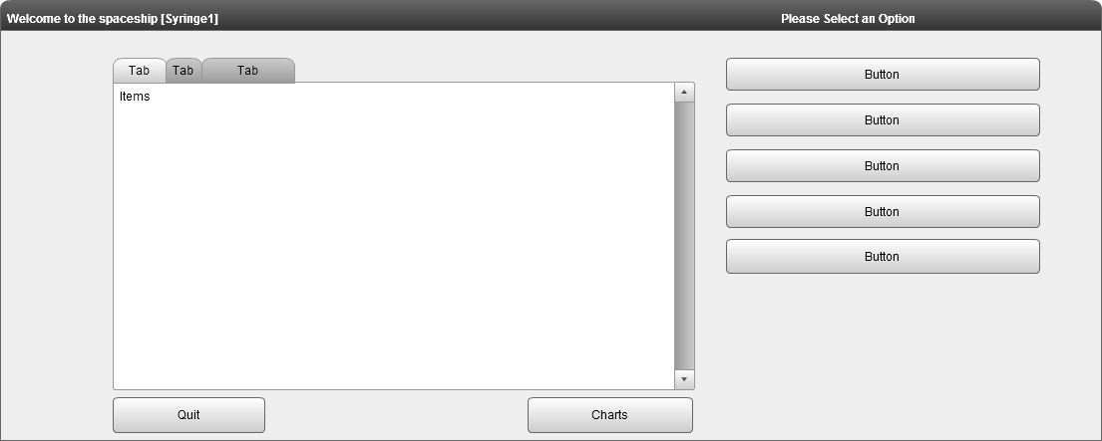
3.2 Edit Form
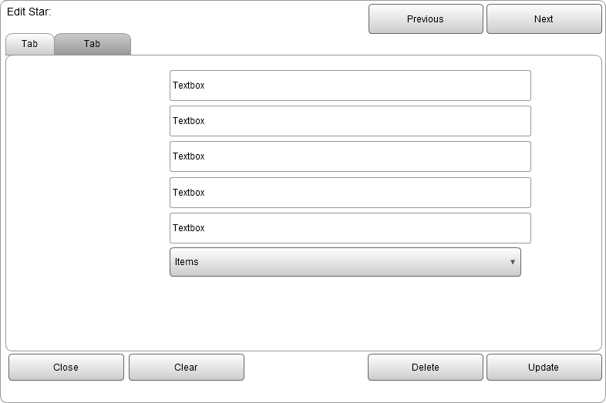

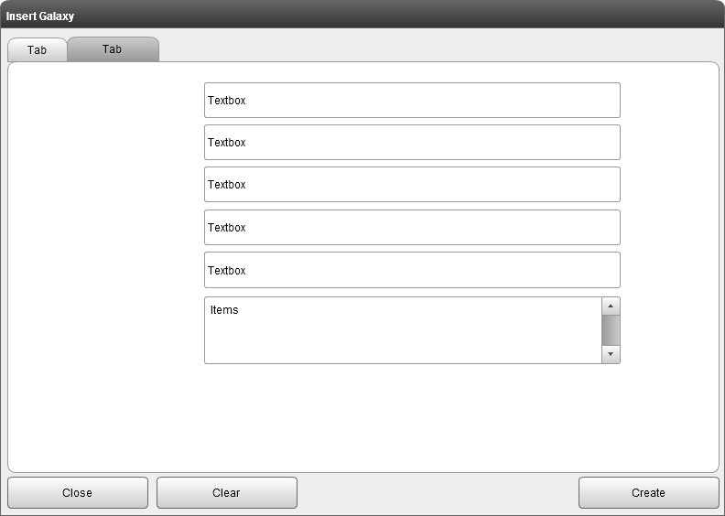
3.3 Insert Form
3.4 Search Form
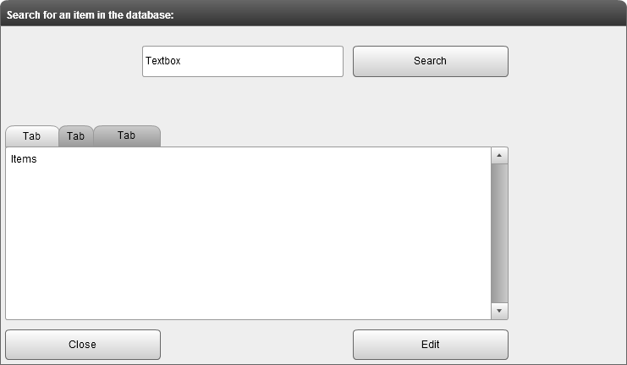

3.5 Chart Form
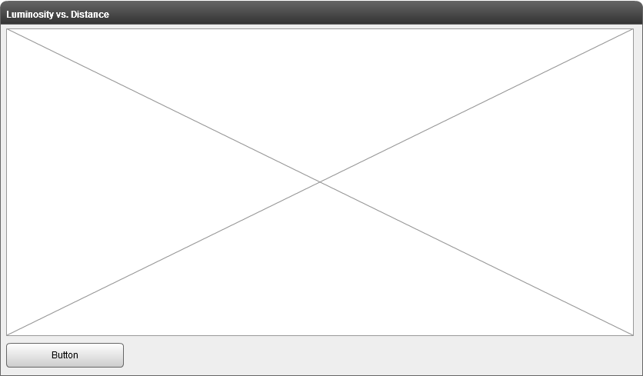
3.6 Config Form
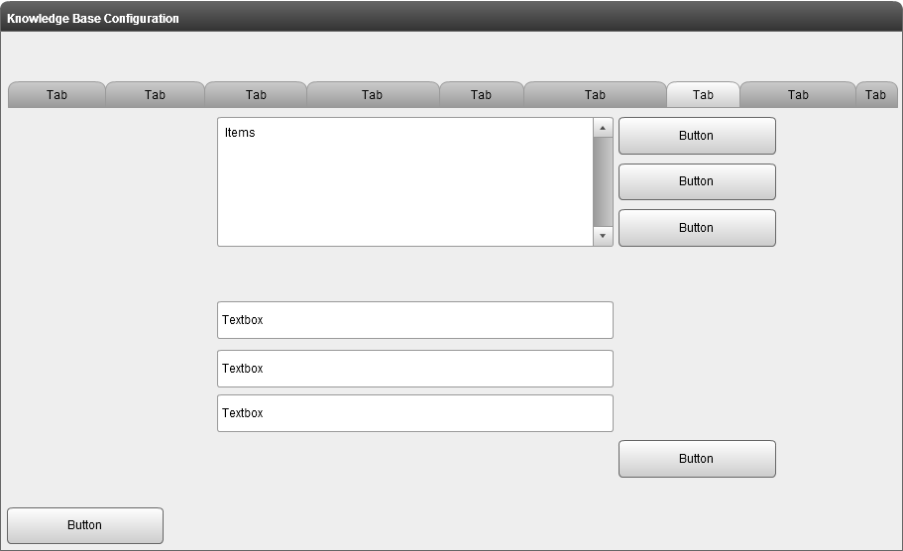

3.7 Options Form
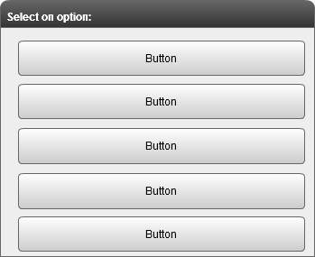

4. Entity Relationship Diagram

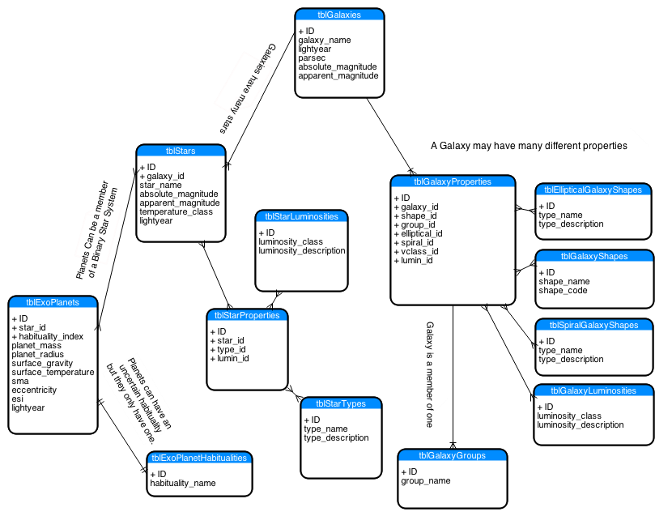

5. Issues

Issue No | Description
1 | Using the search form there appears to be an issue opening up the edit form more frequently than wanted. After unsuccessful attempts at trying to locate the reason for this issue and as it works 90% of the time it has been left using the same mechanism. Since others using the Me.OpenArgs part of the Access Form parameters and some have and other have not experienced the same issue, it is considered a medium risk until further expansion of the database.
2 | The next and browse buttons were implemented manually, since MS SQL has limitations, namely, the 'LIMIT' section of other SQL technologies I found myself stumped as to how to only select one individual record. I have stumbled upon (TOP) and it can be noticed within several of the queries within the database.

6. Future Changes

Since this database system will be required to handle a vast amount of data tables which contain the same fields are not within the same table. This would reduce the future problems that would occur by instead of corrupting all different types of stellar object (galaxy, star, planet) then perhaps only one table would become corrupted.

