Ant Mound eCognition Analysis

R Pienaar

2024-01-12

load packages

library(ggplot2)

## Warning: package 'ggplot2' was built under R version 4.3.2

library(tidyverse)

## Warning: package 'tidyverse' was built under R version 4.3.1

## Warning: package 'stringr' was built under R version 4.3.2

## Warning: package 'lubridate' was built under R version 4.3.2

## ── Attaching core tidyverse packages ──────────────────────── tidyverse 2.0.0 ──  
## ✔ dplyr 1.1.2 ✔ readr 2.1.4  
## ✔ forcats 1.0.0 ✔ stringr 1.5.1  
## ✔ lubridate 1.9.3 ✔ tibble 3.2.1  
## ✔ purrr 1.0.1 ✔ tidyr 1.3.0  
## ── Conflicts ────────────────────────────────────────── tidyverse_conflicts() ──  
## ✖ dplyr::filter() masks stats::filter()  
## ✖ dplyr::lag() masks stats::lag()  
## ℹ Use the conflicted package (<http://conflicted.r-lib.org/>) to force all conflicts to become errors

library(dplyr)  
library(tidyr)  
library(ggpubr)  
library(patchwork)

## Warning: package 'patchwork' was built under R version 4.3.2

library(ggh4x)

## Warning: package 'ggh4x' was built under R version 4.3.2

library(Rmisc)

## Warning: package 'Rmisc' was built under R version 4.3.1

## Loading required package: lattice  
## Loading required package: plyr  
## ------------------------------------------------------------------------------  
## You have loaded plyr after dplyr - this is likely to cause problems.  
## If you need functions from both plyr and dplyr, please load plyr first, then dplyr:  
## library(plyr); library(dplyr)  
## ------------------------------------------------------------------------------  
##   
## Attaching package: 'plyr'  
##   
## The following object is masked from 'package:ggpubr':  
##   
## mutate  
##   
## The following objects are masked from 'package:dplyr':  
##   
## arrange, count, desc, failwith, id, mutate, rename, summarise,  
## summarize  
##   
## The following object is masked from 'package:purrr':  
##   
## compact

library(lme4)

## Loading required package: Matrix  
##   
## Attaching package: 'Matrix'  
##   
## The following objects are masked from 'package:tidyr':  
##   
## expand, pack, unpack

library(stringr)

Input drone imagery counts from 2021

d21 <- read.csv("2021_mound_per_plot.csv") ### Individual mounds from 2021 drone imagery  
  
d21_d <- d21 %>%  
 group_by(Burned, Rodents, Block) %>%  
 dplyr::summarise(Count = n_distinct(OBJECTID)) #summarize the count by block and plot

## `summarise()` has grouped output by 'Burned', 'Rodents'. You can override using  
## the `.groups` argument.

all_combinations <- tidyr::expand(d21, Burned, Rodents, Block, ID = NULL)  
  
d21_d <- dplyr::left_join(all_combinations, d21_d, by = c("Burned", "Rodents", "Block"))  
  
d21_d[is.na(d21_d)]<- 0  
  
d21_d %>%  
 dplyr::group_by(Burned, Rodents) %>%  
 dplyr::summarize(mean_count = mean(Count))

## `summarise()` has grouped output by 'Burned'. You can override using the  
## `.groups` argument.

## # A tibble: 4 × 3  
## # Groups: Burned [2]  
## Burned Rodents mean_count  
## <chr> <chr> <dbl>  
## 1 B N 5   
## 2 B S 2.2  
## 3 U N 2.6  
## 4 U S 1.4

#### Plot 2021 ant mounds from drone imagery  
ggplot(data = d21_d, aes(x = Burned, y = Count, fill = Rodents))+  
 stat_summary(geom = "bar", fun = mean, position = "dodge", color = "black", width = 0.5) +  
 stat_summary(geom = "errorbar", fun.data = mean_se, width = 0.2, position = position_dodge(0.5))+  
 ylab("Disks per 30mx30m plot")+  
 theme(axis.text.y = element_text(color = "black"))+  
 theme(axis.text.x = element_text(color = "black"))+  
 xlab("Fire Treatment")+  
 theme_light()+  
 theme(panel.grid.major = element_blank(), panel.grid.minor = element_blank(),   
 panel.background = element_rect(fill="transparent"))+  
 theme(plot.title = element_text(hjust = 0.5), text = element_text(size=15))+  
 scale_fill_manual(values = c("darkseagreen","darkorchid"),labels=c('Rodents Excluded', 'Rodents Allowed'))+  
 scale_x_discrete(labels= c("Burned", "Unburned"), )+  
 theme(legend.position = "right", aspect.ratio = 1)

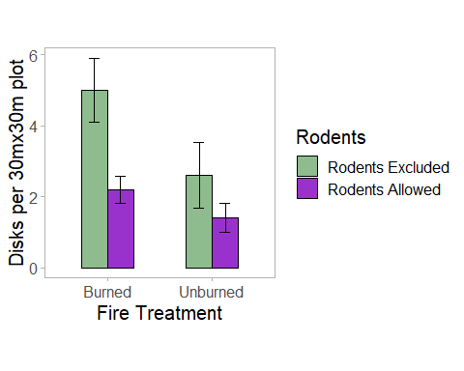

Input manual counts from 2021

d21_m <- read.csv("Density_manual.csv")  
  
#Plot manually counted data from 2021  
ggplot(data = d21_m, aes(x = Burned, y = Count, fill = Rodents))+  
 stat_summary(geom = "bar", fun = mean, position = "dodge", color = "black", width = 0.5) +  
 stat_summary(geom = "errorbar", fun.data = mean_se, width = 0.2, position = position_dodge(0.5))+  
 ylab("Disks per 30mx30m plot")+  
 xlab(NULL)+  
 theme(axis.text.y = element_text(color = "black"))+  
 theme(axis.text.x = element_text(color = "black"))+  
 theme_light()+  
 theme(panel.grid.major = element_blank(), panel.grid.minor = element_blank(),   
 panel.background = element_rect(fill="transparent"))+  
 theme(plot.title = element_text(hjust = 0.5), text = element_text(size=15))+  
 scale_fill_manual(values = c("darkseagreen","darkorchid"),labels=c('Rodents Excluded', 'Rodents Allowed'))+  
 scale_x_discrete(labels= c("", ""), )+  
 theme(legend.position = "none", aspect.ratio = 1)

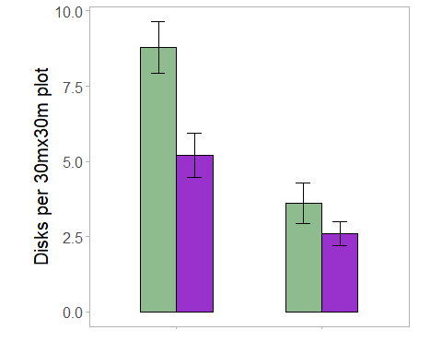

Combine drone and manual counts for 2021

d21_d

## # A tibble: 20 × 4  
## Burned Rodents Block Count  
## <chr> <chr> <int> <int>  
## 1 B N 1 7  
## 2 B N 2 6  
## 3 B N 3 4  
## 4 B N 4 6  
## 5 B N 5 2  
## 6 B S 1 2  
## 7 B S 2 1  
## 8 B S 3 3  
## 9 B S 4 3  
## 10 B S 5 2  
## 11 U N 1 4  
## 12 U N 2 5  
## 13 U N 3 0  
## 14 U N 4 3  
## 15 U N 5 1  
## 16 U S 1 1  
## 17 U S 2 1  
## 18 U S 3 3  
## 19 U S 4 1  
## 20 U S 5 1

d21_m

## Block Plot Burned Rodents Count Area  
## 1 1 BN B N 8 9503.318  
## 2 2 BN B N 9 8607.964  
## 3 3 BN B N 6 6565.929  
## 4 4 BN B N 10 9000.663  
## 5 5 BN B N 11 6418.274  
## 6 1 BS B S 5 5089.380  
## 7 2 BS B S 8 5664.292  
## 8 3 BS B S 5 6776.415  
## 9 4 BS B S 4 5215.044  
## 10 5 BS B S 4 3647.389  
## 11 1 UN U N 6 6352.300  
## 12 2 UN U N 4 6053.849  
## 13 3 UN U N 2 3047.345  
## 14 4 UN U N 3 3078.761  
## 15 5 UN U N 3 2733.186  
## 16 1 US U S 3 4156.327  
## 17 2 US U S 1 1884.956  
## 18 3 US U S 3 2846.283  
## 19 4 US U S 3 3424.336  
## 20 5 US U S 3 5403.539

d21_d$Block <- as.factor(d21_d$Block)  
d21_m$Block <- as.factor(d21_m$Block)  
  
colnames(d21_m)[colnames(d21_m) == "Count"]<- "Count_m"  
  
d_both <- cbind(d21_d, d21_m$Count_m)  
  
colnames(d_both)[colnames(d_both) == "d21_m$Count_m"]<- "Count_manual"  
colnames(d_both)[colnames(d_both) == "Count"]<- "Count_drone"  
  
d_both %>% unite("ID", Burned, Rodents, remove = FALSE) %>%   
 pivot_longer(cols = c(Count_drone, Count_manual), names_to = "type", values_to = "Count") %>%  
ggplot(aes(x= ID, y = Count, fill = type))+  
 #geom_bar(stat = "identity", position = position_dodge())+  
 stat_summary(geom = "bar", fun = mean, position = "dodge", color = "black", width = 0.5) +  
 stat_summary(geom = "errorbar", fun.data = mean_se, width = 0.2, position = position_dodge(0.5))+  
 ylab("Disks per 30mx30m plot")+  
 xlab("Treatment")+  
 labs(fill = "Method")+  
 theme_bw()+  
 theme(panel.background = element_rect(fill="transparent"), panel.border = element_blank())+  
 theme(plot.title = element_text(hjust = 0.5), text = element_text(size=12, family = 'serif'))+  
 theme(legend.position = "right", aspect.ratio = 1)+  
 theme(axis.line = element_line(color = 'black'))+   
 scale_x_discrete(labels= c("BN", "BS", "UN", "US"), )+  
 scale_fill_manual(values = c("darkseagreen","darkorchid"),labels=c('Drone count', 'Manual count'))+  
 theme(legend.position = "right", aspect.ratio = 1)+   
 scale_y_continuous(expand = c(0, 0), limits = c(0, 11))

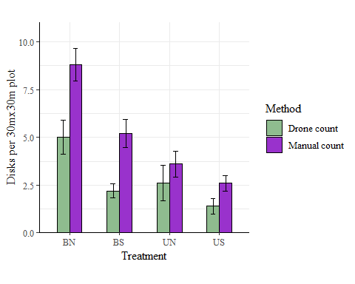

A paired t-test showing the difference for counts between each treatment

t.test(data = d_both, d_both$Count_drone, d_both$Count_manual, paired = TRUE)

##   
## Paired t-test  
##   
## data: d_both$Count_drone and d_both$Count_manual  
## t = -4.3482, df = 19, p-value = 0.0003462  
## alternative hypothesis: true mean difference is not equal to 0  
## 95 percent confidence interval:  
## -3.333053 -1.166947  
## sample estimates:  
## mean difference   
## -2.25

d_both_long <- d_both |> pivot_longer(cols = c("Count_drone", "Count_manual"), names_to = "Method", values_to = "Count")  
d_both_long

## # A tibble: 40 × 5  
## Burned Rodents Block Method Count  
## <chr> <chr> <fct> <chr> <int>  
## 1 B N 1 Count_drone 7  
## 2 B N 1 Count_manual 8  
## 3 B N 2 Count_drone 6  
## 4 B N 2 Count_manual 9  
## 5 B N 3 Count_drone 4  
## 6 B N 3 Count_manual 6  
## 7 B N 4 Count_drone 6  
## 8 B N 4 Count_manual 10  
## 9 B N 5 Count_drone 2  
## 10 B N 5 Count_manual 11  
## # ℹ 30 more rows

d_both_long$Method <- as.factor(d_both_long$Method)  
d_both_long$Burned <- as.factor(d_both_long$Burned)  
d_both_long$Rodents <- as.factor(d_both_long$Rodents)  
  
levels(d_both_long$Block)

## [1] "1" "2" "3" "4" "5"

summary(aov(data = d_both_long, Count ~ Method)) #detection rate differences

## Df Sum Sq Mean Sq F value Pr(>F)   
## Method 1 50.63 50.63 8.582 0.00571 **  
## Residuals 38 224.15 5.90   
## ---  
## Signif. codes: 0 '***' 0.001 '**' 0.01 '*' 0.05 '.' 0.1 ' ' 1

man_drone_diff21 <- d_both  
man_drone_diff21$diff <- man_drone_diff21$Count_manual-man_drone_diff21$Count_drone  
  
summary(aov(data = man_drone_diff21, diff~Burned + Rodents))

## Df Sum Sq Mean Sq F value Pr(>F)   
## Burned 1 26.45 26.450 6.007 0.0254 *  
## Rodents 1 0.45 0.450 0.102 0.7531   
## Residuals 17 74.85 4.403   
## ---  
## Signif. codes: 0 '***' 0.001 '**' 0.01 '*' 0.05 '.' 0.1 ' ' 1

Input drone imagery comparisons across all years

drone_df <- read.csv("year_comp.csv")  
  
head(drone_df)

## OID_ Block Plot Burned Rodents Y2011 Y2016 Y2021 Y2023  
## 1 30 1 US U S 1 1 1 0  
## 2 31 1 BN B N 0 1 1 1  
## 3 32 1 BN B N 1 1 1 1  
## 4 33 1 BN B N 0 1 1 1  
## 5 36 1 BN B N 1 1 1 1  
## 6 37 1 BN B N 1 1 1 1

colnames(drone_df) <- c("OID_", "Block", "Plot", "Burned", "Rodents",   
 "2011", "2016", "2021", "2023")  
  
  
drone_df <- drone_df %>% unite("ID", Burned, Rodents, remove = FALSE) %>%   
 pivot_longer(cols = c("2011", "2016", "2021", "2023"), names_to = "Year",   
 values_to = "Count")  
  
all_combinations_wyear <- tidyr::expand(drone_df, Plot, Block, Year, ID = NULL)  
  
#drone_df$Year <- as.numeric(drone_df$Year)  
  
drone_df <- drone_df[drone_df$Count==1,] |>  
 group_by(Plot, Year, Block) |>   
 dplyr::summarise(mean_count = mean(n()))

## `summarise()` has grouped output by 'Plot', 'Year'. You can override using the  
## `.groups` argument.

drone_df <- left_join(all_combinations_wyear,drone_df, by = c("Plot", "Block", "Year"))  
drone_df[is.na(drone_df)] <- 0  
  
inc_df <- drone_df[drone_df$Year != 2023,]  
  
inc_df |>  
ggplot( aes(x=Plot, y = mean_count, fill = Year)) +  
 #geom_col(position = position_dodge())+  
 stat_summary(geom = "bar", fun = mean, position = "dodge", color = "black", width = 0.5) +  
 stat_summary(geom = "errorbar", fun.data = mean_se, width = 0.2, position = position_dodge(0.5))+  
 ylab("Disks per 30mx30m plot")+  
 xlab("Fire Treatment")+  
 theme_bw()+  
 theme(panel.background = element_rect(fill="transparent"), panel.border = element_blank())+  
 theme(plot.title = element_text(hjust = 0.5), text = element_text(size=12, family = 'serif'))+  
 theme(legend.position = "right", aspect.ratio = 1)+  
 theme(axis.line = element_line(color = 'black'))+  
 #scale_x_discrete(labels= c("BN", "BS", "UN", "US"), )+  
 theme(legend.position = "right", aspect.ratio = 1)+   
 scale_y_continuous(expand = c(0, 0), limits = c(0, 6))+  
 scale_fill_discrete(labels=c('2011', '2016', "2021", "2023"))

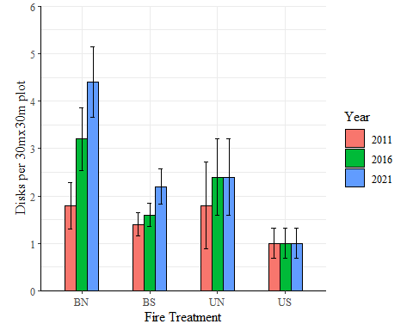

drone_df$Burned <- substr(drone_df$Plot,1,1)  
drone_df$Rodents <- substr(drone_df$Plot,2,2)  
  
  
 year_aov <- aov(mean_count~as.factor(Year)+Burned+ Rodents+ (1|Block), data = drone_df)  
 summary(year_aov)

## Df Sum Sq Mean Sq F value Pr(>F)   
## as.factor(Year) 3 10.85 3.62 2.081 0.10997   
## Burned 1 18.05 18.05 10.386 0.00189 **   
## Rodents 1 42.05 42.05 24.197 5.1e-06 ***  
## Residuals 74 128.60 1.74   
## ---  
## Signif. codes: 0 '***' 0.001 '**' 0.01 '*' 0.05 '.' 0.1 ' ' 1

TukeyHSD(year_aov)

## Tukey multiple comparisons of means  
## 95% family-wise confidence level  
##   
## Fit: aov(formula = mean_count ~ as.factor(Year) + Burned + Rodents + (1 | Block), data = drone_df)  
##   
## $`as.factor(Year)`  
## diff lwr upr p adj  
## 2016-2011 0.55 -0.54570456 1.6457046 0.5536983  
## 2021-2011 1.00 -0.09570456 2.0957046 0.0861566  
## 2023-2011 0.75 -0.34570456 1.8457046 0.2819852  
## 2021-2016 0.45 -0.64570456 1.5457046 0.7030750  
## 2023-2016 0.20 -0.89570456 1.2957046 0.9633421  
## 2023-2021 -0.25 -1.34570456 0.8457046 0.9318330  
##   
## $Burned  
## diff lwr upr p adj  
## U-B -0.95 -1.537351 -0.3626494 0.0018888  
##   
## $Rodents  
## diff lwr upr p adj  
## S-N -1.45 -2.037351 -0.8626494 5.1e-06

This shows the difference between the total counts in each year, however the rodent effect is inflated because UN starts so much higher than the other treatments

Plot the density of the manually collected against the density of the drone collected

d_both |> unite("ID", Burned, Rodents, sep = "", remove = FALSE) |>  
 ggplot(aes(Count_drone, Count_manual, col = ID))+  
 geom_point()+  
 geom_smooth(method = "lm")+  
 stat_regline_equation(aes(label = after_stat(rr.label)), label.x = 0,  
 label.y = c(15,14,13,12))+  
 ylab("Manual count of ant mounds per 30mx30m plot")+  
 xlab("Drone count of ant mounds per 30mx30m plot")+  
 theme_bw()+  
 theme(panel.background = element_rect(fill="transparent"), panel.border = element_blank())+  
 theme(plot.title = element_text(hjust = 0.5), text = element_text(size=12, family = 'serif'))+  
 theme(legend.position = "right", aspect.ratio = 1)+  
 theme(axis.line = element_line(color = 'black'))

## `geom_smooth()` using formula = 'y ~ x'

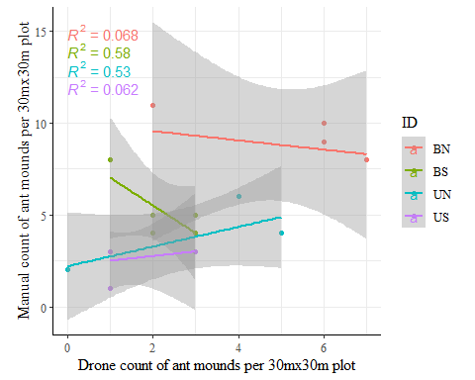

Plot a change in ant mounds over years

inc_df$Year <- as.numeric(inc_df$Year)  
  
inc_df |>  
 group_by(Year, Plot) |>  
 dplyr::summarise(ave = mean(mean_count),  
 se = sd(mean_count) / sqrt(n())) |>  
 ggplot(aes(x=Year, y = ave, color = Plot))+  
 geom_point() +  
 geom_ribbon(aes(ymin = ave - se, ymax = ave + se, fill = Plot), alpha = 0.1) +   
 geom_smooth(aes(group = Plot), alpha = 0.1) +  
 labs(title = "Line Plot with Standard Error",  
 x = "Year",  
 y = "Average",  
 color = "Plot") +  
 theme_bw()+  
 theme(panel.background = element_rect(fill="transparent"), panel.border = element_blank())+  
 theme(plot.title = element_text(hjust = 0.5), text = element_text(size=12, family = "serif"))+  
 theme(legend.position = "right", aspect.ratio = 1)+  
 theme(axis.line = element_line(color = 'black'))

## `summarise()` has grouped output by 'Year'. You can override using the  
## `.groups` argument.  
## `geom_smooth()` using method = 'loess' and formula = 'y ~ x'

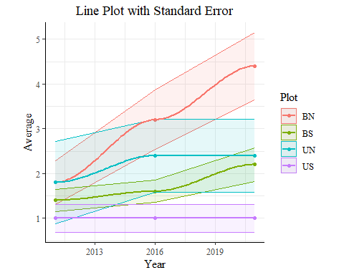

Plot Net Change from 2011 to 2023, this shows the increase in number of mounds so that the starting number doesn’t affect the results

reshaped <- drone_df  
reshaped <- reshaped %>%  
 pivot_wider(names_from = Year, values_from = mean_count)  
  
# Calculate the difference between the values for 2021 and 2011  
reshaped <- reshaped %>%  
 mutate(increase = `2021` - `2011`)   
  
reshaped <- reshaped %>%  
 mutate(decrease = `2023` - `2021`) %>%  
 select(Plot, increase, decrease)  
reshaped$decrease <- reshaped$decrease*-1  
   
#Increase from 2011 to 2021  
reshaped |>  
 ggplot( aes(x = increase, y = Plot)) +  
 stat_summary(geom = "bar", fun = mean, color = "black", fill = "skyblue", width = 0.5) +  
 stat_summary(geom = "errorbar", fun.data = mean_se, width = 0.2)+  
 #geom_bar(stat = "identity", fill = "skyblue", color = "black") +  
 labs( x = "Increase in mounds from 2011 to 2021",  
 y = "Plot") +  
 #geom_text(aes(label = scales::number(difference, accuracy = 0.1)), hjust = -0.2) +  
 theme_bw()+  
 theme(panel.background = element_rect(fill="transparent"), panel.border = element_blank())+  
 theme(plot.title = element_text(hjust = 0.5), text = element_text(size=12, family = 'serif'))+  
 theme(legend.position = "right", aspect.ratio = 1)+  
 theme(axis.line = element_line(color = 'black'))+  
 scale_x_continuous(expand = c(0, 0), limits = c(0, 5))

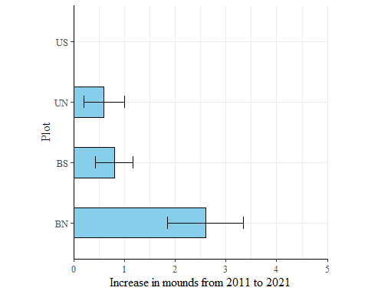

#Decrease from 21 to 23  
reshaped |>  
 ggplot( aes(x = decrease, y = Plot)) +  
 stat_summary(geom = "bar", fun = mean, color = "black", fill = "pink2", width = 0.5) +  
 stat_summary(geom = "errorbar", fun.data = mean_se, width = 0.2)+  
 #geom_bar(stat = "identity", fill = "skyblue", color = "black") +  
 labs( x = "Decrease from 2021 to 2023",  
 y = "Plot") +  
 #geom_text(aes(label = scales::number(difference, accuracy = 0.1)), hjust = -0.2) +  
 theme_bw()+  
 theme(panel.background = element_rect(fill="transparent"), panel.border = element_blank())+  
 theme(plot.title = element_text(hjust = 0.5), text = element_text(size=12, family = 'serif'))+  
 theme(legend.position = "right", aspect.ratio = 1)+  
 theme(axis.line = element_line(color = 'black'))

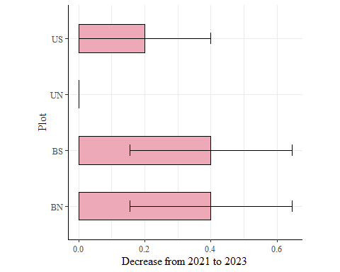

#Actual stats instead of just visualizations  
# Calculate the difference between the values for 2023 and 2011  
  
reshaped$Burned <- substr(reshaped$Plot, 1, 1)  
reshaped$Rodents <- substr(reshaped$Plot, 2, 2)  
  
inc_aov <- aov(data= reshaped, increase~ Burned + Rodents +Burned*Rodents)  
summary(inc_aov)

## Df Sum Sq Mean Sq F value Pr(>F)   
## Burned 1 9.8 9.800 9.116 0.00814 **  
## Rodents 1 7.2 7.200 6.698 0.01982 *   
## Burned:Rodents 1 1.8 1.800 1.674 0.21404   
## Residuals 16 17.2 1.075   
## ---  
## Signif. codes: 0 '***' 0.001 '**' 0.01 '*' 0.05 '.' 0.1 ' ' 1

dec_aov <- aov(data= reshaped, increase~ Burned + Rodents +Burned*Rodents)  
summary(dec_aov)

## Df Sum Sq Mean Sq F value Pr(>F)   
## Burned 1 9.8 9.800 9.116 0.00814 **  
## Rodents 1 7.2 7.200 6.698 0.01982 *   
## Burned:Rodents 1 1.8 1.800 1.674 0.21404   
## Residuals 16 17.2 1.075   
## ---  
## Signif. codes: 0 '***' 0.001 '**' 0.01 '*' 0.05 '.' 0.1 ' ' 1

Joshs Data from 2016

manual_d_16 <- read.csv("C:/Users/ryanp/Documents/Dissertation/Chapter1_Ants/Josh data/Ant mound density.csv")  
head(manual_d_16)

## block plot burn small.mammal density lndensity sqrt ln1density  
## 1 1 us u s 3 1.098612 1.732051 1.3862944  
## 2 1 un u n 4 1.386294 2.000000 1.6094379  
## 3 1 bs b s 4 1.386294 2.000000 1.6094379  
## 4 1 bn b n 6 1.791759 2.449490 1.9459101  
## 5 2 us u s 1 0.000000 1.000000 0.6931472  
## 6 2 un u n 4 1.386294 2.000000 1.6094379

colnames(manual_d_16)[1]<- "Block"  
colnames(manual_d_16)[3]<- "Burned"  
colnames(manual_d_16)[4]<- "Rodents"  
manual_d_16$Burned <- toupper(manual_d_16$Burned)  
manual_d_16$Rodents <- toupper(manual_d_16$Rodents)

Compare 2016 and 2021 manuals to their classifications

d_both <- merge(d_both, manual_d_16, by = c("Block", "Burned", "Rodents"), all.x = TRUE)  
d_both <- d_both[, c("Block", "Burned", "Rodents", "Count_drone", "Count_manual", "density")]  
colnames(d_both)[colnames(d_both) == "density"]<- "Count_manual_16"  
  
d_both %>% unite("ID", Burned, Rodents, remove = FALSE) %>%   
 pivot_longer(cols = c(Count_manual, Count_manual_16), names_to = "Year", values_to = "n") %>%  
ggplot(aes(x= ID, y = n, fill = Year))+  
 #geom_bar(stat = "identity", position = position_dodge())+  
 stat_summary(geom = "bar", fun = mean, position = "dodge", color = "black", width = 0.5) +  
 stat_summary(geom = "errorbar", fun.data = mean_se, width = 0.2, position = position_dodge(0.5))+  
 ylab("Manually counted isks per 30mx30m plot")+  
 xlab("Fire Treatment")+  
 theme_bw()+  
 theme(panel.background = element_rect(fill="transparent"), panel.border = element_blank())+  
 theme(plot.title = element_text(hjust = 0.5), text = element_text(size=12, family = 'serif'))+  
 theme(legend.position = "right", aspect.ratio = 1)+  
 theme(axis.line = element_line(color = 'black'))+   
 scale_x_discrete(labels= c("BN", "BS", "UN", "US"), )+  
 scale_fill_manual(values = c("darkseagreen","darkorchid"),labels=c('2021', "2016"))+  
 theme(legend.position = "right", aspect.ratio = 1)+   
 scale_y_continuous(expand = c(0, 0), limits = c(0, 11))

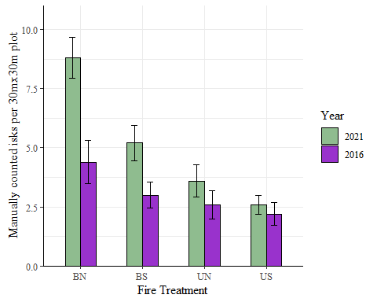

Analysis for differences between 2016 and 2021 manual counts

t.test(d_both$Count_manual, d_both$Count_manual_16, paired = TRUE)

##   
## Paired t-test  
##   
## data: d_both$Count_manual and d_both$Count_manual_16  
## t = 3.9383, df = 19, p-value = 0.0008822  
## alternative hypothesis: true mean difference is not equal to 0  
## 95 percent confidence interval:  
## 0.9370925 3.0629075  
## sample estimates:  
## mean difference   
## 2

d_both$man_diff <- d_both$Count_manual-d_both$Count_manual_16  
d_both$Plot <- str_c(d_both$Burned,d_both$Rodents, sep = "")  
  
d_both |> select(Plot, man_diff) |>  
 ggplot( aes(x = man_diff, y = Plot)) +  
 stat_summary(geom = "bar", fun = mean, position = "dodge", color = "black", fill = "skyblue", width = 0.5) +  
 stat_summary(geom = "errorbar", fun.data = mean_se, width = 0.2, position = position_dodge(0.5))+  
 #geom_bar(stat = "identity", fill = "skyblue", color = "black") +  
 labs( x = "Difference in mounds between 2011 and 2023",  
 y = "Plot") +  
 #geom_text(aes(label = scales::number(difference, accuracy = 0.1)), hjust = -0.2) +  
 theme_bw()+  
 theme(panel.background = element_rect(fill="transparent"), panel.border = element_blank())+  
 theme(plot.title = element_text(hjust = 0.5), text = element_text(size=12, family = 'serif'))+  
 theme(legend.position = "right", aspect.ratio = 1)+  
 theme(axis.line = element_line(color = 'black'))+  
 scale_x_continuous(expand = c(0, 0), limits = c(-5, 5))

## Warning: Removed 1 rows containing non-finite values (`stat_summary()`).  
## Removed 1 rows containing non-finite values (`stat_summary()`).

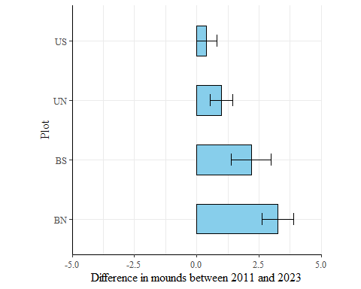

### This needs to be compared to the drone 2021 vs 2016  
  
reshaped |>  
 ggplot( aes(x = increase, y = Plot)) +  
 stat_summary(geom = "bar", fun = mean, position = "dodge", color = "black", fill = "lightgreen", width = 0.5) +  
 stat_summary(geom = "errorbar", fun.data = mean_se, width = 0.2, position = position_dodge(0.5))+  
 #geom_bar(stat = "identity", fill = "skyblue", color = "black") +  
 labs( x = "Difference in mounds between 2021 and 2016",  
 y = "Plot") +  
 #geom_text(aes(label = scales::number(difference, accuracy = 0.1)), hjust = -0.2) +  
 theme_bw()+  
 theme(panel.background = element_rect(fill="transparent"), panel.border = element_blank())+  
 theme(plot.title = element_text(hjust = 0.5), text = element_text(size=12, family = 'serif'))+  
 theme(legend.position = "right", aspect.ratio = 1)+  
 theme(axis.line = element_line(color = 'black'))+  
 scale_x_continuous(expand = c(0, 0), limits = c(-5, 5))

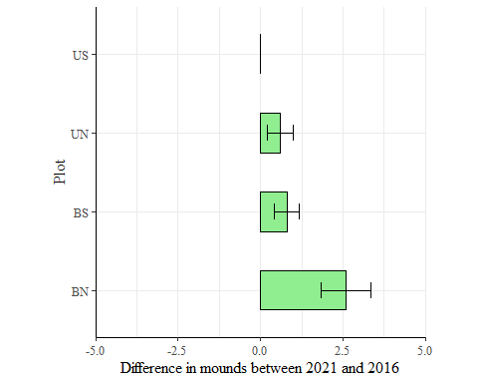

testa <- d_both |> select(Plot, man_diff)  
  
testb <- drone_df |>   
 pivot_wider(names_from = Year, values_from = mean_count) |>  
 mutate(difference = `2021`-`2016`) |>  
 select(Plot, difference)  
   
testb[19,1] <-"UN"  
testb[20,1] <-"US"  
  
testb[is.na(testb)]<- 0  
testb <- as.data.frame(testb)  
  
testa <- testa[order(testa$Plot),]  
testb <- testb[order(testb$Plot),]  
  
testc <- testa  
testc$newdf <- testb$difference  
  
t.test(testc$man_diff,testc$newdf)

##   
## Welch Two Sample t-test  
##   
## data: testc$man_diff and testc$newdf  
## t = 2.9494, df = 21.681, p-value = 0.007488  
## alternative hypothesis: true difference in means is not equal to 0  
## 95 percent confidence interval:  
## 0.4591834 2.6408166  
## sample estimates:  
## mean of x mean of y   
## 2.00 0.45

testc |> pivot_longer(cols = c(man_diff, newdf), names_to = "Method", values_to = "Count") |>   
ggplot( aes(x = Plot, y = Count, fill = factor(Method, levels = c('newdf', "man_diff")))) +  
 stat_summary(geom = "bar", fun = mean, position = "dodge", color = "black", width = 0.5) +  
 stat_summary(geom = "errorbar", fun.data = mean_se, width = 0.2, position = position_dodge(0.5))+  
 ylab("Change in mounds")+  
 xlab("Treatment")+  
 theme_bw()+  
 theme(panel.background = element_rect(fill="transparent"), panel.border = element_blank())+  
 theme(plot.title = element_text(hjust = 0.5), text = element_text(size=12, family = 'serif'))+  
 theme(legend.position = "right", aspect.ratio = 1)+  
 theme(axis.line = element_line(color = 'black'))+   
 scale_x_discrete(labels= c("BN", "BS", "UN", "US"), )+  
 scale_fill_manual("Method", values = c("darkseagreen","darkorchid"),labels=c('Drone count', "Manual count"))+  
 theme(legend.position = "right", aspect.ratio = 1)+   
 scale_y_continuous(expand = c(0, 0), limits = c(0, 9))

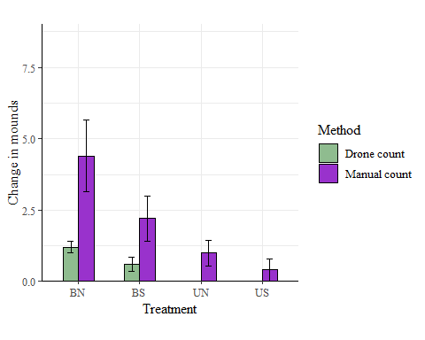

So there are differences in the change in ant mounds detected between 2016 and 2021 by drone and manual counting, but what if I can demonstrate that they show the same trend?

testc$Burned <- substr(testc$Plot,1,1)  
testc$Rodents <- substr(testc$Plot,2,2)  
  
testc_long<- testc |> pivot_longer(cols = c("man_diff", "newdf"),   
 names_to = "Method",   
 values_to = "Count")   
 summary(aov(data = testc_long, Count~ Method))

## Df Sum Sq Mean Sq F value Pr(>F)   
## Method 1 24.03 24.025 8.699 0.00542 **  
## Residuals 38 104.95 2.762   
## ---  
## Signif. codes: 0 '***' 0.001 '**' 0.01 '*' 0.05 '.' 0.1 ' ' 1

man_aov <- aov(data = testc, man_diff~Burned+Rodents)  
dr_aov <- aov(data = testc, newdf~Burned+Rodents)  
  
summary(man_aov)

## Df Sum Sq Mean Sq F value Pr(>F)   
## Burned 1 33.8 33.8 10.563 0.00471 **  
## Rodents 1 9.8 9.8 3.063 0.09814 .   
## Residuals 17 54.4 3.2   
## ---  
## Signif. codes: 0 '***' 0.001 '**' 0.01 '*' 0.05 '.' 0.1 ' ' 1

summary(dr_aov)

## Df Sum Sq Mean Sq F value Pr(>F)   
## Burned 1 4.05 4.050 28.102 5.86e-05 ***  
## Rodents 1 0.45 0.450 3.122 0.0952 .   
## Residuals 17 2.45 0.144   
## ---  
## Signif. codes: 0 '***' 0.001 '**' 0.01 '*' 0.05 '.' 0.1 ' ' 1