TINYWALL LOCALIZATION INSTRUCTIONS
https://tinywall.pados.hu

This file contains instruction on localizing (translating) TinyWall into various spoken languages. Please follow the instructions carefully.

GENERAL NOTES

TinyWall's language resources are grouped into several XML files. Each file in the "Forms" directory contains the localized strings of one specific window TinyWall can show. For example, ConnectionsForm.resx (and all its language variants) contain the strings (texts) that the user can read when opening the Connections window of TinyWall. In addition to the "form" files, additional text can also be found in Exceptions.resx and Messages.resx. Exceptions.resx contains localized names of firewall exceptions, while Messages.resx contains all kinds of miscellaneous text.

When creating a new language, each file must be named in a specific way: a language code is added between the base file name and the resx extension. For example, if the original (untranslated) file is Messages.resx, the German variant must be called Messages.de.resx. Replace "de" by the 2-letter country code of your language. For a list of valid country codes, see the „Language tag“ column in http://msdn.microsoft.com/en-us/goglobal/bb896001.aspx . If you follow this tutorial carefully, all output files will be named correctly by the translation tool.

Please do not use sub-languages. Select a generic variant of your language without a country specialization. For example, do not use "de-AT", just use simply "de".

If a translation for a string does not exist in a specific language, TinyWall will automatically load and use the default (English) version of the string. This means something will always be shown to the user even if not all text is translated, but the untranslated text will appear in English.

THE TRANSLATION PROCESS

1. As a first step, download and install the ZetaResourceEditor from https://www.zeta-resource-editor.com . Any other tool can be used as well, like Visual Studio’s built-in resx editor, or even a plain text editor. However, the recommended tool here is easy to use and install even for non-developers.)

2. Open the pre-made project file "TinyWall-Localization.zreproj" in the Resources folder of TinyWall's localization pack.

The left pane will show each resource file with all the language variants grouped into a single node. Double click a node, and the right pane will then show the strings in multiple columns, one language in each column.

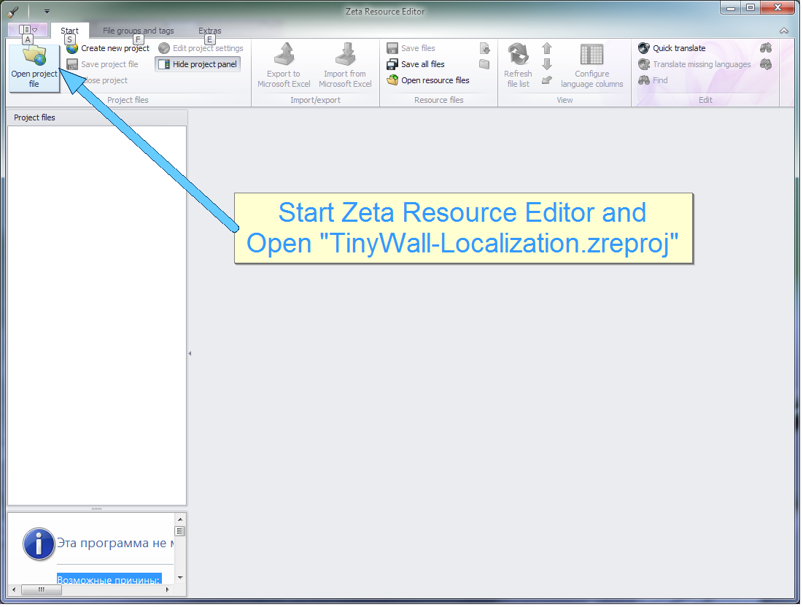
3. Leave the project open, but close all opened language/resource file tabs in the right pane.

4. Right click the first line in the left pane (it says “TinyWall-Localization”), and select "Create new files for language".
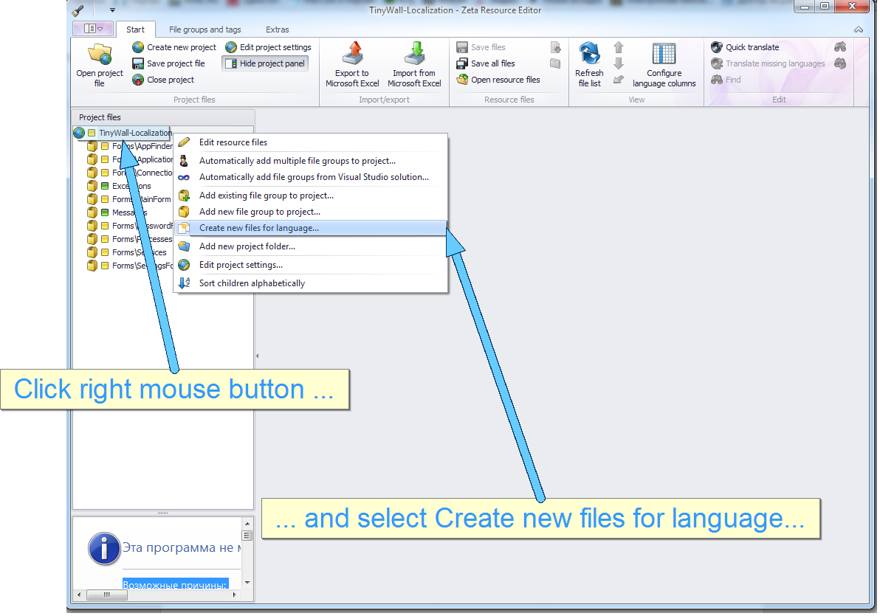
5. In the new dialog, set your new language in the "New language" field, and leave everything else at its default value. Confirm with OK.
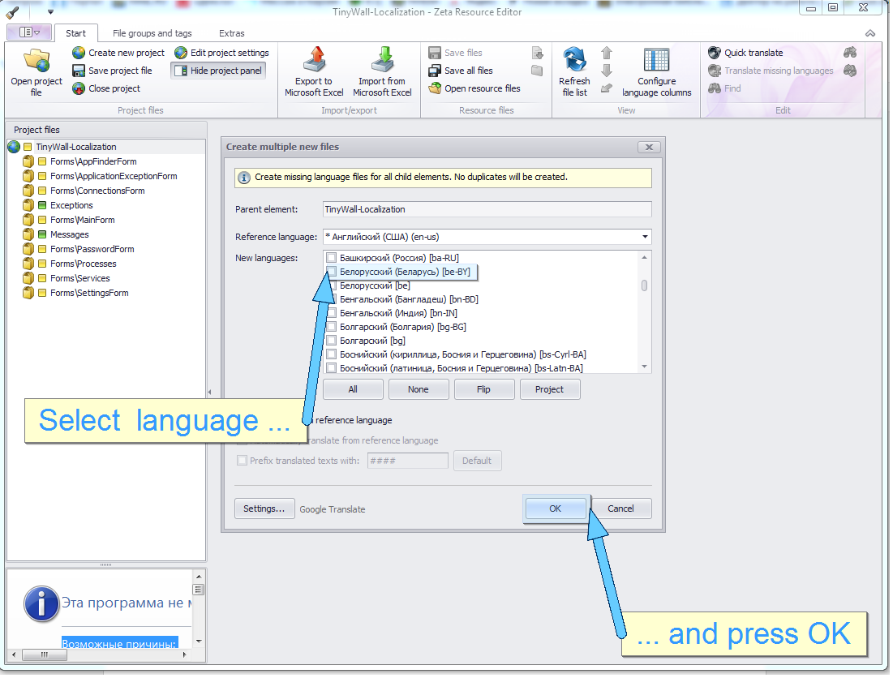

6. Open a resource file by double-clicking on it, and translate all strings. Be sure to save your work before continuing.

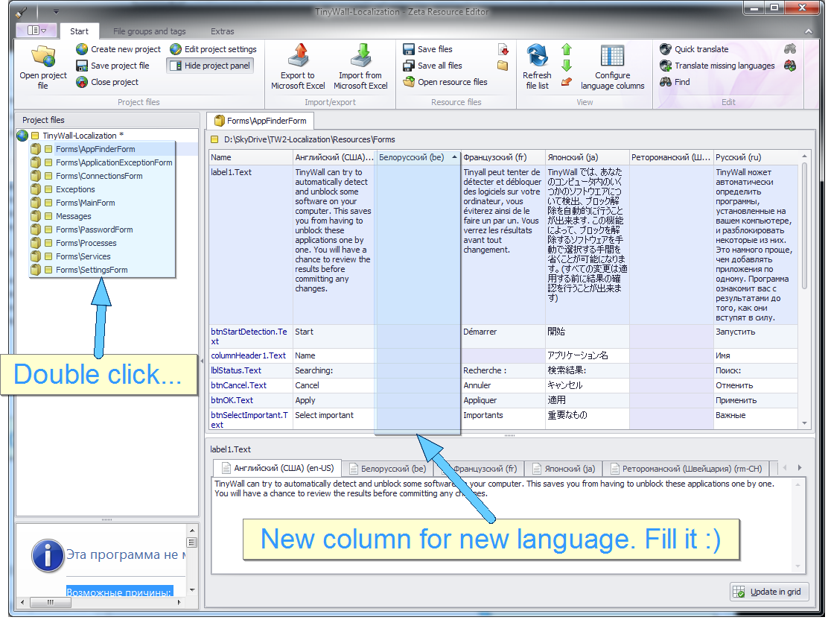

7. Repeat step 6 for all other resource files.

FINISHING UP


When all is done, zip all the files and send them to tinywall pados.hu. In the same e-mail, you need to tell me what the name of the new language is in its same language.

THANK YOU FOR YOUR TRANSLATION!

