Ryan Prior

12/15/2018

SI 206 – Final Project Report

My goal for this project was originally to find a correlation between artists on Spotify and their Instagram accounts. I quickly realized that I would not be able to pull the proper information from Instagram to accomplish what I wanted to do. I decided to change my project to see how age of my favorite playlists compare to one another and see how popularity changes by decade for songs on my playlists. I was able to calculate and graph the data for both of these new project goals. I faced a big problem right off the bat with having to change my project. Once I got on the right track it was not very difficult. Figuring out the Spotipy formatting was a tough task but the Spotipy developer website was a very helpful learning tool in the process. I was able to create two CSV outputs, for the “report” on the calculations, that contain my calculated data. The first is titled “decade_popularity” which contains the decades and average popularity of songs from those decades. A photo example of the calculated data from Excel looks like this:

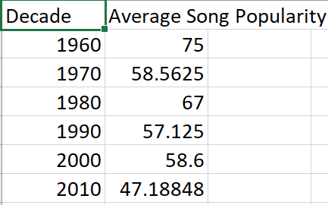

The second CSV output contains each SQLite table name for the playlists and the average age of the songs on each respective playlist. A photo example of the calculated data from Excel looks like this:

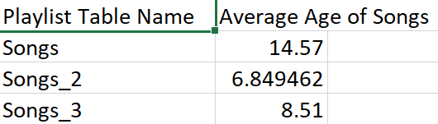

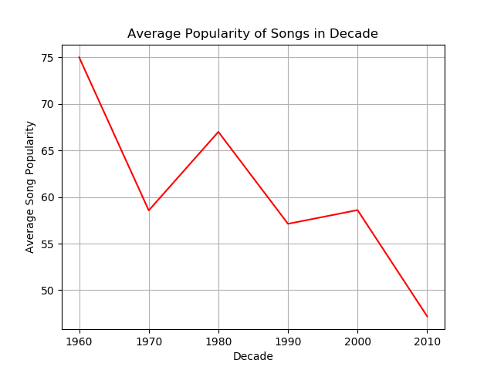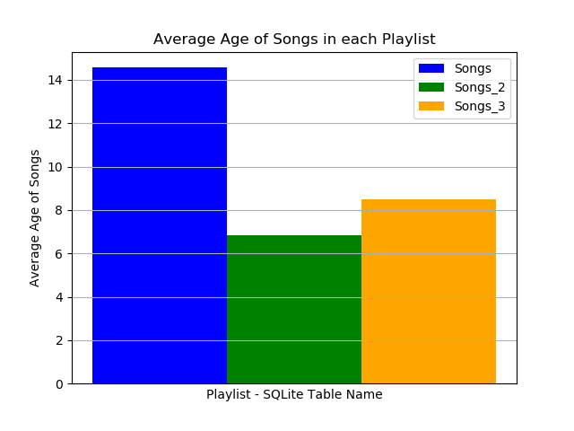In order to run the code properly the user must have proper Spotify credentials (Client ID and Client Secret) saved in a file in the same folder as the code file. Once this is done, simply run the code and you will see two graphs of the data above, one after the other, pop up. The SQLite tables will be made, and the CSV files will be written as well. There is no output in the terminal or text editor window. Examples of the two graphs look like this:

Lines 1-7 import all of the necessary modules. Lines 9-10 set up credentials to access the Spotify API through the Spotipy module and creates the session. Lines 12-17 create cursors for three different SQLite tables that will correlate to three playlists. The function make_song_tables does not take an input and pulls the data from three Spotify playlists from my account. 100 songs are pulled from each and the song names, popularity ranks, and release years are stored in their own SQLite tables. There is no output, it just caches the data into tables. The calculate_popularity_decade function takes the three SQLite data tables as inputs and then combines all of the songs into one list of tuples. The function is calculating the average popularity of songs per decade out of the whole 300. The return is two lists ready to be used for a graph that are in corresponding order, one with decades and the other with popularity average. As well, a CSV file is written with the new data and is shown above as the first example table. The make_line_graph function takes the output calculations from the calculate_popularity_decade function as an input. There is no return value, but the output is a line graph that shows when ran. The line graph displays the average song popularity by decade for all three playlists combined and is shown above on the left-hand side. The calculate_playlist_age function takes the three SQLite data tables as inputs and calculates the age, which is the average age of songs in the playlist, of each playlist. Those three values are the outputs. As well, another CSV file is written with the new data and is shown above as the second example table. The make_bar_chart function takes the output calculations from the calculate_playlist_age function as an input. It then makes a bar chart with the three values given for the three respective playlists. Again, there is no return value, but the chart will be made when ran and is shown above on the right-hand side. The run_all function simply calls all of the other functions correctly and in the right order. The run_all function is called and is what makes the whole program run. For Spotipy as a whole, I used a resource to self-teach which is shown below:

|  |  |  |  |
| --- | --- | --- | --- |
| Date | Issue Description | Location of Resource | Result |
| 12/8/2018 | Trouble with Spotipy formatting. | <https://spotipy.readthedocs.io/en/latest/> | Was able to self-teach the Spotipy formatting, create a session with the Spotify API, and search. |