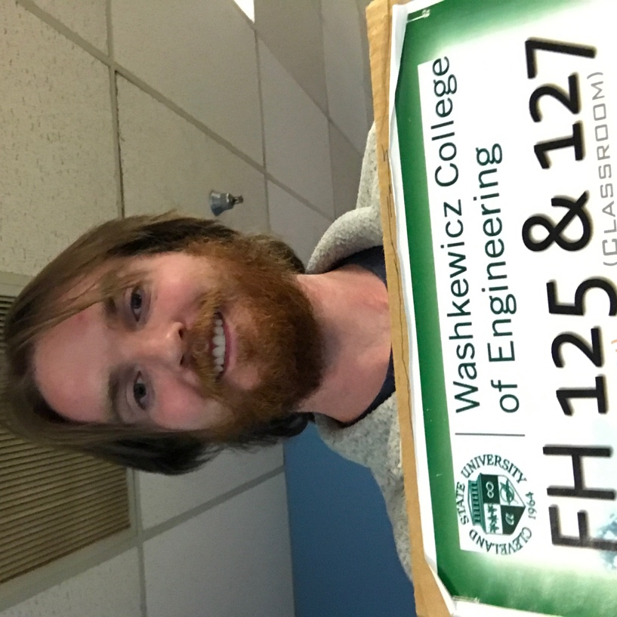

Project 5

Ryan Reynolds

ryreynol

11/27/18

1. Part 1: Device Query

The GPU Clock Rate: 1354 MHz or 1.35 GHz

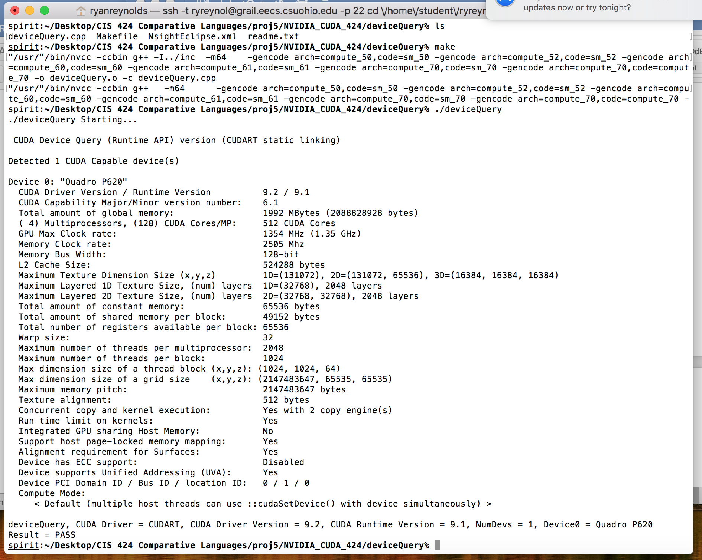There are 512 CUDA cores. The more CUDA cores the more parallelization you can achieve.

1. 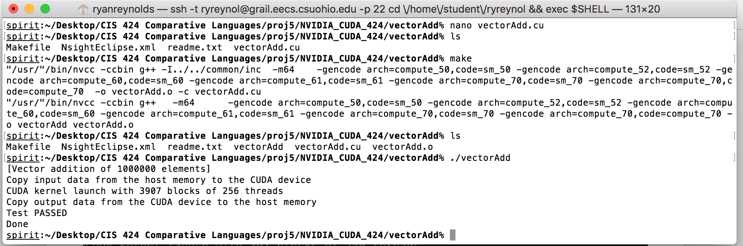Part II: Euclidean Distance

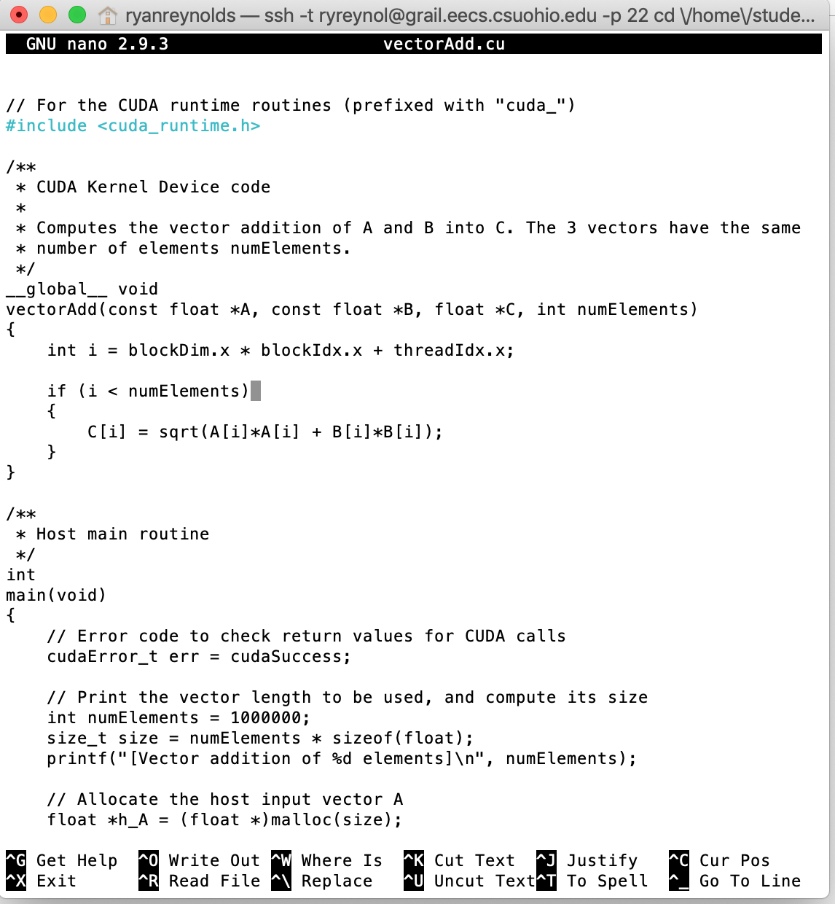implemented Euclidean distance and increased the vector length to 1,000,000.

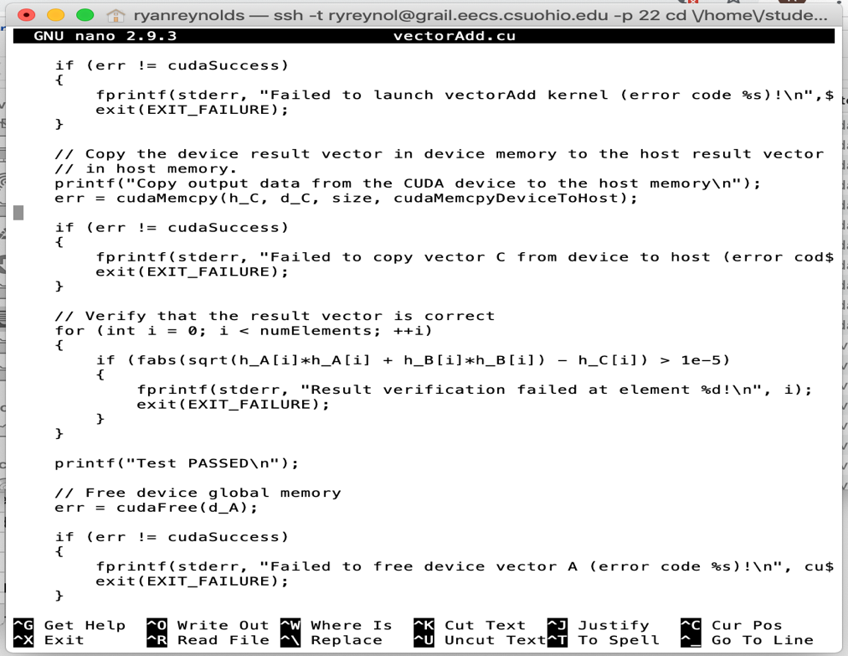Changed the resulting matrix to verify the result is correct

1. Part III: Performance Comparison of Matrix Multiplication

Sequential matrix multiplication on CPU.

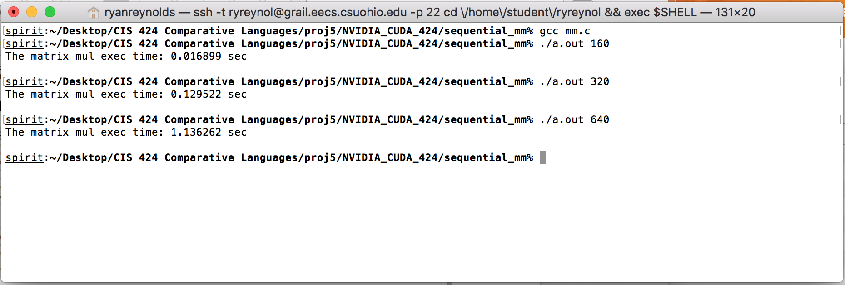

mm.c with my implemented sequential matrix multiplication and elapsed time function.

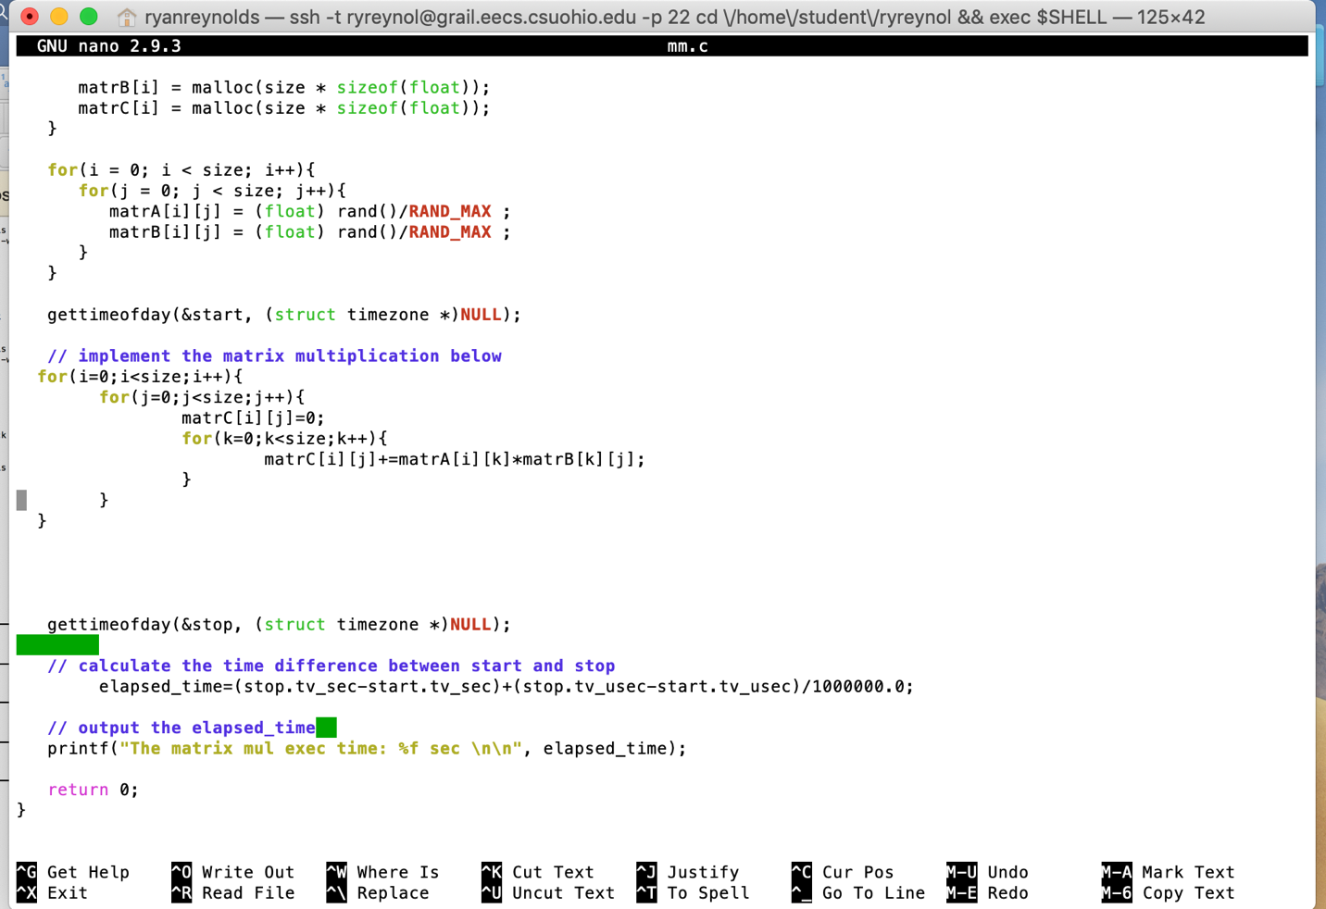

matrixMul.cu run on GPU Results

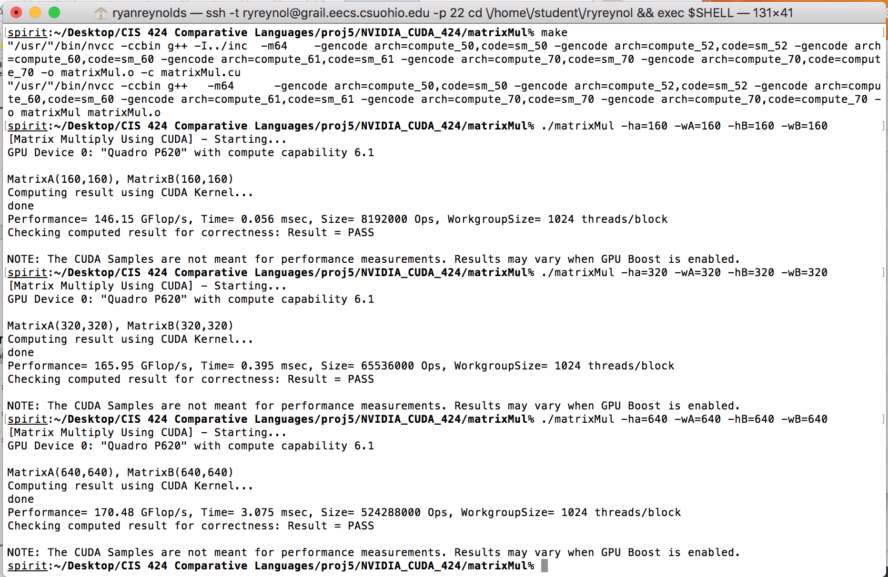

Below is a table showing the output cpu and gpu execution times for the 3 different size matrix multiplications. Additionally, the table includes the speed up values, for each size, achieved by using parallelization to calculate floating point operations on spirit’s Quadro P620.

|  |  |  |  |
| --- | --- | --- | --- |
| **N (matrix size)** | **CPU Execution Time (s)** | **GPU Execution Time (s)** | **Speedup (CPU / GPU)** |
| **160** | 0.016899 | 5.6x10-5 | 307.25 |
| **320** | 0.129522 | 0.000395 | 327.90 |
| **640** | 1.136262 | 0.003075 | 369.52 |

Proof of Submission:

