1. Scripting Interpreter
   1. Prompt Linux
      1. python3

Do not type spaces are indents

Used to cut down on excessive indentions and brackets

Swap

If Statements

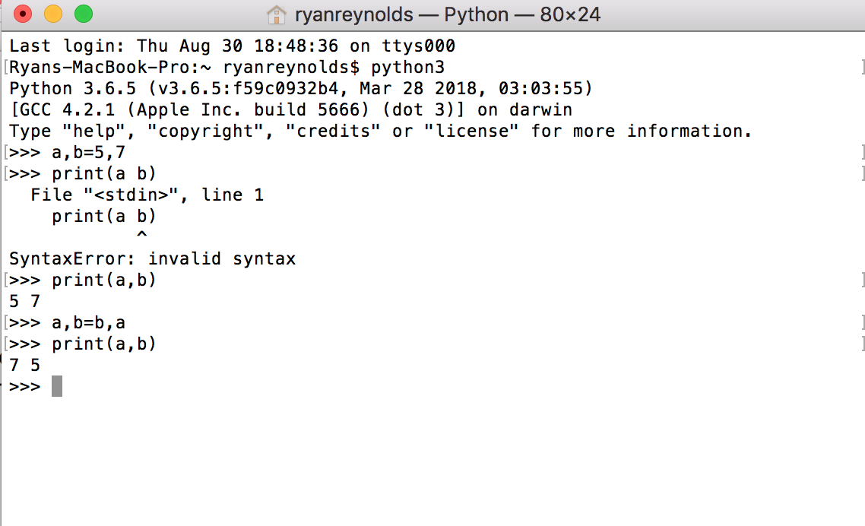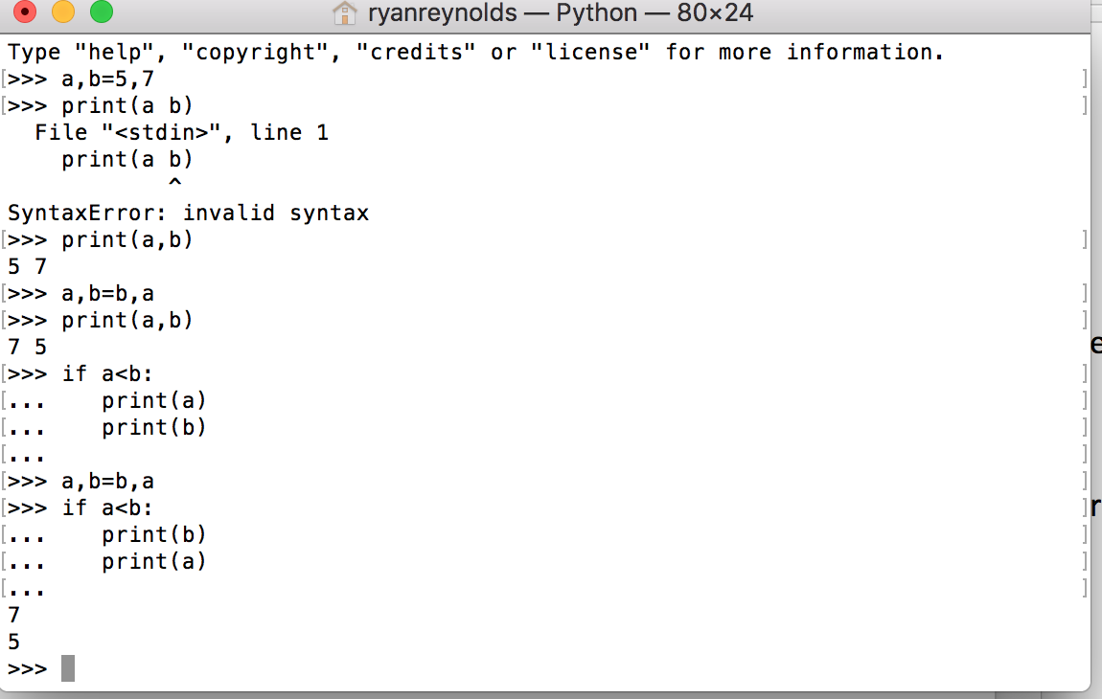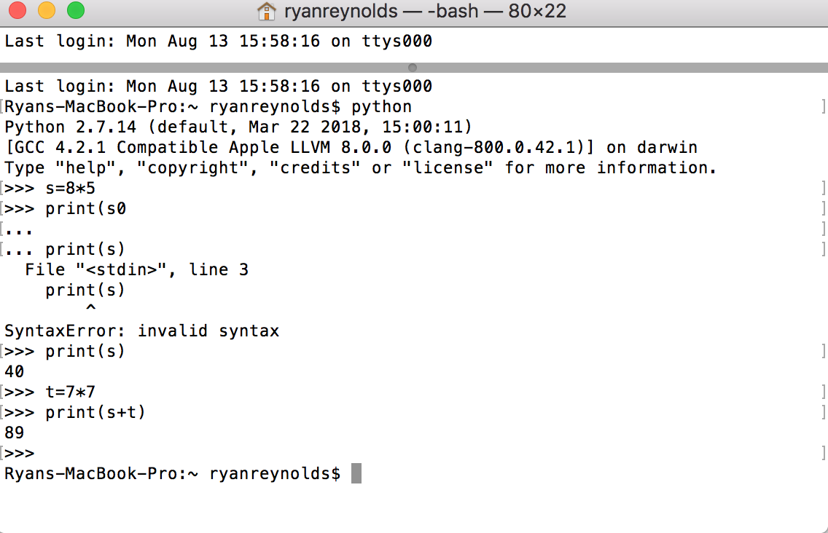

While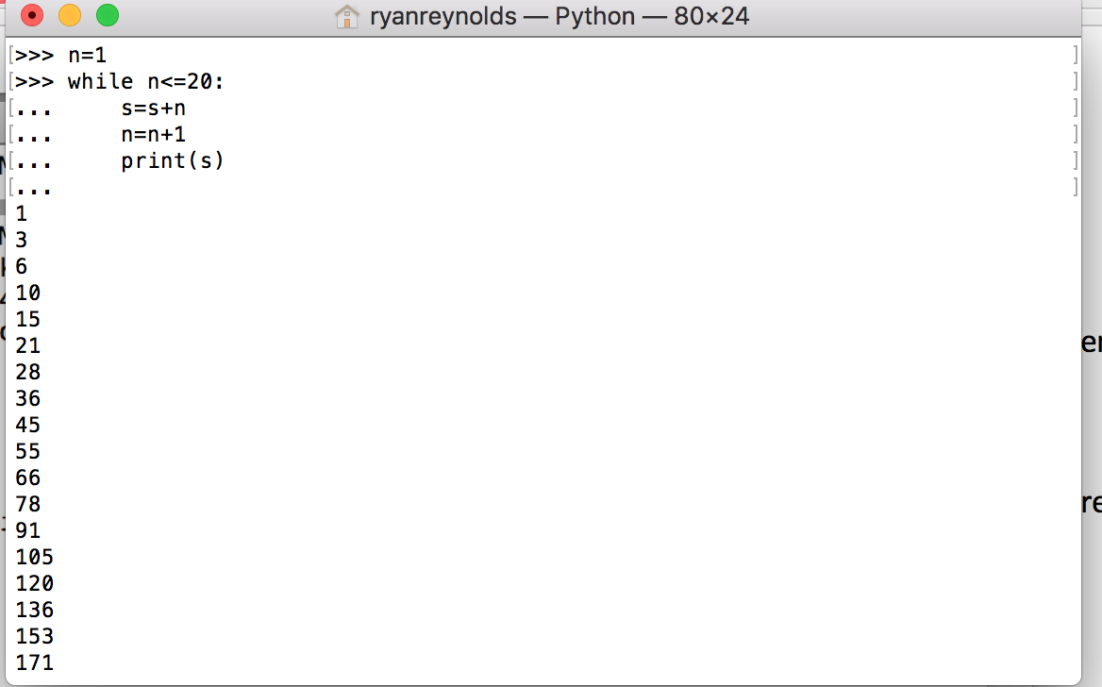Tuple is constant declaration

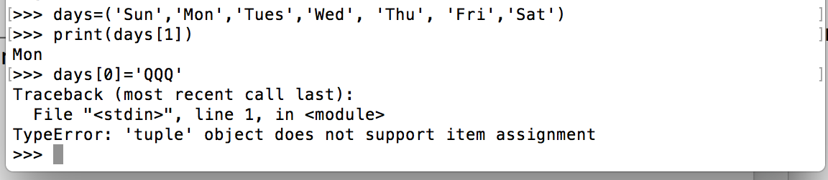

Lists (No need to have the same type)

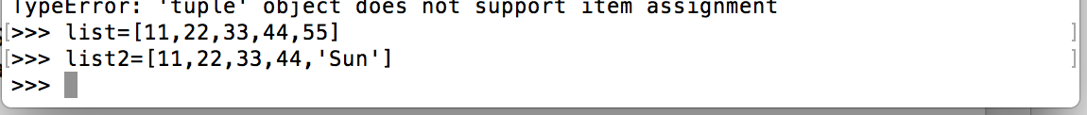

Printing ranges of lists (NOTE 4 WILL NOT BE INCLUDED)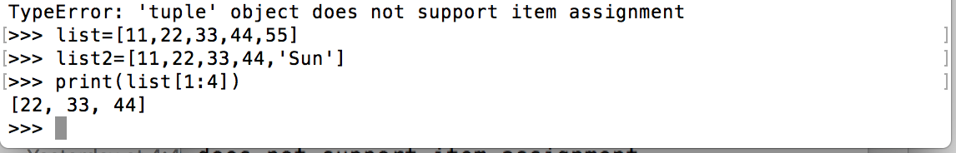

Concatenation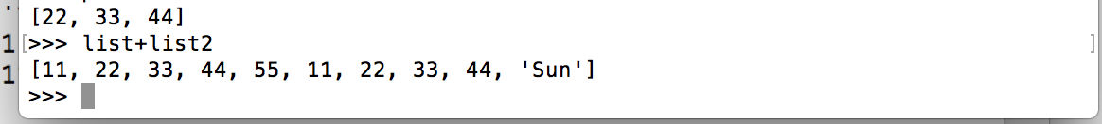

List Manipulation:

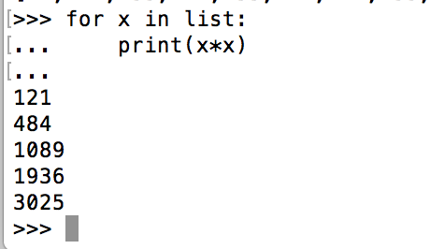

BUILT IN LIST FUNCTIONS

Length Function:

Compare Function: cmp(l1,l2)

Max: max(l)

List function Converts tuples to lists: list(sep)

DICTIONARY (Associative Array)

Scores={ }

List allows you to use index but dictionaries have indexes made up of strings

Scores[‘John’]=90

Scores[‘Tom’]=60

Scores[‘Max’]=30

Scores[‘Bill’]=40

C++ Library STL provides this data structure and will print in the same order. In python they use a hash function when the interpreter runs so the scores can print in random orders

Print(scores[‘Bob])

Print(scores.get(‘Bob’))

1. Can not sort dictionaries need to be put into a list to sort

V=scores.values

Where v is a list

v.sort()

note scores is a dictionary below

scores.get is a function name to retrieve the sorted key which is the score value not the dictionary key

Descending Order

For k in sorted (scores, key=scores.get)

Print(k, scores[k])

Ascending Order

For k in sorted (scores, key=scores.get, reverese=true)

Print(k, scores[k])

**Word Count from a file: count the number of occurrences for each word**

Open the file:

File=open(“fname.txt”,”r”) <--read only read and write is “r+”

Create a dictionary

Do not need to search for it because we are using dictionary

Wdcnt={} //initialize an empty dictionary

For w in L=file.read().split() //read in the file then call the split function to split each input in by a space

If w not in wdcnt:

Wdcnt[w]=1 //create the first entry with that word as the key and the count a 1

Else:

Wdcnt[w]+=1 //increment the word count by 1

Passing file via the command line in python

Python 3 test.py data

Import sys

print(sys.argv) //this will print the entire command passed using python3 OP: test.py data

print(sys.argv[1]) //this will print name of file passed to it at index 1 OP: data

Defining a Function in Python

Def funcname(para1,…, paran):

.

.

.

return value 🡨 redundant if you don’t want to return a value

def hello():  
 print(“hello”)

def world():

return “world”

def this_year():

return 2018

def nextyear(y):

return y+1

hello() print hello

print(world()) //prints world

print(nextyear(this year())) // print 2019

Parameters

def foo (l)

l.append(77)

def inc(n)

n=n+1

a=3

inc(a)

print(a)

Homework

Print the number of different words:

Print out the number of words in the file

Then print out the occurrences of each words that are at least 5 characters long in the file in descending order

Then print out the longest word in the file

Use the length function to check the key value in the list

Report:

Describe your code

Talk about your debugging experience

grail turnin -sc cis424s -p proj1 wdcount.py

python debugger is pdb

notepad ++