Ryan Reynolds

2693018

CIS 457

Homework 2

Questions 1 and 2:

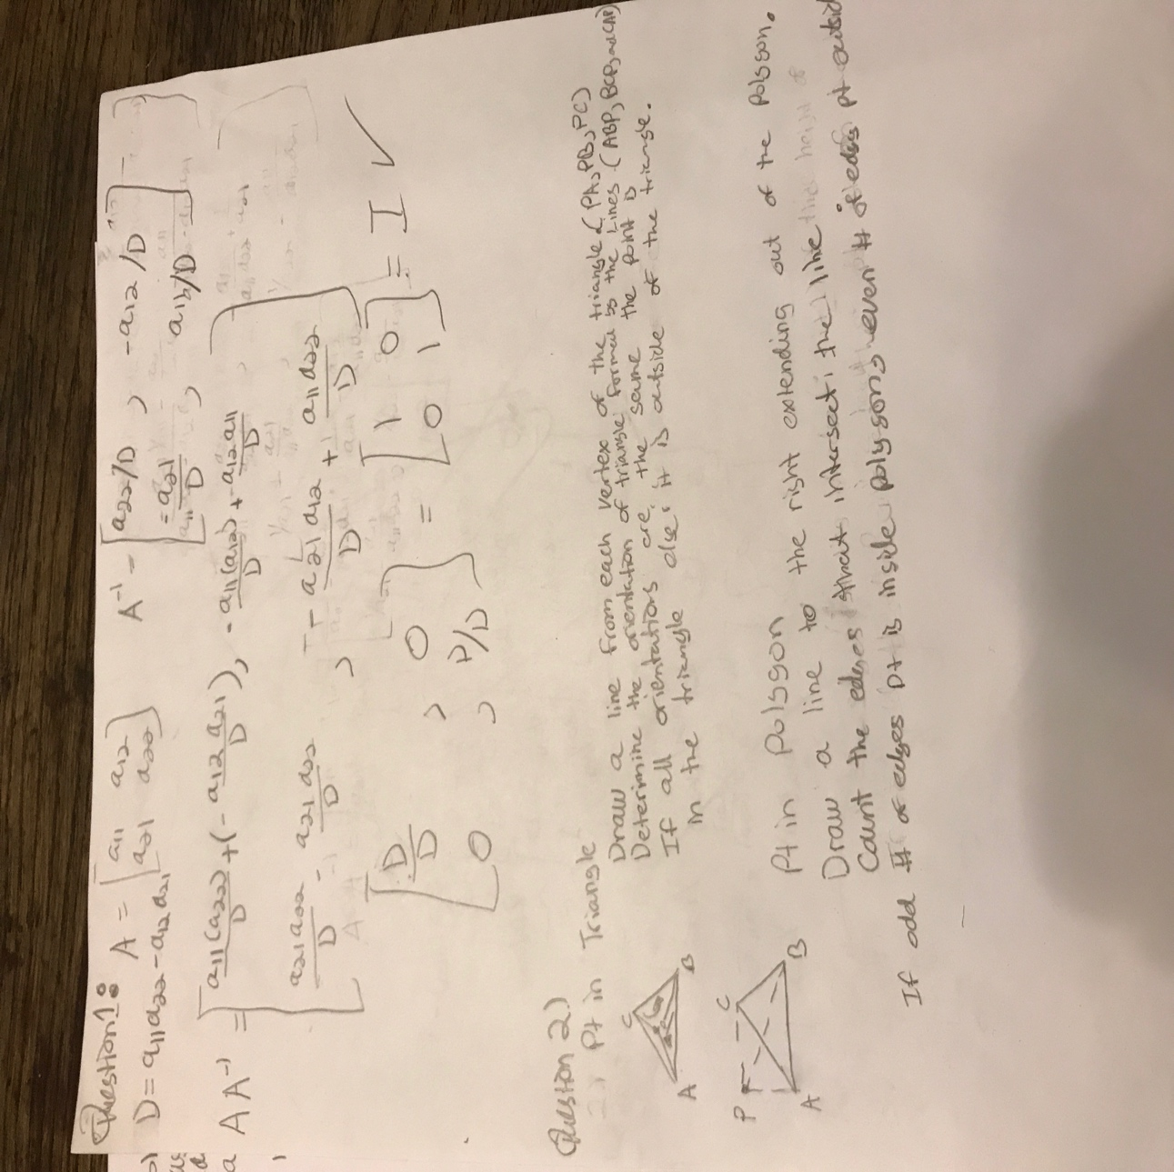

Question 3:

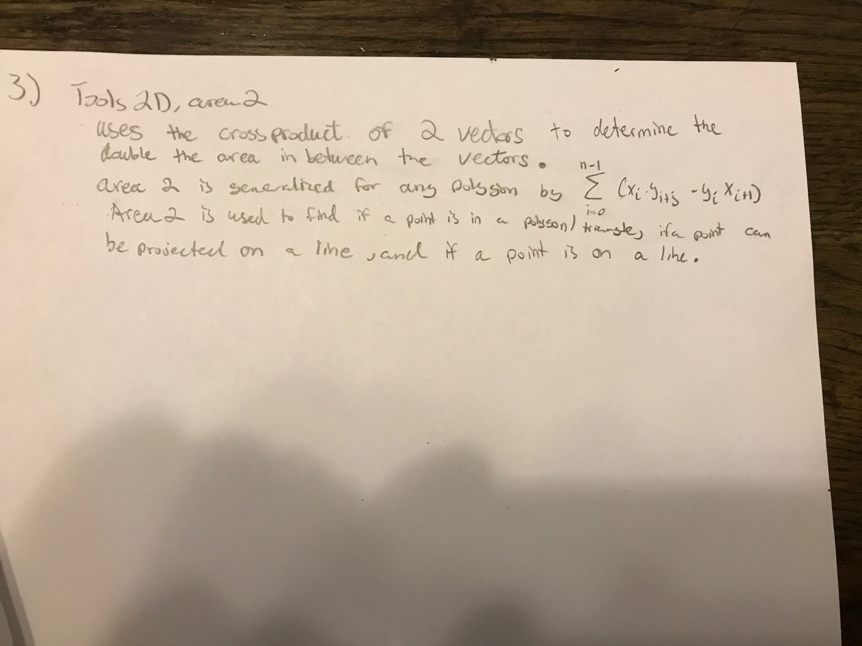

Quesiton 4:

import java.awt.*;  
import java.awt.event.MouseAdapter;  
import java.awt.event.MouseEvent;  
import java.awt.event.WindowAdapter;  
import java.awt.event.WindowEvent;  
import java.util.Vector;  
  
  
public class Question4 extends Frame {  
  
 public static void main(String[] args)  
  
  
 {new Question4();}  
 Question4()  
 {  
  
 super("Define vertices by clicking");  
 addWindowListener(new WindowAdapter()  
 { public void windowClosing(WindowEvent e)  
 { System.*exit*(0);}  
 });  
  
  
 setSize (500, 300);  
 add("Center", new Lines());  
 setCursor(Cursor.*getPredefinedCursor*(Cursor.*CROSSHAIR_CURSOR*));  
 show();  
 }  
}  
  
  
  
class Lines extends Canvas {  
  
  
 Vector v = new Vector();  
  
 Point2D a, b, c, d;  
 float x0, y0, rWidth = 10.0F, rHeight = 7.5F, pixelSize, xI,yI;  
 boolean ready = true;  
 int centerX, centerY;  
 int clickCounter = 0;  
  
 Lines() {  
 addMouseListener(new MouseAdapter() {  
 public void mousePressed(MouseEvent evt) {  
 float xA = fx(evt.getX()), yA = fy(evt.getY());  
 float dx = xA - x0, dy = yA - y0;  
 if (clickCounter < 4) {  
 v.addElement(new Point2D(xA, yA));  
 clickCounter = clickCounter + 1;  
 repaint();  
 ready = true;  
 } else if (clickCounter == 4) {  
 ready = false;  
 v.addElement(new Point2D(xA, yA));  
 }  
 }  
 });  
 }  
  
 public void paint(Graphics g) {  
  
 g.drawString("Click Four Points to create two lines.", 5, 20);  
  
 g.setColor(Color.white);  
  
 selection();  
 int left = iX(-rWidth / 2), right = iX(rWidth / 2),  
 bottom = iY(-rHeight / 2), top = iY(rHeight / 2) + 60;  
 g.drawRect(left, top - 15, right - left, bottom - top);  
 g.fillRect(left, top - 15, right - left, bottom - top);  
 g.setColor(Color.red);  
  
 int n = 4;  
 if (n == 0) return;  
 a = (Point2D) (v.elementAt(0));  
 g.fillOval(iX(a.x) - 2, iY(a.y) - 2, 4, 4);  
  
  
 for (int i = 1; i<n; i++) {  
 if (i == (4) && !ready) {  
 break;  
 }  
  
 Point2D b = (Point2D) (v.elementAt(i % n));  
 g.fillOval(iX(b.x) - 2, iY(b.y) - 2, 4, 4);  
 if(i!=2)  
 g.drawLine(iX(a.x), iY(a.y), iX(b.x), iY(b.y));  
 a = b;  
 }  
 a=(Point2D) (v.elementAt(0));  
 b=(Point2D) (v.elementAt(1));  
 c=(Point2D) (v.elementAt(2));  
 d=(Point2D) (v.elementAt(3));  
 double a1 = b.y - a.y;  
 double b1 = a.x - b.x;  
  
 double c1 = a1*(a.x) + b1*(a.y);  
  
 // Line CD represented as a2x + b2y = c2  
 double a2 = d.y - c.y;  
 double b2 = d.x - c.x;  
 double c2 = a2*(c.x)+ b2*(c.y);  
  
 double determinant = a1*b2 - a2*b1;  
 double epsilon=(Math.pow(10.0,-3.0)*(Math.pow(b1,2)+Math.pow(a1,2)+Math.pow(d.x-c.x,2)+Math.pow(a2,2)));  
 if (determinant<=epsilon)  
 {  
 g.drawString("Line AB and CD are colinear or parrallel", 5, 40);  
 }  
 else  
 {  
 double x = (b2*c1 - b1*c2)/determinant;  
 double y = (a1*c2 - a2*c1)/determinant;  
 g.drawOval(iX((float)x)-5, iY((float)y)-5, 10, 10);  
 }

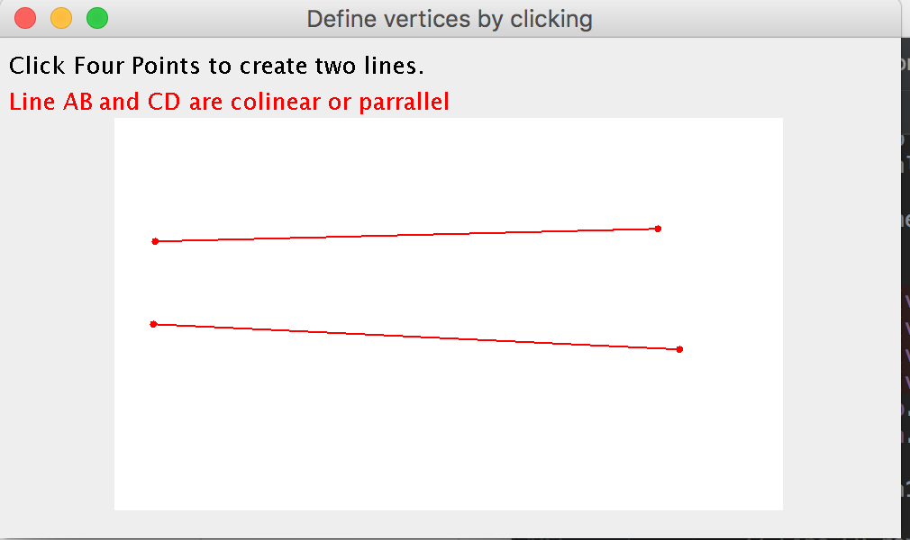

Question 5:

import java.awt.*;  
import java.awt.event.*;  
import java.util.*;  
import java.awt.Graphics;  
  
public class Question5 extends Frame {  
  
 public static void main(String[] args)  
  
  
 {new Question5();}  
 Question5()  
 {  
  
 super("Define vertices by clicking");  
 addWindowListener(new WindowAdapter()  
 { public void windowClosing(WindowEvent e)  
 { System.*exit*(0);}  
 });  
  
  
 setSize (500, 300);  
 add("Center", new Poly());  
 setCursor(Cursor.*getPredefinedCursor*(Cursor.*CROSSHAIR_CURSOR*));  
 show();  
 }  
}  
class Tools2D  
{  
  
  
  
 static float area2(Point2D a, Point2D b, Point2D c)  
 { return (a.x - c.x) * (b.y - c.y) - (a.y - c.y) * (b.x - c.x);}  
  
  
 static boolean onSegment(Point2D a, Point2D b, Point2D p)  
 { double dx = b.x - a.x, dy = b.y - a.y,  
 eps = 0.001 * (dx * dx + dy * dy);  
 return  
 (a.x != b.x &&  
 (a.x <= p.x && p.x <= b.x || b.x <= p.x && p.x <= a.x)  
 || a.x == b.x &&  
 (a.y <= p.y && p.y <= b.y || b.y <= p.y && p.y <= a.y))  
 && Math.*abs*(Tools2D.*area2*(a, b, p)) < eps; }  
  
 static boolean ccw(Point2D[] p)  
 { int n = p.length,k=0;  
 for (int i=1; i<n; i++)  
 if (p[i].x <= p[k].x && (p[i].x < p[k].x || p[i].y <  
 p[k].y))  
 k=i;  
 int prev = k - 1, next = k + 1;  
 if (prev == -1) prev = n - 1;  
 if (next == n) next = 0;  
 return Tools2D.*area2*(p[prev], p[k], p[next]) > 0; }  
  
 static boolean insideTriangle(Point2D a, Point2D b, Point2D c, Point2D p)  
 { return  
 Tools2D.*area2*(a, b, p) >= 0 &&  
 Tools2D.*area2*(b, c, p) >= 0 &&  
 Tools2D.*area2*(c, a, p) >= 0; }  
}  
  
  
class Poly extends Canvas {  
  
  
 Vector v = new Vector();  
 Vector p = new Vector();  
 Point2D aa, bb, cc, pp;  
 float x0, y0, rWidth = 10.0F, rHeight = 7.5F, pixelSize;  
 boolean ready = true;  
 int centerX, centerY;  
 int clickCounter = 0;  
  
 Poly() {  
 addMouseListener(new MouseAdapter() {  
 public void mousePressed(MouseEvent evt) {  
 float xA = fx(evt.getX()), yA = fy(evt.getY());  
 float dx = xA - x0, dy = yA - y0;  
 if (clickCounter < 4) {  
 v.addElement(new Point2D(xA, yA));  
 clickCounter = clickCounter + 1;  
 repaint();  
 ready = true;  
 } else if (clickCounter == 4) {  
 ready = false;  
 v.addElement(new Point2D(xA, yA));  
 }  
 }  
 });  
 }  
  
 public void paint(Graphics g) {  
 Tools2D tools2D = new Tools2D();  
 g.drawString("Click Three Points to paint a Triangle.", 5, 20);  
 g.drawString("Click a Fourth Point to Select Point P.", 5, 40);  
 g.setColor(Color.*white*);  
  
 selection();  
 int left = iX(-rWidth / 2), right = iX(rWidth / 2),  
 bottom = iY(-rHeight / 2), top = iY(rHeight / 2) + 60;  
 g.drawRect(left, top - 15, right - left, bottom - top);  
 g.fillRect(left, top - 15, right - left, bottom - top);  
 g.setColor(Color.*red*);  
  
 int n = 3;  
 if (n == 0) return;  
 Point2D a = (Point2D) (v.elementAt(0));  
 g.fillOval(iX(a.x) - 2, iY(a.y) - 2, 4, 4);  
  
  
 for (int i = 1; i <= n; i++) {  
 if (i == (n) && !ready) {  
 break;  
 }  
 Point2D b = (Point2D) (v.elementAt(i % n));  
 g.fillOval(iX(b.x) - 2, iY(b.y) - 2, 4, 4);  
 g.drawLine(iX(a.x), iY(a.y), iX(b.x), iY(b.y));  
 a = b;  
 }  
  
 //Draws x on fourth point p as an X:  
 g.setColor(Color.*blue*);  
 Point2D p = (Point2D) (v.elementAt(3));  
 float pX = p.x, pY = p.y;  
 g.drawLine(iX(pX) - 3, iY(pY) + 3, iX(pX) + 3, iY(pY) - 3);  
 g.drawLine(iX(pX) - 3, iY(pY) - 3, iX(pX) + 3, iY(pY) + 3);  
 Point2D[] pointsArray = new Point2D[4];  
 int k = 0;  
 for (k = 0; k < pointsArray.length; k++) {  
 pointsArray[k] = (Point2D) (v.elementAt(k));  
 }  
  
  
 if (Tools2D.*onSegment*(pointsArray[2], pointsArray[0], pointsArray[3]) == true  
 || Tools2D.*onSegment*(pointsArray[0], pointsArray[1], pointsArray[3]) == true  
 || Tools2D.*onSegment*(pointsArray[1], pointsArray[2], pointsArray[3]) == true) {  
 g.drawString("Point P lies on an edge of triangle ABC.", 5, 230);  
 } else {  
 //Test if Triangle orientation is ccw  
 if (Tools2D.*ccw*(pointsArray)) {  
 if (Tools2D.*insideTriangle*(pointsArray[0], pointsArray[1], pointsArray[2], pointsArray[3])) {  
 g.drawString("Point P lies inside of triangle ABC", 5, 230);  
 } else {  
 g.drawString("Point P lies outside of triangle ABC", 5, 230);  
 }  
 } else  
  
  
 {  
 if (tools2D.*insideTriangle*(pointsArray[2], pointsArray[1], pointsArray[0], pointsArray[3])) {  
 g.drawString("Point P lies inside of triangle ABC", 5, 230);  
 } else {  
 g.drawString("Point P lies outside of triangle ABC", 5, 230);  
 }  
 }  
 }  
 }  
  
  
 void selection() {  
 Dimension d = getSize();  
 int maxX = d.width - 1, maxY = d.height - 1;  
 pixelSize = Math.*max*(rWidth / maxX, rHeight / maxY);  
 centerX = maxX / 2;  
 centerY = maxY / 2;  
 }  
  
 int iX(float x) {  
 return Math.*round*(centerX + x / pixelSize);  
 }  
  
 int iY(float y) {  
 return Math.*round*(centerY - y / pixelSize);  
 }  
  
 float fx(int x) {  
 return (x - centerX) * pixelSize;  
 }  
  
 float fy(int y) {  
 return (centerY - y) * pixelSize;  
 }  
}  
class Point2D {  
 float x, y;  
 Point2D(float x, float y){this.x = x; this.y = y;}}

