Ryan Reynolds

2693018

CIS 340

Assignment 4

**Question 1:**

|  |  |  |
| --- | --- | --- |
| **label** | **address** | **value** |
| I (parent) | 400-403 | ~~Child PID~~  0 |
| J (parent) | 404-407 | ~~0 1 2 3~~ 4 |
| K (parent) | 408-411 | ~~0 0 1 3~~  6 |
| I (child) | 500-503 | ~~0 3 4 5~~ 6 |
| J (child) | 504-507 | ~~4 1 -3~~ -8 |
| K (child) | 508-511 | 6 |

The output would either be

0 4 6

6 -8 6

or

6 -8 6

0 4 6

The program uses printf which buffers the variables. The processes execute concurrently and the output will be determined by the CPU scheduler i.e. the output depends on which process reaches the printf statement first which could be either for this case.

**Question 2:**

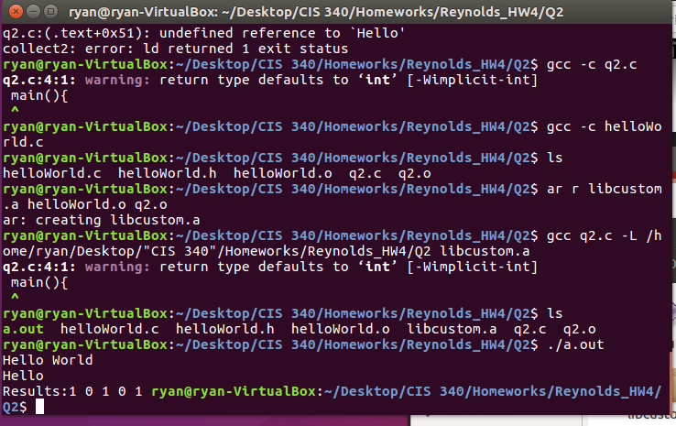

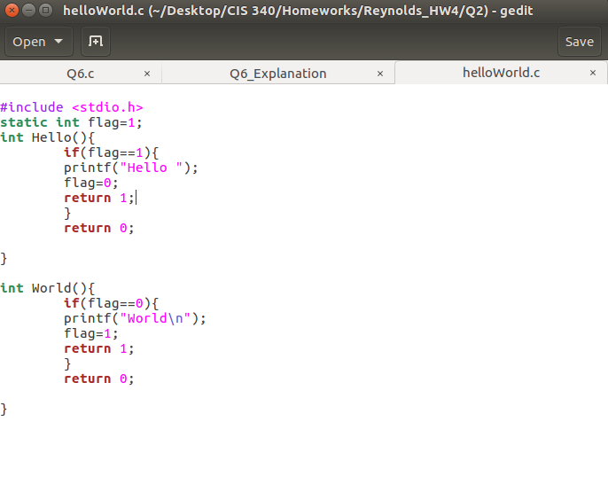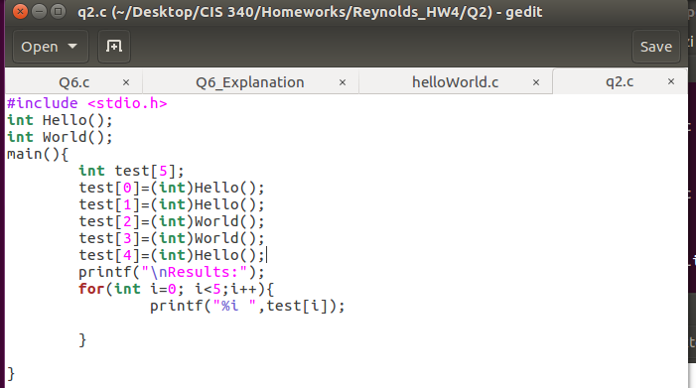

**Question 3:**

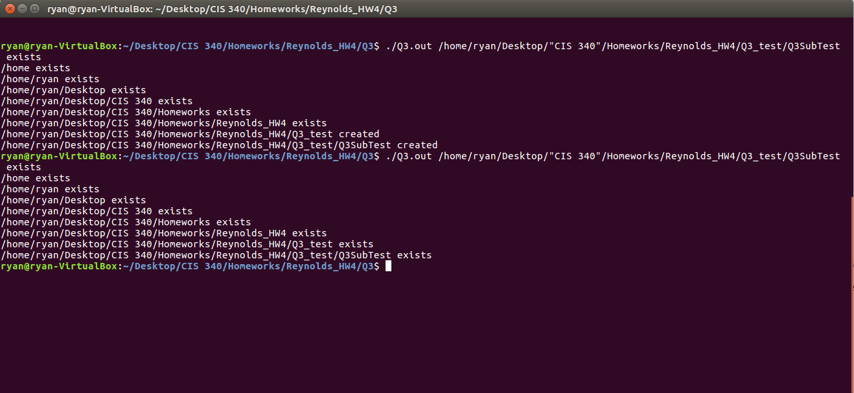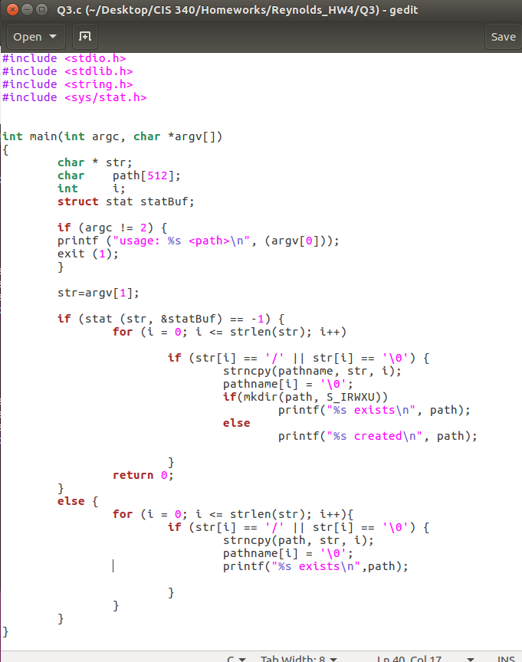

**Question 4:**

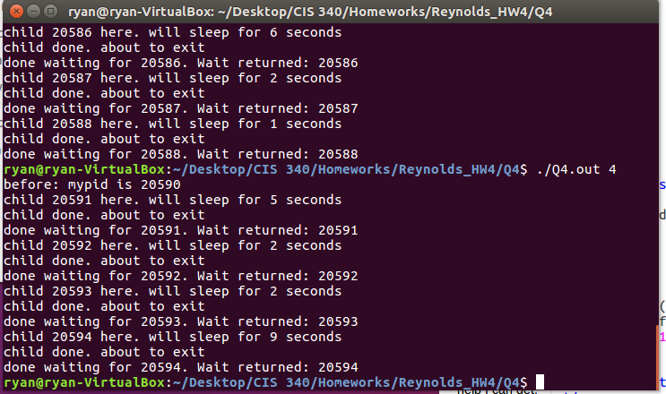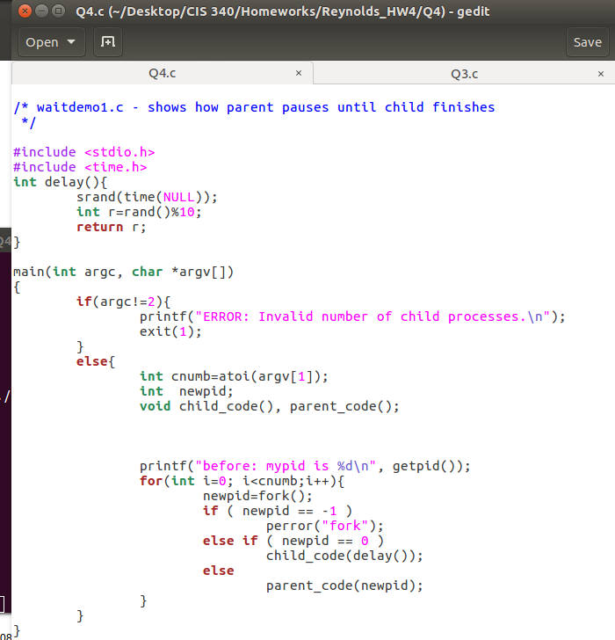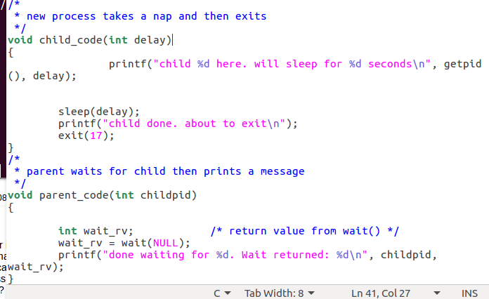

**Question 5:**

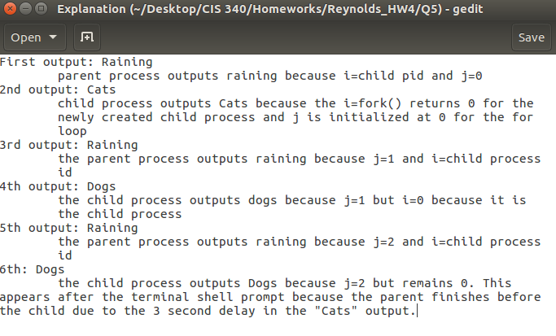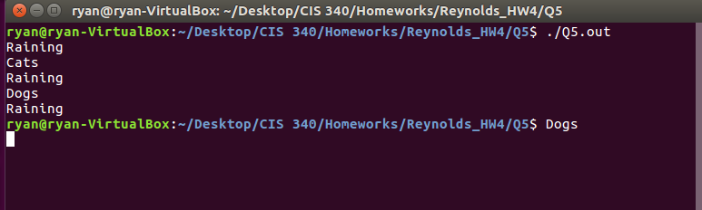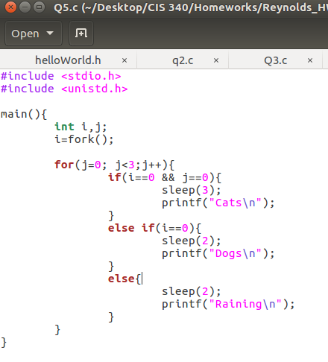

**Question 6:**

