- he app is running cleanly
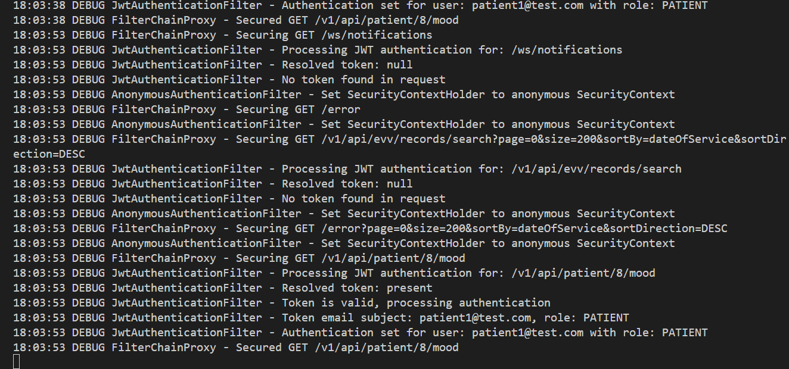
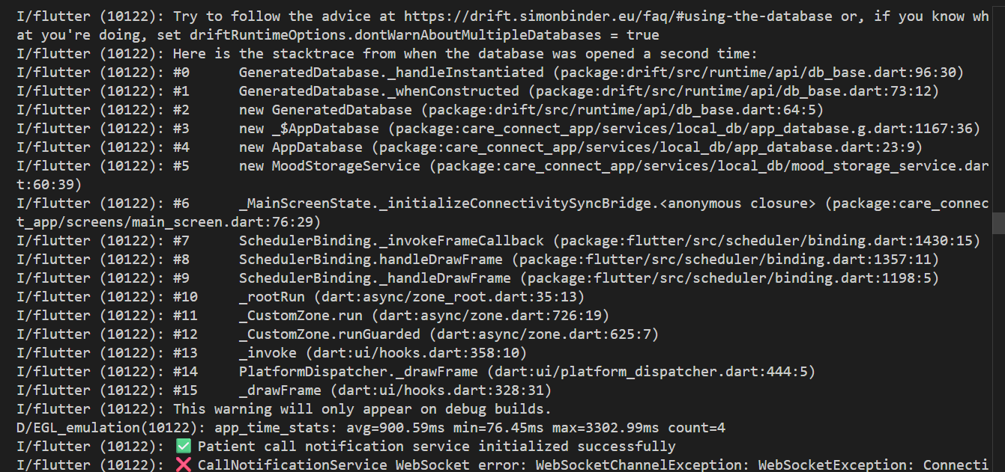

Test ID: TC_APP_START
Purpose: Verify frontend and backend start correctly
Result: PASS

- successful login

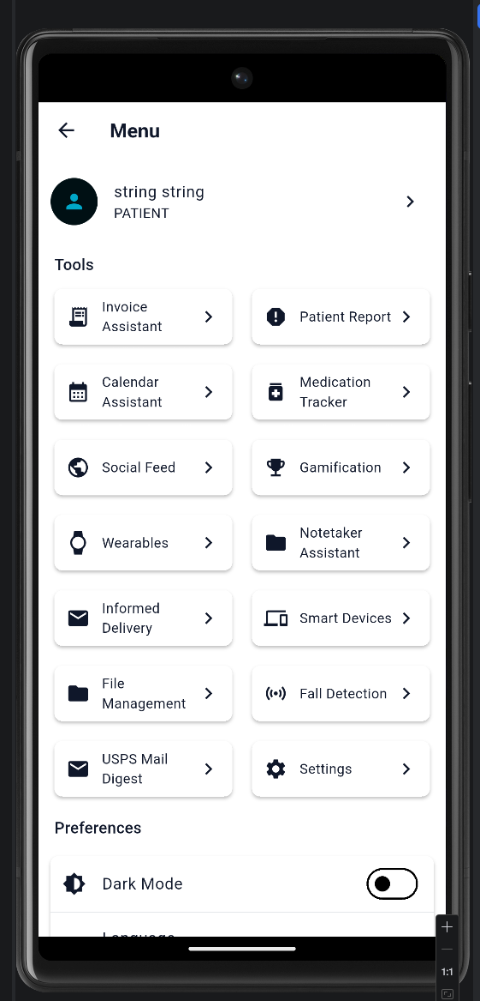

Test ID: TC_LOGIN
Purpose: Verify authentication works
Result: PASS

- Turning offline Persistence on
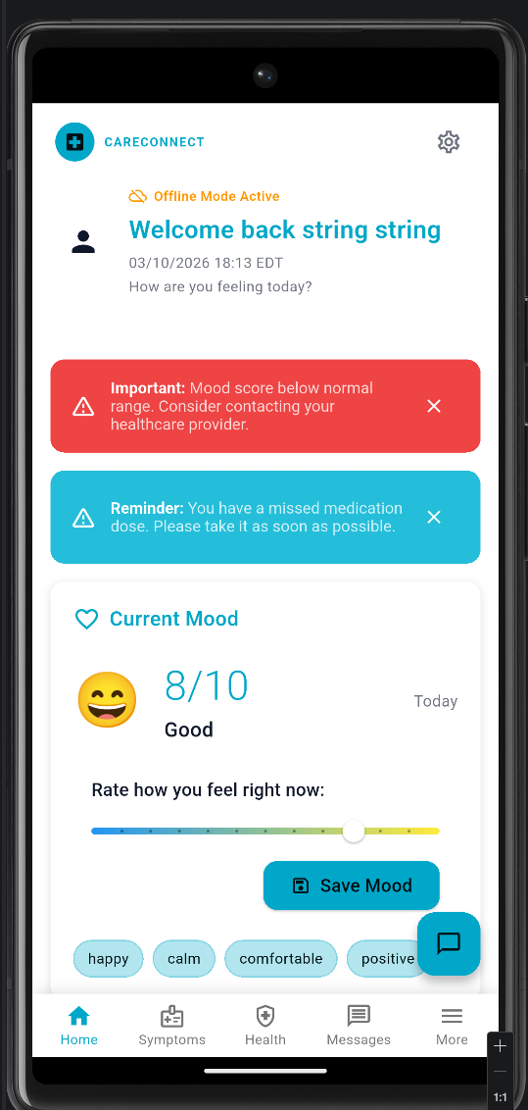
Test ID: TC_OFFLINE_TOGGLE
Purpose: Verify offline mode toggle works
Result: PASS
- Save Data while Online.
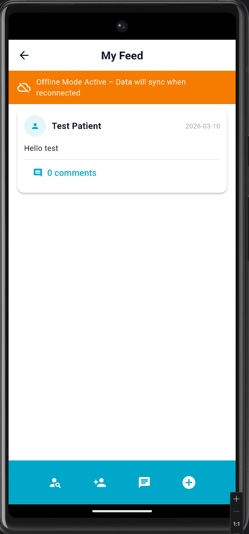

Test ID: TC_DATA_SAVE_ONLINE
Action:
Created a social feed post.
Expected:
Post saves successfully and appears in feed.
Actual:
Post saved successfully and displayed in feed.
Status:
PASS
- Test offline mode result
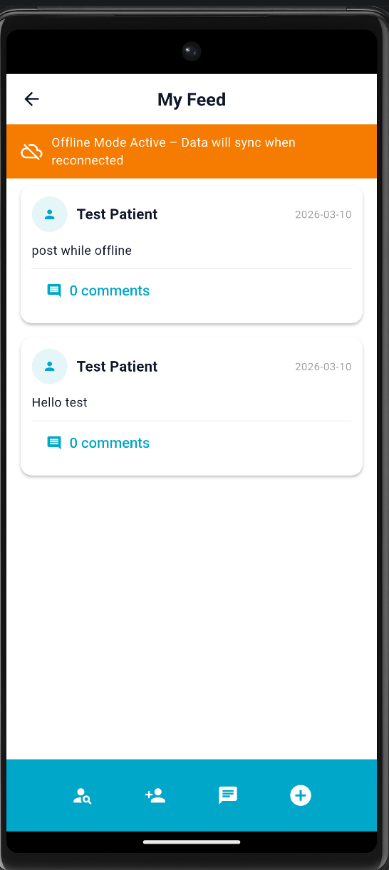
TC_DATA_SAVE_OFFLINE
Purpose:
Verify local_db stores data when internet is unavailable.
Steps:

- network disabled
- Offline Mode banner on
- Post created: post while offline
Expected result:
Post should be stored locally while offline an appeared in the feed.
Status: PASS.
- Both posts made while on and offline exists
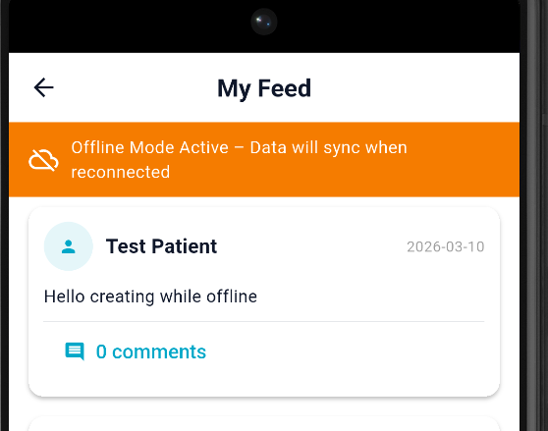
TC_LOCSL_PERSISTENCE
Purpose:
- Stop the application
- Restart the application using flutter run
- Navigate social feed
Expected results:
Both posts remined visible after restarting.
Status: PASS
- Network has been turned on
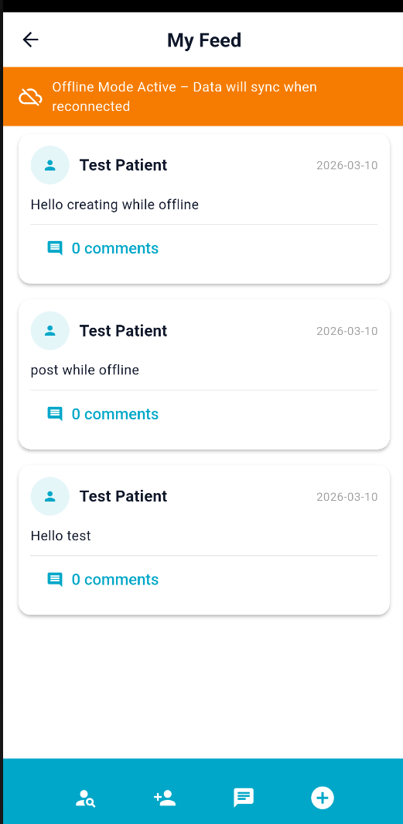
TC_SYNC_AFTER_RECONNECT

Purpose:
Verify offline data remains and synchronizes after internet connection is restored.

Steps:
- Re-enable internet connection on emulator.
- Restart the application.
- Navigate to Social Feed.

Expected Result:
Posts created while offline remain visible and application continues functioning normally.

Actual Result:
Posts remained visible after reconnecting internet and application continued running without errors.

Status:PASS

- Checking terminals
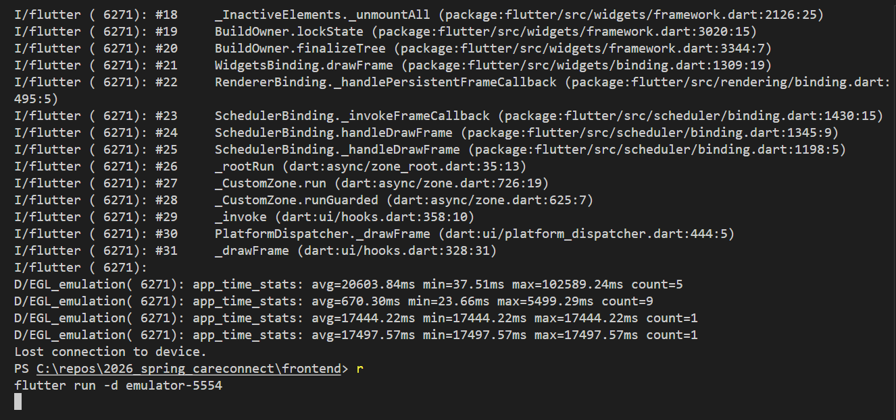

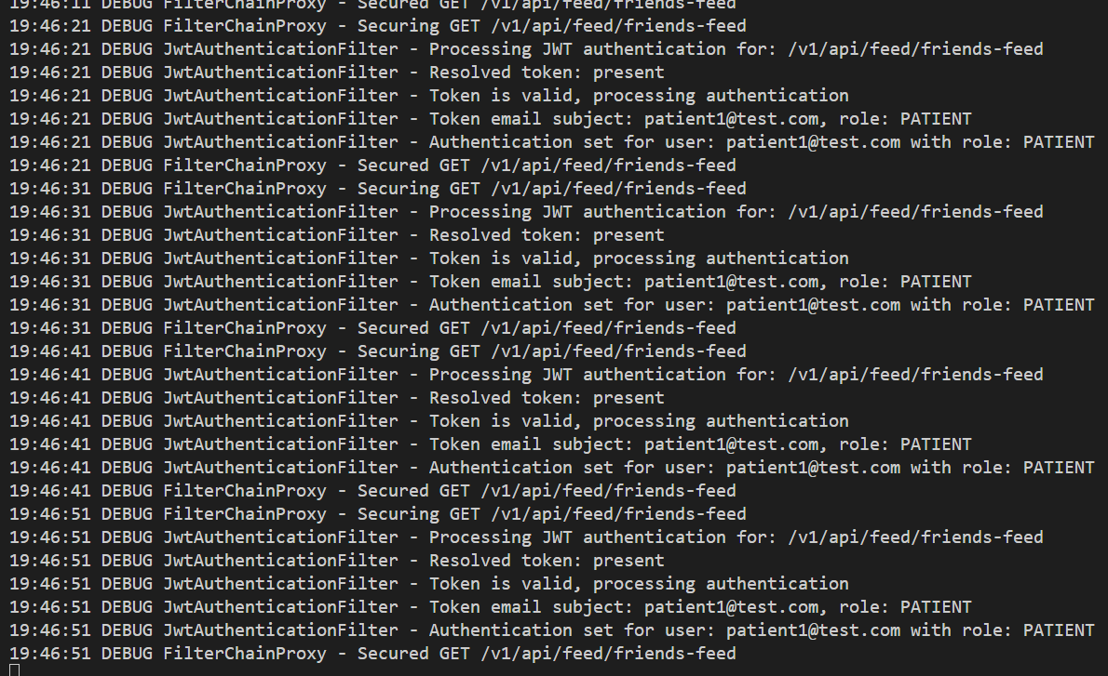

TC_ERROR_MONITOR
Purpose:
Verify no runtime errors occurred during local_db operations while testing offline storage and synchronization.
Steps:
1. Monitored the Flutter frontend terminal during testing.
2. Monitored the backend Spring Boot terminal during testing.
3. Observed logs while performing:
- Online data creation
- Offline data creation
- Application restart
- Network reconnection

Expected Result:
No runtime exceptions, database failures, or application crashes should occur.
Actual Result:
Frontend and backend terminals showed normal debug logs (JWT authentication, secured API requests, Flutter rendering logs). No errors, exceptions, or crashes were observed.
Status: PASS

