1. Research

A few platforms already cover pieces of the parking problem, but none of them put live availability, reservations, in-app navigation, and operator analytics into one system. Here's what I found when I looked at what's already out there.
● SpotHero: A web and mobile marketplace for pre-booking parking at garages and lots. Checkout is smooth, but it only covers partnered facilities and doesn't show live occupancy. Spots are sold from a fixed allotment, not tracked in real time.
● ParkWhiz: Works a lot like SpotHero, but leans heavily on event and venue parking such as concerts and stadiums. Good if you're planning ahead, not much help for parking on the fly.
● ParkMobile: A pay-by-phone app used by a lot of U.S. cities, mostly for on-street metered parking. Great city coverage, but weak when it comes to garage reservations, live availability maps, or anything for operators.
● Passport Parking: Municipal parking and curb-management software sold to city governments. Strong on enforcement and compliance, but it's built for cities, not as an app drivers use directly.
● Google Maps (parking difficulty indicator): Gives a general sense of whether parking will be “harder or easier than usual” in some cities, but there's no reservation, no payment, and no actual space counts per facility.
None of these solutions brings together live availability per facility, in-app reservation and payment, turn-by-turn navigation, and an operator dashboard for occupancy and analytics. Most tools pick a side: SpotHero, ParkWhiz, and ParkMobile serve drivers, while Passport serves cities and operators. The Smart Parking Platform is meant to serve both sides from the same system, and to do it with real-time data instead of pre-sold allotments.

2. Vision and Scope
Project Background
We are Software Corp. A software development studio. This project came about after parking facility operators and city transportation stakeholders flagged a recurring problem: drivers waste a lot of time hunting for open spaces, which adds to congestion and eats into people's day, while operators don't have good real-time tools to manage occupancy or pricing.

Vision Statement
For drivers who need to find and reserve parking quickly, and for operators who need to manage and understand their facilities, the Smart Parking Platform is a web and mobile system that offers real-time availability, in-app reservation and payment, and operator analytics. Existing tools only cover one side of that; this one covers both.

Scope
Scope includes the driver-facing web and mobile experience (search, map, reserve, pay, get notified) along with an operator-facing admin dashboard (managing availability and pricing, viewing occupancy reports). Mapping and payments will be handled through third-party providers rather than built from scratch. Hardware or IoT sensors for physical occupancy detection are not part of this build; that data is assumed to come in as a feed. City-government enforcement tooling is also not included.

3. SRS
3.1 Introduction
Purpose: This document defines the requirements for the Smart Parking Platform, a web and mobile system that helps drivers find, reserve, and pay for parking in real time, and gives parking operators tools to manage availability, pricing, and occupancy.
Scope: The platform covers a driver-facing web and mobile app (search, live availability map, reservations, payment, notifications) and an operator-facing admin dashboard (availability and pricing management, occupancy reporting). Hardware or IoT sensor development for physical occupancy detection is out of scope; that data is assumed to come in as a feed. City-government enforcement tooling is also out of scope.

3.2 Overall Description
Users: Drivers and vehicle owners, parking facility operators, system administrators, and finance/billing personnel.
System Environment: Web-based and mobile application (iOS and Android).

3.3 Functional and Non-Functional Requirements

Functional Requirements:
FR1: The system shall allow drivers to register and log in securely.
FR2: The system shall allow drivers to search for parking near a destination.
FR3: The system shall display real-time space availability on an interactive map.
FR4: The system shall allow drivers to reserve a specific parking spot or space class.
FR5: The system shall allow drivers to pay for a reservation digitally.
FR6: The system shall generate a confirmation and receipt after payment.
FR7: The system shall allow drivers to view, cancel, or modify reservations.
FR8: The system shall provide navigation to a reserved spot through an integrated mapping service.
FR9: The system shall send notifications for reservation status, low availability, and payment issues.
FR10: The system shall allow parking operators to log into an admin dashboard.
FR11: The system shall allow operators to update facility availability and pricing.
FR12: The system shall provide operators with occupancy reporting and analytics.
FR13: The system shall allow operators to manage facility listings.

Non-Functional Requirements:
NFR1: The system shall support at least 1,000 concurrent users.
NFR2: The map and availability data shall update within 5 seconds of a change.
NFR3: The system shall provide 99.9% uptime.
NFR4: Payment processing shall comply with PCI-DSS standards.

3. Use Cases
UC-01
Driver
Register account
A new driver creates an account using email or mobile number to access the platform.

UC-02
Driver
Log in / authenticate
A returning driver logs in securely to access reservations and account details.

UC-03
Driver
Search for parking near destination
Driver enters or selects a destination and the system returns nearby parking facilities.

UC-04
Driver
View real-time availability on map
Driver views an interactive map showing live open and occupied spot counts per facility.

UC-05
Driver
Reserve a parking spot
Driver selects a facility and time window and reserves a specific spot or space class.

UC-06
Driver
Pay for reservation digitally
Driver completes payment via card, digital wallet, or saved payment method.

UC-07
Driver
Receive reservation confirmation and receipt
System generates a digital confirmation and receipt after successful payment.

UC-08
Driver
View reservation history
Driver reviews past and upcoming reservations, including receipts.

UC-09
Driver
Cancel or modify a reservation
Driver cancels or changes an existing reservation within the allowed policy window.

UC-10
Driver
Navigate to reserved spot
System hands off to an integrated mapping and navigation service to route the driver to the facility.

UC-11
Driver
Receive alerts and notifications
Driver is notified of reservation expiration, low availability at a saved location, or payment issues.

UC-12
Parking Operator
Log into admin dashboard
An authorized operator logs into the facility management dashboard.

UC-13
Parking Operator
Update facility availability and pricing
Operator adjusts live space counts, pricing tiers, and blackout dates.

UC-14
Parking Operator
View occupancy reporting and analytics
Operator reviews utilization trends, peak hours, and revenue reports.

UC-15
Parking Operator
Manage facility listings
Operator adds, edits, or deactivates a parking facility profile on the platform.

Homework 2
3.3 Reserve a spot
3.2 Search & Map
3.1 Register & Login
Parking App
Level 1: The Project

Level 2: Deliverables

2.4 Testing & Launch
2.3 Backend Services
2.2 Operator Dashboard
2.1 Driver App

Level 3: Work Packages

1. Driver App

1.1 Register & Login
1.1.1 Sign-up form
1.1.2 Email/phone verification
1.1.3 Login and password reset

1.2 Search & Map
1.2.1 Destination search
1.2.2 Map with facility pins
1.2.3 Open spot counter

1.3 Reserve & Pay
1.3.1 Pick date, time, and spot type
1.3.2 Card and digital wallet payment
1.3.3 Confirmation and receipt

1.4 Manage Reservations
1.4.1 View upcoming and past
1.4.2 Cancel or change booking
1.4.3 Reminders and alerts

2. Operator Dashboard

2.1 Operator Login
2.1.1 Login screen
2.1.2 User roles
2.1.3 Activity log

2.2 Manage Facilities
2.2.1 Add or edit a facility
2.2.2 Update space counts
2.2.3 Set rates and blackout dates

2.3 Reports
2.3.1 Occupancy charts
2.3.2 Peak hours
2.3.3 Revenue export

3. Backend Services

3.1 Database & Accounts
3.1.1 Design and build tables
3.1.2 Store accounts securely
3.1.3 Session handling

3.2 Reservation Engine
3.2.1 Booking logic
3.2.2 Prevent double-booking
3.2.3 Cancellation rules

3.3 Availability Service
3.3.1 Take in occupancy data
3.3.2 Update counts in real time
3.3.3 Send updates to the app

3.4 Integrations
3.4.1 Payment gateway
3.4.2 Maps and location API
3.4.3 Push, email, and text alerts

4. Testing & Launch

4.1 Testing
4.1.1 Test each feature
4.1.2 Test the full system
4.1.3 User testing

4.2 Launch
4.2.1 Submit to app stores
4.2.2 Go live
4.2.3 Fix post-launch issues

2.
Task | Start Date | Duration (Days) | End Date
3.1 Database & Accounts | 08/24/2026 | 21 | 09/13/2026
3.4 Integrations | 08/31/2026 | 21 | 09/20/2026
1.1 Register & Login | 09/14/2026 | 14 | 09/27/2026
3.2 Reservation Engine | 09/14/2026 | 14 | 09/27/2026
3.3 Availability Service | 09/21/2026 | 14 | 10/04/2026
1.2 Search & Map | 09/28/2026 | 21 | 10/18/2026
1.3 Reserve & Pay | 10/12/2026 | 21 | 11/01/2026
2.1 Operator Login | 10/12/2026 | 7 | 10/18/2026
2.2 Manage Facilities | 10/19/2026 | 14 | 11/01/2026
1.4 Manage Reservations | 10/26/2026 | 14 | 11/08/2026
2.3 Reports | 11/02/2026 | 14 | 11/15/2026
4.1 Testing | 11/09/2026 | 21 | 11/29/2026
4.2 Launch | 11/30/2026 | 14 | 12/13/2026
Project start | 08/24/2026
Project finish | 12/13/2026
Total weeks | 16

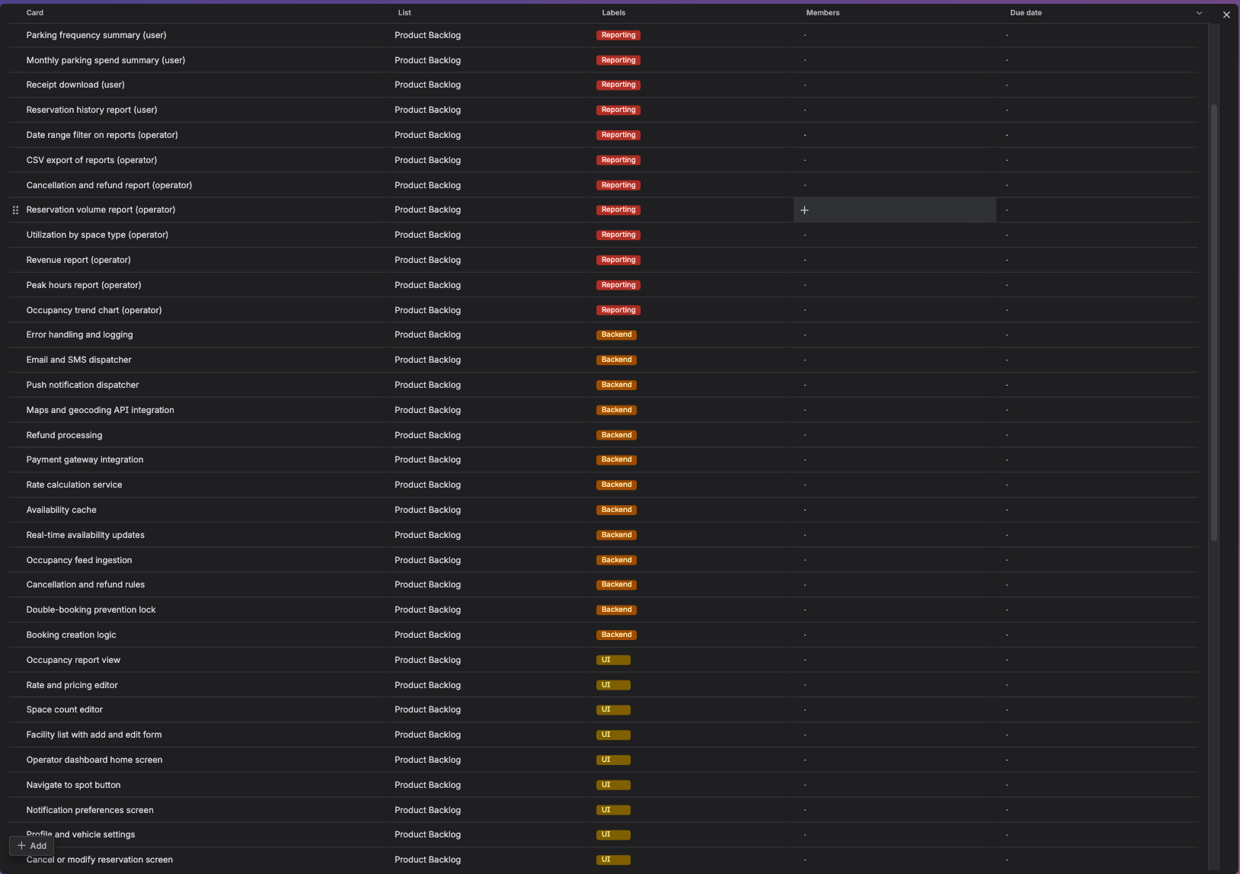

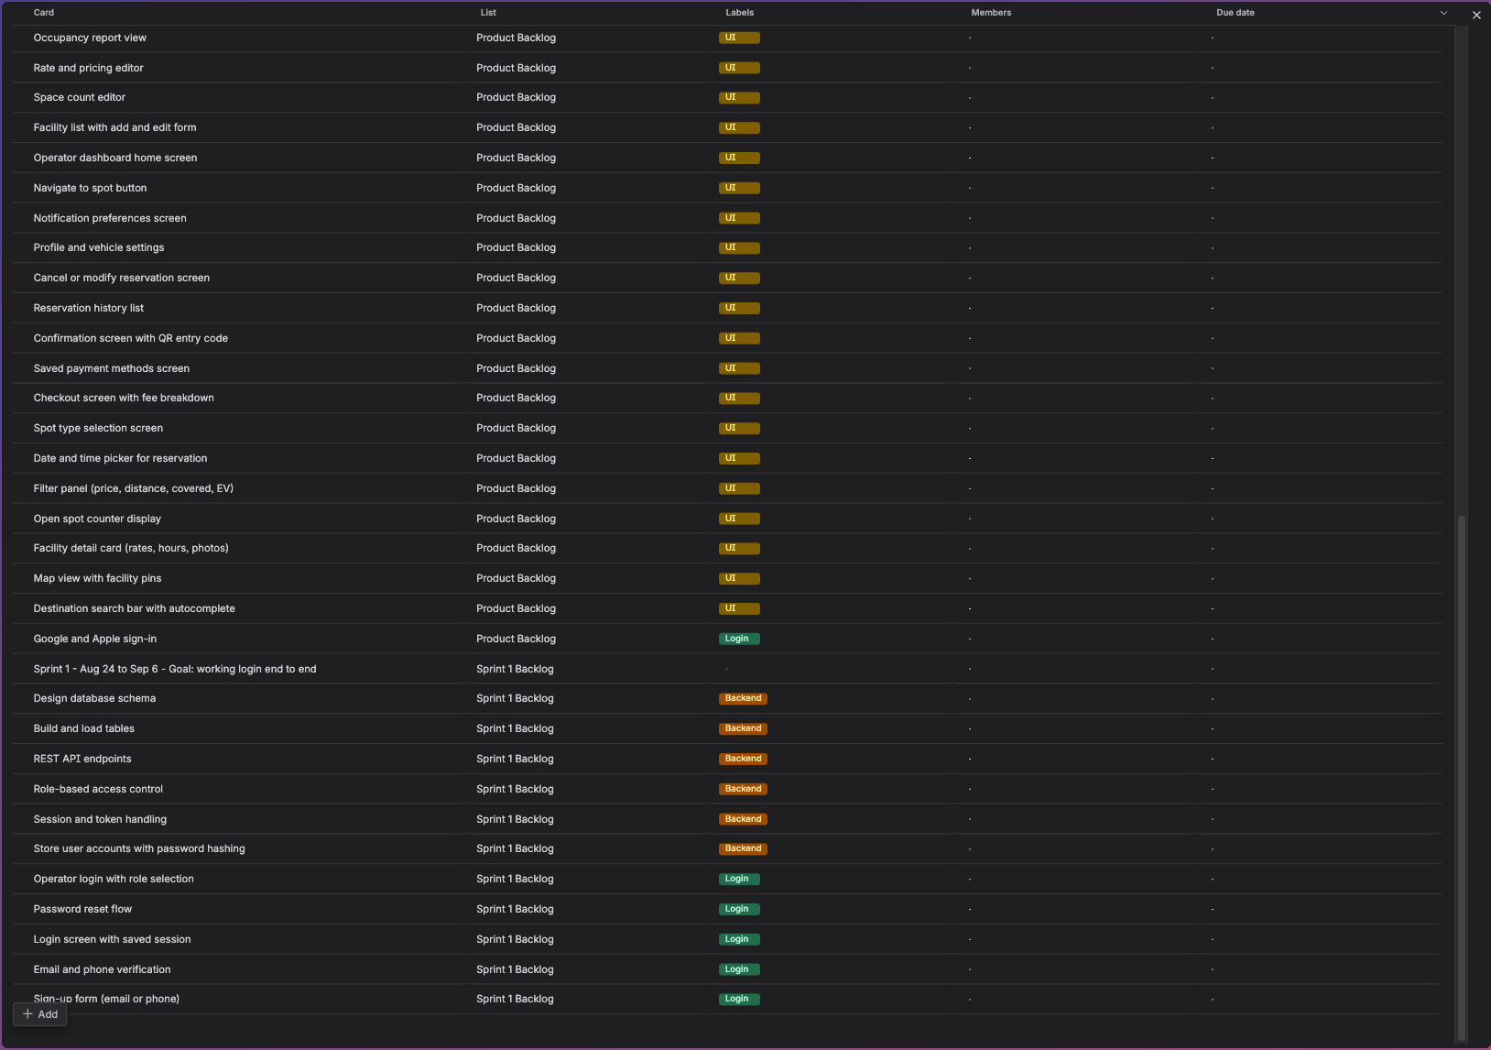
1. Risk Identification
These are the risks I found for the Smart Parking Platform, grouped by the four categories from class. The IDs carry over into the risk register in the next section.
Technical
T1: Operator occupancy feeds come in different formats, and some garages only send updates every few minutes. That would break NFR2, which requires availability to update within 5 seconds.
T2: GPS loses signal inside multi-level concrete garages, so the arrival check-in and the navigation handoff (FR8) may stop working once the driver is inside.
T3: Two drivers could book the last open spot at the same moment, especially during event traffic near NRG Stadium or Toyota Center.
T4: A release could reach some servers but not others, leaving old reservation logic running next to the new version. This is the same kind of failure behind the Knight Capital case from class.

Schedule
S1: The project starts August 24, in the middle of hurricane season. A storm or a long power outage in Houston, like Beryl in 2024, could cost a full sprint.
S2: App Store review can take several days and can reject a build on the first try. The launch window is only November 30 to December 13, which leaves little room for a resubmission.
S3: Thanksgiving week (November 23 to 27) falls inside the testing window (November 9 to 29), which makes it hard to get user testers.
S4: Database & Accounts (August 24 to September 13) is on the critical path. If it slips a week, almost every task after it slips too.

Financial
F1: Mapping API charges are based on usage. Destination search with autocomplete can send a request on nearly every keystroke, so costs could jump once real users are on the app.
F2: Card processing fees are a percentage plus a flat fee per transaction. On a short, cheap booking, like a $4 hour, the fee takes a big piece of the revenue.
F3: If card numbers pass through our own servers, the whole backend falls under PCI-DSS audit scope (NFR4), which is expensive to maintain.
F4: Refunds from cancellations (FR7) and chargebacks usually don't return the processing fee, so each one is a small loss.

People
P1: The team is made up of full-time students. Midterms land during Reserve & Pay (October 12 to November 1), and finals overlap the December launch.
P2: Only one person knows how the payment integration is set up. If they drop the class or leave the team, nobody else can finish it.
P3: Operators may ask for features outside our scope, like enforcement or ticketing tools, which the Vision and Scope section rules out.
P4: User testing depends on one pilot operator's staff. If that contact stops responding, testing at a live facility stalls.

2. Risk Register
Probability and impact use the 1 to 5 scales from the class risk matrix. The rating is where
the two meet on that matrix.

ID | Risk | Probability | Impact | Rating | Owner | Response Strategy | Status / Notes
T1 | Operator feeds too slow or inconsistent to meet the 5-second update (NFR2) | 4 (High) | 3 (Moderate) | HIGH | Backend Lead | Mitigate: convert every feed to one format and show a "last updated" time on facilities with slow feeds | In progress. Part of the Availability Service work (Sep 21 to Oct 4).
T3 | Two drivers book the last open spot at the same time | 3 (Moderate) | 4 (Major) | HIGH | Backend Lead | Mitigate: hold the spot during checkout and lock it in the database; include it in the 1,000-user load test (NFR1) | Open. Test planned for the November testing window.
T4 | Release reaches some servers but not others | 2 (Low) | 5 (Catastrophic) | HIGH | Backend Lead | Mitigate: deploy to staging first, release to all servers at once, keep a written rollback plan, and remove old unused code | Open. Rollback plan due before launch.
S1 | Hurricane or long power outage during peak season | 3 (Moderate) | 4 (Major) | HIGH | Project Manager | Mitigate: keep all work in GitHub and cloud tools so the team can keep going from anywhere with power | Monitoring until Nov 30, the end of hurricane season.
S2 | App Store review delays or rejects the launch build | 3 (Moderate) | 4 (Major) | HIGH | Mobile Lead | Mitigate: submit a test build in mid-November so review problems show up before the launch window | Open.
S3 | Thanksgiving week cuts into user testing | 4 (High) | 2 (Minor) | MEDIUM | QA Lead | Mitigate: schedule user testing sessions before Nov 20 | Open.
F1 | Mapping API costs spike with real traffic | 3 (Moderate) | 3 (Moderate) | MEDIUM | Backend Lead | Mitigate: search only after the user stops typing, cache results, and set budget alerts and daily caps | Open.
F2 | Card fees eat most of the revenue on cheap, short bookings | 4 (High) | 2 (Minor) | MEDIUM | Finance/Billing | Mitigate: add a small booking fee or a minimum charge | Open. Decision needed before Reserve & Pay starts Oct 12.
F3 | Handling card numbers puts the backend in PCI audit scope | 2 (Low) | 4 (Major) | MEDIUM | Backend Lead | Avoid: use the payment provider's hosted checkout fields so card numbers never touch our servers | Closed. Decided during design.
P1 | Midterms and finals cut team availability | 4 (High) | 3 (Moderate) | HIGH | Project Manager | Mitigate: plan lighter sprints during exam weeks using the UH calendar | Monitoring.
P2 | Only one person knows the payment setup | 2 (Low) | 4 (Major) | MEDIUM | Project Manager | Mitigate: pair a second person on payment work and keep setup notes in the repo | Open.
P3 | Operators push for out-of-scope features | 3 (Moderate) | 3 (Moderate) | MEDIUM | Product Owner | Mitigate: new requests go to sprint review and get checked against the Vision and Scope section | Open.

1. Roles & Resources
Our team is small and everyone is still in school, so nobody works on this full-time. The allocation is how much of a 40-hour week each person puts into the project. All names are made up.
Role | Name | Skill Level | Allocation | Hours/Week | What They Do
Project Manager | Danny Ortiz | Mid (has run a few team projects) | 25% | 10 | Runs the schedule, Trello board, and weekly updates
Product Owner | Lauren Mitchell | Mid (used to work for a parking garage company) | 15% | 6 | Decides what features matter most and talks to operators
Backend Lead | Kevin Tran | Senior (4 years with databases and APIs) | 50% | 20 | Builds the database, reservation logic, and payment setup
Mobile Lead | Jessica Alvarez | Mid (2 years building iOS and Android apps) | 50% | 20 | Builds the driver app and the operator dashboard
QA Lead | Brandon Lee | Junior (first QA role) | 25% | 10 | Writes test cases and runs testing
Finance/Billing | Nicole Harper | Mid (handles budgets and payment fees) | 5% | 2 | Tracks spending and card processing costs

2. Resource & Cost Plan
I used the bottom-up method since we already have the WBS and schedule broken into tasks. I figured out each person's hours over the 16 weeks (August 24 to December 13), multiplied by their rate, then added the other costs on top.
Labor
Role | Name | Total Hours | Rate | Cost
Project Manager | Danny Ortiz | 160 | $40/hr | $6,400
Product Owner | Lauren Mitchell | 96 | $40/hr | $3,840
Backend Lead | Kevin Tran | 320 | $45/hr | $14,400
Mobile Lead | Jessica Alvarez | 320 | $40/hr | $12,800
QA Lead | Brandon Lee | 160 | $30/hr | $4,800
Finance/Billing | Nicole Harper | 32 | $35/hr | $1,120
Total |  | 1,088 |  | $43,360

Other Costs
Item | Category | When | Unit Cost | Total
Cloud hosting | Infrastructure (OPEX) | Sep to Dec, 4 months | $150/month | $600
Maps API | Third-party API (OPEX) | Oct to Dec, 3 months | $100/month | $300
Text and email alerts | Third-party API (OPEX) | Oct to Dec, 3 months | $50/month | $150
Apple developer account | License | One time, August | $99 | $99
Google Play developer account | License | One time, August | $25 | $25
Test phones (1 iPhone, 1 Android, used) | Hardware (CAPEX) | One time, August | $600 | $600
Load testing tool | Tools | One time, November | $100 | $100
Total |  |  |  | $1,874

Hosting doesn't start until September because the first couple of weeks are just building the database on our own laptops.
Totals
Labor: $43,360
Other costs: $1,874
Total before contingency: $45,234
Contingency (15%): $6,785
Grand total: $52,019
I went with 15% contingency. The lecture said 5% to 20% is normal, and our risk register has six risks rated HIGH, so I didn't want to go on the low end.
Card processing fees aren't in the budget. Those come out of each booking after the app launches, so they aren't a build cost.
Monthly Cashflow
I counted each week in the month its Monday falls in. That's why November has 5 weeks and December only has 1. Contingency is rounded to whole dollars.
Month | Weeks | Labor | Infra & APIs | Licenses, Tools & Hardware | Contingency (15%) | Total
August | 2 | $5,420 | $0 | $724 | $922 | $7,066
September | 4 | $10,840 | $150 | $0 | $1,648 | $12,638
October | 4 | $10,840 | $300 | $0 | $1,671 | $12,811
November | 5 | $13,550 | $300 | $100 | $2,092 | $16,042
December | 1 | $2,710 | $300 | $0 | $452 | $3,462
Total | 16 | $43,360 | $1,050 | $824 | $6,785 | $52,019

3. RACI Matrix
R = Responsible (does the work), A = Accountable (signs off on it), C = Consulted, I = Informed. Each row has only one A. If someone does the work and also signs off on it, they're marked A/R.
The way I split it: the Product Owner is accountable for the requirements and anything users actually see, QA is accountable for testing, and the PM is accountable for everything else.
Deliverable | PM (Danny) | PO (Lauren) | Backend (Kevin) | Mobile (Jessica) | QA (Brandon) | Finance (Nicole)
Requirements (SRS) | R | A | C | C | C | I
Schedule & Gantt chart | A/R | C | C | C | I | I
Budget & cashflow | A | C | I | I | I | R
Database & accounts | A | I | R | C | I | I
Reservation & availability engine | A | C | R | C | C | I
Payment & maps integrations | A | I | R | C | I | C
Driver app screens | I | A | C | R | C | I
Operator dashboard | I | A | C | R | C | I
Testing | I | C | C | C | A/R | I
App store launch | A | I | C | R | C | I
Risk register & shareholder updates | A/R | C | I | I | I | C

